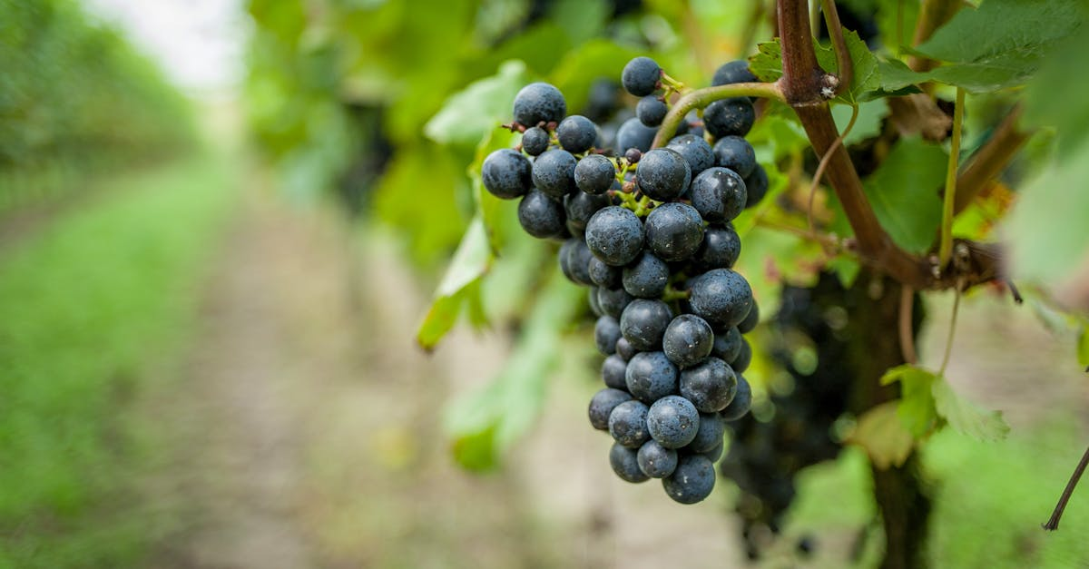
Rosh Chodesh Celebrations
NISAN, 5787 (Sunday, April 11, 2027)
NEW CYCLE OF MONTHS
6:00PM – 8:00PM

IYAR, 5787 (Wednesday, May 5, 2027)
6:00PM – 8:00PM

SIVAN, 5787 (Sunday, June 6, 2027)
6:00PM – 8:00PM

TAMMUZ, 5787 (Wednesday, July 7, 2027)
6:00PM – 8:00PM

AV, 5787 (Sunday, August 1, 2027)
6:00PM – 8:00PM

ELUL, 5787 (Wednesday, September 1, 2027)
6:00PM – 8:00PM

5 7 8 7
First FruitsGatherings
“The New Wine is found
in the cluster.”
(Isaiah 65:8)
TISHREI, 5787 (Sunday, September 13, 2026)
HEAD OF THE YEAR 5787
6:00PM – 8:00PM

CHESHVAN, 5787 (Sunday, October 11, 2026)
6:00PM – 8:00PM

KISLEV, 5787 (Sunday, November 8, 2026)
6:00PM – 8:00PM

TEVET, 5787 (Sunday, December 13, 2026)
6:00PM – 8:00PM

SHEVAT, 5787 (Sunday, January 10, 2027)
6:00PM – 8:00PM

ADAR I, 5787 (Sunday, February 7, 2027)
6:00PM – 8:00PM

ADAR II, 5787 (Sunday, March 7, 2027)
6:00PM – 8:00PM

