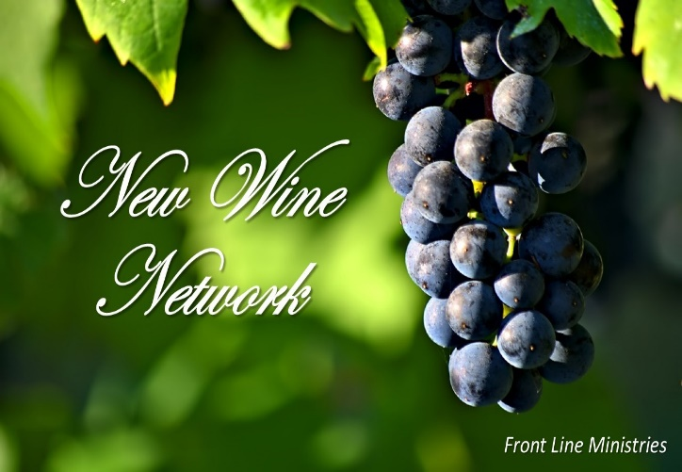
UNDERSTANDING SYNAXIS?

The word used for house-to-house gatherings in the Early Church was SYNAXIS … a Greek word that means “a gathering; a coming together; a reunion”. A synaxis was an on-going “family reunion” of believers, outside the corporate setting. A synaxis was a very specific kind of gathering, with a very specific purpose. While synaxis gatherings are mentioned many times throughout the New Testament, the book of I Corinthians gives us the clearest picture of what took place in these meetings. The teachings of the Apostle Paul in the book of I Corinthians reveal that synaxis gatherings were designed to accomplish at least five (5) specific things:
  - Fellowship
  - Praise and Worship
  - The Lord’s Supper (Communion)
  - Opportunity for believers to exercise their spiritual gifts
  - Development of a “Go ye therefore …” mindset
Every week, the members of the early church gathered in synaxis … some on more than 1 day! These house-to-house gatherings were incubators for encounter with the supernatural power of Holy Spirit among the people of God. In synaxis, believers were led to discover, develop, and practice their spiritual gifts. It is in the context of synaxis that the goal of Ephesians 4 is fulfilled … God’s people are equipped for the work of ministry. The undeniable presence & power of God that moved in synaxis, soon necessitated the building of temples to protect the unity & purity of teachings within the exploding Ekklesia. Thus, temple (corporate) gatherings became incubators for vision, celebration and teaching.

We believe synaxis was a major key to the success of the Early Church. When believers are built up in vision and faith through corporate gatherings, and given opportunity to exercise their gifts in synaxis, a revival dynamic is created. The Body of Christ should no longer be content as a passive group, dependent solely upon a congregational identity. We are a growing army, operating in the supernatural power of God to change the world!

It's time for he restoration of SYNAXIS!
A RETURN TO ACTS 2
NEW TESTAMENT LIFE … RESTORED!
syn*ax*is | a gathering; a coming together; a reunion

CLUSTERS (ABIDE Groups) … “The new wine is found in the clusters.” (Isaiah 65:8)

In recent days, God has been revealing a deeper understanding of the way people gathered in the Early Church … the explanation for how The Ekklesia exploded in such a short period of time. We are beginning to sense this may be the new “wineskin” for the New Wine (Glory) He is preparing to pour out upon His people in the days ahead. We believe that new, faster, and more innovative ways of communicating and demonstrating the power of God are rising quickly. Could it be that these new ways will come forth through small, intimate gatherings in homes, developed for more personal interaction among God’s people, and aimed at gaining fresh direction and divine strategy to overcome in the world around us? CLUSTERS (ABIDE Groups) will enable us to effectively minister to and more effectively mobilize The Body, communicate quickly, and advance our influence into the region around us. How we gather, equip and empower the saints, and strategize will be the key to advancing The Kingdom in the days ahead.

