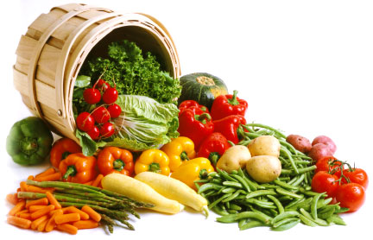
The Daniel Fast Recipe Book
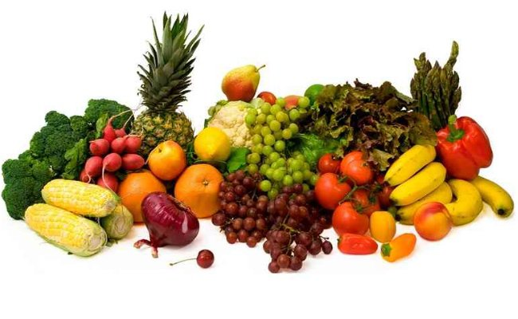

Mount Zion AME Church
Consecration 2024
To God be the Glory!
404 Zion Hill Road
Atglen, PA 19310

Pastor Linda Ellerbe, Servant Leader
Recipe Suggestions for the Fast and a Healthier Lifestyle

Try something new.
After all, this is a Daniel Fast, and with God, anything is possible, right? Enjoy!
We have assembled some recipes to assist us in the fast. The following are examples and suggestions only. Remember the focus of the fast is not what we are giving up, but rather the focus is focused on what this opportunity enable us to receive from God.
Search God’s Word. Seek God in Prayer. Submit to God’s will. Watch what God does.
As we feed our souls and pull our bodies into subjection we submit our will to align ourselves with God’s will.
Fasting is designed to increase our focus on God and take the spotlight off of us; our wants; our desires, and seek what God desires.
The fast is really not about food. It is about our submitting ourselves to God; moving from being selfish to selfless.
“Not my will, but Thy will”.
Please, please, please, if you have dietary constraints or medical concerns, please contact your physician.
Diabetics can do the Daniel fast, however, you must monitor your blood sugar.
If you need to take meds with food, please do that.
Our young people [or all of us] may wish to consider fasting from social media, secular music and gaming, while they invest that time in their soul’s eternal destination.

The Food List- also see the Recipe Book
Special Note: If you have health issues, please be sure to contact your health professional for advice before committing to any fast, including the Daniel Fast. Please make sure to READ THE LABEL when purchasing packaged, canned or bottled foods. They should be sugar-free and chemical-free [preservatives]. Keep this in mind as you review this list of acceptable foods.
The fast also includes the avoidance of all alcohol, nicotine, caffeine, and recreational drugs.
Foods to include in your diet during the Daniel Fast
All fruits. These can be fresh, frozen, dried, juiced or canned. Fruits include but are not limited to apples, apricots, bananas, blackberries, blueberries, boysenberries, cantaloupe, cherries, cranberries, figs, grapefruit, grapes, guava, honeydew melon, kiwi, lemons, limes, mangoes, nectarines, oranges, papayas, peaches, pears, pineapples, plums, prunes, raisins, raspberries, strawberries, tangelos, tangerines, watermelon
All vegetables. These can be fresh, frozen, dried, juiced or canned. Vegetables include but are not limited to artichokes, asparagus, beets, broccoli, Brussels sprouts, cabbage, carrots, cauliflower, celery, chili peppers, collard greens, corn, cucumbers, eggplant, garlic, ginger root, kale, leeks, lettuce, mushrooms, mustard greens, okra, onions, parsley, potatoes, radishes, rutabagas, scallions, spinach, sprouts, squashes, sweet potatoes, tomatoes, turnips, watercress, yams, zucchini, veggie burgers are an option if you are not allergic to soy.
All whole grains[excluding leaven], including but not limited to whole wheat, brown rice, millet, quinoa, oats, barley, grits, whole wheat pasta, whole wheat tortillas, rice cakes and popcorn[without butter].
All nuts and seeds, including but not limited to sunflower seeds, cashews, peanuts, sesame. Also nut butters[no sugar added] including peanut butter.
All legumes. These can be canned or dried. Legumes include but are not limited to dried beans, pinto beans, split peas, lentils, black eyed peas, kidney beans, black beans, cannellini beans, white beans, chick peas.
All quality oils including but not limited to olive, canola, grape seed, peanut, and sesame.
Beverages: spring water, distilled water or other pure waters.
Other: tofu, soy products, vinegar, seasonings, salt, herbs and spices.

Foods to AVOID on the Daniel Fast
Avoid All meat and animal products including but not limited to beef, lamb, pork, poultry, and fish. Plant based food is an option.
Avoid All dairy products including but not limited to milk, ice cream, yogurt, cheese, cream, butter, and eggs.
Avoid All sweeteners including but not limited to sugar, raw sugar, syrups, molasses, and cane juice.
Avoid All leavened bread including Ezekiel Bread (it contains yeast and honey) and baked goods.
Avoid All refined and processed food products including but not limited to artificial flavorings, food additives, chemicals, white rice, white flour, and foods that contain artificial preservatives.
Avoid All deep fried foods including but not limited to potato chips, French fries, corn chips.
Avoid All solid fats including shortening, margarine, lard and foods high in fat.
Choose Olive or Avocado Oil
Avoid beverages including but not limited to Caffeinated coffee and tea, carbonated beverages, energy drinks, and alcohol.-Water is then preferred beverage for the fast this year!
Remember, READ THE LABELS!

Suggested Substitutes
Decaffeinated Coffee/ Herbal Tea
Just Eggs is a plant-based egg substitute that can be used for cooking or scrambled.
Plant Based Crumbles is a great protein substitute for chili and spaghetti sauce.
Chic Pea Pasta
Riced Cauliflower for mashed potatoes, pizza crust
Hearty Vegetable Stew is a winter winner.
Have questions? Text or call pastor.

Smoothies
Smoothie Meals: Smoothies are great snacks or meals! They are filling and curb cravings. Unsweetened almond milk may also be used in the smoothie, but is discouraged as a beverage. Frozen fruits work very well in the blender. This is a great grab and go in the morning!
NOTE: For best results at least one fruit should be frozen. To freeze bananas peel them and place them in a freezer storage bag. The following recipes may also serve as a guide for making your favorite flavor smoothie. Use the measurement ratios below or experiment and make your own creations!
Pouches of “no sugar added” frozen fruit is available at ShopRite, ACME, Walmart and other local grocery stores.

Berry Blast Smoothie
1 cup water
1 cup frozen blackberries, blueberries, and raspberries
1 banana, peeled
Mix all ingredients in a blender until smooth.

Mango Blueberry Smoothie
1 cup water
1 cup fresh or frozen mango chunks
1 fresh or frozen banana, peeled, sliced
1/2 cup fresh or frozen blueberries
1 tablespoon flaxseed meal, optional
1 tablespoon unsweetened coconut flakes
Mix all ingredients in a blender until smooth.

Raspberry-Pecan Smoothie
1 cup water
1 cup spinach or mixed greens
1 large frozen banana, peeled, sliced
½ cup fresh or frozen raspberries
2 tablespoons chopped pecans
Mix all ingredients in a blender until smooth.

Sweet Spinach Smoothie
1 cup water or non-dairy milk (almond, coconut, rice, or soy milk)
1 Bosc pear, unpeeled, cored
1 cup fresh spinach leaves, packed
1 frozen banana
1 tablespoon flaxseed meal, optional
1/2 tablespoon kelp powder, optional
1/2 tablespoon spirulina powder, optional
Yield: 2 servings (serving size: about 8 ounces or 1 cup)

Recipe Notes
- To freeze bananas, remove peels before placing in freezer. Put in a plastic zip-top bag until completely frozen.
- Substitute spinach with kale leaves.
- Use an Anjou, Asian, or Bartlett pear instead of a Bosc pear.
- Flaxseed meal is a powder made from ground flaxseeds. It is high in fiber and a good source of Omega-3 fatty acids.
- Kelp is a sea vegetable that is a concentrated source of minerals, including iodine, potassium, magnesium, calcium, and iron.
- selenium, and gamma linolenic acid (an essential fatty acid).

Breakfast
Start your day with the Word, prayer and healthy choices for the temple.
Know ye not that ye are the temple of God, and that the Spirit of God dwelleth in you? 1 Corinthians 3:16

What? Know ye not that your body is the temple of the Holy Ghost which is in you, which ye have of God, and ye are not your own? 1 Corinthians 6:19
Oatmeal with any unsweetened fruit- ie: Applesauce, peaches, berries
Or this gluten free substitute

Apple-Cinnamon Hot Cereal
1 (14.5-ounce) can coconut milk
2 cups cooked brown rice[or oatmeal]
1 apple, chopped, unpeeled (about 1 1/2 cups)
1 banana, mashed (about 1 cup)
1 cup roughly chopped dates
1½ teaspoons cinnamon
Pinch nutmeg
½ cup toasted pecans or walnuts

Broiled Pineapple Slices
6 fresh or canned pineapple slices –
1 tablespoon Date Honey*
1 tablespoon fresh lime juice
1 tablespoon unsweetened coconut flakes

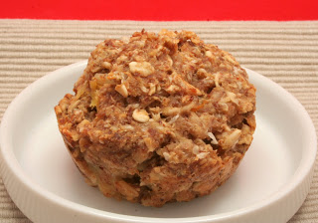
Pineapple Citrus Muffins
1 cup old-fashioned rolled oats
1 cup oat flour (see Recipe Notes)
1 cup unsweetened applesauce
½ cup diced pineapples
¼ cup chopped pecans or walnuts
¼ cup Date Honey*
¼ cup flaxseed meal
2 teaspoons unsweetened coconut flakes
2 teaspoons grated orange zest
½ teaspoon ground ginger
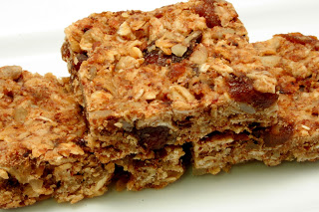

Apricot-Nut Breakfast Bars
1 ½ cups old-fashioned rolled oats
2 tablespoons flaxseed meal
½ cup unsweetened apple juice
1 tablespoon extra-virgin olive oil
¼ cup almond butter
¼ cup Date Honey *
½ cup diced dried apricots (unsulfured)
¼ cup chopped macadamia nuts
2 tablespoons raw sunflower seeds
Preheat oven to 350 degrees. Toast oats in a large skillet over medium heat 5-7 minutes or until oats are golden, stirring frequently. Transfer to a large bowl, and add flaxseed meal, apple juice, olive oil, almond butter, and Date Honey. Mix until well combined. Stir in apricots, macadamia nuts, and sunflower seeds.
Press into an 8 by 8-inch square pan that has been lightly rubbed with olive oil. Bake 15-20 minutes. Let cool in pan on a wire rack for about 5 minutes. Cut into 2 x 2 ½-inch bars and serve.
Yield: 12 servings (serving size: 1 bar)
Lunch, Dinner and Sacks

*Date Honey
1 cup pitted dates (about 6-8 Medjool or 18-20 Deglet Noor)
1 cup water
½ teaspoon cinnamon
Pour dates and water into a small saucepan, making sure dates are completely covered (add additional water if necessary). Bring to a boil over high heat
Reduce heat to low and simmer 45-60 minutes or until dates are very soft and broken down. Remove from heat and allow to cool slightly for about 15 minutes.
Pour mixture (including liquid) into a blender or food processor and puree until completely smooth.
Sprinkle in cinnamon and stir well. Store in a sealed container in the refrigerator.
Yield: 12 servings (serving size: about 1 tablespoon)
Salads
Salads can be a side dish, snack or very creative entre meal. Mix veggies and fruits with nuts and beans for a heartier, heart healthy meal.

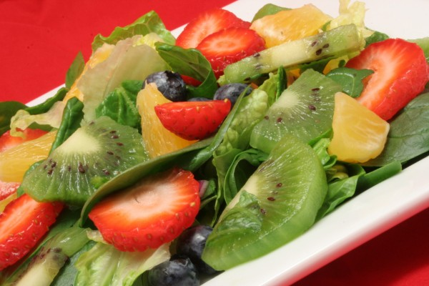
Tropical Fruit Salad
2 cups sliced strawberries
3 kiwifruit, peeled and quartered
1 1/2 cups orange segments, cut into 1-inch pieces
1 cup red seedless grapes, halved
1 cup fresh pineapple chunks, cut into tidbits
Mix fruit in a large bowl, and chill until ready to serve.
Yield: 6 servings (serving size: about 1 cup)
Recipe Notes
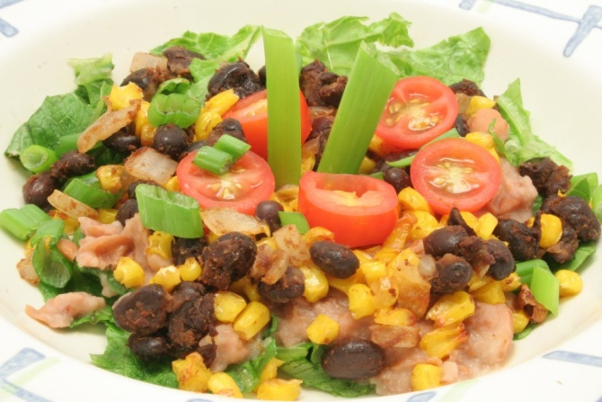
Taco Salad
1 (14.5-ounce) can corn kernels, drained
1 (15.5-ounce) can pinto beans, undrained
1/4 teaspoon garlic powder
1/4 teaspoon salt
1 tablespoon extra-virgin olive oil
1/2 cup diced onion
1 (15-ounce) can black beans, rinsed and drained
1/2 tablespoon Taco Seasoning
2 cups torn romaine or iceberg lettuce
Garnishes: Avocado slices, chopped green onions, sliced olives, and/or diced tomatoes
Preheat oven to 425 degrees. Spread corn kernels out in one layer on a lightly oiled [olive oil] 11 x 17-inch baking sheet. Bake for 20-25 minutes. [or until corn is browned and slightly crunchy]
While corn is roasting, place pinto beans in a small saucepan over medium heat. Add garlic powder and salt. Cook 10 minutes, stirring occasionally. Using a fork or potato masher, mash beans until they are the consistency of refried beans. Lower heat, and continue to cook until some of the liquid has evaporated and beans have thickened, about 10 minutes more. Stir frequently to avoid scalding beans on the bottom of the pan.
Heat olive oil over medium heat, and add onions. Cook until onions are soft and translucent. Add black beans, corn, and taco seasoning. Stir well to coat. Reduce heat to low, and keep warm until pinto beans are done. To serve, place about 1/2 cup lettuce on each plate, and top with 1/4 cup pinto beans and a heaping 1/2 cup of black bean and corn mixture. Add desired toppings to salad.
Yield: 4 servings (serving size: about 1 1/2 cups)

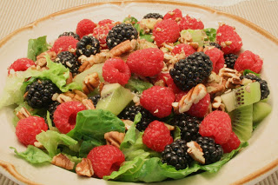
Fruit and Nut Salad
4 cups torn romaine lettuce, packed
3 kiwifruit, peeled and cut into half-moons
1 cup blackberries
1 cup raspberries
½ cup roughly chopped pecan halves
1 recipe Orange-Poppy Seed Salad Dressing*
Place lettuce in a large bowl, and top with kiwifruit, blackberries, raspberries, and pecans. Toss lightly, and serve with Orange-Poppy Seed Salad Dressing.* Yield: 4 servings (serving size: about 1 ½ cups)

In a blender or food processor combine the orange juice, agave nectar, white wine vinegar, & poppy seeds. With the motor running slowly add the olive oil.
*Orange Poppy seed Dressing
1/4 cup freshly squeezed orange juice
2 tbsp Date Honey
1 tbsp white wine vinegar
1/2 teaspoon poppy seeds
1/4 cup olive oil

Top of Form

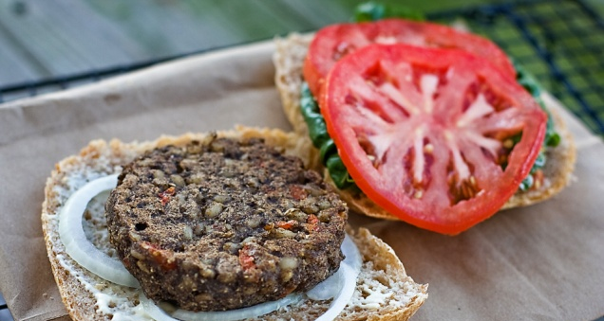
If you’ve been craving a burger, take a look this recipe. It’s a burger, all right, but one that’s completely Daniel Fast friendly. Yummy!

Ingredients
- 1 lb [3 large] portabella mushrooms
- 1/2 large white onion
- 2 cloves garlic
- 10 springs fresh parsley
- 2 tbsp tomato paste
- 2 tsp organic Kirkland seasoning; [or 1 tsp dried oregano and 1 tsp dried thyme]
- 3 cups cooked barley*
- sea or Himalayan salt to taste [but don’t go crazy! ;)]
- 1/2 of 12 oz jar of Mezzetta roasted red bell peppers [makes about 3/4 cup when chopped]**, dice or chop into small pieces
- 1 cup of rolled oats, ground into flour [instructions below]
- 1/4 cup brown rice flour
*it takes about1-1.5 cup of dry barley to make 3 cups of cooked barley
**you can use any other brand, but look for the ones marinated in water, not oil!

Preparation
- cook barley until very soft; to reduce your cooking time, soak grains for a few hours, strain water, rinse and then cook in water, as instructed on the package
- wash and chop mushrooms into medium size chunks
- peel and chop onion into medium size chunks
- peel garlic
- wash and chop parsley
- place ingredients 1-4 into a food processor and process until puree-like consistency is achieved [see first image below]
- preheat a pan on medium heat, transfer ingredients into it;
- add tomato paste, seasoning, salt and roasted pepper
- when mixture warms up and start bubbling, reduce heat to medium-low and let it simmer, while stirring for about 15 minutes to reduce water
- add barley and stir it in
- reduce hit to the lowest setting
- have 1 cup of rolled oats prepared into flour by placing oats into a high speed blender, and giving them a whirl for a few seconds until you get oat flour [it this is not an option, just buy some oat flour]; same goes for brown rice–you can make your own flour at home in blender, or buy from the store
- stir in oat and brown rice flour, until well blended in [see second image below]
- remove pan from heat; let the mixture cool off until warm so you do not burn your hands shaping burger patties from it; or, if you are impatient like me, see step 16
- the only oil I used, since I do not have a grill, and you might find a way around it, was a tiny bit to grease baking sheets–it was the tiniest bit–so, lightly grease two baking sheets, and preheat your oven to 375 F; to avoid using any and all oil, try using parchment paper to line the baking sheets
- I used a little gadget, known as Adjust-A-Cup, to make my patties, that is why they were so pretty and round; stuff the container with the veggie burger mixture and push it out slowly, cutting it off ever 1.5 inch or so with a knife, onto the baking sheet, the lightly press it down, to make the patty bigger [see third image below]
- bake at 375 F for 7 minutes–one sheet on top and one on the bottom; then switch and bake for additional 7 minutes
- pull out, and make your very own, favorite veggie burger! To make it extra creamy, place a little bit of Daiya cheese on top, and place back in the oven, set to broil, for a few second, so the cheese melts [you won’t see it on my image–I held it off until later to make my picture look prettier ;)]
- you can store extra patties in a glass container and reheat to eat later

SOUTHWEST CORN AND BLACK BEAN SALAD Serves 4
1 ½ cups corn kernels (fresh or frozen)
- 1/3 cup pine nuts
- 1/4 cup lime juice
- 2 tablespoons extra-virgin olive oil
- 1/4 cup chopped fresh cilantro
- 2 (14.5 ounce) cans black beans, rinsed
- 2 cups shredded red cabbage
- 1 large tomato, diced
- 1/2 cup minced red onion
1. Place pine nuts in a small dry skillet over medium-low heat and cook, stirring, until fragrant and lightly browned, 2 to 4 minutes.
2. Whisk lime juice, oil, cilantro, salt and pepper in a large bowl. Add the corn, pine nuts, beans, cabbage, tomato and onion; toss to coat. Refrigerate until ready to serve.
3. Freshly ground pepper and salt to taste just before serving

Two-Bean Burger
1 teaspoon extra-virgin olive oil
2 tablespoons chopped onion
1 cup canned black beans, rinsed and drained
1 cup canned great northern beans, rinsed and drained
2 tablespoons flaxseed meal
1 teaspoon garlic powder
1/4 teaspoon cumin
1/4 teaspoon salt
Mash beans in a large bowl, leaving about 1/4 of the beans whole. Set aside. Heat olive oil in large skillet over medium heat. Add onions, and cook until soft and translucent. Place in a bowl with beans, and add flaxseed meal, garlic powder, cumin, and salt.
Return skillet to medium heat, and add a teaspoon of olive oil, if needed, to prevent burgers from sticking. Scoop about 1/3 cup of bean mixture for each burger. sticking. Use a 1/4 cup measuring cup to scoop bean mixture, and add to skillet. Flatten with a spatula. Cook 5 minutes, or until bottoms are browned and slightly crispy. Flip, and cook another 5 minutes.
Yield: 4 servings (serving size: 1 burger)
Recipe Notes
- For more texture, stir in 1/4 cup brown rice.
- Spread burger with Guacamole with a Little Kick* or a milder Guacamole .
- Top with tomato slices, lettuce, and/or onions.
- Try with Taco Seasoning instead of using cumin, garlic powder, and salt.

Testing Avocado Ripeness
The trick to perfect guacamole is using good, ripe avocados. Check for ripeness by gently pressing the outside of the avocado. If there is no give, it’s not ready and won’t taste good. If there is a little give, the avocado is ripe. If there is a lot of give, the avocado may be too ripe and shouldn’t be used.
Another test is to try to flick the small stem off the avocado. If it comes off easily and you can see green underneath it, the avocado is ripe.

*Guacamole with a Little Kick
2 medium avocados
1/2 medium tomato, diced
1/4 cup diced red onions
1/2 medium jalapeno pepper, seeded & diced
2 cloves garlic, minced
2 tablespoons chopped fresh parsley
1 tablespoon lime juice
1 tsp salt

Cut avocados in half. Remove seed. Scoop out avocado from the peel, put in a small mixing bowl, and mash until smooth. Stir in the rest of the ingredients. Chill in refrigerator for 1-2 hours.

HUMMUS!!

Confetti Hummus
1 (15-ounce) can chickpeas, rinsed and drained
½ cup chopped canned artichokes, drained
½ cup chopped jarred roasted red bell peppers, drained
¼ cup tahini
¼ cup water
2 tablespoons extra-virgin olive oil
2 tablespoons fresh lemon juice
2 cloves garlic, minced
¼ cup fresh parsley, packed
½ teaspoon salt
¼ teaspoon ground cumin
Place all ingredients in a food processor or blender. Process, scraping the sides of bowl often, until mixture is a smooth paste. Refrigerate or serve immediately.
Yield: 10 servings (serving size: about ¼ cup)

Pumpkin Hummus
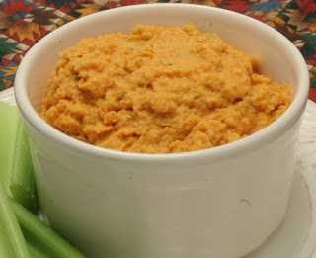
1 recipe Hummus
1 (15-ounce) can pumpkin
Prepare Hummus as directed [see recipe next page]. Keep Hummus in food processor, and add pumpkin. Puree for 30 seconds or until mixture is well blended. Transfer to a medium-sized bowl. Refrigerate, or serve immediately.
Yield: 10 servings (serving size: about 1/4 cup)

Hummus
1 (15-ounce) can chickpeas, rinsed and drained
1/4 cup tahini
1/4 cup water
2 tablespoons extra-virgin olive oil
2 tablespoons fresh lemon juice
2 cloves garlic, minced
1/4 cup fresh parsley, packed
1/2 teaspoon salt
1/4 teaspoon ground cumin
Place ingredients in a food processor or blender. Process, scraping sides of bowl often, until mixture is a smooth paste. You can either refrigerate at this point, or serve immediately. Use as a dip with fresh vegetables or as a spread on a tortilla.
Yield: 8 servings (serving size: about 1/4 cup)
Recipe Notes
- Hummus has more flavor after it has been refrigerated at least 24 hours before serving. Prepare large quantities of hummus at one time. It can be refrigerated up to a week and frozen up to 3 months.

Romaine Wraps
4 romaine lettuce hearts or leaves
1/2 cup Hummus, Confetti Hummus, or Pumpkin Hummus,
1/4 cup cucumber slices, cut 1/4″ thick & into half-moons
1/4 cup shredded carrots
1/4 cup zucchini, chopped
1/2 yellow bell pepper, julienned
Spread 2 tablespoons Hummus on each leaf. Top with cucumber, carrots, zucchini, and pepper. Eat like a taco, or roll up like a tortilla (depending up the size and shape of the leaf).
Yield: 2 servings (about 2 stuffed leaves)

Green Bean Casserole
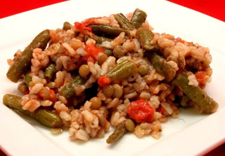
1 cup brown rice
4 cups water, divided
½ cup lentils [beans], rinsed and sorted
3 cups fresh, canned or frozen green beans, cut into 1-inch pieces
1 (14.5-ounce) can diced tomatoes
1/2 cup chopped red onion
2 cloves garlic, minced
2 teaspoons dried basil
1/2 teaspoon salt
Place the rice and 2 cups water in a medium saucepan, and bring to a boil. Cover, reduce heat to low, and simmer 20 minutes. Place lentils in a pot with the remaining 2 cups water, and bring to a boil. Lower heat, and simmer 20 minutes, with the lid slightly tilted.
Preheat oven to 350 degrees. Add green beans, tomatoes, onions, garlic, basil, and salt to saucepan. Stir well. Transfer to a 9 x 13-inch casserole dish. Bake 30 minutes.
Yield: 8 servings (serving size: about 1 cup)

Black Bean Chili Bake
2 (15-ounce) cans black beans, rinsed & drained
2 cups cooked brown rice
2 (8-ounce) cans tomato sauce
1 (14.5-ounce) can corn kernels, drained
1 cup chopped jarred roasted red bell peppers
1/2 cup diced onion
1 tablespoon chili powder
Preheat oven to 350 degrees. Put beans in a large bowl, and mash. Add tomato sauce, rice, peppers, corn, onions, and chili powder. Stir to combine. Rub a 9 by 13-inch casserole dish with olive oil, and place mixture in it. Bake 20 minutes, or until heated through.
Yield: 6 servings (serving size: about 1 cup)

Butternut Squash and Sweet Potato Soup
1/2 tablespoon extra-virgin olive oil
1/2 cup chopped onion
4 cups water or Vegetable Broth
1 pound butternut squash, peeled & cut into 1-inch cubes
1 pound sweet potatoes, peeled & cut into 1-inch cubes
1 teaspoon fresh minced ginger root or 1/2 teaspoon ground ginger
1/2 teaspoon salt
1/8 teaspoon allspice
1/8 teaspoon cinnamon
1/8 teaspoon nutmeg
Heat olive oil over medium heat, and add onions. Cook until onions are soft and translucent. Add water or broth and remaining ingredients to saucepan, and bring to a boil. Reduce heat, and cover. Simmer 30 minutes, or until vegetables are tender.
Remove vegetables with a slotted spoon and place in a food processor or blender. Puree until smooth. (You may need to do this in two batches because filling your processor or blender more than half full could cause the hot soup to pop the lid.) Return to heat, and stir well. Use a whisk, if necessary, to smooth out the texture. Cook another 5-10 minutes, and serve. Yield: 6 servings (serving size = about 1 cup)

Jamaican Chili

1 tablespoon extra-virgin olive oil
1 yellow bell pepper, seeded & chopped (1-1 1/2 cups)
1 cup chopped onions
2 cloves garlic, minced
1 cup Vegetable Broth or water
3 medium tomatoes, chopped or 1 (14.5-ounce) can diced tomatoes
1 (15-ounce) can black beans, rinsed and drained
1 (15-ounce) can cannellini beans, rinsed and drained
1 (15-ounce) can kidney beans, rinsed and drained
1 teaspoon ground cumin
1 teaspoon ground paprika
1/2 teaspoon salt
Heat olive oil over medium heat, and cook until onions are soft and translucent. Add yellow pepper and garlic. Cook until pepper is tender. Add water tomatoes, beans, cumin, paprika, and salt. Bring to a boil. Cover, and simmer 30 minutes. Stir in parsley just before serving.
Yield: 4 servings (serving size = 1 1/4 cups)

Recipe Notes:
- For a spicier chili, add a diced jalapeno pepper or hot chile powder.
- Use chickpeas instead of cannelini beans.
- Add more vegetables, such as carrots, celery, sweet potato, or zucchini

Moroccan Stew

1/2 tablespoon extra-virgin olive oil
1 cup chopped red onion
8 cups Vegetable Broth or water
1 acorn squash (about 1 pound), peeled and cut into 1-inch cubes
1 butternut squash (1-1 1/2 pounds), peeled and cut into 1-inch cubes
2 sweet potatoes (about 1 pound), peeled and cut into 1-inch cubes
1 cup dry lentils
1 (15.5-ounce) can chickpeas, rinsed and drained
2 teaspoons minced ginger root
1 teaspoon cinnamon
1 teaspoon cumin
1 teaspoon salt
1/4 teaspoon cloves
1/4 teaspoon pepper
Chopped fresh parsley, to taste
2 cups cooked brown rice or cooked couscous
Heat olive oil over medium heat in large saucepan or stockpot, and add onions. Cook 3-5 minutes, or until onion is translucent. Add broth or water, acorn squash, butternut squash, sweet potatoes, lentils, and chickpeas. Stir in ginger root, cinnamon, cumin, salt, cloves, and pepper. Heat to boiling, and then reduce heat to low. Simmer 30-45 minutes or until vegetables are tender. About 10 minutes before serving, add parsley and brown rice.
Yield: 10 servings (serving size: about 1 1/4 cups)

STIR FRY VEGETABLES WITH BROWN RICE
Serves 4
- 1 tablespoon sesame oil
- 3 green onions, finely chopped
- 3 tablespoons fresh ginger, minced
- 4 cups fresh broccoli, chopped
- ½ pound fresh green beans, chopped
- 2 carrots, peeled and sliced on diagonal
- 2 cloves garlic, minced
- 4 cups greens, chopped (kale, bok choy, spinach, collards, etc)
- 1 can sliced water chestnuts, drained
- 3 cups cooked brown rice
- 2 tablespoons soy sauce
- 1 ½ cups peas (if frozen run under water to thaw)
- ½ cup toasted sliced almonds
Instructions
1. Heat a deep skillet or wok over medium heat for about 1 minute. Add oil and heat for 1 minute.
2. Add green onions and ginger. Sauté for 5 minutes.
3. Add broccoli, green beans, carrots, and garlic. Stir fry for 8-10 minutes.
4. Add greens and toss for about 2 minutes or until greens are wilted.
5. Stir in water chestnuts, brown rice, soy sauce, peas and almonds.
6. Serve as complete meal
Tip: Serve this dish as a complete main dish along with a side of sliced fruit such as oranges, pineapple or mango. This is also a great recipe to double and then use the leftovers for lunch. Merely heat in the microwave or eat at room temperature.
BEAN CURRY AND BROWN RICE

Serves 8
Ingredients
- 2 tablespoons olive oil
- 1 large white onion, chopped
- 1/2 cup dry lentils
- 2 cloves garlic, minced
- 3 tablespoons curry powder
- 1 teaspoon ground cumin
- 1 pinch cayenne pepper
- 1 can crushed tomatoes (28 ounce)
- 1 can garbanzo beans, drained and rinsed (15 ounce)
- 1 can kidney beans, drained and rinsed (8 ounce)
- 1/2 cup raisins
- 8 cups cooked brown rice
- salt and pepper to taste
Instructions
- 1. Prepare the brown rice according to package directions so you have enough for 8 servings.
- 2. Heat the oil in a large pot over medium heat, and cook the onion until tender.
- 3. Mix in the lentils and garlic, and season with curry powder, cumin, and cayenne pepper. Cook and stir 2 minutes.
- 4. Stir in the tomatoes, garbanzo beans, kidney beans, and raisins. Season with salt and pepper.
- 5. Reduce heat to low, and simmer at least 1 hour, stirring occasionally.
Daniel Fast http://daniel-fast.com/

BEAN AND RICE CASSEROLE

Serves 4
Ingredients
- 1 medium onion, chopped
- 2 cup uncooked brown rice
- 1 can red kidney beans (15 1/4 - 19 oz), drained and rinsed
- 1 can black beans (15 1/4 - 19 oz), drained and rinsed
- 1 can garbanzo beans (15 1/4 - 19 oz), drained and rinsed
- 1 can stewed tomatoes (14 1/2 - 16 oz), drained
- 1 can chopped mild chilies (4 oz), drained
- 10 ounces frozen green peas, thawed by placing under running water
- 1 cup frozen corn, thawed by placing under running water
Instructions
- Preheat oven to 375
- 1. In a 5-qt Dutch oven over medium high heat, sauté onion in liquid of your choice (balsamic vinegar, olive oil, water) until tender, stirring occasionally.
- 2. Add rice; cook while stirring until parched and slightly opaque.
- 3. Add beans, tomatoes, chilies and 3 1/2 cups of water to rice and onion in Dutch oven and bring mixture to boil.
- 4. Cover tightly place in oven, baking until rice is tender and liquid is absorbed (around 1 hour for brown rice).
- 5. Add peas and corn, adjust seasonings, and return to oven until heated through.
Daniel Fast http://daniel-fast.com/

TOFU BREAKFAST SCRAMBLE

Ingredients
- 1 box firm tofu
- 1 zucchini, diced small
- 1 tomato, diced
- ½ onion, diced
- 1 red bell pepper, diced
- 2 green onions, finely sliced
- 1 tablespoon fresh cilantro, minced
- 1 clove garlic, minced
- Salt and pepper to taste / Tomato paste if desired
Instructions
- 1. Spray pan with 100% olive oil spray
- 2. Add all ingredients and fry until vegetables are soft and ready to eat.
- 3. Salt and pepper to taste
- 4. Serve with tomato paste
Daniel Fast http://daniel-fast.com/

POTATO AND GREEN ONION FRITTATA
2014-12-26 14:54:32

Serves 4
Ingredients
- 1/4 cup olive oil
- 1 onion, finely chopped
- 4-5 green onions, chopped with the green and white parts separated
- 4 cloves garlic, minced
- 2 medium potatoes, shredded (or 2 cups of frozen shredded potatoes)
- 2 tsp. salt, divided
- 1/2 tsp. pepper, divided
- 2 lb. firm tofu
- 2-3 Tbsp. soy sauce, to taste
Instructions
- 1. In a large skillet, heat the olive oil over medium heat. Add the onion and the white part of the green onions and sauté for 2 to 3 minutes.
- 2. Add the garlic and heat for another 30 seconds.
- 3. Increase the heat to medium-high and add the potatoes, 1 tsp. of the salt, and 1/4 tsp. of the pepper. Cook for 10 to 15 minutes, flipping the potatoes regularly until they are well-browned.
- 4. Blend the remaining salt and pepper, the tofu, and soy sauce in a food processor until they are creamy.
- 5. Pour creamy mixture and the green part of the green onions over the fried potatoes and mix. Pour this mixture into a large, oiled pie or tart pan.
- 6. Bake for 30 to 40 minutes or until the center is firm. Allow the frittata to cool for 10 minutes then invert onto a serving plate.
Daniel Fast http://daniel-fast.com/

Desserts and “Sweets”

Frozen Banana Bars
2 medium bananas, peeled, sliced (about 2 cups)
1 cup roughly chopped dates
1 cup roughly chopped raw cashews
Place bananas, dates, and cashews in a food processor or blender. Process about 30 seconds or until smooth. Transfer to an 8 x 8-inch baking dish. Place in freezer 3-4 hours or until firm. To serve, cut into 2 x 2 1/2 –inch bars and serve. Store in freezer.
Yield: 12 servings (serving size: 1 bar)
Nutrition Facts
Calories per serving: 111
Carbohydrates: 19
Fat: 4
Sugar: 12
Calcium: 2

Apple Raisin Nut Cookies
2 cups chopped apples, unpeeled (about 2 apples)
1 cup brown rice flour
1 cup cashew halves and pieces
1 cup pecan halves
1 cup raisins
Preheat oven to 350 degrees. Add apples, brown rice flour, cashews, pecans, and raisins to a food processor. Process about 30 seconds for a smooth texture, or 15 seconds for a nuttier cookie. Drop by spoonful, two inches apart, on an ungreased 11 by 17-inch baking sheet. Bake 15 minutes. Let cool on a wire rack.
Yield: 16 servings (serving size: about 1 cookie)
.

Pumpkin Spice Bars
1 cup cooked sugar pumpkin*
1 cup almond meal
½ cup sliced banana (about 1/2 large banana)
¼ cup Date Honey
1 tablespoon flaxseed meal
1 teaspoon pumpkin pie spice
¼ cup finely chopped walnuts
Preheat oven to 350 degrees. Place pumpkin, almond meal, banana, Date Honey, flaxseed meal, and pumpkin pie spice in a food processor or blender. Purée until smooth. Stir in walnuts, and pour into an 8 x 4 x 2 1/2-inch bread loaf pan (small size). Use a spatula to smooth mixture into an even layer. Bake 45-50 minutes. Remove from oven, and let cool for about 5 minutes. Cut the loaf vertically down the middle, and then horizontally to make 16 bars (2 x 1-inch each).
*To bake a sugar pumpkin: Preheat oven to 375°F. Remove stem from pumpkin, and cut pumpkin in half. Scoop out pulp and seeds. Discard (or set aside if you want to keep the pumpkin seeds). Using a basting brush, rub olive oil across surface of pumpkin (use about ½ tablespoon total)
Place halves on a baking sheet, cut sides up. Bake about 1 hour, or until pumpkin is tender when pierced with a fork. Remove from oven, and let sit on baking sheet until cool enough to handle, about 10-15 minutes.
Yield: 8 servings (serving size = about 2 bars)
Recipe Notes
- If you don’t have a food processor or blender, you can mix the ingredients by hand. Just make sure the pumpkin and banana are well mashed.
- You can also use an 8 x 8-inch pan. However, your bars will not be as thick, and the baking time will be 30-35 minutes.
- Substitute pecans for the walnuts.
- Add raisins or chopped dates.

Other Snacks
Ingredients
- Rice cakes, just plain old crunchy patties
- Rice cakes with peanut butter and raisins
- Almonds
- Dried fruit including apricots
- Apples dipped in nut butter
- Sliced fruit
- Veggies with dip
- Popped popcorn
- Trail mix with nuts, raisins, sunflower seeds, coconut pieces and dried fruit
- Fruit kabobs
- Frozen fruit including grapes, blueberries, strawberries & bananas
- Whole wheat crackers* with nut butter or hummus

