
Daniel Fast Recipe Book

Mount Zion
AFRICAN METHODIST EPISCOPAL CHURCH

Holy Consecration 2025

Beloved, as we go before God and seek His favor, we fast. A fast is so much more than not eating or not eating certain things. Feast on God in prayer. Feast on His Word, saturate yourself with hymns and spiritual songs, God has promised that of we seek Him, we will find Him. O bless His name.
Our Fast this year begins on Monday, January 6, 2025.
In this book are some suggestions for variety while adhering to the fast.
While most fruits and vegetables are edible as is,[raw or steamed] sometimes it’s nice to have recipes, so here are a few to get you started on your Daniel Fast. Enjoy!

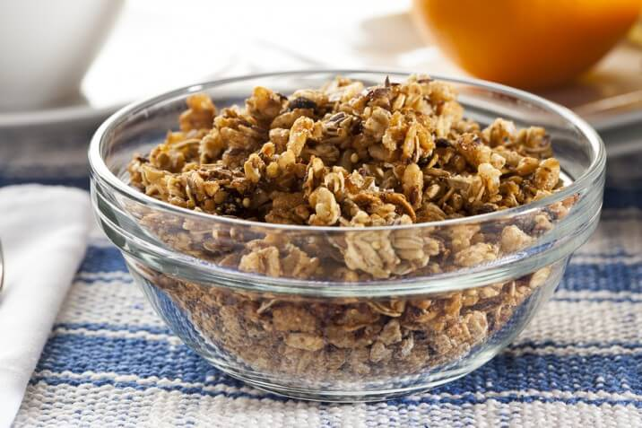
Daniel Fast SNACKS

Granola

Ingredients:
- 1 cup crushed almonds
- 1 cup oats
- 1 cup sunflower seeds
- 1 cup pumpkin seeds
- 1/2 cup coconut flakes
- 1 cup honey
- 1 teaspoon cinnamon

Directions:
- Mix all together and spread out on a non-stick cookie sheet.
- Bake 20 minutes in a 250-degree preheated oven.
- Stir and continue to bake another 20 minutes, stirring periodically to prevent burning. The granola should be lightly browned.
- Remove from oven and serve warm or cool thoroughly and store in tightly sealed container or plastic bags.
- Option: After the granola is cooled, add raisins or other organic, unsulphured dehydrated fruit.

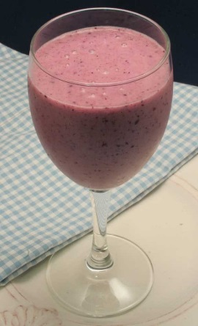
The Taste of Pure Bliss
August 26, 2013 By Kristen Feola

This sweet coconut treat will make you think
you’re in a tropical paradise. One sip, and
you’ll be in a hammock on the beach, feeling
the ocean breeze caress your face as you
bask in the warm sunshine. No deadlines.
No laundry. No meetings. No responsibilities at all. Just pure relaxation and rest.
Sounds nice, right? Wait until you taste it for yourself!

Coconut Bliss
½ cup water
½ cup unsweetened coconut milk
1 cup sliced fresh or frozen banana (about 1 medium banana)
1 cup fresh or frozen blueberries
1 cup frozen or fresh mango chunks
1 cup fresh or frozen sliced strawberries
Place all ingredients in a blender, and process until smooth.
Yield: 2 servings (serving size: about 8 ounces or 1 cup)
Recipe Notes
- To freeze bananas, remove peels before placing in freezer. Put in a plastic zip-top bag until completely frozen.
- Make it green! Add 1 cup chopped kale or spinach leaves.

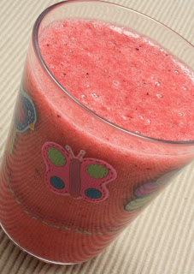
Berry Blast Smoothie
January 6, 2011 By Kristen Feola

1 cup water or any unsweetened
non-dairy milk (such as almond, coconut, rice or soy)
1 cup frozen blackberries, blueberries, and raspberries
1 banana, peeled
Yield: 1 serving (serving size: about 8 ounces or 1 cup)
Recipe Notes
- Your smoothie will taste best if either the berries or the banana is frozen. To freeze bananas, remove peels before placing in freezer. Put in a plastic zip-top bag until completely frozen.
- To make this a “green” smoothie, add 1 cup of fresh spinach or kale leaves (stems removed from the kale).
- Add 1 tablespoon flaxseed meal for a fiber boost.

Apple-Cinnamon Hot Cereal
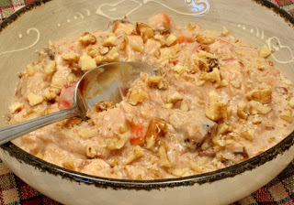
October 31, 2011 By Kristen Feola

1 (14.5-ounce) can coconut milk
2 cups cooked brown rice
1 apple, chopped, unpeeled (about 1 1/2 cups)
1 banana, mashed (about 1 cup)
1 cup roughly chopped dates
1½ teaspoons cinnamon
Pinch nutmeg
½ cup toasted pecans or walnuts
Add coconut milk, brown rice, apple, banana, dates, cinnamon, and nutmeg to a medium saucepan. Cook over medium-low heat about 10 minutes or until heated through. Stir frequently to prevent burning on bottom of pan. Sprinkle 1 tablespoon pecans or walnuts over each serving.
Yield: 8 servings (serving size: about ½ cup)

Nutty Fruit Cereal June 15, 2010 By Kristen Feola

1 banana, peeled and sliced (about 1 cup)
1/3 cup fresh blueberries
1 tablespoon chopped almonds
1 tablespoon chopped walnuts
1 teaspoon unsweetened coconut flakes
½ cup unsweetened almond or rice milk
Place banana slices in a bowl and top with blueberries, almonds, walnuts, and coconut flakes. Pour in almond milk.
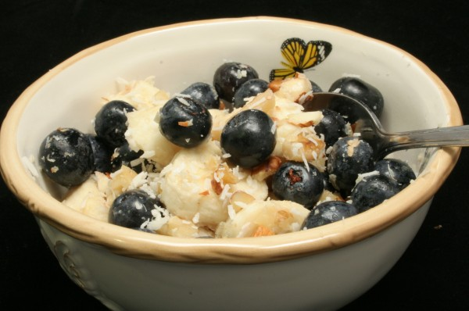
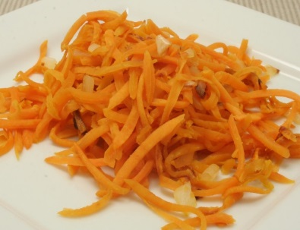
Yield: 1 serving (serving size: about 1 1/3 cups)
Sweet potatoes like you’ve never seen them before!
February 10, 2012 By Kristen Feola

The recipe is simple and requires only four ingredients. The best part is, you can enjoy these tasty browns for breakfast or a side dish (or an afternoon snack).
I’ve also put together a short cooking video to help you: How to Make Sweet Potato Hash Browns. I hope you like this recipe as much as I do!

Sweet Potato Hash Browns
1 ½ pounds sweet potato, peeled, shredded
1 cup chopped onion
4 teaspoons extra-virgin olive oil, divided

Mix sweet potatoes and onions in a large bowl. Heat 2 teaspoons olive oil over medium-low to medium heat in a large skillet. Add about half of the sweet potatoes and onions, and stir to coat. Press with a spatula to flatten. Cook about 7-8 minutes; do not stir. Flip, and cook another 3-5 minutes. Remove from skillet, and set aside. Repeat to cook remaining vegetables. When done, combine the two batches in the skillet. Cook another 2-3 minutes, stirring occasionally. Serve immediately.
Yield: 8 servings (serving size: about ½ cup)
Recipe Notes
- To shred potatoes, it’s best to use a food processor (shredding disc attachment), although you can do it by hand.
- Variation: Use a combination of sweet potatoes and Yukon Gold or russet potatoes.
- Makes a great breakfast dish!

Pineapple Citrus Muffins
July 12, 2010 By Kristen Feola
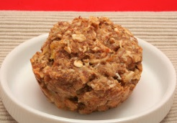
1 cup old-fashioned rolled oats
1 cup oat flour (see Recipe Notes)
1 cup unsweetened applesauce
½ cup diced pineapples
¼ cup chopped pecans or walnuts
¼ cup Date Honey
¼ cup flaxseed meal
2 teaspoons unsweetened coconut flakes
2 teaspoons grated orange zest
½ teaspoon ground ginger
Preheat oven to 350 degrees. Lightly rub 8 cups of a 12-cup muffin tin with olive oil, and set aside.
Combine all ingredients in a large bowl, and stir well to combine. Scoop out mixture into muffin tin cups, allowing about 1/3 cup for each muffin. Bake 20 minutes, or until muffin tops are lightly browned. Serve warm.
Yield: 8 servings (serving size: 1 muffin)
Recipe Notes
- Make your own oat flour by placing old-fashioned rolled oats in a food processor or blender and process until fine (½ cup old-fashioned oats will yield about ½ cup ground oats).
- Spread almond butter or Date Honey on top.
- Flaxseed meal is a powder made from ground flaxseeds. It can be found in health food stores and some grocery stores. Instead of buying flaxseed meal, you can also grind whole flaxseeds at home by using a coffee or seed grinder.
- The zest is the outermost, colorful skin of citrus fruits. Zest is often used to enhance flavor in recipes. The pith, or white membrane underneath the outside peel, has a bitter, unpleasant taste and should be avoided while zesting.

Date Honey

- In a bowl, combine 1 cup boiling water and dates. Soak 20 minutes.
- Mash dates with your hands. Add remaining 2 cups boiling water. ...
- Cook over medium heat, stirring occasionally, to prevent mixture from sticking to sides of pan, until it reduces to the consistency of honey, 40 to 45 minutes. Let cool.

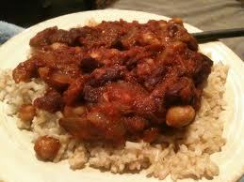
BEAN CURRY AND RICE

Serves 8
Ingredients
- 2 tablespoons olive oil
- 1 large white onion, chopped
- 1/2 cup dry lentils
- 2 cloves garlic, minced
- 3 tablespoons curry powder
- 1 teaspoon ground cumin
- 1 pinch cayenne pepper
- 1 can crushed tomatoes (28 ounce)
- 1 can garbanzo beans, drained and rinsed (15 ounce)
- 1 can kidney beans, drained and rinsed (8 ounce)
- 1/2 cup raisins
- 8 cups cooked brown rice
- salt and pepper to taste
Instructions
- 1. Prepare the brown rice according to package directions so you have enough for 8 servings.
- 2. Heat the oil in a large pot over medium heat, and cook the onion until tender.
- 3. Mix in the lentils and garlic, and season with curry powder, cumin, and cayenne pepper. Cook and stir 2 minutes.
- 4. Stir in the tomatoes, garbanzo beans, kidney beans, and raisins. Season with salt and pepper.
- 5. Reduce heat to low, and simmer at least 1 hour, stirring occasionally.
BEAN AND RICE CASSEROLE
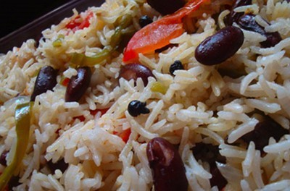
Serves 4
Ingredients
- 1 medium onion, chopped
- 2 cup uncooked brown rice
- 1 can red kidney beans (15 1/4 - 19 oz), drained and rinsed
- 1 can black beans (15 1/4 - 19 oz), drained and rinsed
- 1 can garbanzo beans (15 1/4 - 19 oz), drained and rinsed
- 1 can stewed tomatoes (14 1/2 - 16 oz), drained
- 1 can chopped mild chilies (4 oz), drained
- 10 ounces frozen green peas, thawed by placing under running water
- 1 cup frozen corn, thawed by placing under running water
Instructions
- Preheat oven to 375
- 1. In a 5-qt Dutch oven over medium high heat, sauté onion in liquid of your choice (balsamic vinegar, olive oil, water) until tender, stirring occasionally.
- 2. Add rice; cook while stirring until parched and slightly opaque.
- 3. Add beans, tomatoes, chilies and 3 1/2 cups of water to rice and onion in Dutch oven and bring mixture to boil.
- 4. Cover tightly place in oven, baking until rice is tender and liquid is absorbed (around 1 hour for brown rice).
- 5. Add peas and corn, adjust seasonings, and return to oven until heated through.

TOFU BREAKFAST SCRAMBLE
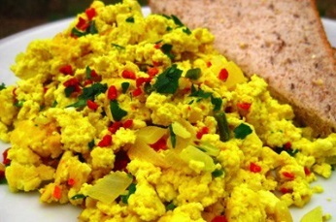

Ingredients
- 1 box firm tofu
- 1 zucchini, diced small
- 1 tomato, diced
- ½ onion, diced
- 1 red bell pepper, diced
- 2 green onions, finely sliced
- 1 tablespoon fresh cilantro, minced
- 1 clove garlic, minced
- Salt and pepper to taste / Tomato paste if desired
Instructions
- 1. Spray pan with 100% olive oil spray
- 2. Add all ingredients and fry until vegetables are soft and ready to eat.
- 3. Salt and pepper to taste
- 4. Serve with tomato paste

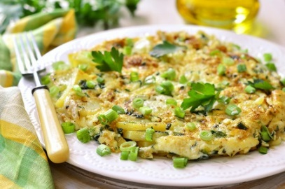
POTATO AND GREEN ONION FRITTATA

Serves 4
Ingredients
- 1/4 cup olive oil
- 1 onion, finely chopped
- 4-5 green onions, chopped with the green and white parts separated
- 4 cloves garlic, minced
- 2 medium potatoes, shredded (or 2 cups of frozen shredded potatoes)
- 2 tsp. salt, divided
- 1/2 tsp. pepper, divided
- 2 lb. firm tofu
- 2-3 Tbsp. soy sauce, to taste
Instructions
- In a large skillet, heat the olive oil over medium eat. Add the onion and the white part of the green onions and sauté for 2 to 3 minutes.
- Add the garlic and heat for another 30 seconds.
- Increase the heat to medium-high and add the potatoes, 1 tsp. of the salt, and 1/4 tsp. of the pepper. Cook for 10 to 15 minutes, flipping the potatoes regularly until they are well-browned.
- Blend the remaining salt and pepper, the tofu, and soy sauce in a food processor until they are creamy.
- Pour creamy mixture and the green part of the green onions over the fried potatoes and mix. Pour this mixture into a large, oiled pie or tart pan.
- Bake for 30 to 40 minutes or until the center is firm. Allow the frittata to cool for 10 minutes then invert onto a serving plate.
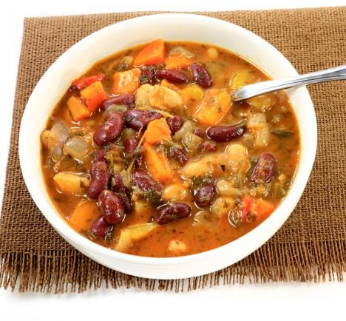
Minestrone Soup
Ingredients:
- 8 cups vegetable stock
- 1½ cups of dried garbanzo beans
- 2 cups dried red kidney beans
- ½ cup carrots
- 3 medium tomatoes (or one 14-ounce can of unsweetened, unsalted Italian tomatoes)
- ½ cup fresh parsley
- 1 cup cabbage
- ¼ teaspoon oregano
- ¾ teaspoon basil
- ¼ teaspoon thyme
- ½ cup celery
- ½ cup onion
- 1 clove garlic
- 1 package spinach noodles, cooked
- sea salt, to taste
Directions:
- Soak garbanzo and kidney beans overnight, drain and rinse.
- Peel and dice tomatoes.
- Cook and drain garbanzo and kidney beans as per directions on package.
- Mince garlic and parsley.
- Chop carrots, onion, celery, cabbage and garlic and sauté in water or soup stock over medium heat for 5 to 7 minutes.
- Stir in cooked and drained garbanzo beans, kidney beans, diced tomatoes and minced herbs.
- Bring to a simmer, then turn heat down and simmer 10 minutes.
- Stir in cabbage and parsley with lid partially on for about 15 minutes or until cabbage is tender.
- Add more soup stock or tomatoes as needed. Serve over cooked spinach noodles.

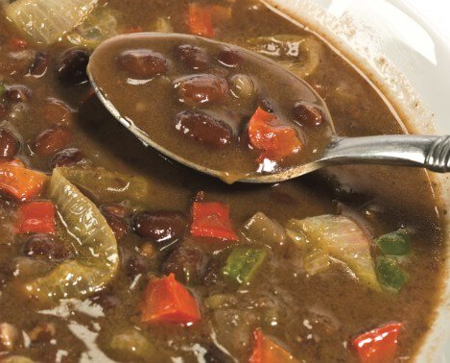
Black Bean Soup
Ingredients:
- 8 cups vegetable stock
- 1 cup celery
- 1 potato
- 2 garlic cloves
- 1 teaspoon honey
- 2 bay leaves
- 1 pound of black beans, soaked overnight, rinsed and drained
- 1 yellow or red pepper
- 1 cup carrots, diced
- 2 tablespoons cilantro
- 1 tablespoon parsley
- 2 tablespoons marjoram
- 1 whole onion
- sea salt, to taste
Directions:
- Place beans in pot with vegetable stock, whole onion and bay leaves.
- Bring to a boil and cook 2-½ hours or until beans are tender.
- Remove onion and bay leaves.
- Chop onion, pepper and celery.
- Grate carrots and potato on cheese grater.
- Mince garlic and sauté in a tablespoon of olive oil until tender.
- During last hour of cooking, combine vegetables and seasonings with beans.
- Bring to a boil, lower heat to simmer and cook until veggies and beans are tender.

Carrot, Apple, and Ginger Soup
January 27, 2010 By Kristen Feola
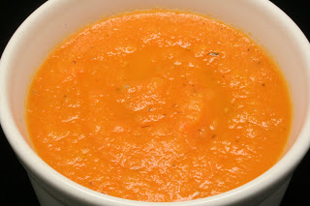
1/2 tablespoon extra-virgin olive oil
1/2 cup chopped onion
1 clove garlic, minced
1 tablespoon minced fresh ginger root
6 cups Vegetable Broth or water
2 pounds carrots, peeled and cut into 2-inch pieces
2 cups chopped apples, peeled
1 bay leaf
1/2 teaspoon dried thyme
1 teaspoon salt
Heat olive oil over medium heat in a large saucepan or stockpot. Add onion, and cook until translucent. Mix in garlic and ginger, and cook about 1 minute, stirring constantly. Add vegetable broth, carrots, apples, bay leaf, thyme, salt. Bring to a boil. Reduce heat, cover, and simmer 20 minutes, or until carrots are tender.
Remove from heat, and allow soup to cool about 5 minutes. Discard bay leaf. Purée the soup in batches in a food processor or blender. When completely smooth, return to stovetop, and cook another 10 minutes.
Yield: 8 serving (serving size: about 1 cup)
Recipe Notes
- I used Fuji apples, but you could use just about any type of apple, depending upon your personal preference.
- If you like this flavor combination and would like to try a new juice recipe, try the Orient Express.
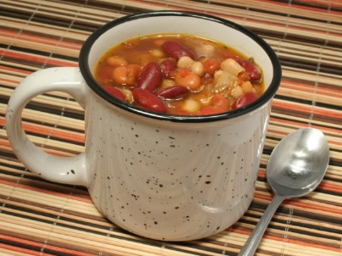
Spicy Three-Bean Chili
Serves 6 Ingredients
- 1 tablespoon extra-virgin olive oil
- 1/2 cup chopped red onion
- 2 cloves garlic, minced
- 3 cups Vegetable Broth or water.
- 1 (15-ounce) can black or pinto beans, rinsed and drained
- 1 (15-ounce) can great northern beans, rinsed and drained
- 1 (15-ounce) can kidney beans, rinsed and drained
- 1 (10-ounce) can diced tomatoes and green chiles (mild, medium, or hot)
- 1 1/2 teaspoons ground cumin
- 1 1/2 teaspoons dried oregano
- 1/2 teaspoon salt
- Pinch of ground cloves
- Pinch of cayenne pepper
- Chopped green onions (optional)
Instructions
- Heat olive oil in a large saucepan over medium heat. Stir in onions, and cook until soft and translucent. Add garlic, and cook for 30 seconds, stirring constantly so garlic doesn’t burn.
- Add broth or water, beans, Ro-Tel, cumin, oregano, salt, cloves, and cayenne pepper. Heat to boiling. Reduce heat, and simmer uncovered for 30 minutes.
- To serve, sprinkle chopped green onions over each serving (if desired).

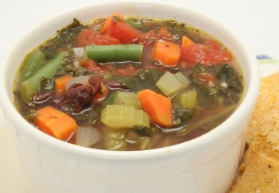
Black Bean Minestrone
August 31, 2009 By Kristen Feola

1 tablespoon extra-virgin olive oil
½ cup chopped onion
1 cup chopped carrots
2 stalks celery, sliced
2 cloves garlic, minced
4 cups water or Vegetable Broth
1 (15-oz) can black beans, rinsed and drained
1 cup fresh or frozen green beans, cut into 1-inch pieces
1 cup chopped tomatoes, unpeeled, unseeded
1 cup chopped fresh spinach or ½ cup frozen spinach, thawed
2 tablespoons chopped fresh basil or 1 ½ teaspoons dried basil
2 tablespoons chopped fresh parsley or 1 ½ teaspoons dried parsley
½ teaspoon salt
1/8 teaspoon pepper

Heat olive oil in a large saucepan over medium heat. Cook onions, carrots, and celery until vegetables are softened. Stir in garlic, and cook for another minute, stirring constantly so garlic doesn’t burn.
Add water or broth, black beans, green beans, tomatoes, spinach, basil, salt and pepper. Bring to a boil. Simmer, uncovered, over low heat about 20 minutes to allow the flavors to blend. Stir in parsley before serving.
Yield: 6 servings (serving size: about 1 ¼ cups)

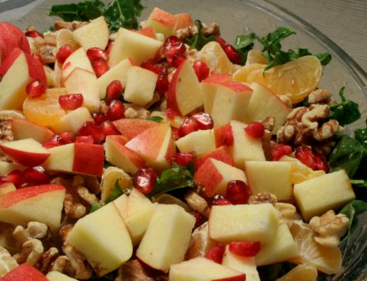
Apple, Pomegranate, and Kale Salad
December 20, 2016 By Kristen Feola

Serves 8
Ingredients
- 8 cups torn kale leaves, ribs removed, lightly packed
- 2 cups chopped apples
- 1 ½ cups mandarin orange segments (about 4 mandarins)
- ½ cup chopped toasted chopped walnuts
- ½ cup pomegranate arils
Dressing
- ¼ cup unsweetened applesauce
- 2 tablespoons extra-virgin coconut or olive oil
- 2 tablespoon fresh lemon juice
- ¼ teaspoon salt
Instructions
- Place kale leaves in a large bowl, and set aside. Whisk applesauce, olive oil, lemon juice, and salt in a smaller bowl (you can also mix in a blender).
- Pour dressing over kale, and use your hands to massage onto leaves. Add apples, oranges, walnuts and arils. Stir well to coat.
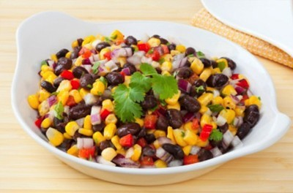
SOUTHWEST CORN AND BLACK BEAN SALAD

Serves 4
Ingredients
- 1 ½ cups corn kernels (fresh or frozen)
- 1/3 cup pine nuts
- 1/4 cup lime juice
- 2 tablespoons extra-virgin olive oil
- 1/4 cup chopped fresh cilantro
- 2 (14.5 ounce) cans black beans, rinsed
- 2 cups shredded red cabbage
- 1 large tomato, diced
- 1/2 cup minced red onion
Instructions
- 1. Place pine nuts in a small dry skillet over medium-low heat and cook, stirring, untilfragrant and lightly browned, 2 to 4 minutes.
- 2. Whisk lime juice, oil, cilantro, salt and pepper in a large bowl. Add the corn, pine nuts, beans, cabbage, tomato and onion; toss to coat. Refrigerate until ready to serve.
- 3. Freshly ground pepper and salt to taste just before serving

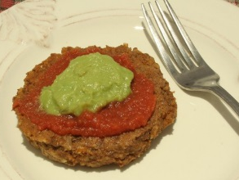
Taco Burgers
August 10, 2016 By Kristen Feola
Serves 5
Ingredients
- 1 tablespoon extra-virgin olive oil
- ½ cup chopped red onion
- 1 cup cooked brown rice
- 1 cup cooked brown lentils
- ¼ cup flaxseed meal or whole grain flour
- 1 ½ tablespoons Taco Seasoning
Instructions
- Preheat oven to 350 degrees.
- Heat olive oil in a large skillet over medium heat. Add onions, and cook until soft and translucent.
- Place cooked onions, brown rice, lentils, flaxseed meal, and Taco Seasoning in the bowl of a food processor. Pulse about 12-15 times or until mixture has a “meaty” texture. (If you don’t have a food processor, place ingredients in a large bowl, and stir. Use a potato masher to bind ingredients together.)
- Scoop out 1/3 cup of mixture, and place on an 11 x 17-inch baking sheet that has been rubbed with olive oil. Flatten and shape into a circle. Repeat with the remaining mixture to make 5 burgers.
- Bake for 15 minutes. Flip burgers (a thin metal spatula works best), and cook another 15 minutes.

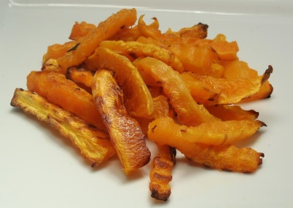
Butternut Squash Fries
December 20, 2016 By Kristen Feola
Serves 4
Three words. Best fries EVER.
Ingredients
- 2 pounds butternut squash, peeled, seeds removed, and sliced into fries about 3” L x ½”W (or to desired size)
- 1 tablespoon coconut oil
- ½ teaspoon garlic powder
- ½ teaspoon salt
- ½ teaspoon freshly ground black pepper
Instructions
- Preheat oven to 450 degrees. Prepare an 11 x 17 baking sheet by coating it with a little coconut oil. You can also use a non-stick sheet.
- Place fries in a large bowl. Stir in one tablespoon of coconut oil, and toss until well coated. Add garlic powder, salt, and pepper. Stir again.
- Pour fries onto baking sheet, making sure none of the pieces overlap. You may need to use two baking sheets to cook at one time (or cook in two batches).
- Bake 20 minutes on a middle oven rack. Use a metal spatula to flip fries, and then bake another 15-20 minutes.
- Turn over to broiler setting, and flip fries one more time. Move baking sheet to the top rack. Broil 5 minutes, or until desired crispness is reached.
Notes works well with sweet potatoes as well.

Stir Fry Vegetables
Ingredients:
- 1 red onion, sliced
- 3 stalks celery, thinly sliced
- ½ cup broccoli, chopped
- 1 bell pepper, sliced
- 3 carrots, peeled and sliced
- ½ cup cauliflower, chopped
- 1 cup zucchini, thinly sliced
- 1 cup yellow squash, thinly sliced
- 1 teaspoon sea salt
- 1 tablespoon Asian seasoning (or a mix of garlic powder, onion powder, ginger powder and black pepper)
Directions:
- Stir-fry all vegetables in 1 to 2 tablespoons of olive oil until tender.
- Add salt and seasoning.
- Serve alone or over brown rice.

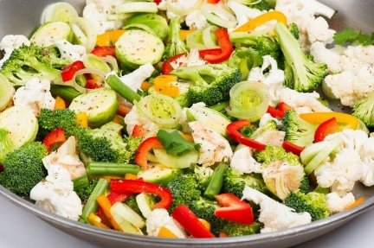

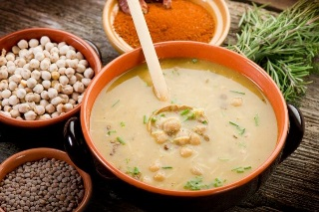
Harira
[Serves 4]
Ingredients:
- 2 tablespoons healthy oil, such as coconut oil or olive oil
- 1 cups chopped onion
- ½ cups chopped celery
- 2 cups warm water
- pinch of saffron threads
- ½ teaspoon salt, divided
- ¼ teaspoon peeled fresh ginger, minced
- ¼ teaspoon ground red pepper
- ¼ teaspoon ground cinnamon
- 2 garlic cloves, minced
- 2 cups organic mushroom broth
- 1½ cups chopped and seeded plum tomatoes
- ½ cup dried small red lentils
- 2 15-ounce cans no-salt-added chickpeas, drained
- 3 tablespoons chopped fresh cilantro
- 3 tablespoons chopped fresh parsley
Directions:
- Heat oil in a large saucepan on medium heat.
- Add onion and celery and sauté 4 minutes or until tender.
- Combine 2 cups warm water and saffron; let stand 2 minutes.
- Add ¼ teaspoon salt, ginger, red pepper, cinnamon and garlic.
- Cook 1 minute. Add saffron water mixture, broth, tomato, lentils and chickpeas.
- Bring to boil; then reduce heat.
- Simmer 20 minutes or until lentils are tender.
- Stir in cilantro, parsley and remaining ¼ teaspoon salt.

Daniel Fast Frequently Asked Questions (FAQ LIST)
If you are pregnant or a nursing mother or are on a special diet of any sort for health reasons, then you should not go on the Daniel Fast without the approval of your primary healthcare professional.
Otherwise, here are some frequently asked questions you may want to know about.
1. What about prepared foods?
Read the labels of all prepared foods. Remember the Daniel Fast is sugar-free and chemical-free. That is why I suggest organic, fresh or frozen foods.
2. What about pasta?
Make sure the label says whole grain or vegetable-based pasta like quinoa, black bean or brown rice with no additives or sugar. But, the diet should consist mostly of vegetables and fruits.
3. What about roasted nuts?
Try to stick to organic, raw, unsalted nuts and/or soaked or sprouted ones. These are harder to find, so if you have to choose roasted nuts, then get plain roasted, unsalted nuts with no preservatives.
4. How do I get enough protein in my diet while on the fast?
Protein-rich foods allowed on the Daniel Fast are almonds, sunflower seeds, lentils, quinoa, brown rice, split peas and some whole grains. Be sure you eat plenty of those.

5. What about salad dressing?
Salads are great on the Daniel Fast. Use olive oil combined with lemon or lime juice as salad dressing options.
6. Do I need to eat organic foods while on the fast?
You don’t have to eat organic, but I recommend it because opting for organic keeps toxins out of your foods, meaning no use of chemically formulated fertilizers, growth stimulants, antibiotics or pesticides.
7. Can I go out to eat?
Yes; you can. Just make sure what you get is compliant with the Daniel Fast, such as a salad with olive oil and a baked potato with no extras on it.
8. What about bread?
If you eat bread, then I would only recommend a sprouted or sourdough bread that comes from ancient grains.
9. How much can I eat?
As long as your food choices fit the Daniel Fast, then you can eat all and as often as you want until you are satisfied!
.

