Truths We Confess
The Nicene Creed
We believe in one Lord, Jesus Christ, the only-begotten Son of God, eternally begotten of the Father, God from God, Light from Light, true God from true God, begotten, not made, of one Being with the Father; through him all things were made.  For us and for our salvation he came down from heaven, was incarnate from the Holy Spirit and the Virgin Mary, and was made man. For our sake he was crucified under Pontius Pilate; he suffered death and was buried. On the third day he rose again in accordance with the Scriptures; he ascended into heaven and is seated at the right hand of the Father. | He will come again in glory to judge the living and the dead, and his kingdom will have no end.  We believe in the Holy Spirit, the Lord, the giver of life, who proceeds from the Father [and the Son], who with the Father and the Son is worshiped and glorified, who has spoken through the prophets.  We believe in one holy catholic (Universal) Church. We acknowledge one Baptism for the forgiveness of sins. We look for the resurrection of the dead, and the life of the world to come. Amen.

Weekly Giving
Previous Weeks  February 16 - February 22: $4,183.60  February 9 - February 15: $17,341.72  February 2 - February 8: $3,529.86  January 26 - February 1: $1,670.35 | Ways to Give  In Person: Cash or Check  Online:truthkingsville.com/give  TCC App
Contact Info

Cody:
Cody@truthkingsville.com

Cody’s Office Hours:
Tue, Thur: 7am-4pm
Wed: 9am-6pm


Get Connected
Thank you for worshipping with us!

Scan the QR code or fill out a Connect Card
at the welcome table.

WELCOME
March 15, 2026
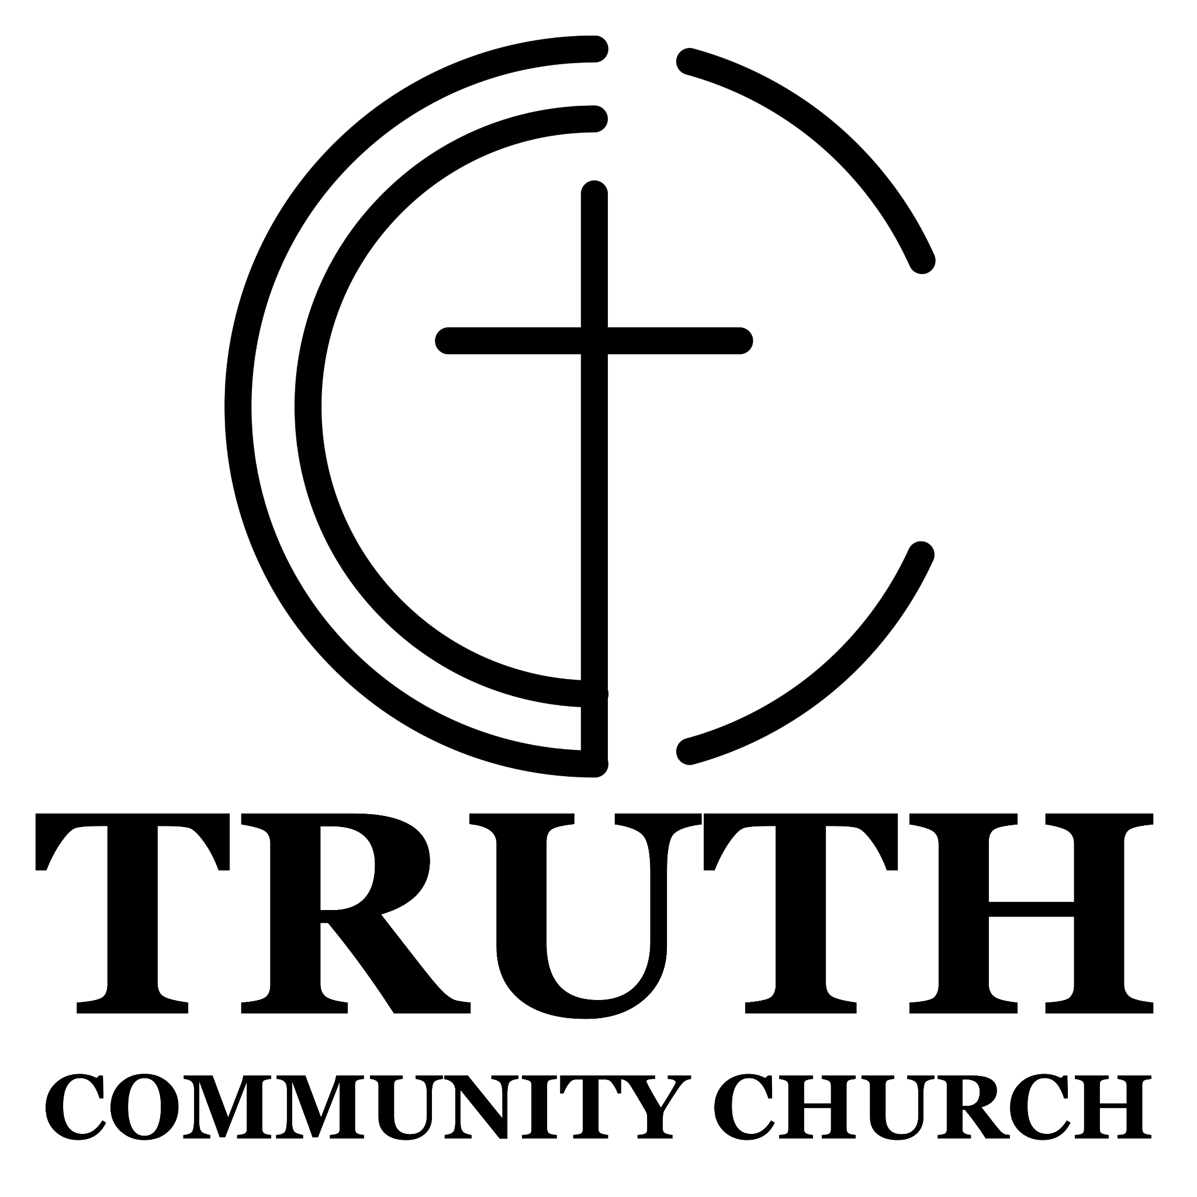

Bible Teaching,
Gospel-Centered,
Christ-Glorifying

Weekly Meetings

Truth  Community Groups  Men, Women, Kids  Wednesdays | 6pm | TCC Community groups seek to dive deeper into the scripture passage from the previous sermon and discuss its practical applications.  Studies available on the app.
Truth Youth  Wednesdays | 6pm | Truth Youth focuses on teaching the youth to apply the Word while living as authentic believers and inviting others to receive the hope of Christ.
TCC  Prayer Meetings  Tuesdays | 6:30am @ TCC  Tuesdays | 7:00pm @ Breden House  1205 S. 11th St. | (361) 500-2256 | “A prayerless church is a powerless church.” Every week we gather together in prayer to be conformed to his will, offer thanksgiving, and make our petitions known.

Upcoming Events
Good Friday Service
Friday 04.03.26 | 7pm
On Good Friday we gather to reflect on The Humble Obedience of Christ. Through Scripture, prayer, and song we will walk through the downward path Christ took for our redemption.
Easter Sunrise Service
Sunday 04.05.26 | 7am
As the sun rises on Easter morning, we gather to celebrate the exaltation of Christ. This service will be followed by a breakfast potluck.

The Peaceful Christian Life
Philippians 4:2-9

- The Community

- The Heart

- The Mind

