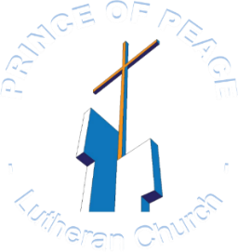
D

2600 Atlantic Avenue, Fernandina Beach, Florida 904-261-6306 www.poplcweb.com

This Week at
Prince of Peace
Come … Be A Part of Peace!
!


⁴ who redeems your life | from the grave
and crowns you with steadfast | love and mercy
Psalms 103:4

(Psalm 103:4)

Week of September 7th
This Week’s Events |  |  |  | Worship Servers  September 13th—Sunday
Day | Date | Events |  | Role | Server
Monday | 7 | 9:00 AM Men’s Property Group  12:00 PM—1:30 PM AA Group in Fellowship Hall  Church Offices Closed |  | Assisting Minister | Duane Whitesel
Tuesday | 8 | No POP Events |  | Scripture Reader | Ken Bryson
Wednesday | 9 | 4:00 PM Choir Practice |  | Ushers /  Greeter | Garrett Price  Ted Richardson /  Rich Ekwall
Thursday | 10 | No POP Events |  | Altar/  Lay Asst. | Karen Blair  Jeanette Chaffee
Friday | 11 | 11:00 AM Bell Choir |  | Tellers | Gene Kilcawley  Patti Marotz
Saturday | 12 | 10:00 AM-12:00 PM Confirmation Class |  | Flowers | Open
Sunday | 13 | BACK TO CHURCH SUNDAY  9:00 AM Sunday School  10:00 AM Worship  BTCS Fellowship Lunch & Activities—After Worship  POP Band Practice—After Worship


THIS WEEKS HAPPENINGS

MEN’S PROPERTY GROUP—“THE NEHEMIAH BUNCH”
Monday, September 7th
at Church

CHURCH OFFICES CLOSED
Monday, September 7th
Labor Day Holiday


NO POP EVENTS
Tuesday, September 8th


CHOIR PRACTICE
Wednesday, September 9th at 4:00 PM
in Sanctuary

NO POP EVENTS
Thursday, September 10th


BELL CHOIR PRACTICE
Friday, September 11th at 11:00 AM
in Sanctuary

Confirmation Class in Family Resource Room
Saturday, September 12th 10:00 AM

SUNDAY SCHOOL is Back!
Sunday, September 13th at 9:00 AM with Breakfast
in Fellowship Hall

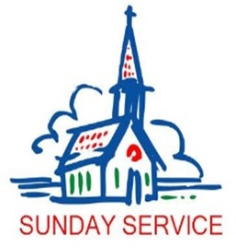
SUNDAY WORSHIP SERVICE—BACK TO CHURCH SUNDAY
Welcome Back To Church!
Sunday, September 13th at 10:00 AM (with Holy Communion)

NOTE: Services are now accessible via Facebook Live by clicking –
Prince of Peace Lutheran Church | Fernandina Beach FL | Facebook
Also, all services are recorded and will be available on church website:
Prince of Peace Lutheran Church - FL - Worship (poplcweb.com)
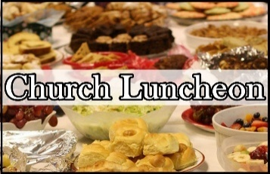
BACK TO CHURCH—LUNCHEON
Sunday, September 13th^{t} After Worship

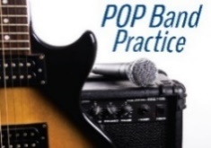

POP BAND PRACTICE
Sunday, September 21st —After Worship
in Sanctuary

ABOUT OUR CHURCH

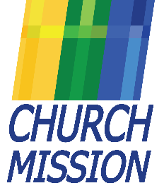
OUR MISSION
“To strengthen our faith in Jesus through worship and fellowship;
to be the face of Christ for others.”

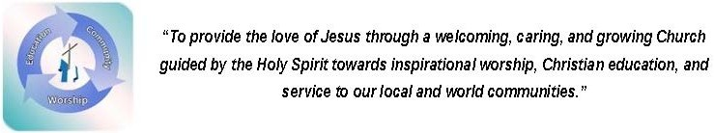


FACEBOOK – Check It Out!
Follow all of POP’s breaking news, upcoming events, and enjoy activities that were held on POP’s Facebook page. Everyone can visit our page. If you're a Facebook subscriber, please remember to share posts and like posts of interest with your Facebook friends. Visit us by clicking - Prince of Peace Lutheran Church | Fernandina Beach FL | Facebook

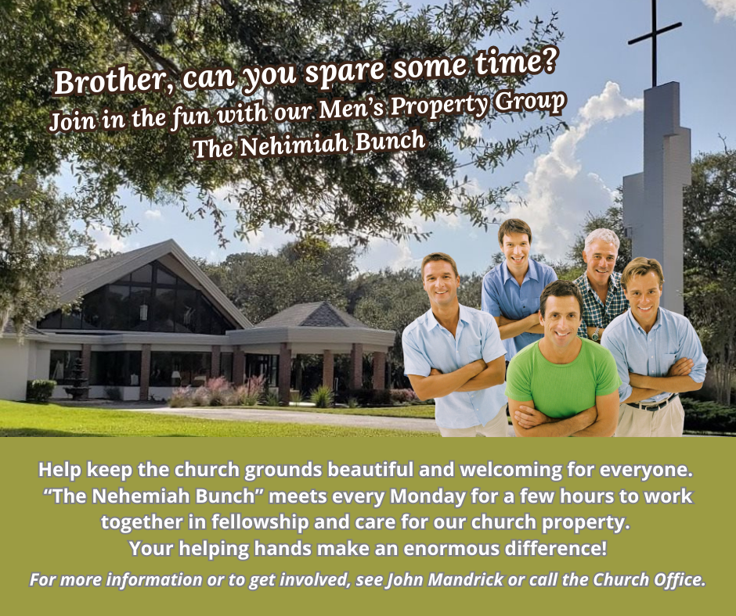

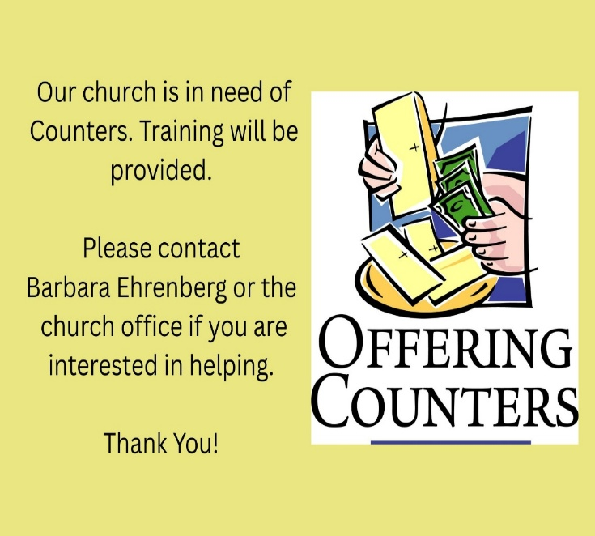

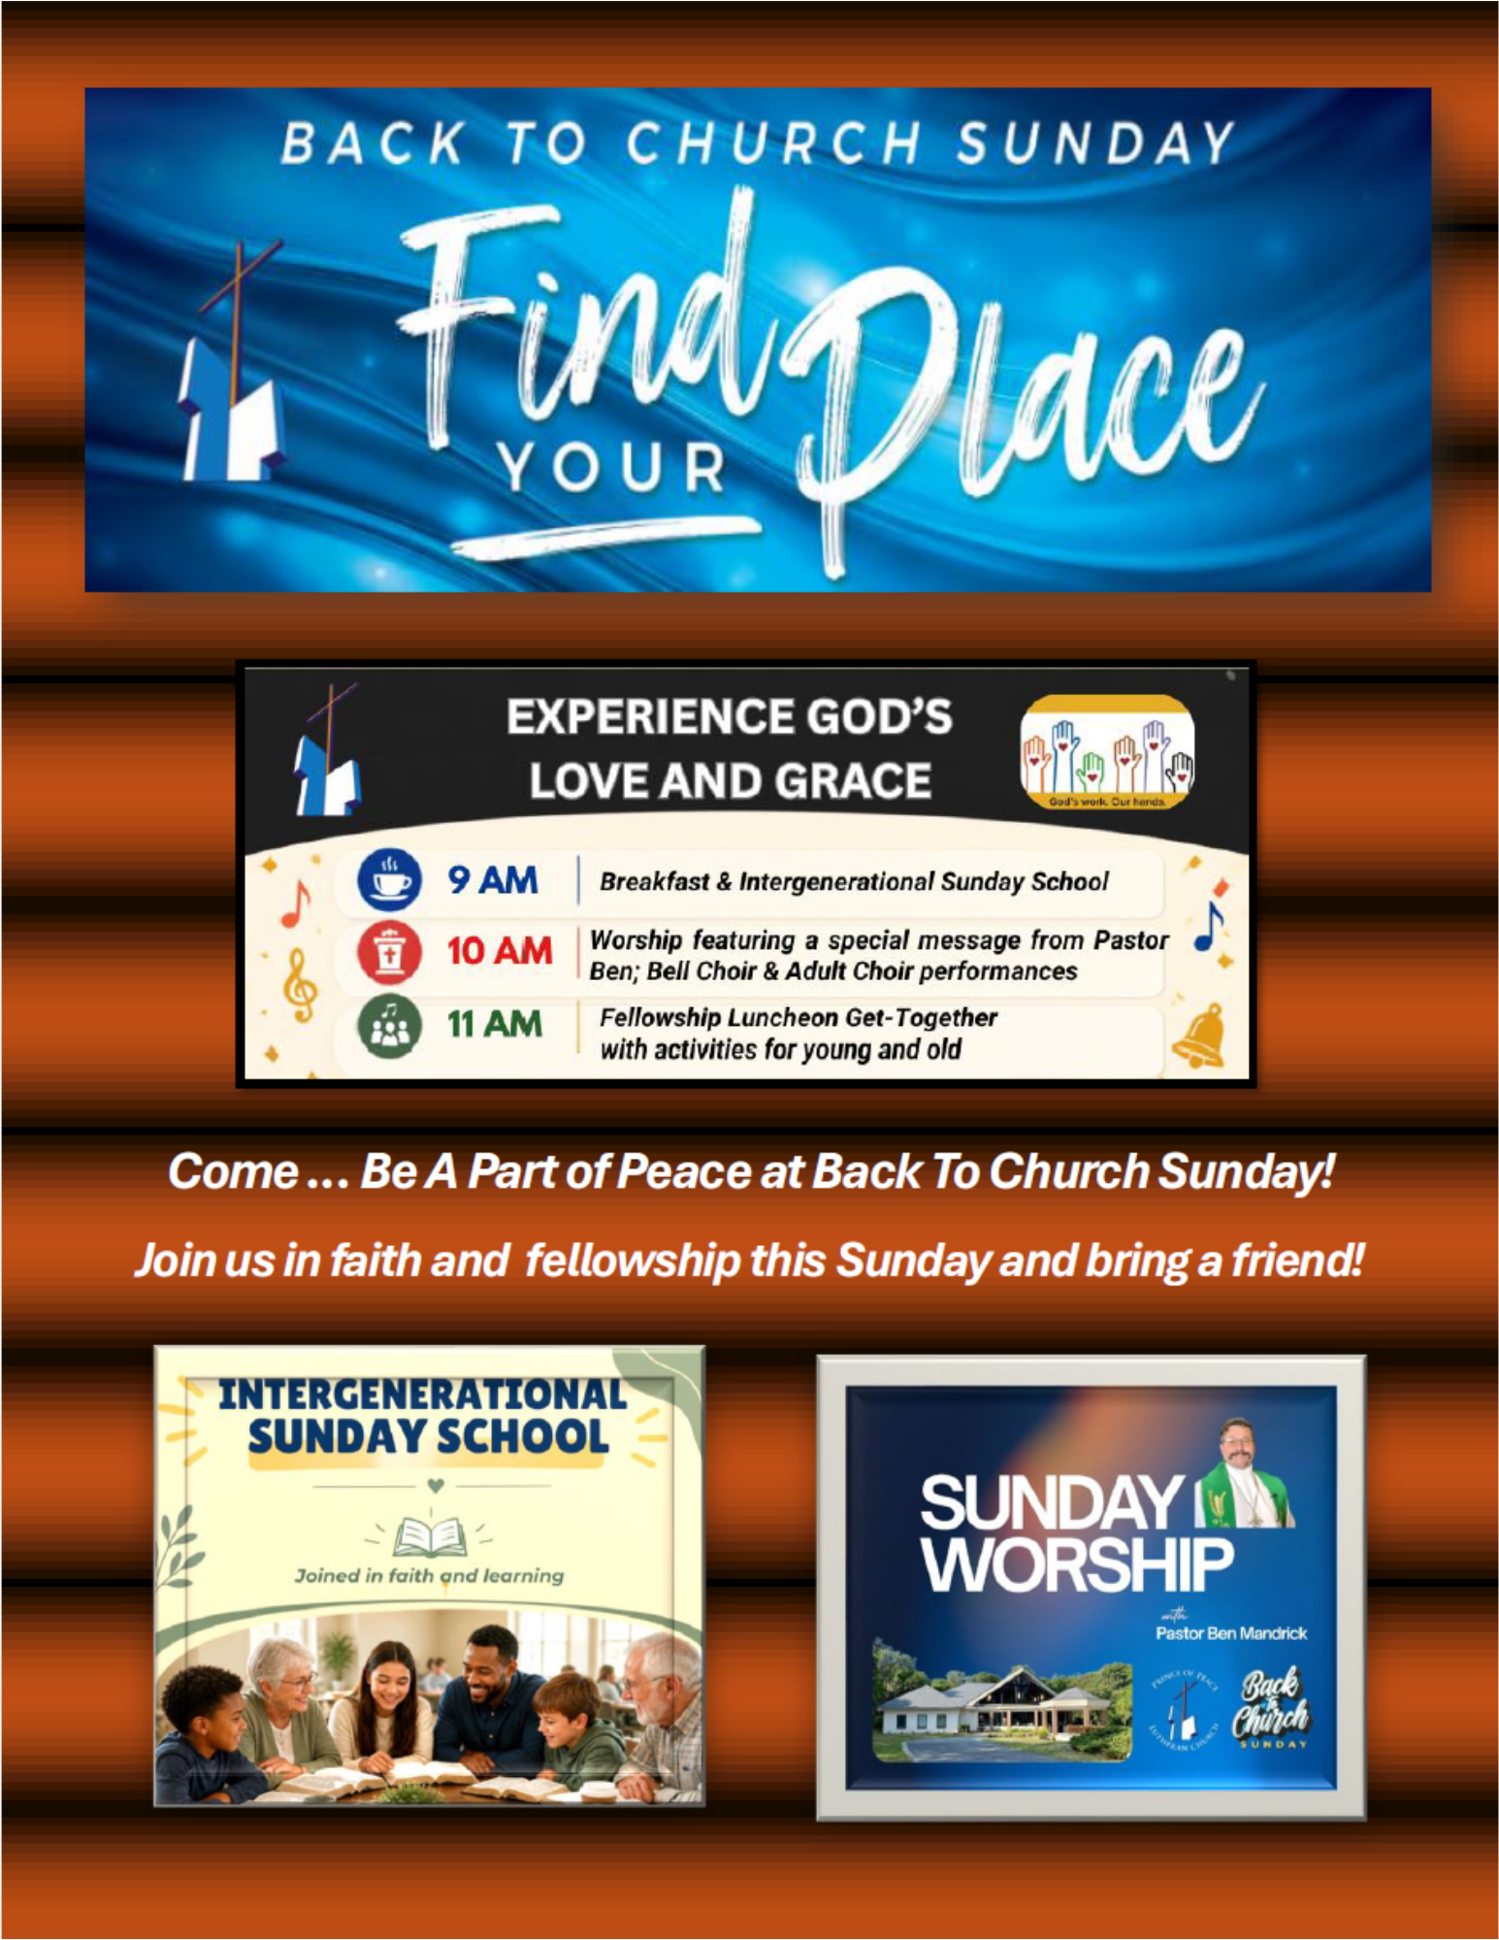

PLEASE SUPPORT OUR BACK TO CHURCH SUNDAY MISSION

