Holy Thursday
April 2, 2026
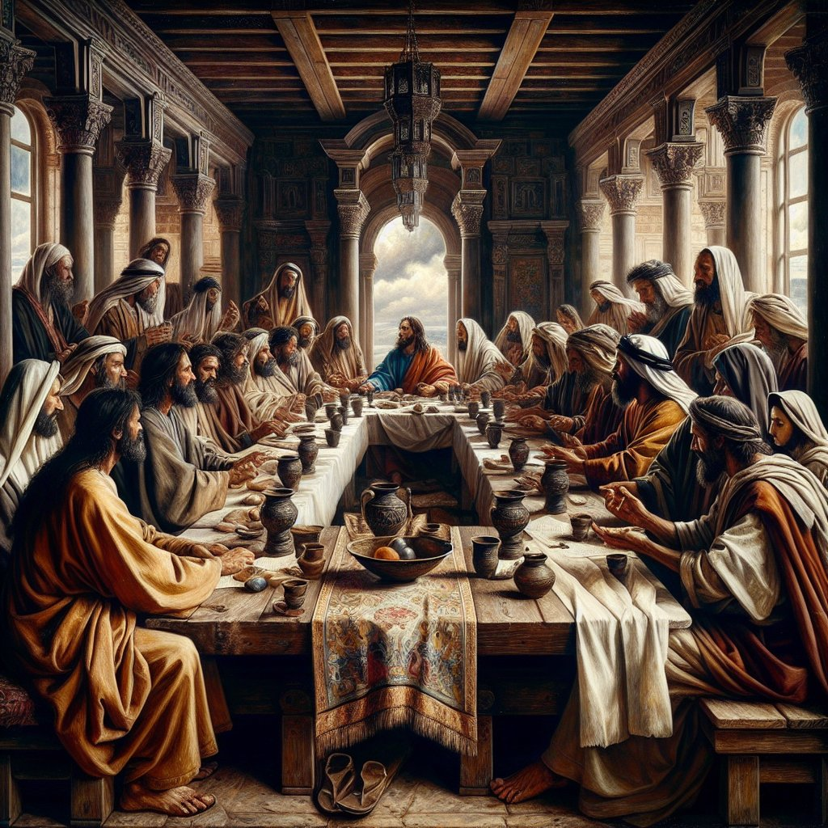

Offerings to the Lord may be left in the
Offering plate in the Narthex when entering or leaving worship.

St. John’s Lutheran Church
1450 30th Ave, East Moline, Illinois
(309) 792-0755
www.stjohnsem.org

Vacancy Pastor Steven Anderson
rev@focusonthegospel.com Cell: (309) 269-5276
Music Director Christine Engebrecht
bcengebrecht@att.net Cell:(309) 738-2797

Stand
Communion Notice Today we celebrate Holy Communion in which we joyfully receive Christ’s own body and blood, under bread and wine, for the forgiveness of our sins. Because we believe that participation in this sacrament is also a public confession of unity in the faith we invite communicant members of congregations in fellowship with the Lutheran Church – Missouri Synod to receive the sacrament.
We welcome our fellow Christians who wish to come forward but do not share all our beliefs to fold their arms in front of them and receive a blessing. We pray that our common baptism and the continued work of the Holy Spirit will draw us closer to one another and dispel the sad divisions that separate us. We pray that as we are led into all truth from God’s Word such divisions will lessen and finally disappear, in keeping with Christ's prayer for us "that they may all be one" (John 17:21). Let us all express in our hearts a prayerful desire for such unity of faith to be achieved.

Hymn
445 When You Woke That Thursday Morning
1 When You woke that Thursday morning,
Savior, teacher, faithful friend,
Thoughts of self and safety scorning,
Knowing how the day would end;
Lamb of God, foretold for ages,
Now at last the hour had come
When but One could pay sin’s wages:
You assumed their dreadful sum.

2 Never so alone and lonely,
Longing with tormented heart
To be with Your dear ones only
For a quiet hour apart:
Sinless Lamb and fallen creature,
One last paschal meal to eat,
One last lesson as their teacher,
Washing Your disciples’ feet.

3 What was there that You could give them
That would never be outspent,
What great gift that would outlive them,
What last will and testament?
“Show Me and the world you love Me,
Know Me as the Lamb of God:
Do this in remembrance of Me,
Eat this body, drink this blood.”

4 One in faith, in love united,
All one body, You the head,
When we meet, by You invited,
You are with us, as You said.
One with You and one another
In a unity sublime,
See in us Your sister, brother,
One in ev’ry place and time.

5 One day all the Church will capture
That bright vision glorious,
And Your saints will know the rapture
That Your heart desired for us,
When the longed-for peace and union
Of the Greatest and the least
Meet in joyous, blest communion
In Your never-ending feast.
Text: Jaroslav J. Vajda, 1919–2008
Text: © 1991 Concordia Publishing House. Used by permission: LSB Hymn License no. 110001214

Invocation & Exhortation
P In the name of the Father and of the T Son and of the Holy Spirit.
C Amen.
P I will go to the altar of God,
C to God my exceeding joy.
P Our help is in the name of the Lord,
C who made heaven and earth.

Collect for Holy Thursday
P O Lord, in this wondrous Sacrament You have left us a remembrance of Your passion. Grant that we may so receive the sacred mystery of Your body and blood that the fruits of Your redemption may continually be manifest in us; for You live and reign with the Father and the Holy Spirit, one God, now and forever.
C Amen.

Sit
Passion Reading (Matthew 26:17-30)

Nicene Creed
C I believe in one God,
the Father Almighty,
maker of heaven and earth
and of all things visible and invisible.

And in one Lord Jesus Christ,
the only-begotten Son of God,
begotten of His Father before all worlds,
God of God, Light of Light,
very God of very God,
begotten, not made,
being of one substance with the Father,
by whom all things were made;
who for us men and for our salvation came down from heaven
and was incarnate by the Holy Spirit of the virgin Mary
and was made man;
and was crucified also for us under Pontius Pilate.
He suffered and was buried.

And the third day He rose again according to the Scriptures
and ascended into heaven
and sits at the right hand of the Father.
And He will come again with glory to judge both the living and the dead, whose kingdom will have no end.

And I believe in the Holy Spirit,
the Lord and giver of life,
who proceeds from the Father and the Son,
who with the Father and the Son together is worshiped and glorified, who spoke by the prophets.
And I believe in one holy Christian and apostolic Church,
I acknowledge one Baptism for the remission of sins,
and I look for the resurrection of the dead
and the life T of the world to come. Amen.

Sit

Hymn 547 The Lamb
1 The Lamb, the Lamb,
O Father, where’s the sacrifice?
Faith sees, believes
God will provide the Lamb of price! Refrain

ref Worthy is the Lamb whose death makes me His own!
The Lamb is reigning on His throne!

2 The Lamb, the Lamb,
One perfect final offering.
The Lamb, the Lamb,
Let earth join heav’n His praise to sing. Refrain

3 The Lamb, the Lamb,
As wayward sheep their shepherd kill
So still, His will
On our behalf the Law to fill. Refrain

4 He sighs, He dies,
He takes my sin and wretchedness.
He lives, forgives,
He gives me His own righteousness. Refrain

5 He rose, He rose,
My heart with thanks now overflows.
His song prolong
Till ev’ry heart to Him belong. Refrain
Text: Gerald P. Coleman, 1953–2023
Text: © 1987 and 1997 MorningStar Music Publishers. Used by permission: LSB Hymn License no. 110001214

The Sermon

Stand
The Prayers
A Lord God, heavenly Father, Author of the everlasting covenant and Giver of the cup of salvation,
C we Your children gather in Your courts to offer to You our sacrifice of thanksgiving.
A For fulfilling Your promise to establish a new covenant through the blood of Your Son Jesus Christ,
C we give You humble and hearty thanks.
A Through the veil of His flesh
C we enter the Holy of Holies of your presence without fear or trembling.
A As our Lord Jesus Christ gave thanks to You when He broke the bread,
C so we give You thanks.
A As He gave You thanks when He took the cup,
C so we give You thanks.
A Lord Jesus Christ, both our High Priest and the offering,
C awe and wonder fill our hearts as we partake of Your body, broken for us, and your blood, shed for us.
A In our poverty of righteousness we have nothing to offer but our gratitude for Your perfect righteousness.
C Were it not for Your tremendous sacrifice, we would still be in our sins.
A But thanks be to You, for through Your Sacrament of the New Testament
C we are assured that our iniquities are forgiven and our sins are no longer remembered.
A O Holy Spirit, dwell within us as we remember in this Sacrament our Lord’s death.
C Enter our hearts, and help us to show our gratitude by encouraging one another to love and do good works.
A Lord, in your mercy
C Hear our prayer
A Help us to live our lives as sacrifices of thanksgiving.
C to Him who first loved us. May our love for Him express itself in love and service to one another. In His name we pray. Amen
Confessional Address
P Beloved in the Lord, it is our intention to receive the Holy Supper of our Lord Jesus Christ, in which he strengthens our faith by giving us His body to eat and His blood to drink. Therefore, it is proper that we diligently examine ourselves, as St. Paul urges us to do, for this holy Sacrament has been instituted for the special comfort of those who are troubled because of their sin and who humbly confess their sins, fear God's wrath, and hunger and thirst for righteousness. But when we examine our hearts and consciences, we find nothing in us but sin and death, from which we are incapable of delivering ourselves. Therefore, our Lord Jesus Christ has had mercy on us. For our benefit He became man so that He might fulfill for us the whole will and law of God and, to deliver us, took upon Himself our sin and the punishment we deserve.

The Words of Our Lord
So that we may more confidently believe this and be strengthened in the faith and in holy living, our Lord Jesus Christ took bread, broke it, and gave it to His disciples and said: "Take, eat; this is My body, which is given for you." In the same way also He took the cup, gave thanks, and gave it to them, saying: "Drink of it, all of you; this cup is the new testament in My blood, which is shed for you for the forgiveness of sins."

Confessional Address Continued
It is as if He said, "I became man, and all that I do and suffer is for your good. As a pledge of this, I give you My body to eat." Again, it is as if He said, "I have had mercy on you by taking into Myself all your iniquities. I give Myself into death, shedding My blood to obtain grace and forgiveness of sins, and to comfort and establish the new testament, which gives forgiveness and everlasting salvation. As a pledge of this, I give you My blood to drink." Therefore, whoever eats this bread and drinks this cup, confidently believing this Word and promise of Christ, dwells in Christ and Christ in him and has eternal life. We should also do this in remembrance of Him, showing His death—that He was delivered for our offenses and raised for our justification. Giving Him our most heartfelt thanks, we take up our cross and follow Him and, according to His commandment, love one another as He has loved us. For we are all one bread and one body, even as we are all partakers of this one bread and drink from the one cup. For just as the one cup is filled with the wine of many grapes and one bread made from countless grains, so also we, being many, are one body in Christ. Because of Him, we love one another, not only in word, but in deed and in truth. May the almighty and merciful God and Father of our Lord Jesus Christ, by His Holy Spirit, accomplish this in us.
C Amen.
P Having heard the Word of God, let us confess our sins to Him, imploring Him for the sake of His Son Jesus Christ to grant us forgiveness.

Confession of Sins
C O almighty God, merciful Father, I, a poor, miserable sinner, confess unto You all my sins and iniquities with which I have ever offended You and justly deserved Your temporal and eternal punishment. But I am heartily sorry for them and sincerely repent of them, and I pray You of Your boundless mercy and for the sake of the holy, innocent, bitter sufferings and death of Your beloved Son, Jesus Christ, to be gracious and merciful to me, a poor sinful being.

P God be merciful to you and strengthen your faith.
C Amen.

P Do you believe that the forgiveness I speak is not my forgiveness but God's?
C Yes.
P Let it be done for you as you believe. In the stead and by the command of my Lord Jesus Christ I forgive you all your sins in the name of the Father and of the T Son and of the Holy Spirit.
C Amen.

Lord's Prayer
Our Father who art in heaven, hallowed be Thy name, Thy kingdom come, Thy will be done on earth as it is in heaven; give us this day our daily bread; and forgive us our trespasses as we forgive those who trespass against us; and lead us not into temptation, but deliver us from evil. For Thine is the kingdom and the power and the glory forever and ever. Amen.

Pax Domini
P The peace of the Lord be with you always.
C Amen.

Agnus Dei LSB 198
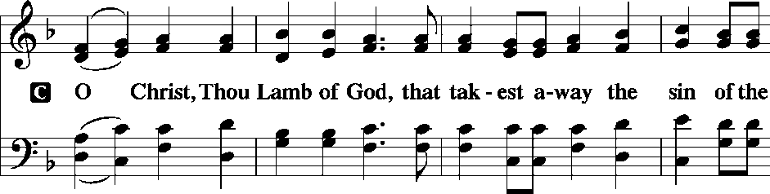
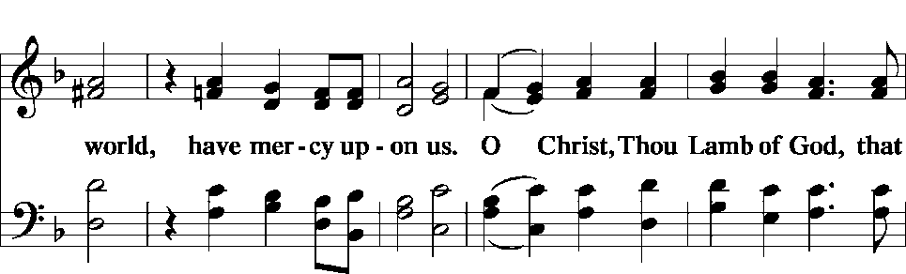
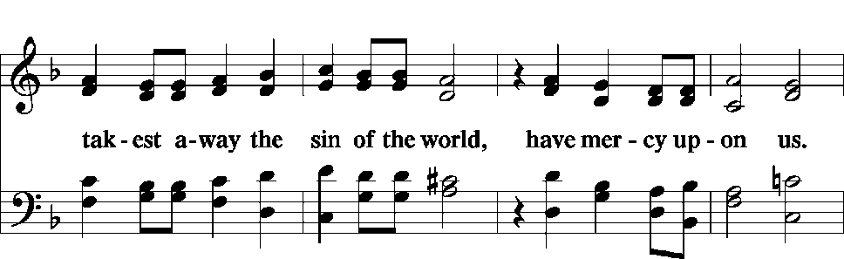
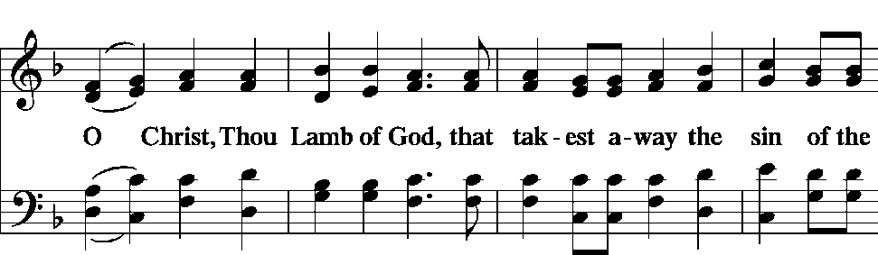
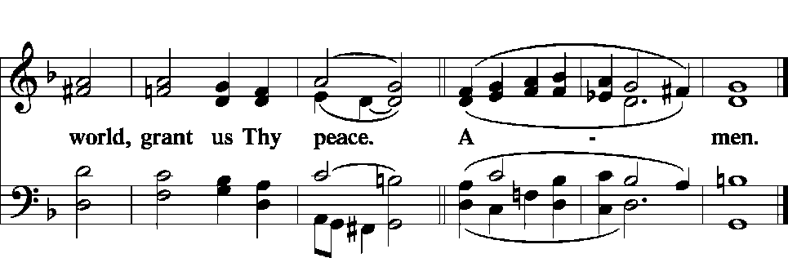

Sit

Distribution

Hymn 619 Thy Body, Given for Me, O Savior
1 Thy body, giv’n for me, O Savior,
Thy blood which Thou for me didst shed,
These are my life and strength forever,
By them my hungry soul is fed. Refrain

Ref Lord, may Thy body and Thy blood
Be for my soul the highest good!

2 With Thee, Lord, I am now united;
I live in Thee and Thou in me.
No sorrow fills my soul, delighted
It finds its only joy in Thee. Refrain

3 Who can condemn me now? For surely
The Lord is nigh, who justifies.
No hell I fear, and thus securely
With Jesus I to heaven rise. Refrain

4 Though death may threaten with disaster,
It cannot rob me of my cheer;
For He who is of death the master
With aid and comfort e’er is near. Refrain

5 My heart has now become Thy dwelling,
O blessèd, holy Trinity.
With angels I, Thy praises telling,
Shall live in joy eternally. Refrain
Text: Friedrich Christian Heyder, 1677–1754; tr. The Lutheran Hymnal, 1941, abr.
Text: © 1941 Concordia Publishing House. Used by permission: LSB Hymn License no. 110001214

Stand

Thanksgiving
A O give thanks unto the Lord, for He is good,
C and His mercy endureth forever.

A Let us pray.
We give thanks to You, almighty God, that You have refreshed us through this salutary gift, and we implore You that of Your mercy You would strengthen us through the same in faith toward You and fervent love toward one another; through Jesus Christ, Your Son, our Lord, who lives and reigns with You and the Holy Spirit, one God, now and forever.
C Amen.

Sit

440 Jesus, I Will Ponder Now
1 Jesus, I will ponder now
On Your holy passion;
With Your Spirit me endow
For such meditation.
Grant that I in love and faith
May the image cherish
Of Your suff’ring, pain, and death
That I may not perish.

2 Make me see Your great distress,
Anguish, and affliction,
Bonds and stripes and wretchedness
And Your crucifixion;
Make me see how scourge and rod,
Spear and nails did wound You,
How for them You died, O God,
Who with thorns had crowned You.

3 Yet, O Lord, not thus alone
Make me see Your passion,
But its cause to me make known
And its termination.
Ah! I also and my sin
Wrought Your deep affliction;
This indeed the cause has been
Of Your crucifixion.
4 Grant that I Your passion view
With repentant grieving.
Let me not bring shame to You
By unholy living.
How could I refuse to shun
Ev’ry sinful pleasure
Since for me God’s only Son
Suffered without measure?

5 If my sins give me alarm
And my conscience grieve me,
Let Your cross my fear disarm;
Peace of conscience give me.
Help me see forgiveness won
By Your holy passion.
If for me He slays His Son,
God must have compassion!

6 Graciously my faith renew;
Help me bear my crosses,
Learning humbleness from You,
Peace mid pain and losses.
May I give You love for love!
Hear me, O my Savior,
That I may in heav’n above
Sing Your praise forever.
Text: Sigismund von Birken, 1626–81; tr. August Crull, 1845–1923, alt.
Text: Public domain

The Stripping of the Altar and the Reading of Psalm 22

Depart In Silence

The stripping of the altar (and washing) is an ancient feature of Maundy Thursday, symbolic of the humiliation of Jesus at the soldiers’ hands. Psalm 22 rehearses that and other themes of the Passion.

Holy Week Schedule
Good Friday Service - 6:30 p.m.

NO SATURDAY WORSHIP

SUNDAY: Easter Festival at 6:30 a.m and 9:00 a.m.

