

Annual Church Business Meeting
Sunday, March 1, 2026
12:00 p.m. (Noon)
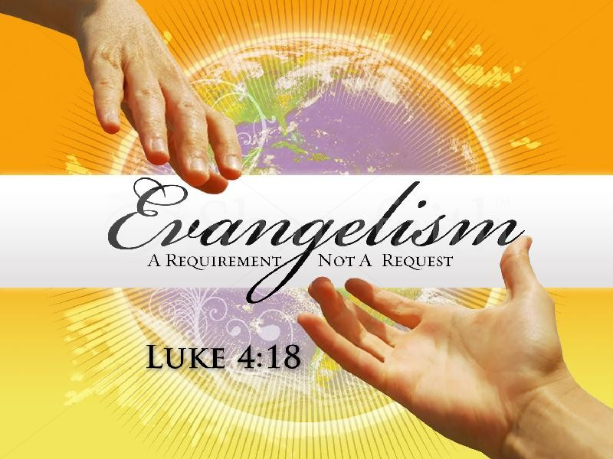

Rev. Joe and Krystal Oby, Pastors
709 Northport Drive
Madison, WI 53704
Email: info@ncamadison.com
Website: ncamadison.com

Making DISCIPLES - Matthew 28:19
We build believers into leaders who impact the world for God’s Kingdom!

Annual Church Business Meeting
Sunday, March 1, 2026

Agenda:

Opening Devotional and Prayer
Call to Order
Roster Report
Approval of Previous Minutes
Unfinished Business
Reports: General Church Report; Treasurer’s Report

New Business:
Review of Safe Church Policies
Update on Development and Church Renovation;
Announcements: Upcoming Ministry and Leadership Initiatives

Adjournment

Church Business Meeting Minutes:
Date: Sunday, February 1, 2025
Time: 10:00 a.m.
Location: NCA Church Sanctuary,
709 Northport Drive, Madison, Wisconsin

Devotional: Pastor Joe Oby
Meeting Called to Order: 10:35 a.m.
Roster Report: Quorum present.
Approval of Previous Minutes: Minutes from the Sunday, February 18, 2024, Business Meeting were approved.
Departmental Reports: Treasurer, Departmental, and Pastoral reports were presented and accepted.
New Business: Discussion held regarding updated “Safe Church Policies.” The church is working with its insurance company to review and update policies concerning children and youth teachers, restroom use, building security, concealed carry, and church response procedures to ICE enforcement.
NCA Church Development: An update was provided regarding the church’s property development plans, including the overall vision, potential timeline, expectations for church partners and the community, and proposed projects—affordable housing, senior housing, renovations to church facilities, and the addition of single-family homes.
Adjournment: 12:20 p.m.

2025 Annual Church Report

Theme 2025: Impact

As we reflect on 2025, we give glory to God for an incredible year of growth, transformation, and impact. Our theme, “Impact,” invited us to move from inspiration to action—living out our faith in ways that influence our city, equip our people, and advance God’s Kingdom. Every milestone reminds us that God is faithful when we walk by faith, serve with purpose, and lead with vision.

Building Believers into Leaders: Our mission remains central: We build believers into leaders who impact the world for God’s Kingdom. This purpose was evident throughout 2025 as our church family deepened its roots in discipleship and leadership development, equipping people to live out their calling in everyday life.

Teaching and Spiritual Growth:
The Word guided us through five life-shaping sermon series that fueled faith and formation:
- Community – building stronger relationships and belonging through Christ-centered connections.
- Discipleship: The Way of the Master – following Jesus faithfully and leading others to do the same.
- Finding Purpose: Positioned for Purpose – recognizing God’s design for us in every season.
- Kingdom Investors – learning to steward our resources for eternal fruit.
- Leadership: Identity Reset – rediscovering who we are as leaders in God’s Kingdom.

Life Groups: All In for Growth:
In 2025, we went “all in” on our Partners’ spiritual growth and care by engaging every partner in a Life Group. We expanded to six active Life Groups, each becoming a space for discipleship, care, and practical faith application. Through these smaller communities, our partners built friendships, grew in accountability, and learned to live out the sermon messages in daily life.

Employment and Ministry Expansion:
2025 was a year of strategic growth in leadership and ministry operations. We hired a full-time Associate & Executive Pastor to strengthen pastoral oversight and ministry structure. We also added a part-time Giving Champion, who led three impactful campaigns—Fall Fest Giving Campaign, To the Tithe, and Babies & Beyond, and hosted a Financial Workshop on Building Financial Wisdom and Faith. These initiatives not only raised resources but also deepened our culture of generosity and stewardship.

Outreach, Events, and Community Impact:
Our outreach presence grew stronger in 2025. We hosted our 1st Annual Fall Fest in October, connecting with youth and families across the city of Madison. Our church also partnered with Love Dane for a Day of Impact at Mendota Elementary School, serving our local community with love in action. Throughout the year, we saw 17 water baptisms, celebrated 23 new Partners, and ended the year with 70 active Partners faithfully engaged in ministry and mission.

Challenges and Faith Steps:
While 2025 marked great accomplishments, we continued to face the ongoing challenge of facility limitations. Our current space no longer meets the growing demands of ministry, but we continue to pray, plan, and believe God for expansion—to create more room for people and purpose.

Looking Ahead to 2026: Sending and Reaching:
As we step into 2026, our focus shifts toward sending and reaching. This new chapter, NCA 3.0, marks a pivotal moment of strengthening systems, developing leaders, and preparing for multiplication. Key initiatives include:

- Re-establishing our Executive Team for stronger administrative and ministry oversight.
- Expanding from 6 to 8 Life Groups, with 100% partner participation—*All In!*
- Introducing Activation Weeks and Prayer and Fasting Weeks to cultivate spiritual depth and empowerment.
- Adding 7 new Leadership Team members to sustain growing ministries.
- Shifting Sunday Services toward greater community outreach and evangelistic engagement.
- Expanding employment and volunteer roles to meet increasing ministry outreach and effective facilities’ utilization.
- Preparing for growth in people, resources, and physical space—as we build for the future.

We step into 2026 with faith and expectation, ready to send, reach, and continue fulfilling our purpose: to build believers into leaders who impact their world for God.

Annual Church Business Meeting
Sunday, March 1, 2026

Church Board

Rev. Joe T. Oby, Pastor
Krystal Oby, Pastor
Vernon Blackwell, Board Member
James Garwo, Board Member

Church Leadership
Isaiah Oby, Pastor
Alina Oby, Pastor
Linda Blackwell, Elder
Vernon Blackwell, Elder
Doris Williams, Elder
Alonzo Hunter, Deacon
Shunette Hunter, Deacon
Israel Oby, Associate Pastor & Executive Director

