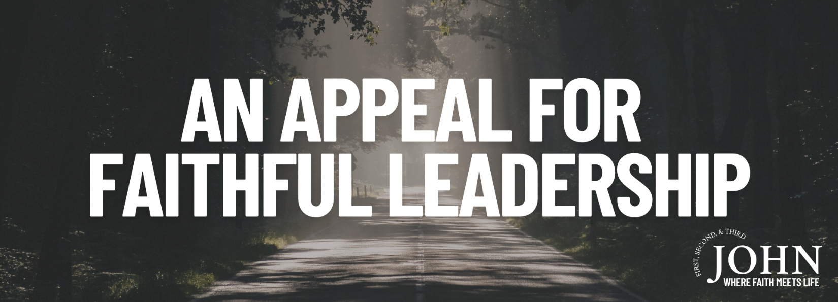

Pastor Keith Thompson
3 John 1-15 (ESV)

- Faithful leaders walk according to the ____________ of Truth (1-4).
- Faithful leaders support the ________________ of Truth (5-8).
- Faithful leaders oppose the ________________ of Truth (9-12).

