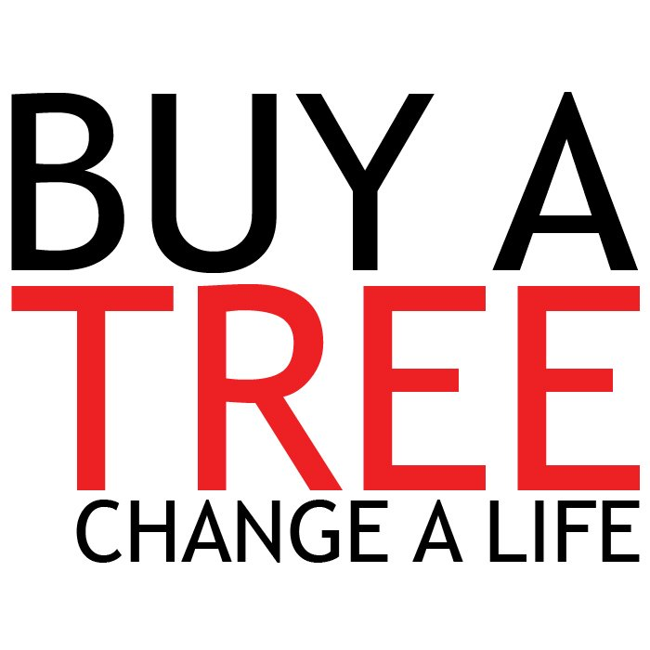
Dear Business Partners,

In 2020, BUY A TREE. CHANGE A LIFE. joined partners across the country and raised $1,056,169 to help children globally and locally. Oak Park Church alone raised over $30,000! This would not have been possible without the help of our generous sponsors and business partners! You have a chance to join this movement along with many other business partners across the country! Last year’s event produced local media attention in the papers, radio, and television across the country. We are expecting great things in 2021!

SPONSORSHIP

Title Sponsor - $3,000
This sponsorship goes towards the wholesale cost of the Christmas trees. This level of sponsorship could have multiple sponsors. These sponsors will enjoy the benefits of their name being displayed prominently at the site and attached to BUY A TREE. CHANGE A LIFE. throughout the project in all advertisement. Each Title Sponsor with receive an individual 4x8 banner along with social media advertisement throughout the whole event. Title Sponsors receive the largest amount of social media advertisement.

Lot Sponsor - $1,500
This sponsor would pay for all items/materials associated with the tree lot. Lot Sponsors will have their name displayed prominently at the Christmas tree site throughout the project as well as on printed material. Lot Sponsors will receive and individual 3x5 banner located within the Buy A Tree Change A Life lot.

Life Sponsor - $1,000
This level of sponsorship will have multiple sponsors. These sponsors will help fund the general costs that it takes to operate Buy A Tree Change A Life. The business/organization will be placed on a group 4x8 banner that will be located within the Buy A Tree Change A Life lot.

Other: $100 ______ $250 ______ $500 ______
Will have business/organization name displayed inside the tent.

Company: Contact:

Phone: Email:

Mailing Address:

Payment Method:

Check Credit Card# Exp: CCV:
Signature:
Please email your company logo to: jroberts@opcmobile.org
Thank you!

