Lutheran Office for Public Policy in Wisconsin:
2025-2026 Updates
The Lutheran Office for Public Policy in Wisconsin (LOPPW) is a ministry of the ELCA engaged in advocacy for policies that promote peace, justice, and care for creation.
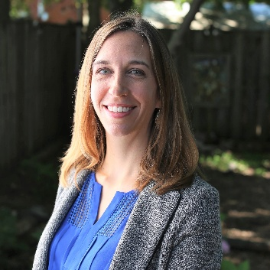
New Director
In September 2025, LOPPW welcomed a new director. Kacy Kostiuk comes to this position with experience in policy, advocacy, and communications on issues such as early childhood development, disability inclusion, and immigration and refugee resettlement. She grew up in Merrill, Wisconsin.
New Website
Kacy Kostiuk, new LOPPW Director.
The LOPPW website (www.loppw.org) underwent a major refresh in January 2026. It now has an improved look and is easier to navigate. Check out the News & Blog page for ongoing updates, and visit the Resources page for advocacy tips and tools.
State Policy Advocacy
During the 2025-26 Wisconsin legislative session, LOPPW engaged in advocacy related to bills focused on the priority areas of hunger, poverty, care for creation, and immigration. Highlights from the 2025-26 session include:
- Securing state funding to help offset federal cuts and changes to the Supplementary Food Assistance Program (SNAP) in Wisconsin.
- Advocating for a bill with bipartisan support that would enable qualified Deferred Action for Childhood Arrivals (DACA) recipients to obtain professional licenses to work in professions such as nursing, education, plumbing, and other fields.
- Advocating against a bill that would deregulate predatory rent-to-own transactions, which resulted in significant improvements to the bill’s language to increase protections for vulnerable Wisconsinites.
During this session, LOPPW built stronger relationships with ecumenical, interfaith, and secular partners; created new connections with legislators; and built momentum on bills related to groundwater pollution and anti-human trafficking, which we expect will lead to possible passage in a future session.
Outreach & Presentations
LOPPW is committed to connecting with congregations and members throughout Wisconsin to share information and learn how LOPPW can support their advocacy and service. In winter 2026, LOPPW visited Trinity Lutheran Church in Eau Claire and attended the Northwest Synod’s Winter Theological Event. If you are interested in inviting LOPPW to your congregation or would like to learn more, please contact Kacy at kacy.kostiuk@elca.org or 608-940-1808.
Elections in 2026 & Civic Engagement
LOPPW is developing a nonpartisan civic engagement and elections plan for 2026. We anticipate creating and sharing election resources and organizing several online events this year. Upcoming election dates in Wisconsin include: August 11 (Primary) and November 3 (General Election).
Sign Up to Receive Action Alerts or Newsletter Blurbs
Join LOPPW’s mailing list for action alerts and e-newsletters: loppw.org/action/mailing-list. LOPPW is also developing monthly blurbs that can be added to congregation or ministry newsletters. If you would like to be included in the distribution list for these blurbs, please contact Kacy at kacy.kostiuk@elca.org.

