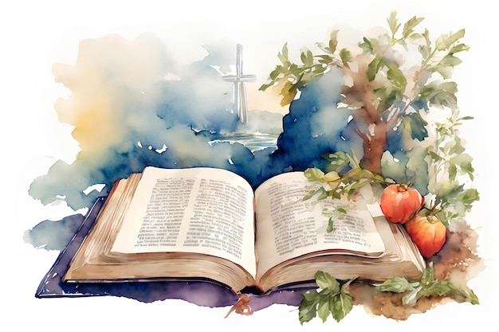
NORTHWEST SYNOD OF WISCONSIN
WELCA WOMEN’S RETREAT

God Is Writing Your Story
Speaker: Pati Kachel
https://www.theparablefund.org/bio

Monday and Tuesday, June 29 & 30
One day option available for Monday, June 29
$95.00 (2 days) Early bird special available until 6/5/26
$65.00 (Monday) Early bird special until 6/5/26

Luther Park Bible Camp
944 24 ¼ Street Chetek, WI

Contact Barb Krug for more information
715-965-5696 or barbkrug@charter.net

