AS YOU SETTLE IN…
- Turn to the book of (1 Peter 1:17-25) NLT

~ LET’S PRAY ~

NOTE TAKERS…
- I titled today’s message: “The Sting of Social Conditioning”

~ INTRO ~

WE FINISHED LAST WEEK WITH (v.16) NLT

OK… AS WE DO EVERY WEEK…
- We begin our study against the backdrop of the present moment.
  - How does God’s word apply to me today!?!

THEN…
- We discover three ways God’s word speaks to us:

- It tells us of sinful conditions in a fallen world.
- It tells us how God can forgive sin and change us in Jesus.
- It teaches us how to live out our faith, in a hostile world.

THIS WEEK…
- Another sinful reality… has arrived at the Churches front door.

- When we forget Gods word…
  - It’s because we’ve rejected God’s grace!
    - (And that has a National consequences)

A FEW DAYS AGO…
- The House of Representatives passed a Bill…
  - Called the “Equality Act”

THIS BILL…
- Amends the Civil Rights Act of 1964…
  - By adding discrimination language for sexual orientation…
    - AND gender identity…
      - To the areas of:

Employment / housing / public accommodation / education / credit /& jury service.

WHY DOES THIS MATTER TO THE CHURCH?
- Because the Church is being stripped of rights (1st Amendment)…
  - And categorized as “public accommodation.”

WHICH MEANS…
- This Bill penalizes… God given beliefs about marriage & biological sex.
  - And the morality the Church is to promote!

THE Equality Act IS AN EXTENSION OF THE SEXUAL REVOLUTION…
- Thru homosexual & transgender activists (LGBTQ)…
- Who are forcing public policy & opinion to bend to the minority.

The Williams Institute of Law @ UCLA:

“… the CDC’s Behavioral Risk Factor Surveillance System… estimate[s] the percentage and number of adults who identify as transgender… in all 50 states. We find that 0.6% of U.S. adults identify as transgender. …an estimated 1.4 million adults… (June 2016)
*(Source: williamsinstitute.law.ucla.edu )

NPR REPORTS:

… the bill [Equality Act] also explicitly says that it trumps the Religious Freedom Restoration Act... The law, passed in 1993, set a higher bar for the government to defend laws, IF people argued those laws infringed upon religious freedom. *(Source: NPR.org )

POINT BEING:

- The “Equality Act” infringes on religious freedoms!

NOW… HERE’S THE SCARY PART…
- The data shows… it is targeted toward kids.
  - And statistically… the most vulnerable ARE girls!

~ POST GRAPHS ~

Female = 56%
Race = 58% white
Age = (The greatest percentage) = 30% between 18-24 years old

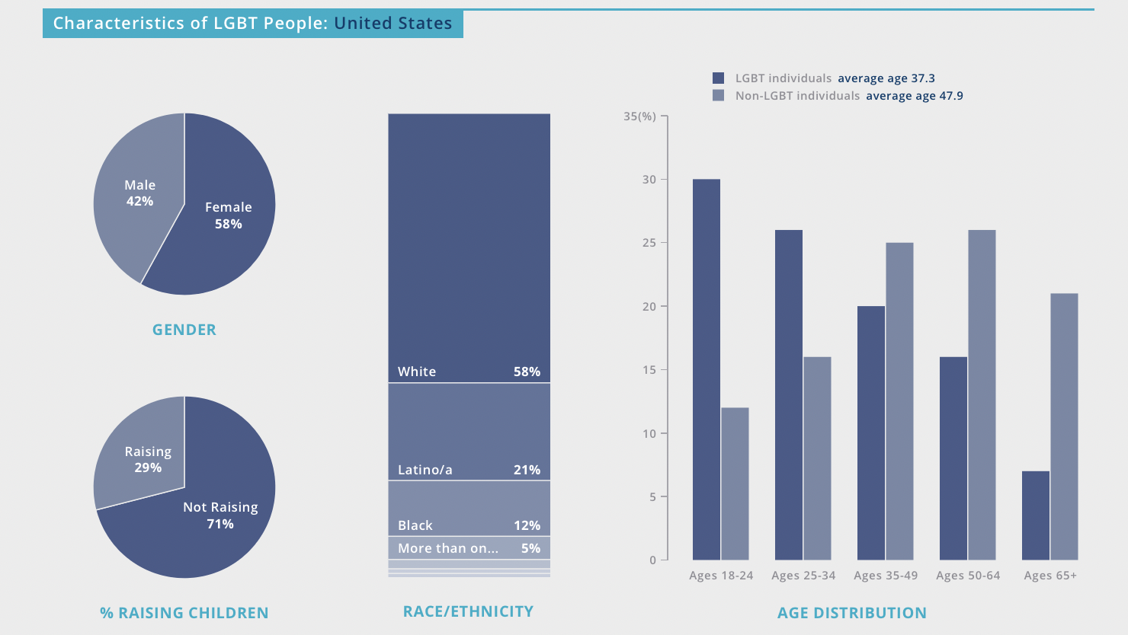
*(Source: williamsinstitute.law.ucla.edu )

~ STUDY ~

(Isa. 5:20) NKJV
- God pronounces judgment on those who pervert values & morals.
- “Woe to those who call evil good, and good evil…”

JESUS SAID (Matt. 18:6) NLT
“… If you cause one of these little ones who trust in me to fall into sin, it would be better for you to have a large mill stone tied around your neck and be drowned in the depths of the sea.”

IN (1 Peter)…
- We’re learning to live out our faith…
  - Under increasing hostile conditions.

HERE’S THE QUESTION WE’RE ASKING TODAY:
- Am I living out a Biblical Faith?

IDEA #1 – “RIGHT PERSPECTIVE”

GOD HAS NO FAVORITES… (v.17)
- He does not wink at bad beliefs & bad behavior!

THREE TRUTHS TO REMEMBER:

- Hard times come when we forget God’s ways:

(Hosea 4:6) NLT
“My people are being destroyed because they don’t know me. Since you priests refuse to know me, I refuse to recognize you as my priests. Since you have forgotten the laws of your God, I will forget to bless your children.”

WHEN PASTORS NEGLECT
- To confront the moral landslide…
  - Our kids get hurt!

- We CAN escape the propaganda:

AS A BELIEVER IN JESUS CHRIST…
- God has provided His word to help us think clearly & stay close!

(Rom. 12:2) NLT
“Don’t copy the behavior and customs of this world, but let God transform you into a new person by changing the way you think. Then you will learn to know God’s will for you, which is good and pleasing and perfect.”

- We’re fighting FOR freedom:

GOD IS VERY CLEAR…
- About the conditions that leads to the downfall of a nation.

(Prov. 14:34) NKJV
“Righteousness exalts a nation, but sin is a reproach to any people.”

(Deut. 22:5) NLT

The Canaanite religious practice for sexual stimulation was cross dressing.
- Which promoted perversity!
  - Today it’s a rainbow flag.

CHURCH…
- You’re the preserving agent of this moment.
  - And God has empowered you to take His message forward!

BUT…
- The further OUR culture gets away from God…
  - The more extreme His truth seem!

CONSIDER GOD’S VIEW ON…
- On male and female differences (gender)…
- His view on sexuality
- His view on intoxicants (weed)
  - All the hot-issues of our time!

LISTEN… IF YOU’RE CLAIMING THE NAME OF CHRIST…
- And yet supporting things contrary to His revealed will…
  - You’ve got to STOP!!!

I’M NOT QUESTIONING YOUR SALVATION…
- I’m saying the Bible tell us we can’t be walking with God…
  - And support things He died for.

(1 Cor. 6:9-10) NLT
- Our aim is to save…
  - But it means we have to step into messy discussions!

~ IN CLOSING ~

TWO LESSONS TO LEAVE WITH:

- Don’t ignore the gift God has given you (2 Cor. 6:1-2) NLT

- The original “Cancel” came from Jesus (Col. 2:13-14) NLT

HERE’S YOUR CALL TO ACTION THIS WEEK:
- Your saltiness can have a real-time impact – if you let it.

*Call your Senator on Monday and tell them to vote NO…
- On the Equality Act.

THIS IS NOT A POLITICAL STATEMENT…
- It’s a moral imperative!

~ LET’S PRAY ~

