~ INTRO ~

ALRIGHT…
- It’s amazing that after 2-years we’re finally…
  - At the last two chapters of (Acts).

I’M SUPER EXCITED TO FINISH THIS BOOK…
- And put into practice… what we’ve learned about ministry…
  - From the early church.

NOW… TODAY…
- We see Paul’s final mission… take shape.
  - And this chapter records his journey to Rome.
    - (Acts 19:21) NLT
    - (Acts 23:11) NLT

IDEA #1 – GOSPEL TARGET

IT’S BEEN… ABOUT 3-YEARS…
- Since God told Paul of his final mission.
  - In (Acts 25:12) we read of the natural steps…
    - That put this mission in motion.
      - And Paul was finally on the way Rome.

THIS IS WHAT THE ROUTE LOOKED LIKE…

WHILE LIVING OUT GOD’S PLAN WE CAN EXPECT TWO THINGS:

- To experience God’s favor along the way.
- (v.3) Paul got help in practical matters.

- There will still be difficulty along the way.
- (v.4) Resistance can take any shape!
- In the book of (Job 1:19) NLT

IN THIS SCENE BEFORE US…
- It was the wind on the Mediterranean Sea.

(v.37) Tells us the ship Paul was on… had 276-passengers aboard.
- It was a much smaller ship, and the weather was much worse.

LAST MONTH (Nov. of 2024’)…
- Jodi & I sailed on the northside of Crete… (v.7)
  - With seven-foot waves… on a ship carrying 1,200 people.

WE VISITED…
- The Cave of the Apocalypse on the Island of Patmos…
  - Where John wrote the book of Revelation (Rev. 1:9-11) NLT

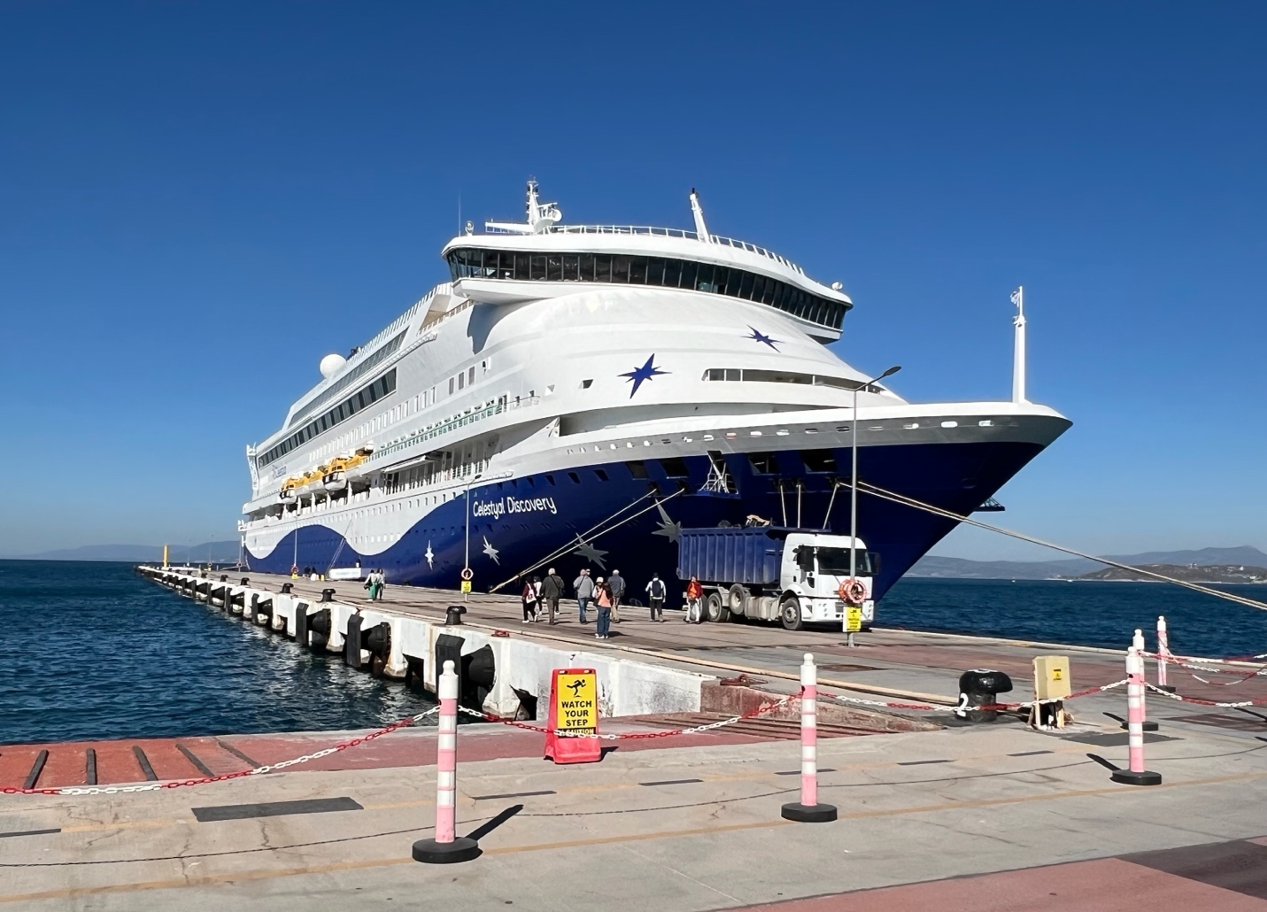

IT’S SO EXCITING…
- That we have the opportunity and connections…
  - To visit the historical locations… that testify of our faith.

VISTING WHAT WE READ ABOUT…
- Adds a whole new level of insight to our Bible reading.

NOTE: We’re finalizing details to take 20-people…
- On the Footsteps of Paul Tour (Oct. 9th – 19th, 2025).
  - If anyone is interest in going…
    - We have an interest list on the app… (sign up today).

*Show Map Now:

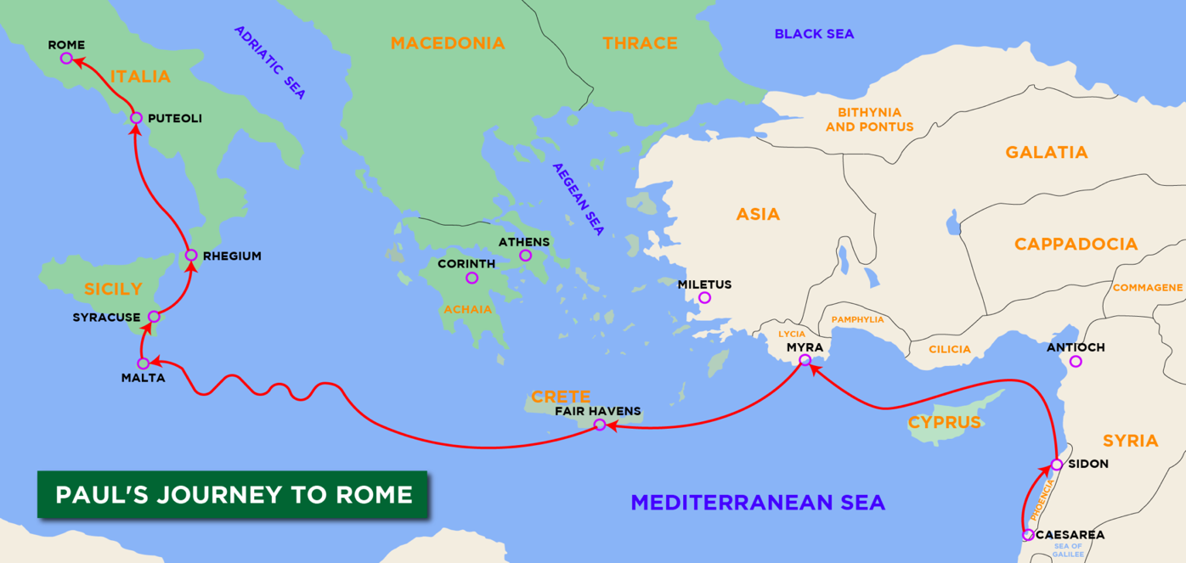

CAPTURE THE BIG PICTURE: (vv.1-20)
- Sidon (v.3)
- Around Cyprus (v.4)
- On to Myra (v.5) >>> ship change here
- Cnidus (Ni-Dus) (v.7)

- Sailed on south side of Crete
  - Fair Haven (v.8)
  - Phoenix (v.12)

(v.14) The wind gets worse…
- Kaa-Duh (English Claudia)

THE STORM GOT WORSE AGAIN…
- This reminds me of (Jonah 1:11-12 & 17) NKJV

JONAH RAN FROM THE CALL OF GOD ON HIS LIFE…
- And he brought trouble on the people around him.
- How many people get hurt when we run from God?

PAUL… WAS RUNING INTO HIS CALL…
- And there was resistance was from the enemy!
- But God gave protection & safety.

IDEA #2 – BOLD LEADERSHIP

PAUL SPEAKS UP…
- At a time when all hope had been lost!
  - The strength of man’s efforts had failed…
    - And there was no way forward.

MANY TIMES…
- Those wrestling with God have to get to the bottom…
  - Before they will listen to God.
    - (Ps. 51:17) NLT

IDEA #3 – PROTECTION & SAFETY

AS WE LEARN TO WALK WITH GOD…
- Our faith is strengthened thru the difficulties we face.

- God often takes un into dead-end situations…
  - So that we remove our hands… and allow Him to take over.

~ IN CLOSING ~

THE BIBLE TEACHES US TO…
- Stand still (Ex. 14:13) NLT
- Sit still (Ruth 3:18) NKJV
- Be still (Ps. 46:10) NKJV

POINT BEING…
- The way forward always requires us to place faith in God…
  - And not self.

AMEN!

