
Sunday, May 3, 2026
Christ’s Lutheran Church
Murrysville, Pennsylvania
“A Place to Believe, Belong, and Become”
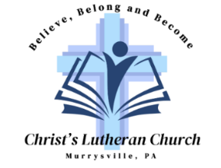

Christ’s Lutheran Church is a Christ-centered and welcoming,
Christian community committed to encouraging faith-filled living,
deepening friendships, and life-changing discipleship.

Welcome! If you are new to worship in a Lutheran church, this introduction will help guide you through our worship service. The prayers, responses, and service music are printed in this bulletin. You will need to use the red Evangelical Lutheran Worship (ELW) hymnals to sing the hymns. Our Sunday morning service is livestreamed on YouTube and your image may appear.

Communion - All baptized Christians are welcome to receive the gift of Holy Communion. Children who haven’t received Holy Communion may also come forward for a blessing. You can either kneel or remain standing when you come to the altar. We offer both wheat and gluten-free wafers, and both wine and grape juice. If you would like to receive grape juice, please take a glass from the tray that has already been filled when you come forward. If you would like to receive a gluten-free wafer, please let the Pastor know when you are given the bread.

Children are always welcome! Please feel free to walk around in the rear area of our worship space if your child becomes restless. Rest rooms (with diaper decks) are located in the hallway to the right of the entryway. You can find cloth bags containing activities for children aged 3 and older in the back of our worship space. We ask you to please return the cloth bags and their contents (minus any artwork your child creates while you are worshiping) at the end of today’s service.

CHRIST’S LUTHERAN CHURCH
5330 Old Logan Ferry Road, Murrysville, PA 15668
Office: 412-795-1212
Church Office email: office@christsmurrysville.org
Website: www.christsmurrysville.org
App: Christ’s Lutheran (ELCA)

Fifth Sunday of Easter
(Please silence your electronic devices)

PRELUDE Instrumental

ANNOUNCEMENTS AND SHARING OF CONCERNS

COMMISSIONING OF YOUTH FOR MISSION

CONFESSION AND FORGIVENESS
P: Blessed be the holy Trinity, ☩ one God, our creator, our protector, our wellspring of life.
C: Amen.

P: Trusting that God receives our words and the meditations of our hearts, let us confess our sin.

Silence is kept for reflection

P: Merciful God,
C: we confess to you all our sins. Our burden is heavy, and we cannot free ourselves. In your mercy, call us back to you. Your yoke is easy and your burden is light. Restore us to dwell in your peace. In Christ’s name we pray, Amen.

P: The Book of 1 Peter proclaims, “He himself bore our sins in his body on the cross, so that, having died to sins, we might live for righteousness; by his wounds you have been healed.” In ☩Christ you are forgiven. In the Spirit you are made free. Refreshed by the waters of mercy, live anew as beloved children of God.
C: Amen.

P: In the spirit of reconciliation with both God and neighbor, let us share Christ’s peace with each other. The peace of the Lord be with you always.
C: And also with you.

The congregation shares the peace of Christ with each other.

GATHERING HYMN
“The Church’s One Foundation” ELW #654

GREETING
P: The grace of our Lord Jesus Christ, the love of God, and the communion of the Holy Spirit be with you all.
C: And also with you.

KYRIE
P: In peace, let us pray to the Lord.
C: Lord have mercy.

P: For the peace from above, and for our salvation, let us pray to the Lord.
C: Lord have mercy.

P: For the peace of the whole world, for the well-being of the church of God, and for the unity of all, let us pray to the Lord.
C: Lord have mercy.

P: For this holy house, and for all who offer here their worship and praise, let us pray to the Lord.
C: Lord have mercy.

P: Help, save, comfort, and defend us, gracious Lord
C: Amen.

HYMN OF PRAISE

PRAYER OF THE DAY
P: Almighty God, your Son Jesus Christ is the way, the truth, and the life. Give us grace to love one another, to follow in the way of his commandments, and to share his risen life with all the world, for he lives and reigns with you and the Holy Spirit, one God, now and forever.
C: Amen.

FIRST READING: PSALM 31: 1-5, 15-16
A: In you, O Lord, have I taken refuge;
let me never be put to shame;
deliver me in your righteousness.
C: Incline your ear to me;
make haste to deliver me.
A: Be my strong rock, a castle to keep me safe,
for you are my crag and my stronghold;
for the sake of your name, lead me and guide me.
C: Take me out of the net that they have secretly set for me,
for you are my tower of strength.
A: Into your hands I commend my spirit,
for you have redeemed me, O Lord, God of truth.
C: My times are in your hand;
rescue me from the hand of my enemies,
and from those who persecute me.
A: Let your face shine upon your servant;
save me in your steadfast love.

SECOND READING: 1 PETER 2: 9-12
But you are a chosen people, a royal priesthood, a holy nation, God’s own people, in order that you may proclaim the excellence of him who called you out of darkness into his marvelous light. Once you were not a people, but now you are God’s people; once you had not received mercy, but now you have received mercy. Beloved, I urge you as aliens and exiles to abstain from the desires of the flesh that wage war against the soul. Conduct yourselves honorably among the gentiles, so that, though they malign you as evildoers, they may see your honorable deeds and glorify God when he comes to judge.

IMAGINATION TIME with Pastor Sue

GOSPEL ACCLAMATION (please stand)
P: The Holy Gospel according to St. John, the fourteenth chapter
C: Glory to you, O Lord.

HOLY GOSPEL: JOHN 14: 1-14
Jesus said to the disciples: “Do not let your hearts be troubled. Believe in God; believe also in me. In my Father’s house there are many dwelling places. If it were not so, would I have told you that I go to prepare a place for you? And if I go and prepare a place for you, I will come again and will take you to myself, so that where I am, there you may be also. And you know the way to the place where I am going.” Thomas said to him, “Lord, we do not know where you are going. How can we know the way?” Jesus said to him, “I am the way and the truth and the life. No one comes to the Father except through me. If you know me, you will know my Father also. From now on you do know him and have seen him.” Philip said to him, “Lord, show us the Father, and we will be satisfied.” Jesus said to him, “Have I been with you all this time, Philip, and you still do not know me? Whoever has seen me has seen the Father. How can you say, ‘Show us the Father’? Do you not believe that I am in the Father and the Father is in me? The words that I say to you I do not speak on my own, but the Father who dwells in me does his works. Believe me that I am in the Father and the Father is in me, but if you do not, then believe because of the works themselves. Very truly, I tell you, the one who believes in me will also do the works that I do and, in fact, will do greater works than these, because I am going to the Father. I will do whatever you ask in my name, so that the Father may be glorified in the Son. If in my name you ask me for anything, I will do it.”

P: The Gospel of the Lord.
C: Praise to you, O Christ.
MESSAGE Pastor Sue Washburn (please be seated)
“Faithful Living in Challenging Times”

HYMN OF THE DAY
“You Are the Way” ELW #758
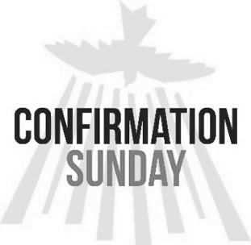
AFFIRMATION OF BAPTISM
Congratulations to this year’s confirmands, Isabel Nazak and Brady Yurisinec! We are pleased that we can celebrate this big day in their lives as they come forward to affirm their faith.

SPONSOR: I present Isabel Nazak and Brady Yurisinec, who desire to make public affirmation of their baptism for their confirmation.

P: God, who is rich in mercy and love, gives us a new birth into a living hope through the sacrament of Holy Baptism. By water and the word God delivers us from sin and death and raises us to new life in Jesus Christ. We are united with all the baptized in the one body of Christ, anointed with the Holy Spirit, and joined in God’s mission for the life of the world.

Let us pray: Merciful God, we thank you for those who are gathered here – people whom you have made your own by water and the word in Baptism. You have called them to yourself, enlightened them with the gifts of your Spirit, and nourished them in this community of faith. Uphold us in the gifts and promises of baptism and unite our hearts in love and service. We ask this in the name of Christ.
C: Amen

P: I ask you to profess your faith in Christ Jesus, reject sin, and confess the faith of the Church.

P: Do you renounce the devil and all the forces that defy God?
C: I renounce them.

P: Do you renounce the powers of this world that rebel against God?
C: I renounce them.

P: Do you renounce the ways of sin that draw you from God?
C: I renounce them.
P: Do you believe in God the Father?
C: I believe in God, the Father almighty,
creator of heaven and earth.

P: Do you believe in Jesus Christ, the Son of God?
C: I believe in Jesus Christ, His only Son, our Lord,
who was conceived by the Holy Spirit,
born of the virgin Mary,
suffered under Pontius Pilate,
was crucified, died, and was buried;
he descended to the dead.
On the third day, he rose again;
he ascended into heaven,
he is seated at the right hand of the Father,
and he will come to judge the living and the dead.

P: Do you believe in God the Holy Spirit?
C: I believe in the Holy Spirit,
the holy catholic church,
the communion of saints,
the forgiveness of sins,
the resurrection of the body,
and the life everlasting. Amen

P: You have made public profession of your faith. Do you intend to continue in the covenant God made with you in Holy Baptism:
to live among God’s faithful people,
to hear the word of God and share in the Lord’s supper,
to proclaim the good news of God in Christ through word
and deed,
to serve all people, following the example of Jesus,
and to strive for justice and peace in all the earth?
C: I do, and I ask God to help and guide me.

P: People of God, do you promise to support and pray for Isabel and Brady and for each other in your life in Christ?
C: We do, and we ask God to help and guide us.

P: Let us pray: We give you thanks, O God, that through water and the Holy Spirit you give us new birth, cleanse us from sin, and raise us to eternal life. Stir up in all of your people the gift of your Holy Spirit: the spirit of wisdom and understanding, the spirit of counsel and might, the spirit of knowledge and the fear of the Lord, the spirit of joy in your presence, both now and forever.
C: Amen.

THE PRAYERS OF INTERCESSION
P: Trusting in the power of Christ’s resurrection to heal and redeem our broken world, let us pray for the needs of all creation.

A brief silence

P: God of glory, you have built your church on Christ the cornerstone. Inspire lay leaders, deacons, pastors, and bishops to proclaim forgiveness and your steadfast love to all whom they encounter. Lord in your mercy,
C: Hear our prayer.

P: God of majesty, you bring forth plants and animals, skies and seas, mountains and valleys. Protect all you have made from the ravages of pollution and climate disaster. Lord in your mercy,
C: Hear our prayer.

P: God of mercy, you intend governments and social service agencies to be instruments of peace and justice. Guide political leaders and organizations to be agents of compassion, and raise up advocates for those who seek refuge and assistance. Lord in your mercy,
C: Hear our prayer.

P: God of community, you call us together as your people for mutual support and to witness to your love in the world. Make your presence known among those unable to attend worship today. Lord in your mercy,
C: Hear our prayer.

P: Sustainer of faith, we pray for Christ’s Church as it discerns your call for future ministries. Guide the leadership of the church to seek your vision first. Inspire everyone to share in the new thing that you have begun. Work in the heart and mind of the incoming pastor as he or she prepares for this leadership. Lord in your mercy,
C: Hear our prayer.

P: God of eternal life, you have prepared dwelling places for your people, so that we are never separated from you. We give you thanks for the faithful departed who witnessed to your mighty acts in word and deed. Lord in your mercy,
C: Hear our prayer.

P: God of well-being, you soothe those in distress, console all who grieve, provide for any in need, and comfort those who are sick. Instill caregivers with a sense of purpose to be your healing hands in this world. Lord in your mercy,

C: Hear our prayer.

Today we pray for:
Lindsey Boyer, Kim Boyer, Ron Brennan, James Burton, Jr., Terry Burton, Randy Clouser, Joel Erwin, Pearl Elliott, David Favero, Nancy Fiedler, Joseph Grabowski, Sr., Peggy Henry, Lisa Lehman, John Magnus, Derwood Montgomery, Michael O'Donnell, Evan Pavloff, Jeff Pope, Betty Reagan, Paul Rizzo, Lonnie Shurnia, Ron Spagna, Marianne Trainor, and Sue Werner

And for our church members and friends:
Tina Ashbaugh
Nancy Bailie
Tiffany Baird
Janet Beall

P: God of resurrection power, use us and these prayers to proclaim the good news of new life to all the world, through Jesus Christ, our risen Savior.
C: Amen.

OFFERING
P: Our offering is an act of worship, a demonstration of our love for God. The Apostle Paul says: “Each of you should give what you have decided in your heart to give, not reluctantly or under compulsion, for God loves a cheerful giver.” We will receive your gifts, tithes, and offerings.

You can place your offering in the offering plate that is passed at this time in our service,

You can scan this QR code to our online giving page,

You can use our app to send your offering,

or mail your offering to the church:
Christ’s Lutheran Church
5330 Old Logan Ferry Road
Murrysville, PA 15668

THE OFFERTORY Instrumental

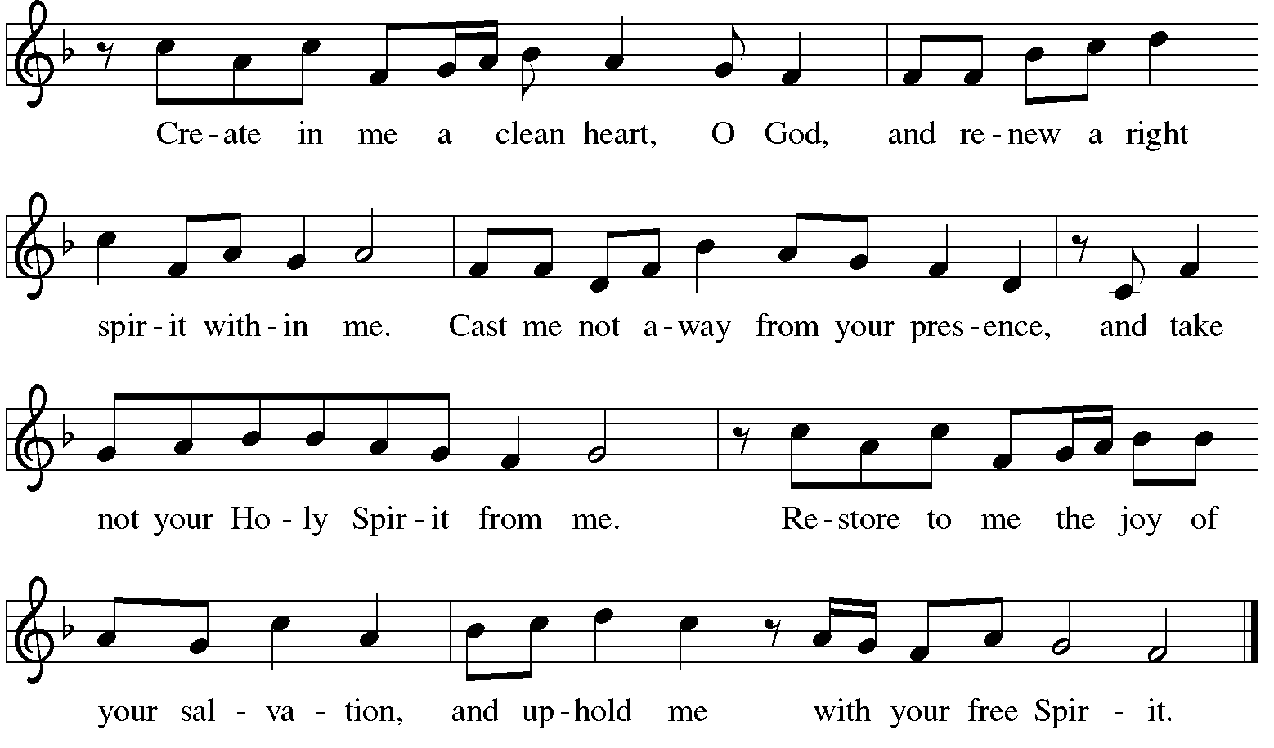
OFFERTORY RESPONSE

OFFERING PRAYER
A: Merciful God, accept the fruits of our labor, gathered to give you glory. You have set a table before us, a glimpse of that great day when we will hunger and thirst no more. Nourish us with the body and blood of Jesus, that goodness and mercy may follow us and bless the world you love. In the name of Jesus,
C: Amen.

THE GREAT THANKSGIVING
P: The Lord be with you.
C: And also with you.

P: Lift up your hearts.
C: We lift them to the Lord

P: Let us give thanks to the Lord our God.
C: It is right to give our thanks and praise.

P: It is right, and a good and joyful thing, always and everywhere to give thanks to you, Father Almighty, creator of heaven and earth. And so, with your people on earth and all the company of heaven we praise your name and join their unending hymn:

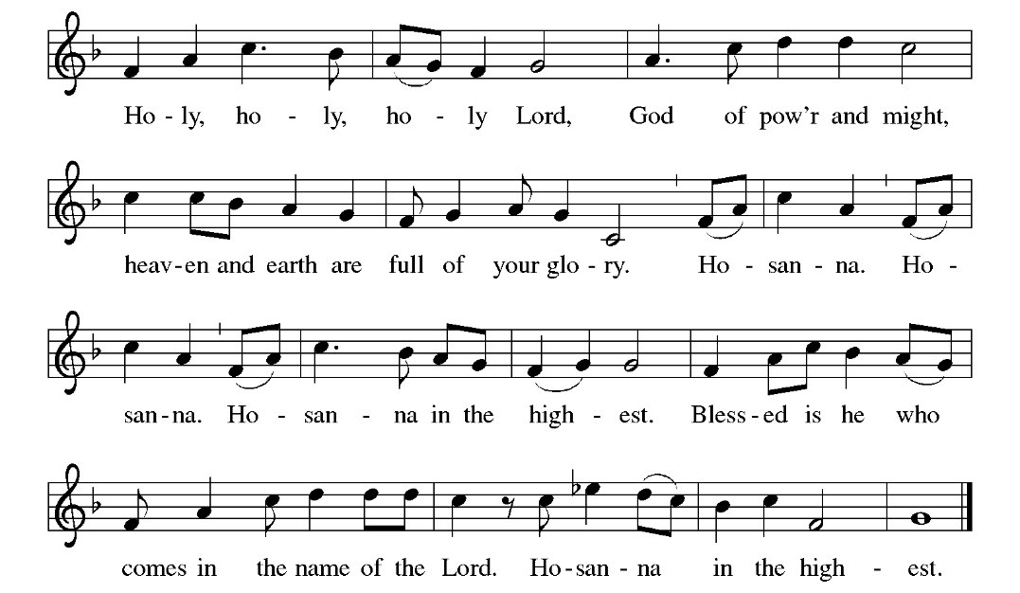
HOLY, HOLY, HOLY

WORDS OF INSTITUTION

THE LORD’S PRAYER
P: Let us now pray together as Jesus taught us.
C: Our Father, who art in heaven,
hallowed be thy name.
Thy kingdom come,
thy will be done on earth, as it is in heaven.
Give us this day our daily bread,
and forgive us our trespasses,
as we forgive those who trespass against us;
and lead us not into temptation,
but deliver us from evil.
For thine is the kingdom,
and the power, and the glory, forever and ever.
Amen.

INVITATION TO COMMUNION
P: Come to the table of new life. Receive the risen Lord.
C: Amen.

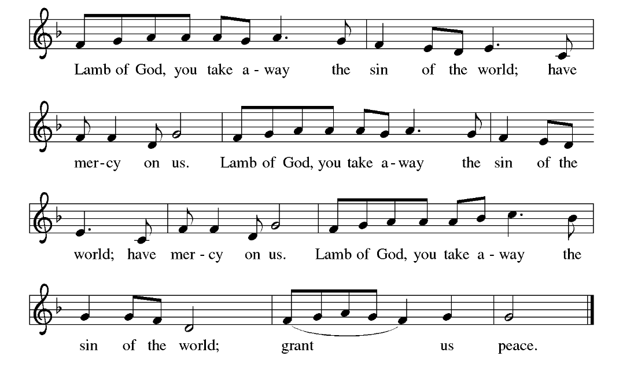
LAMB OF GOD
HOLY COMMUNION (please be seated)
All baptized Christians are welcome to receive the gift of Holy Communion. If you are unable to come forward, please let us know and we will come to you. When Communion is finished, please stand.
P: The body and blood of our Lord Jesus Christ strengthen you and keep you in his grace.
C: Amen.

PRAYER AFTER COMMUNION
A: Holy One, through this meal you have made your home among us and are making all things new. Send us now to speak peace to anxious hearts, to love our enemies, and to bring your healing to the nations. In the name of Jesus,
C: Amen.

THE BLESSING
P: God Almighty, who is the beginning and the end, Jesus Christ, the firstborn of the dead, and the Spirit, our advocate and peace, ☩ bless you now and forever.
C: Amen.

SENDING HYMN
“Christ is Alive! Let Christians Sing” ELW #389

THE DISMISSAL
A: Go in peace. Praise the Lord. Alleluia!
C: Thanks be to God. Alleluia!

POSTLUDE Instrumental

Pastor Rev. Sue Washburn
Pastor Emeritus Rev. Steven J. Myers
Organist Joshua Beck
Pianist Nancy Finke Sheehan
Parish Administrator Laura Vincenti
ONE LICENSE LICENSING PERMISSION: REPRINTED/STREAMED WITH PERMISSION UNDER ONE LICENSE A – 739156. ALL RIGHTS RESERVED* Sunday worship materials are reprinted from Evangelical Lutheran Worship hymnal, copyright © 2006, Augsburg Fortress. All rights reserved. Used by permission of Augsburg Fortress under License # SB177840. Bible readings are from the English Standard Version, copyright 2001, Good News Publishers. Prayers are from Sundays and Seasons, copyright 2025, Augsburg Fortress.

ANNOUNCEMENTS
We’re hosting a reception following today’s service in honor of Isabel Nazak and Brady Yurisinec in the upper Social Hall. Please plan to join us as we celebrate with our new confirmands!
~~~~~~~~~~~~~~~~~~~~~~~~~~~~~~~~~~~~~~~~~~~~~~~~~~

MAKE NOISE FOR MISSION! May 2nd and 3rd
Gather up your change and let’s make some NOISE!!!
Donation of your loose change benefits our sister church, Trinity Lutheran on the North Side. Collection cans will be located on the offering table and up front by the baptismal font.
~~~~~~~~~~~~~~~~~~~~~~~~~~~~~~~~~~~~~~~~~~~~~~~~~~

2026 HIGH SCHOOL & COLLEGE SENIORS
May 16th & 17th is GRADUATE WEEKEND at CLC when we will be recognizing our graduates during services. We hope you can be with us to receive our congratulations on achieving this milestone and blessings for your future!
We invite you to submit a photo and a summary of your activities, interests and future plans. The info will be posted on the bulletin board in the Entryway and featured in our June newsletter.
Parents, you’re welcome to submit on behalf of your graduate; it’s a busy time for them! Deadlines: May 11th to have your picture and your write-up for display on the CLC bulletin board. May 20th to have your information included in our June newsletter. Email to: office@christsmurrysville.org

~~~~~~~~~~~~~~~~~~~~~~~~~~~~~~~~~~~~~~~~~~~~~~~~~~
Our last day of Sunday School is Sunday, May 3rd. Thank you to our teachers Rebekah McKenzie, Amy Wineman, Abby Wineman, Harry Replogle and Kim Boyer for their time and dedication in teaching God’s word to our child and adult classes.

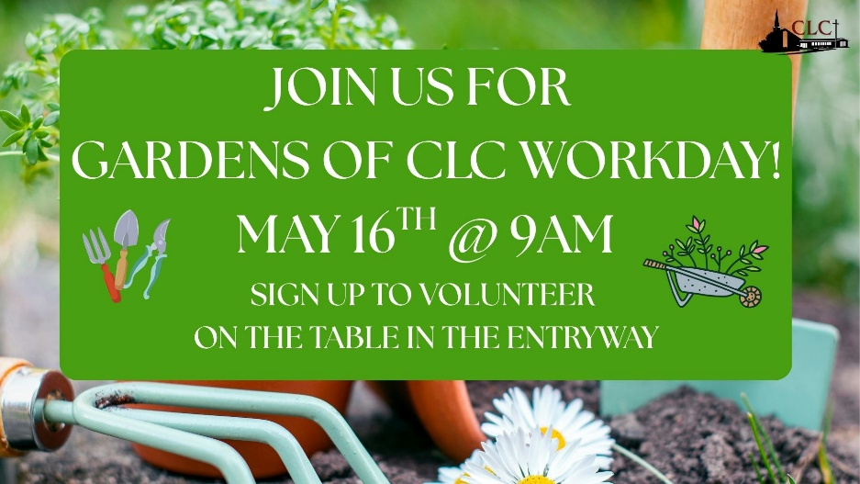
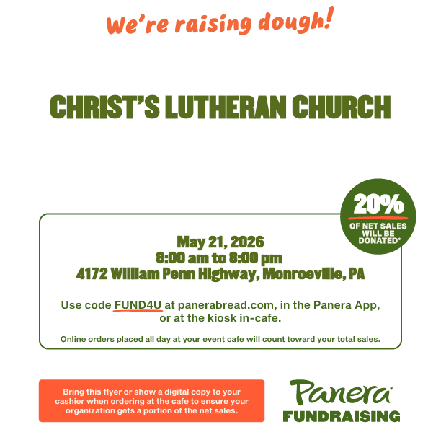

~~~~~~~~~~~~~~~~~~~~~~~~~~~~~~~~~~~~~~~~~~~~~~~~~~
Panera in Miracle Mile Shopping Center
Monroeville

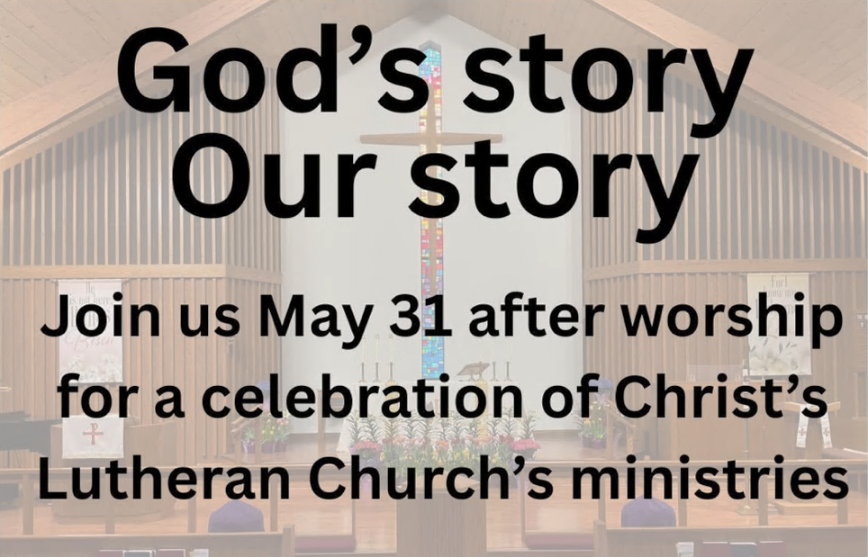
Starting a new chapter at Christ’s Lutheran
We are all part of God’s big story! And we all have little stories of God’s goodness in our lives. Join us on May 31 after worship for the opening exercise of the pastoral search process. As we begin this new chapter, you are invited to share your stories of Christ’s Lutheran Church. Together we will reflect upon the meaningful moments you’ve had as part of the church as well as some of the challenges the congregation has overcome over the years. The information from this gathering will allow the leadership to begin to create a profile of the church and to discern God’s mission for this new time. Join us to tell your story!
~~~~~~~~~~~~~~~~~~~~~~~~~~~~~~~~~~~~~~~~~~~~~~~~~~
May 9th & 10th CHRIST’S LITTLE PANTRY WEEKEND
Are you, or someone you know, experiencing food insecurity?
If you need food, “Take what you need.”
If you have extra food to share, please “Leave what you can.”

THANK YOU, THANK YOU, THANK YOU to everyone who has been contributing to the success of our Little Pantry. The food in the Pantry goes quickly and we have been replenishing our Pantry almost daily. If you are interested in more information and want to see a list of our current needs, you can click on this QR code or contact the church office.
We currently have an overabundance of canned vegetables. PLEASE DO NOT DONATE ANY CANNED VEGETABLES AT THIS TIME! Thank you.


Men, join us on the second Saturday of each month at 8:30 am when we serve up a traditional breakfast and spend time in fellowship.
Our next breakfast will be on May 9th at 8:30 am in the downstairs social hall.
No RSVP needed, you’re welcome anytime.
~~~~~~~~~~~~~~~~~~~~~~~~~~~~~~~~~~~~~~~~~~~~~~~~~
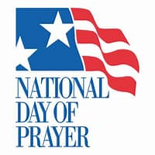
75th Annual National Day of Prayer
for Murrysville, Delmont & Export
Thursday, May 7th 7 to 8:30 pm
Delmont VFD Hall, 2360 Route 66 in Delmont
It’s been exciting seeing the work God is doing in our communities as a result of people coming together in prayer. There is no specific speaker and this is not a political event or a platform for an agenda. 2 to 3 minutes is allotted to 7 prayer topics: family, church, education, military, business/workplace, and arts/entertainment/media.

~~~~~~~~~~~~~~~~~~~~~~~~~~~~~~~~~~~~~~~~~~~~~~~~
Drop off times for the sale are:
- Thursday, May 28 & Friday, May 29 between 9 am and 2:30 pm.
- Saturday May 30 & Sunday May 31 when you come to worship services.
- Monday, June 1, Tuesday, June 2 & Thursday, June 4 from 9 am to 2:30 pm AND from 6-8 pm.
Please check the CLC newsletter for the list of items that we, unfortunately, cannot accept.
The bake sale is an important part of the day! Baked goods can be
dropped off on Friday, June 5th between 9 am and 2:30 pm.
Many hands make light work…
We invite you to share your time and talents to help to make our worship services go smoothly.

- Worship Assistants read the lessons and assist Pastor Sue with communion. If you would like to be a reader but not serve communion, we can team you up with someone to share the Worship Assistant duties;
- Greeters and Ushers welcome people to service and assist with passing the collection plates;
- Camera operators prepare the camera and laptop, then monitor the camera to livestream for those who worship online (don’t be intimidated – you’ll be well trained and an experienced live streamer will be with you your first couple of times);

- You can also set up the altar for services, and/or put away communion elements and extinguish candles after services
If you would like to join our team, you can sign up using the app: Click on “Join a Weekend Worship Team,” or scan this QR code.
Questions? Please contact the church office. Thanks!
~~~~~~~~~~~~~~~~~~~~~~~~~~~~~~~~~~~~~~~~~~~~~~~~~~

Caring Hearts & Hands is a volunteer group that keeps in touch with CLC families and friends who are on our Caring List who appreciate and enjoy knowing that others are thinking of them. This contact can be in the form of a phone call, a visit, a card, or even a box lunch! Our lunches are delivered in a beautifully decorated box that offers a delicious lunch with goodies and surprises!
CH&H meets on the second Thursday of the month; our next meeting will be at 9:30 AM, May 14th in the downstairs fellowship hall. We’ll be planning our box lunch menu, which we will pack and deliver in June. After our meeting, we’ll be going for brunch. Even if you can’t attend the meeting, you’re welcome to join us for brunch!
We always look forward to having more volunteers! Also, if you or someone you know could benefit from our outreach of Caring, or if you have any questions, please call Romaine Miller at 412-996-4915.
~~~~~~~~~~~~~~~~~~~~~~~~~~~~~~~~~~~~~~~~~~~~~~~~~~

Christ’s Lutheran’s 1st quarter
Financial Report is available in the
rack outside the church office.
Please join us on Saturday, June 20th from 9:00 am -11:30 am at the Westmoreland County Food Bank to pack food boxes for Seniors in our community. Youth over 14 years of age are welcome when accompanied by an adult.
Please email Kris Meade at kmeade@medbrokersllc.com to be added to our team. We have a total of 15 volunteer slots to fill. If you’ve volunteered before, you can login to http://www.westmorelandfoodbank.org/ to register for the event.
Thank you for volunteering and helping to feed our Senior neighbors!

~~~~~~~~~~~~~~~~~~~~~~~~~~~~~~~~~~~~~~~~~~~~~~~~~~
Looking for a volunteer job with Christ's Lutheran Church that you can do at home? We're seeking someone to address, stamp and mail out materials (all supplies provided by CLC) each month for our Cradle Roll program. Cradle Roll is a faith formation ministry within CLC that focuses on caring for young children from 1 month to 3 years old by providing resources for parents which helps connect young children to the church community.
Our Cradle Roll volunteer would also need to maintain a list of children to be mailed to.
If interested please contact Marlene Gerdes at mogerdes@aol.com or the office at 412-795-1212 or office@christsmurrysville.org for more information.
We're so grateful to Marlene for her many years of service in this important CLC ministry.
~~~~~~~~~~~~~~~~~~~~~~~~~~~~~~~~~~~~~~~~~~~~~~~~~~

Are you considering a special gift or an estate gift to Christ’s Lutheran Church?
Gift planning services are available at no cost to you through the services of the ELCA Foundation and our Regional Gift Planner, Ryan Ebner.
Ryan can assist you with establishing a comprehensive estate plan that provides for your family and the ministries you care about.
See the “Legacy and Special Gifts” brochure in the rack outside of the office for more information. You can contact Ryan at (814)-823-3285 or ryan.ebner@elca.org.

UPDATED INFO
Receive Important CLC Information on Your Smart Phone

Scan the QR code or search your app store for Christ’s Lutheran (ELCA) to download the CLC app to your phone. Set up your profile, then follow the steps below.
Even if you previously downloaded our app and created your profile, there are a few things to be done in order to receive our notifications:
- Open the app and click on your initials in the circle on the top right to go to the settings for the CLC app. Check your Profile to make sure your mobile phone number is correct.
- Go back to the settings, scroll down to App Settings and click on Notifications. Make sure Notifications in the CLC app is set to ON (the button should be slid to the right).
When you receive a notification from CLC, it will pop up briefly on your screen then download to where your unread texts, social media messages, etc. are stored until you read them. You’ll also see the church


icon in the notifications bar on your phone screen. Tap or swipe your notifications bar to read what we’ve sent.
Messages from CLC are not texts and the message won’t appear in the app you use to send/receive texts.
If you have any questions, contact the church office at 412-795-1212.
~~~~~~~~~~~~~~~~~~~~~~~~~~~~~~~~~~~~~~~~~~~~~~~~~~

Stitched With Love
If you enjoy knitting and crocheting, or would like to learn, our stitching group meets Tuesdays from 9 to 11 am in the downstairs social hall.
We make hats for cancer patients, baby blankets, prayer shawls, and other needed items. Or bring your own project to work on. It’s a time to be creative & enjoy one another’s fellowship. For information, contact Leslie Sill at nonnasill@comcast.net.

~~~~~~~~~~~~~~~~~~~~~~~~~~~~~~~~~~~~~~~~~~~~~~~~~~

Worshiping via our livestream? Type “Hello” in the chat box so we know you’re here!

CLC’s Ronald McDonald House Pull Tab Project!

We’re collecting aluminum tabs for Ronald McDonald House. Working with a local recycler, pop tabs from soda cans, soup cans, pet food, and other canned goods are turned into money to support RMHC’s mission.
That money helps RMHC provide comfort, care and support for families with children who are sick.
You can help by depositing tabs you collect in the container in the church Entryway.

~~~~~~~~~~~~~~~~~~~~~~~~~~~~~~~~~~~~~~~~~~~~~~~~~~
Do something drastic, cut the plastic!

Thank you for continuing to bring your plastic bags for recycling!

All plastic must be clean, dry and free of food residue.
Check the sticker on the front of the recycling bin
for the list of which plastics can be recycled.
Please, no hard plastic: food containers, soda bottles, milk jugs,
cleaning product bottles, etc.

~~~~~~~~~~~~~~~~~~~~~~~~~~~~~~~~~~~~~~~~~~~~~~~~~~
Our church office is open:

Monday 9 am - 2:30 pm
Tuesday 9 am - 2:30 pm
Thursday 9 am - 2:30 pm
Fridays 9 am - 2:30 pm

Please call before coming to the church
to be sure someone is available to help.
412-795-1212

WEEKLY CALENDAR May 3rd – May 10, 2026

NOISE FOR MISSION WEEKEND
Keep our Ministry and Community in Your Prayers Each Day This Week

Sunday 5/3 Isabel Nazak and Brady Yurisinec who are
being confirmed today
9:00 am Sunday School for Children & Adults
10:00 am CONFIRMATION WORSHIP SERVICE
live streamed at christsmurrysville.org
11:15 am Confirmands’ Reception
7:30 pm Narcotics Anonymous

Monday 5/4 Our Synod Council and the ministry of our Synod
5:00 pm Kindermusik
8:00 pm Alcoholics Anonymous

Tuesday 5/5 All who serve to help make our worship services go smoothly
9:00 am Stitched With Love
9:30 am Kindermusik
5:00 pm Kindermusik

Wednesday 5/6 Kiara – the young woman we sponsor through Compassion International
9:00 am Property Committee
10:00 am Kindermusik

Thursday 5/7 Those who work for world peace
9:30 am Kindermusik
6:30 pm East Suburban Artist League

Friday 5/8 The ministry of Heifer International and those who support its work

LITTLE PANTRY WEEKEND

Saturday 5/9 Those who faithfully serve at local food banks and pantries
8:30 am Men’s Breakfast
11:30 am AKC Dog Event
6:00 pm Saturday Worship

Sunday 5/10 Those who don’t have enough to eat
10:00 am Sunday Worship
live streamed at christsmurrysville.org
7:30 pm Narcotics Anonymous

