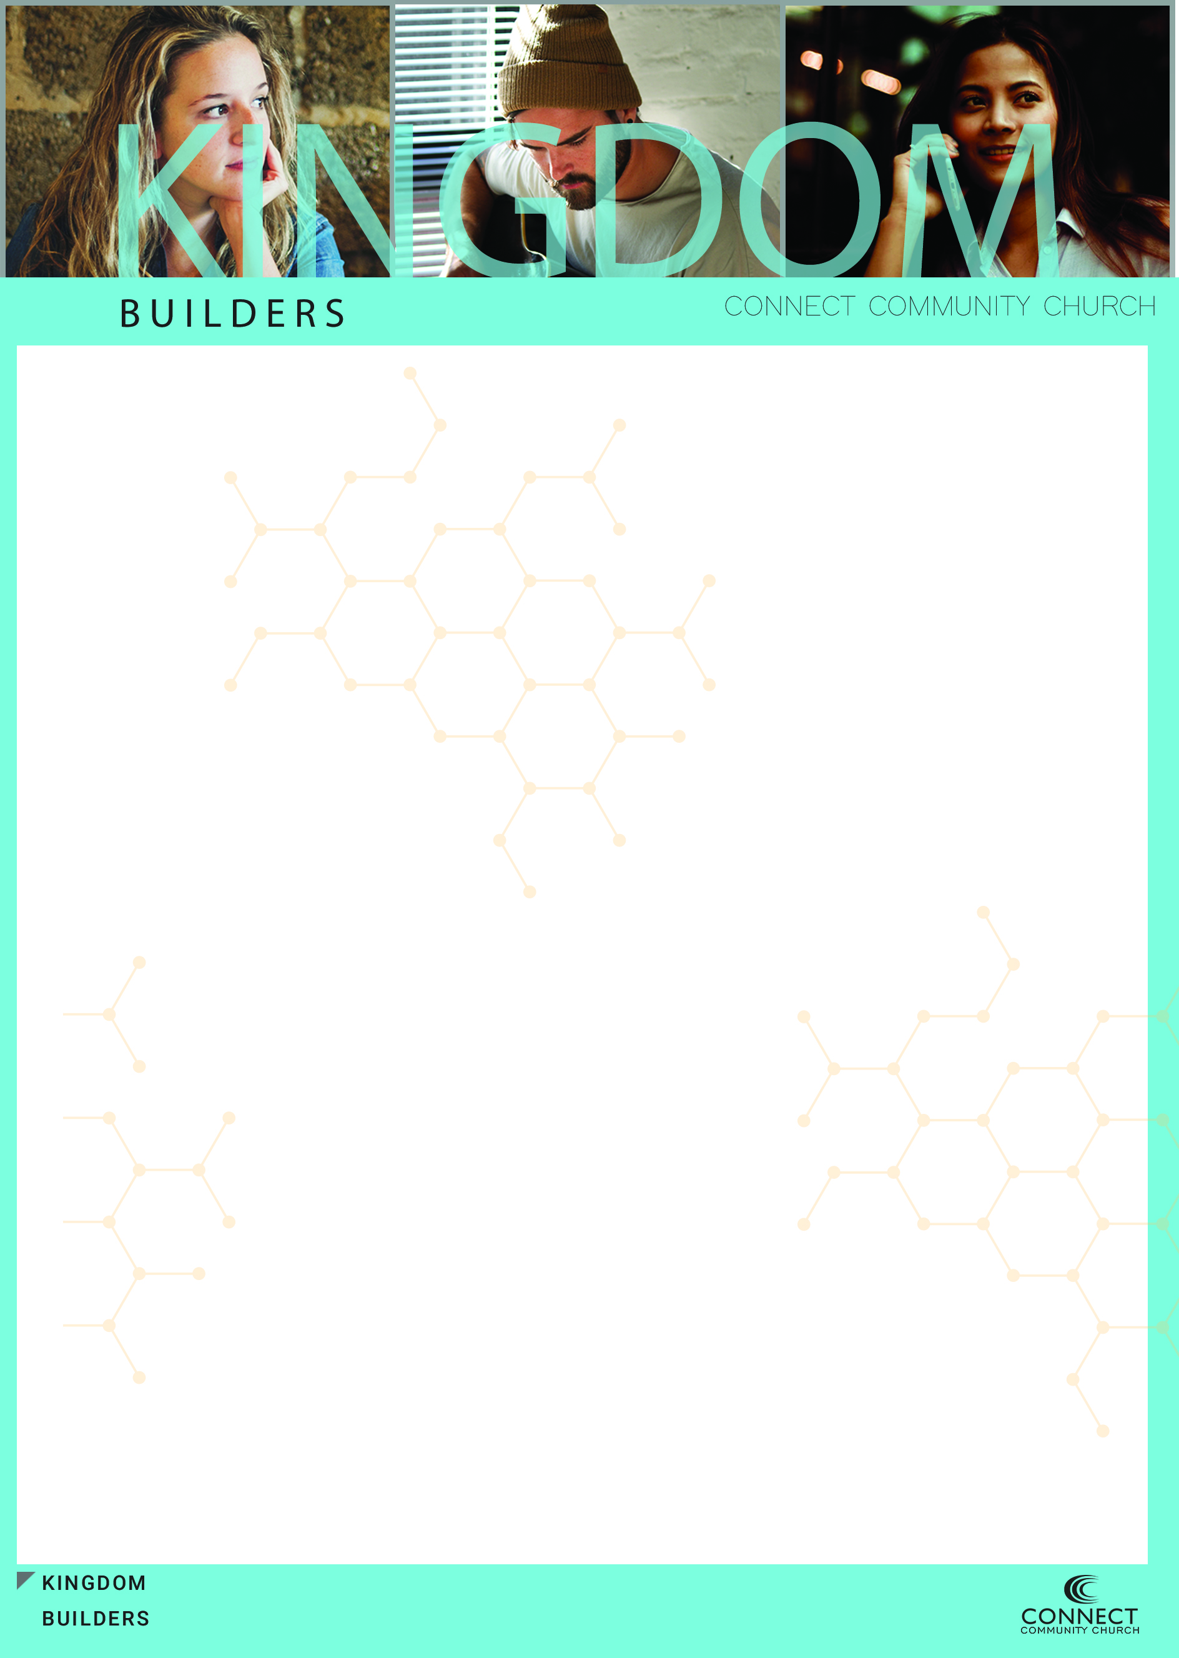
The Kingdom is made up of __________who are a part of a _______ cultural occupying ______ for change that are living in a _______ world

We can _______ to culture, but we can’t _________ the culture

John 17:14-19 (NASB)
¹⁴ "I have given them Your word; and the world has hated them, because they are not of the world, even as I am not of the world.
¹⁵ "I do not ask You to take them out of the world, but to keep them from the evil one.
¹⁶ "They are not of the world, even as I am not of the world.
¹⁷ "Sanctify them in the truth; Your word is truth.
¹⁸ "As You sent Me into the world, I also have sent them into the world.
¹⁹ "For their sakes I sanctify Myself, that they themselves also may be sanctified in truth.

We can only ________ culture when we are __________ than culture

“Counter – Culture” means we are going the _________ direction of culture

We should live our lives in such a ___________ way that it brings attention to Jesus not our _____________

Not an outward ________ but an inward _________

We are an ___________ force

We have come to take _________ for the kingdom of God

What we mean by territory is _________

We are on a ______ _________ mission

We are in ________ territory and need to know that there will be __________

Hostile to our ______, hostile to our __________, hostile to our way of ______

Even in hostility it must always be about ________

The Kingdom Difference

______________ is a matter of ___________

We can’t settle for a “circle the ________” mentality, but we must be close _______, ________ and __________ at a different level.

Our Community must have an ________ strength and an outward ____________

Our Community must have Kingdom _____________

The Kingdom is a place where people can be ________ to the Savior Jesus Christ and grow in that _____________. It’s a place of such strong ______ that has such dramatically different _________, and by that, presents a clear _________ of what it is to ________ according to what Jesus has taught us. The kingdom is a place of _________ and a place of ________. Those of us who are a part of the Kingdom realize that we are in an “all out” fight to _________the Kingdom by _________ new people to Jesus and expanding His __________ wherever and whenever we can.

