

Camera Operator

Video Production Team

Position Handbook

Terminology
Pan Horizontal movement of the camera left or right
Tilt Vertical movement of the camera up and down
Zoom Using thumb controls or by rotating the zoom control on the rounded part of the camera to enlarge (zoom in) or shrink (zoom out) the subject.
Framing Adjusting the subject to a certain place in the camera viewing area
Lead Room When viewing a subject from the side, the space in front of the subjects face
Head Room Space above the subject’s head – less for close shots, more for wider shots.
Rule of Thirds
Imagine that there is a 3x3 box on the camera viewing screen to “frame” the subject so that they are ideally placed within the viewing area (not just centered).
On closer shots, the subject’s ears should be found on either the left or right-side vertical lines, depending on which way they are facing.
Example: For a tighter shot, if the subject is facing left to right in the shot, they should be framed so their ears are on or near the upper left intersection of the lines to provide them with more “lead” room (more room to their front than behind them). Center (“head on”) shots can center the subject.

Examples below

From right
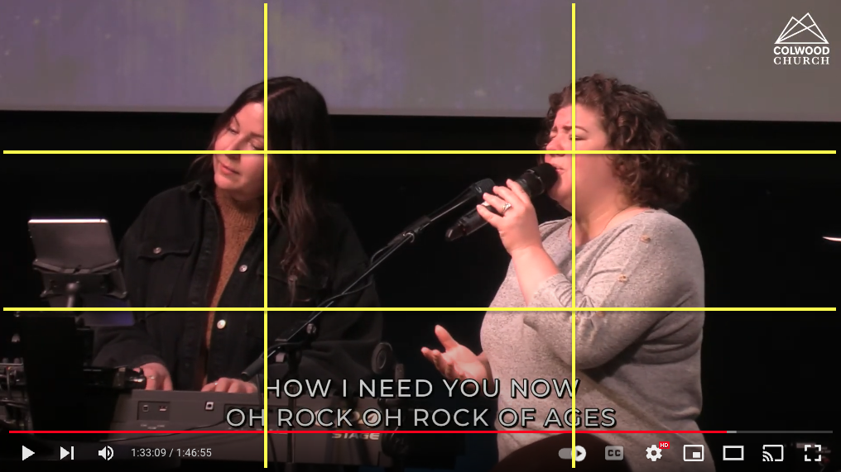
From Left
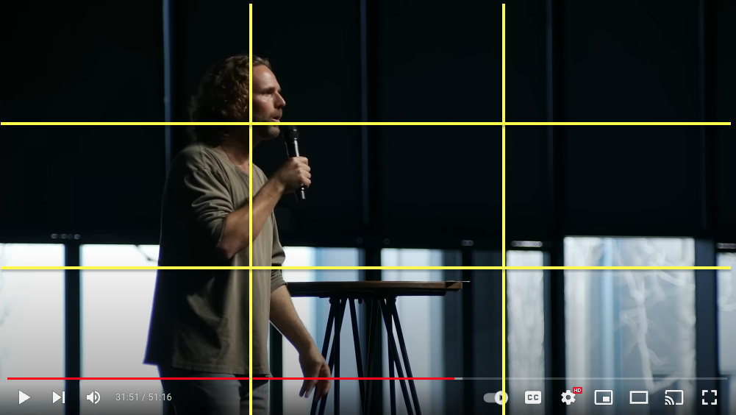
From Center
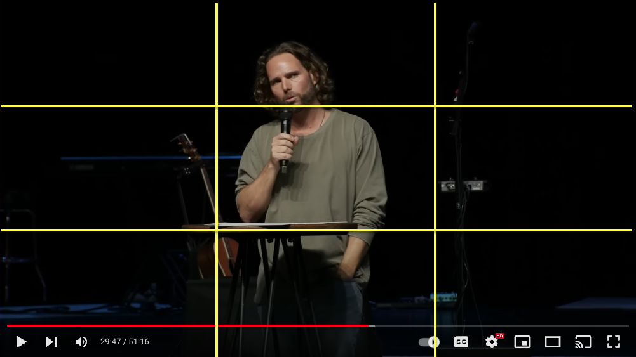

Camera Shot Names

Cover Shot – zoom out as far as you can covering a lot of the room.
Full Body – From head to toe of the person
Knee Up – From the subjects knees up
Waist up – From the subjects waist up
Chase – Keep up with the subject
Live – This means your camera is on air.
Preview – This means the video Director has your camera to go live next

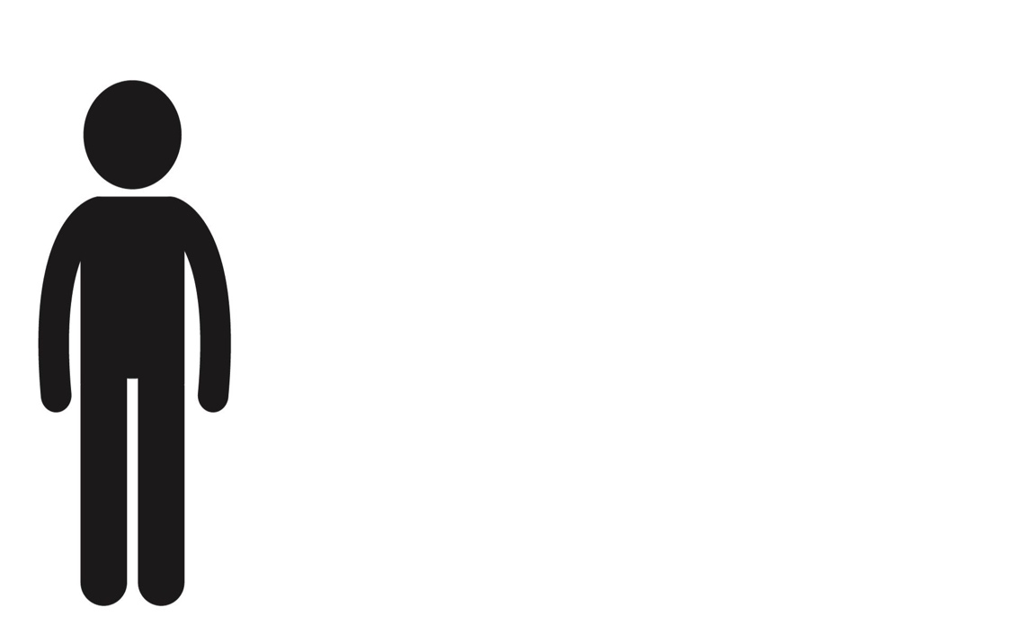

Full Body Shot
Knee Up Shot

Waist Up Shot

