

Production Team

Lyrics & Media Tech
ProPresenter 7 by Renewed Vision

Position Handbook

What is a Lyrics & Media Technician?

Lyrics & Media (L&M) refers to the position that provides the lyrics, audio, video, and graphic elements to various screens and the live stream.

The L&M Tech is.

- A Servant – The L&M Tech is tasked with supporting the on-stage vocalists with a confidence monitor (stage display), and the in-house and online attendees with lyrics text, sermon notes, scripture, and videos. The L&M tech is a critical position that serves and supports every person that takes in the service by allowing them to engage in the service more interactively.

- Reliably Focused – The L&M Tech must always stay focused to ensure lyrics are advanced, the verses are displayed, and all things multimedia are provided, all at the right moment they’re needed. This takes a high-level of unbroken concentration and conscientiousness.

- Communicative – The L&M Tech is tasked with communicating transitions to the Video Director, Telling the directors what is coming up next.
For example, Full Screen Graphics, Lyrics, Scripture, Sermon Notes, and Videos.
You have to tell them what is coming up next before it happens so they know what is coming up next and can be prepared.

Worship Lyric Best Practices

- As a general term, when advancing lyrics during a song, trigger the next slide as the second to last word on the slide begins to be sung.
Reader comprehension is such that you read and understand the word seconds before you verbalize the word, so the lyrics must be visually available 2-3 seconds before the word is being sung. Some songs will require you to advance the slides a little faster or a little slower depending on the song.

- The first slide of all the presentations will trigger actions, looks, lights, and other features. When moving from one section to the next, always click on the very first slide of the given presentation. Also, you should not click the first slide after the first time this will retrigger the actions and advance the lights to the next cue.

- Only move to a particular announcement slide when the Announcer mentions it. Try not to pre-empt them in case they jump around between announcements.

Use a similar rule of thumb for timing the advancing of slides for multi-slide scripture passages or quotes. Advance to the next slide as the second to last word is being read.

- For Sermon notes use a similar rule of thumb as announcements, try not to show a slide before the Pastor verbalizes the content on the slide.

Terminology

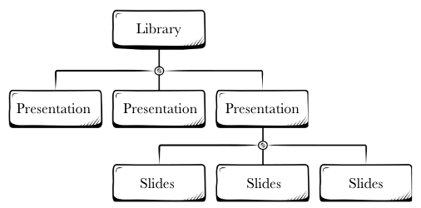
ProPresenter is an extremely powerful application, with many layers of complexity, depending on your use of the program. For our volunteer training purposes, we will include only the terms here that are directly relevant to our Sunday morning and Wednesday night L&M Tech’s responsibilities and troubleshooting.

Library – A searchable storage database for many presentations

Presentation – A series of one or more slides grouped together for a specific purpose. All a song’s lyrics are created as a single presentation using multiple slides.

Slide – A single screen of text, graphics or actions that are displayed or triggered in a moment of time. It can contain lyrics, pictures, videos, sermon notes and various action triggers.

Playlist – A series of presentations assembled, often to form an order of service. Each week we create a new Playlist to contain all the services elements.

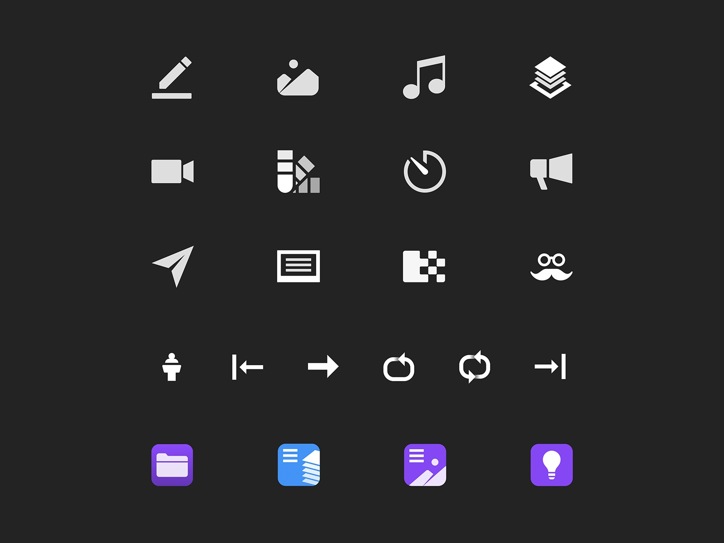
Macro – A macro is used to put all the corect actions are put onto the slide.

Stage Display – Sometimes referred to as the “Confidence Monitor”, a stage screen refers to the screen that faces the stage for the band, singers, pastors, and speakers to be able to see. It is used by singers to see lyrics and by the pastors to see announcement details and sermon notes.

Other Commonly Used Icons
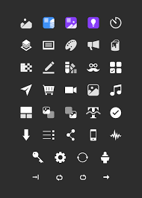
Media Action (foreground) Media Action (background)

Audio Action Timer Action (sermon timer)

Slide Transitions Announcements layer action

Workflow

Mid-week Practices
I would recommend before arriving for a practice or service to familiarize yourself with the service order and listen to the songs members that are scheduled to serve can listen in the Planning Center Services app.

During the Practice (both Wednesday and Sunday practices)

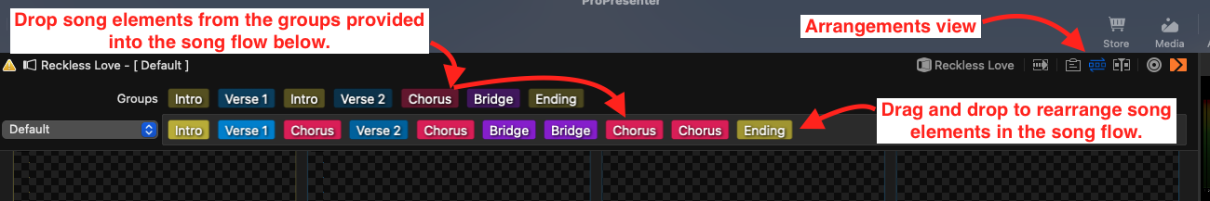

- For each song, activate the “Arrangements” view. Use the dropdown list on the left of the coloured labels to choose the correct arrangement or add a new arrangement.

- Drag and drop the song elements (Intro, verse 1, chorus 1, bridge, ect) available (first row of colored labels) into the song flow (second row of colored labels). The second row of colored labels constitutes the songs arrangement.

- Adjust the arrangement as the band performs to match their desired flow.
IMPORTANT: Ask questions of the leader during the practice (interrupt them between playing sessions if need be) to ensure your song arrangement matches their plan. This will eliminate a large portion of your stress (and attendee confusion) during the service.

