Want to talk about coms a little.
Calling (Full Screen Graphic, Point, Verse,)
You are responsible for letting the video Director know what is coming next (Even before it happens) so they can prepare and be ready.

Ok let’s get into ProPresenter
You always have to go to the first slide. But You cannot go back to the first slide. If needed, you can put a blank slide in the presentation where you need one.

Let’s talk about some Shortcut Keys.
(These are all for Mac)
Command C is Copy, Command V is Paste (one thing to note is if you are copying text from outside ProPresenter this Paste will copy the text style from outside the application. You have to right click and click “Paste and Match Style.) Command A is Select All, Command D is Duplicate, Control S, E, B, R help you maneuver around the different pages.
There are many many more, but these are some of the main ones I use every time I am on ProPresenter.

You can also customize the short cut Keys.
By clicking (ProPresenter and Key Mappings) in the top left of the screen or by (option K) on your keyboard.

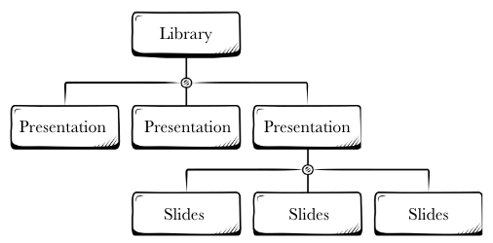
Let’s talk about Libraries,
Presentations,
Playlists, and Slides

Libraries are where you keep all the different Presentations. You can make Several Libraries and name them for example (Worship, Sermons, Announcements, Videos, (Ect)

Presentations are what you put your Media (Slides) in to then be put into a Playlist.

Let’s Talk about Smart Playlists and importing media
These are Playlists in your Media section
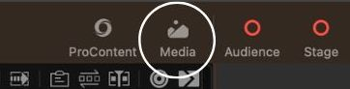
You can create a File Folder on your Computer in the Finder or on your Desktop.
This will let you put Pictures or Videos in the folder on your computer and it will automatically populate into the Smart Playlist in ProPresenter.
You can make several of these if need be.
For example I use these: Announcements, Graphics, Videos, and Sermon Graphics.

Smart Playlists make importing media into ProPresenter much easier.

Let’s talk about Groups
You can group different song elements to Groups by Right Clicking and Clicking Groups (Intro, Verse 1, Verse 2, Verse 3, Chorus 1, Chorus 2, Chorus 3, Bridge, Blank Slide, (Etc.)

Let’s talk about Arrangements.
Arrangements are one of the best things (In my opinion). This lets us add, subtract, and move around Song Elements in a matter of seconds.
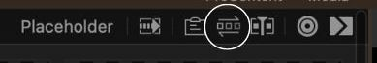
- For each song, activate the “Arrangements” view. Use the dropdown list on the left of the colored labels to choose the correct arrangement or add a new arrangement.

- Drag and drop the song elements (Intro, verse 1, chorus 1, bridge, etc.) available (first row of colored labels) into the song flow (second row of colored labels). The second row of colored labels constitutes the songs arrangement
- Adjust the arrangement as the band performs to match their desired flow.
- IMPORTANT: Ask questions of the leader during the practice (interrupt them between playing sessions if need be) to ensure your song arrangement matches their plan. This will eliminate a large portion of your stress (and attendee confusion) during the service.

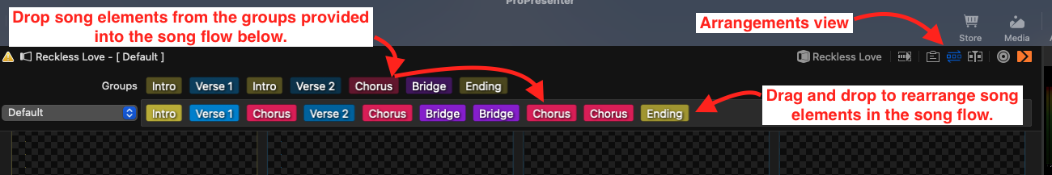

Let’s talk about adjusting multiple slides text (Font, Color, Size) at one time by selecting all the slides you want to adjust then clicking the (Aa Text) in the top Left of the screen.
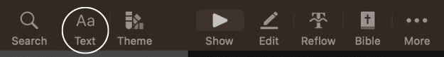
You Can select multiple slides by pressing and holding (shift) and clicking all that you want or (command A) to select the entire presentation.

Let’s talk about (Edit) Page
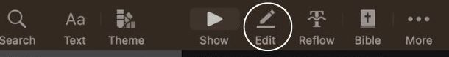
There are 3 pages inside of the Edit Page
1.Presentation
The Edit page is very powerful. You can Edit your text on your slide, Add a background color, Adjust your slide elements positioning, And put in your CCLI info.

2.Slide
Add a Hot Key, Add a label, Background, Chord Charts, Media Action, And Video Input Action.

3.Build
You can add Build ins and Build outs.

More to come on this Section

Let’s Talk about Transitions
There are 3 different ways of adding Transitions
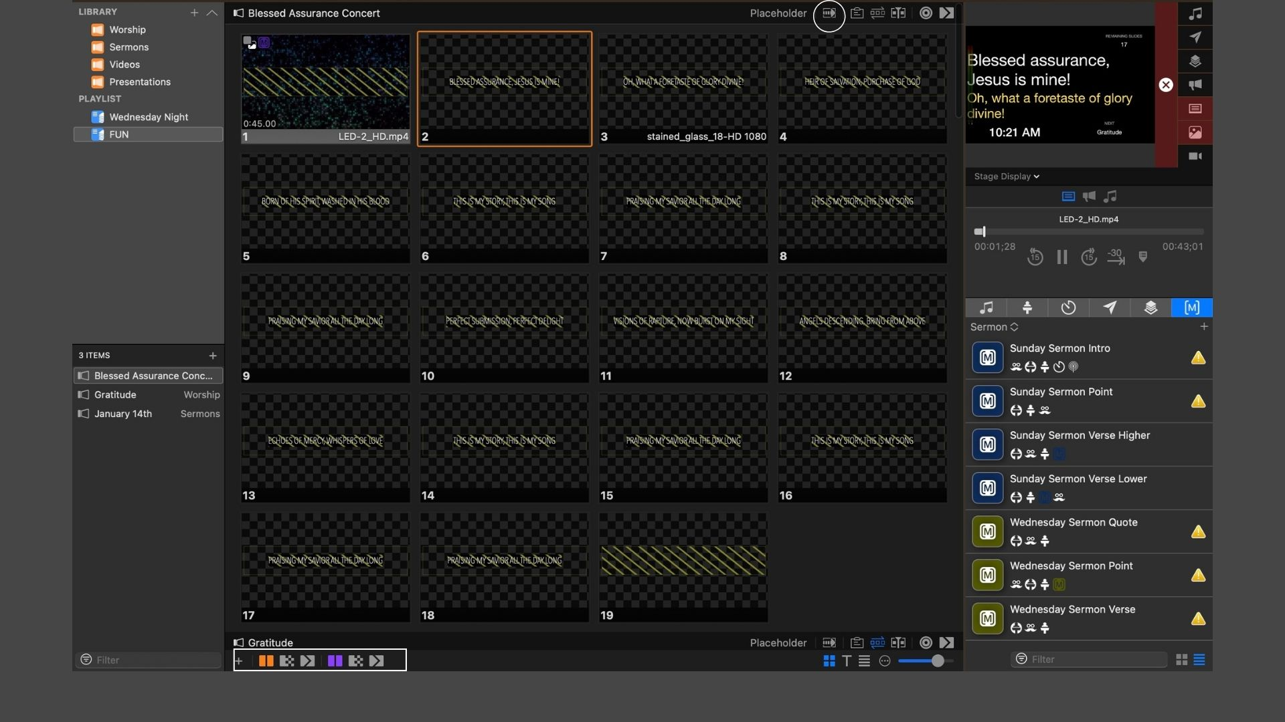
1.Presentation Transitions
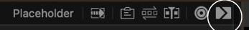

2. Foreground / Background transitions
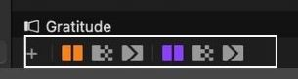

3.You can also right click on a slide and click Transition and add one that way

Let’s talk about the different View sections
Grid view
This will let you see everything in squares like seen below.
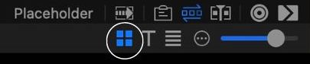

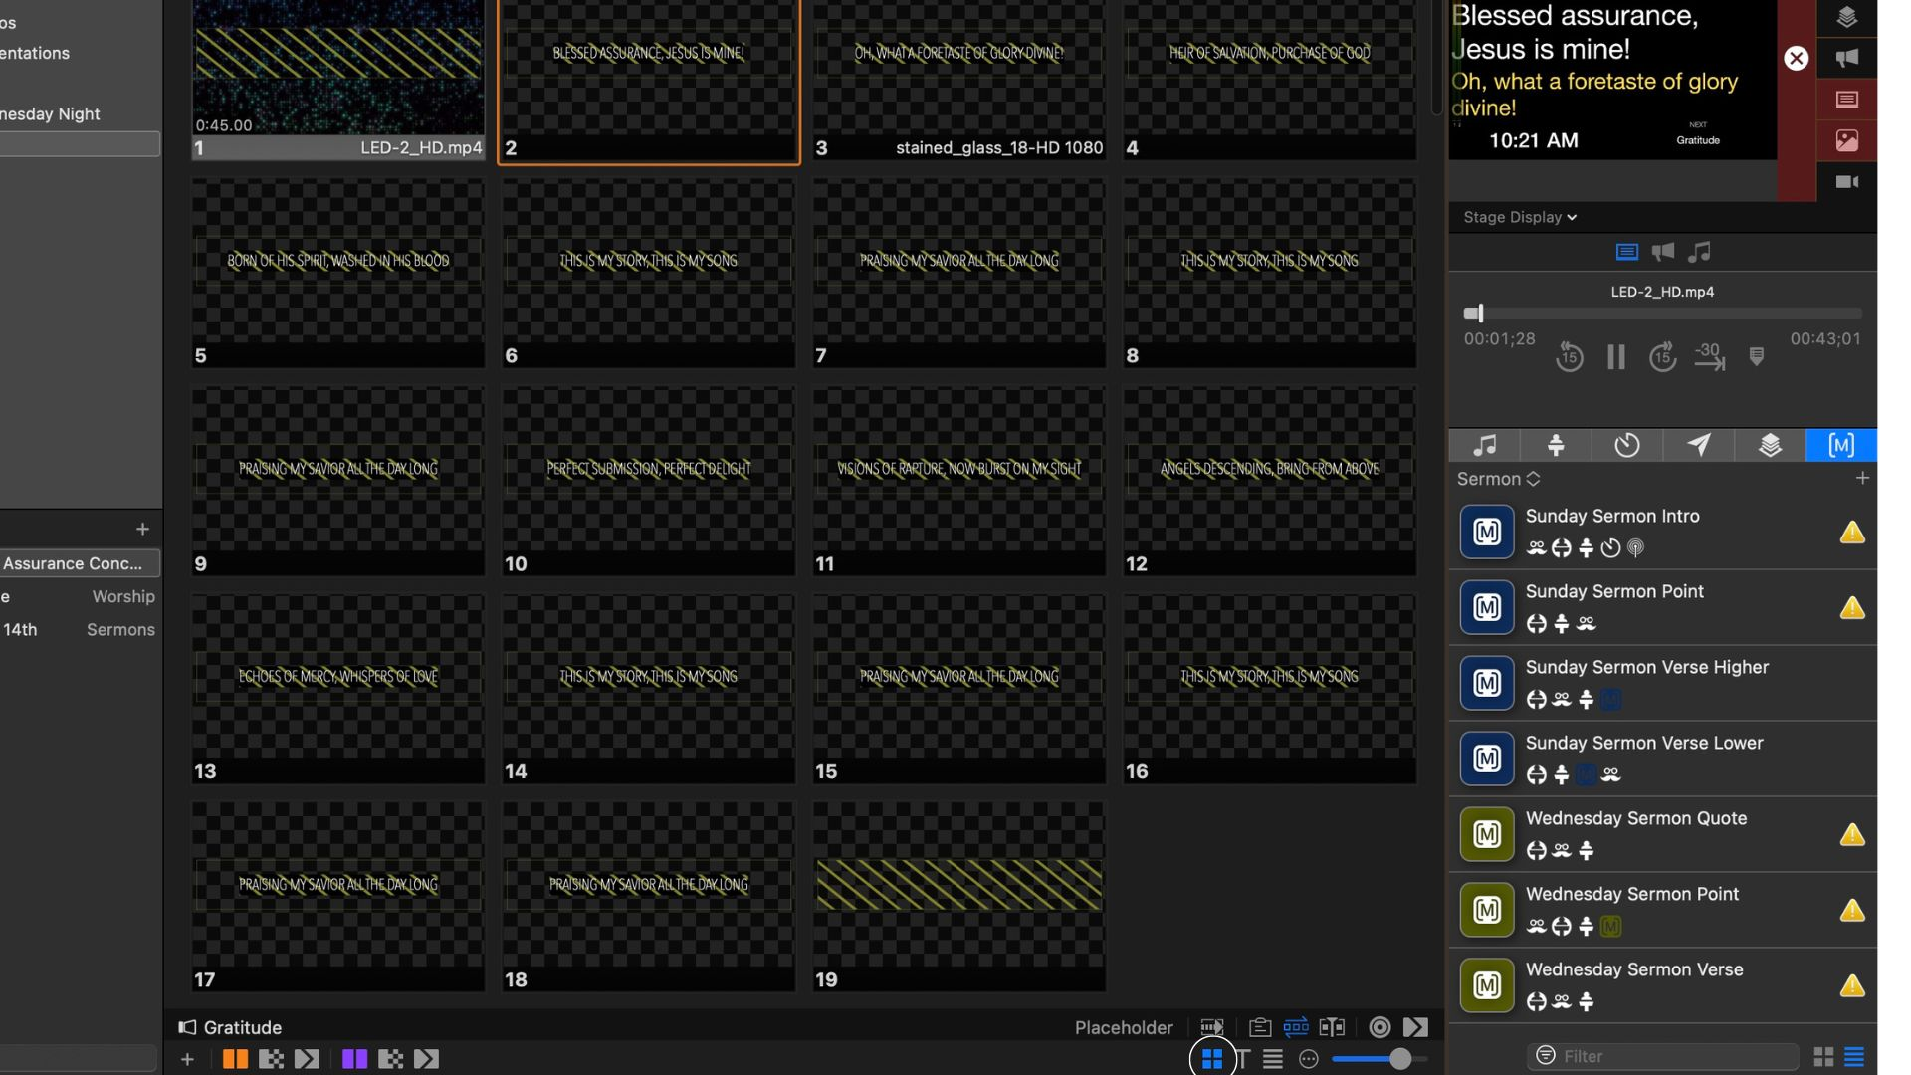
Easy view
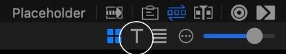
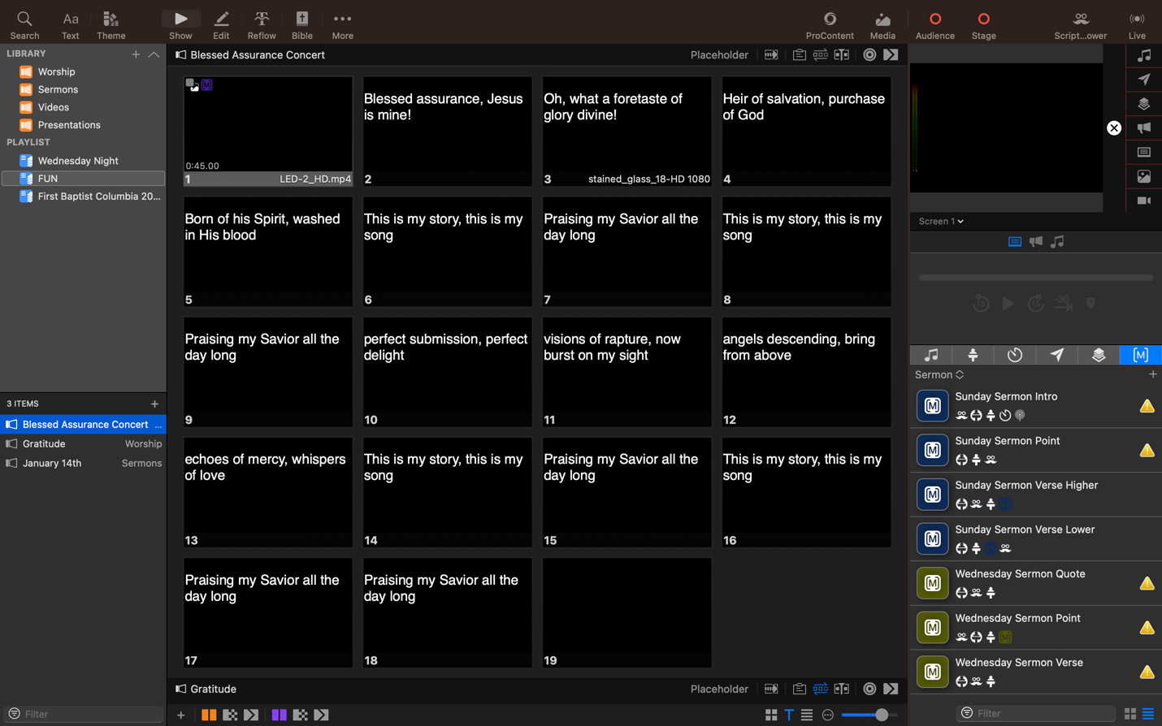

One issue with Easy view is your full screen graphics will show up as blank black slides.

List view
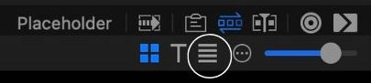
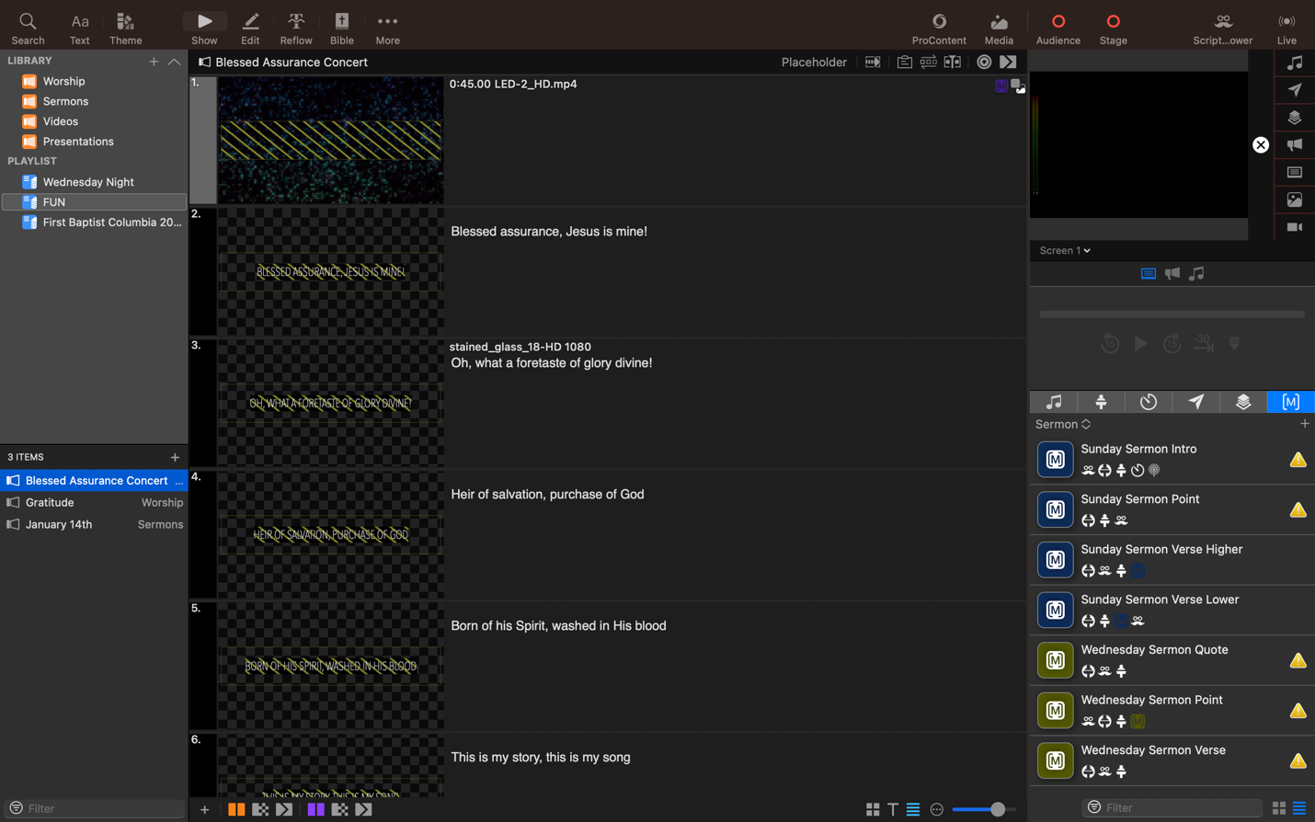

Most of the time I would use Grid view.

