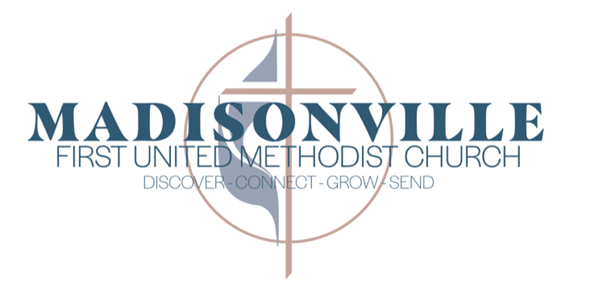

ADMINISTRATIVE ASSISTANT (PART TIME)
JOB OPENING
Job Summary: The Administrative Assistant is a key player in the staff team at Madisonville First United Methodist Church, a dynamic and missional church at center of our community. The Administrative Assistant performs reception, office, and administrative support tasks to the church staff & congregation to further the church’s mission.

Job Duties:
- Provide general assistance to church staff in completing administrative tasks, making phone calls, sending correspondence, and general communication. Staff members supported include: Director of Media Ministries, Director of Music Ministries, Finance Director & Facilities Supervisor.
- Greeting guests to the church office, answering the phone, responding to the door bell, answering emails, and providing general reception services.
- Collecting and Recording attendance for worship, Sunday School, and Wednesday Night Alive
- Weekly production of the church bulletin and other bulletins for special servies as needed
- Order materials for office, staff, and classes as needed
- Interface with individuals requesting assistance or in need of help, and those volunteers helping to provide that assistance
- Prepare financial receipts and documents
- Maintain the church calendar and scheduling of facilities and vehicles.
- Respond to various ministries and groups using the church building to address needs
- Work with church database system to communicate effectively on behalf of staff, ministries, and the church.
- When the Assistant to the Pastors is out of the office, help with assisting pastors and other staff.
- Other Duties as Assigned

Job Requirements: Familiarity with Microsoft Office & General Computer Skills
Friendly, Able to Work with Diverse People
Responsible & Self-Starter
High School Degree or Equivalent
Familiarity with Church Settings & Faith-Based Work

Anticipated Hours: Part Time (25-30 hours/week)
Approximate Work Hours: M-F 8:00am-2:30pm

Pay: Hourly; $15/hr

How to Apply: Send your resume and cover letter to jobs.m1umc@gmail.com

