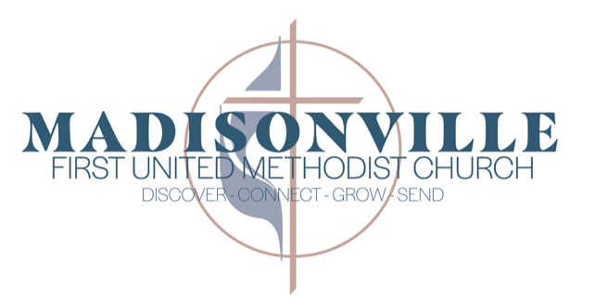

DIRECTOR OF MEDIA MINISTRIES JOB OPENING
JOB SUMMARY
The Director of Media Ministries coordinates and oversees the various media ministries of First United Methodist Church including audio/visual, video production, livestreaming, photography, and technology-related ministries. The Director recruits, engages, and sustains volunteers in meaningful Christian service in various media ministries and provides spiritual leadership to those ministry areas.
JOB TYPE: Flexible- Part Time or Full Time – Candidates should note whether they are interested in Part Time or Full Time work.
SKILLS
- Live Audio/Visual Production – audio, video, and presentation software. Current technology used in our setting includes audio (Allen & Heath Advantis 96-channel sound board), video (multi-camera set up some with live operators, multiplatform streaming through Subsplash to Website, App, YouTube & Facebook), and presentation (ProPresenter).
- Volunteer recruitment, training, and scheduling
- Equipment inventory, maintenance, and budget planning
- Strong interpersonal communication skills, working with a variety of staff and volunteers.
- Video editing skills using Adobe Premier Pro

EXPECTATIONS
- Present and leading production for Sunday services each week, and special events as needed
- Build and develop a volunteer team that can operate independently
- Maintain consistent quality for both in-room and online worship
- Coordinate with pastors & staff on content, scheduling, and upcoming events
- Keep equipment well maintained and flag any needs
- Operate with spiritual integrity as committed Christian working within the context of the church’s mission.
- Availability for video production, special events, and trainings.
QUALIFICATIONS
- Experience in live production, audio/visual or church media
- Demonstrated ability to lead and develop a volunteer team
- Self-directed and highly motivated to excellence in production
- Degree in a related field preferred, relevant experience considered
COMPENSATION RANGE: $17.50 to $25.00/hour based on experience.
- Full Time Employees eligible for Retirement Contributions and Paid Time Off

TO APPLY:
Send a resume, cover letter, and portfolio/work sample links to jobs.m1umc@gmail.com. Note in your cover letter whether you are interested in this as a Full Time or Part Time position.

