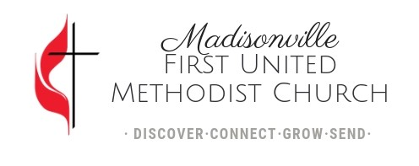

DIRECTOR OF MUSIC MINISTRIES JOB OPENING
First United Methodist Church of Madisonville, Kentucky, a dynamic, missional 1000-member congregation, seeks an experienced and faithful music professional for the position of Director of Music Ministries. This is a full-time, salaried ministry position that is designed to implement the mission of First United Methodist Church by coordinating the planning and implementation of a comprehensive music ministry for the congregation and community. Our existing music programs includes chancel choir, children’s choir, praise band, Spanish-language praise band, youth praise band, handbell choir, and instrumental ensembles.
The qualified candidate should have education or equivalent experience in the field of church music, with an appreciation of both traditional and contemporary musical worship. The candidate should also have a vital relationship with Jesus Christ and proven ability to conduct a diverse and comprehensive church music program. Candidates should be self-motivated, creative, a team-player, and a team builder with organizational and leadership skills.
JOB POSITION – Director of Music Ministries (Full Time)
JOB SUMMARY
The Director of Music Ministries oversees all aspects of the music ministry at First United Methodist Church and the resources needed to deliver excellent and enriching musical worship. The Director will lead and grow the music ministry at the church as we pursue a vision of fostering spiritual growth that brings glory to Jesus Christ. She or he will coordinate the planning and implementation of a comprehensive music ministry for the congregation and community.
JOB TYPE: Full-Time, Exempt
SALARY RANGE: $51,000-$58,000 depending on experience and education.
ORGANIZATIONAL STRUCTURE
The Director of Music Ministries reports directly to the Lead Pastor. The Director of Music Ministries oversees two part-time positions: Music Associate (Modern Worship and Students), and Music Associate (Children).
AREAS OF RESPONSIBILITY
- Worship service leadership: regular and primary leadership presence during the 9:00am (Blended, More Traditional), and 11:00am (Blended, More Contemporary) Worship services.
- Oversight of all music groups including adult ensembles/choirs, orchestra, worship band, handbell choir, student ministries band, bilingual Spanish/English band, children’s choir, and more.
- Supervise paid music staff including the two Music Associates.
- Coordinate and/or provide for music needs for special services, music events, weddings, funerals, and community events hosted by the church.
- Recruit, train, rehearse, and spiritually develop music ministry volunteers
- Provide for the upkeep and proper use of church-owned instruments
- Connect with, provide support, and occasional worship leadership for the bilingual Spanish/English service.
- Administrative tasks including budgeting and communication for music ministry
- Work closely with other Pastors and faith formation staff to support collaboration and the overall mission of the church
- Use music as means for outreach to the community
EXPERIENCE & EDUCATION:
- Relevant bachelor and/or master’s degree preferred
- Experience in music and worship leadership in a congregation
LOCATION:
- Madisonville, Kentucky
BENEFITS:
- 16 Paid Time Off Days Annually
- 4% Pension Contributions after 90 days
- Cell Phone Allowance
- Continuing Education Budget
- First UMC does not offer health insurance.
TO APPLY:
All applicants must send a cover letter detailing their interest in the position and qualifications along with a résumé to jobs.m1umc@gmail.com
All applicants should send their cover letter and résumé by July 10, 2026.
To learn more about Madisonville First United Methodist Church, visit www.m1umc.org

