The Lord’s Day

April 5, 2026
7:00 a.m.

Prelude Hail the Day that Sees Him Rise

Responsive Call To Worship
Pastor: He is Risen.
People: He is Risen Indeed!
Pastor: Let us Praise our Risen Savior.

*Hymn of Praise “I Know That My Redeemer Lives—Glory, Hallelujah!” #281

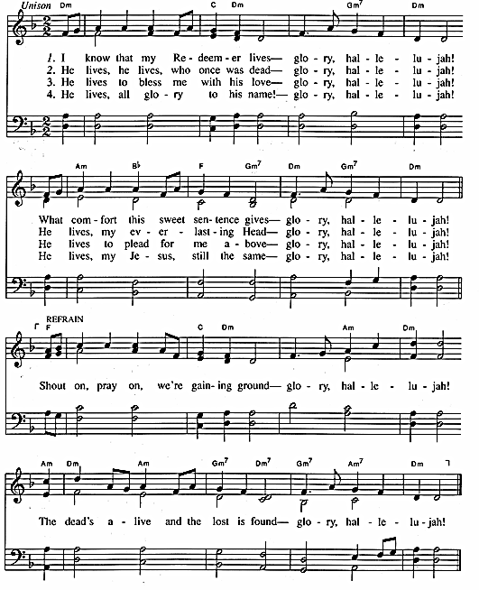
CCLI # 340996

Welcome
We greet you in the Lord Jesus Christ and are happy that you joined us this morning. We invite you to return and share in our Worship with us.

*The Invocation

*Hymn Of Praise “Thine Be the Glory” #274
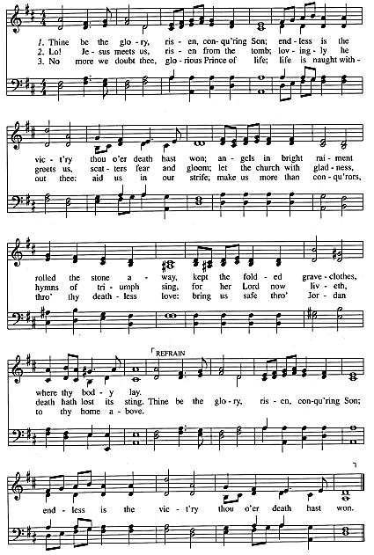

CCLI # 340996

*Confession of Faith: Westminster Larger Catechism Q. 52
Pastor: How was Christ exalted in his resurrection?
People: Christ was exalted in his resurrection, in that, not having seen corruption in death (of which it was not possible for him to be held) and having the very same body in which he suffered, with the essential properties thereof (but without mortality and other common infirmities belonging to this life) really united to his soul, he rose again from the dead the third day by his own power; whereby he declared himself to be the Son of God, to have satisfied divine justice, to have vanquished death, and him that had the power of it, and to be Lord of quick and dead: all which he did as a public person, the head of his church, for their justification, quickening in grace, support against enemies, and to assure them of their resurrection from the dead at the last day.

Scripture Reading 1 Corinthians 15:20-28
But in fact Christ has been raised from the dead, the firstfruits of those who have fallen asleep. ²¹ For as by a man came death, by a man has come also the resurrection of the dead. ²² For as in Adam all die, so also in Christ shall all be made alive. ²³ But each in his own order: Christ the firstfruits, then at his coming those who belong to Christ. ²⁴ Then comes the end, when he delivers the kingdom to God the Father after destroying every rule and every authority and power. ²⁵ For he must reign until he has put all his enemies under his feet. ²⁶ The last enemy to be destroyed is death. ²⁷ For “God has put all things in subjection under his feet.” But when it says, “all things are put in subjection,” it is plain that he is excepted who put all things in subjection under him. ²⁸ When all things are subjected to him, then the Son himself will also be subjected to him who put all things in subjection under him, that God may be all in all.

Pastoral Prayer Elder Ken Dewhurst

Scripture Job 19:23-29
“Oh that my words were written!
Oh that they were inscribed in a book!
²⁴ Oh that with an iron pen and lead
they were engraved in the rock forever!
²⁵ For I know that my Redeemer lives,
and at the last he will stand upon the earth.
²⁶ And after my skin has been thus destroyed,
yet in my flesh I shall see God,
²⁷ whom I shall see for myself,
and my eyes shall behold, and not another.
My heart faints within me!
²⁸ If you say, ‘How we will pursue him!’
and, ‘The root of the matter is found in him,
²⁹ be afraid of the sword,
for wrath brings the punishment of the sword,
that you may know there is a judgment.”

Sermon “My Redeemer Lives” Rev. Chad Bailey

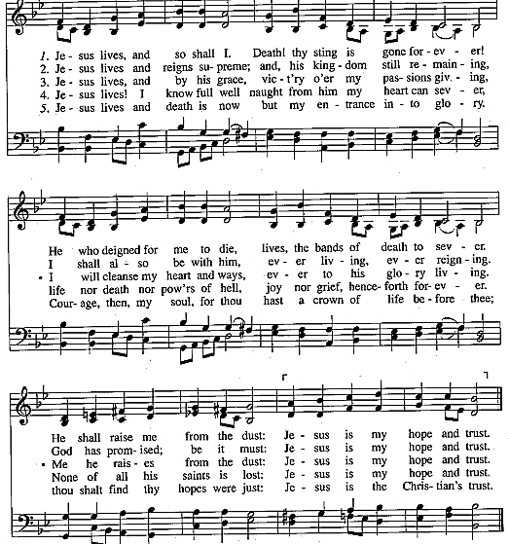
*Hymn of Affirmation “Jesus Lives, and So Shall I” #706

CCLI # 340996

*The Benediction

*Postlude Jesus Christ Is Risen Today

If you are visiting with us we would like to get to know you! Please contact
Pastor Chad Bailey at chad.bailey@midwaypca.org or 770-422-4974
for more information.

Sermon Notes

Job 19:23-29

In the face of guilt, death, and enemies, Confidence is found in knowing our Redeemer lives.

- Confident in the Face of Guilt (vv. 23-24)

- Confident in the Face of Death (vv. 25-27)

- Confident in the face of Enemies (vv. 28-29)

Please join us for our Easter Services
April 5th
9:45 a.m. Sunday School Classes
11:00 a.m. and 5:30 p.m. Services – 2009 Sanctuary

The Lord’s Day
Celebrating the Resurrection of Jesus Christ

April 5, 2026

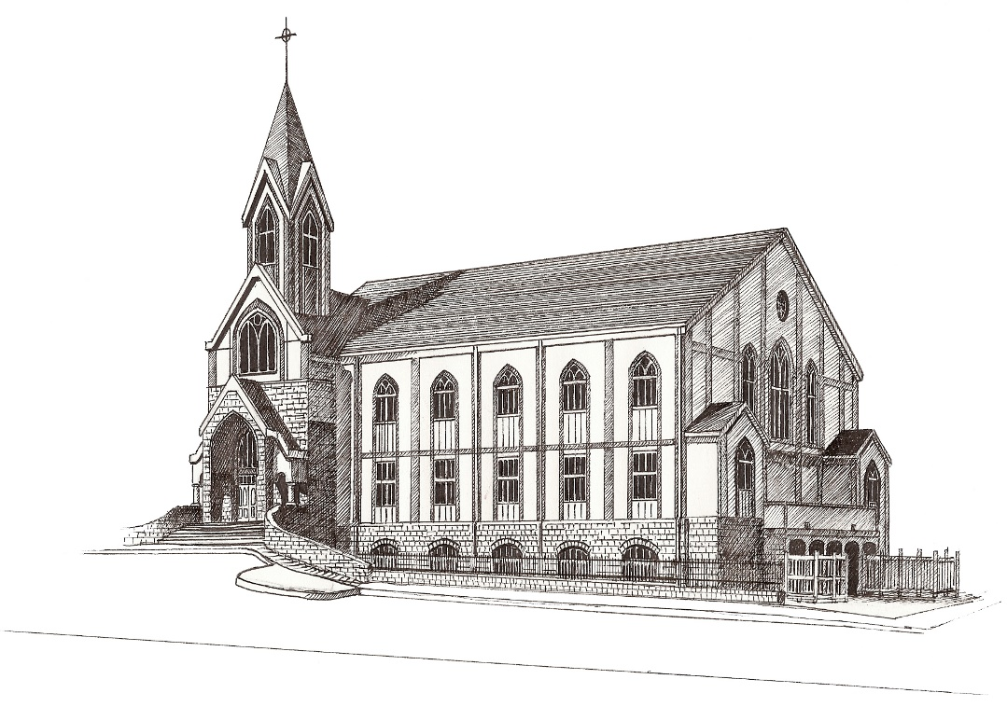

Midway Presbyterian Church

4635 Dallas Highway
Powder Springs, Georgia 30127
770.422.4974
www.MidwayPCA.org

Rev. Marc Harrington, Associate Pastor
Rev. Chad Bailey, Associate Pastor
Rev. Cilas Menezes, Associate Pastor

Founded in 1850, Midway Church is a congregation of the Presbyterian Church in America (PCA), a Reformed, evangelical denomination organized in 1973. Our church seeks to be Scriptural in both its government and its doctrine. We believe the Bible is the inerrant Word of God, our infallible and divine authority in all matters of life and faith.

“In the beginning was the Word, and the Word was with God, and the Word was God. The Word became flesh and made his dwelling among us. We have seen his glory, the glory of the One and Only, who came from the Father, full of grace and truth.”
John 1:1,14

