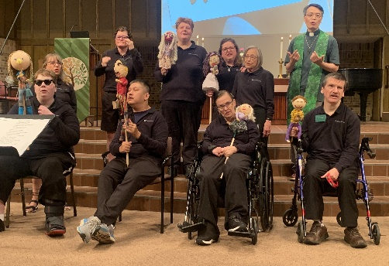

Centennial United Methodist Flames,
Families, Friends & Volunteers
  - Join us for Fall & Advent Events

Sept 20th NEW Worship TIME
- 10 AM Welcome Sunday Worship with ASL, visit music, UWF, mission tables and more
  - Ask questions about your interest areas and get swag

October 11th
- 10 AM Worship with ASL, assist with service or coffee time (optional)
- 11 AM Class: God’s with Me-Job, when bad things happen | Journals | Music with Trevor
Nov 8th
- 10 AM Worship with ASL, assist with service or coffee time (optional)
- 11 AM Class: God’s with me-Esther’s Choices | Music & practice with Trevor

Dec 9th 5 PM Supper, Card Making and Gift Bags with Youth
Dec 13th 9 AM Class: “God’s with me” - An angel visits | 10 Light Advent Wreath at Worship
TBD Practice for all church choir, all church concert | Salvation Army Ring and Sing, with lunch
Most events are at CUMC: 1524 W County Rd C2 at Snelling, Roseville. For questions, rides etc.:
Deb 651-491-2121 or Annika 633-7644. Flames are adults with unique abilities, disabilities & other life challenges.

Centennial United Methodist Flames,
Families, Friends & Volunteers
  - Join us for Fall & Advent Events

Sept 20th NEW Worship TIME
- 10 AM Welcome Sunday Worship with ASL, visit music, UWF, mission tables and more
  - Ask questions about your interest areas and get swag

October 11th
- 10 AM Worship with ASL, assist with service or coffee time (optional)
- 11 AM Class: God’s with Me-Job, when bad things happen | Journals | Music with Trevor
Nov 8th
- 10 AM Worship with ASL, assist with service or coffee time (optional)
- 11 AM Class: God’s with me-Esther’s Choices | Music & practice with Trevor

Dec 9th 5 PM Supper, Card Making and Gift Bags with Youth
Dec 13th 9 AM Class: “God’s with me” An angel visits | 10 AM Light Advent Wreath at Worship
TBD Practice for all church choir, all church concert | Salvation Army Ring and Sing, with lunch
Most events are at CUMC: 1524 W County Rd C2 at Snelling, Roseville. For questions, rides etc.:
Deb 651-491-2121 or Annika 633-7644. Flames are adults with unique abilities, disabilities & other life challenges

