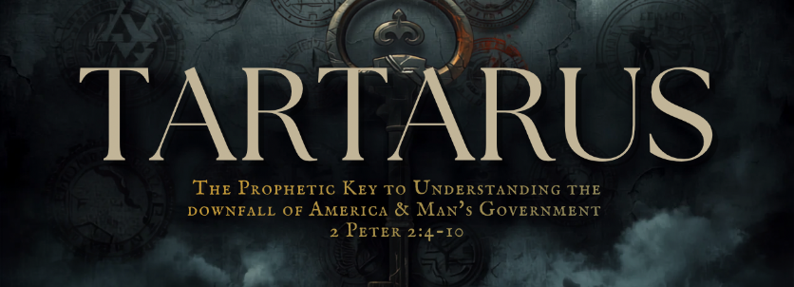

A People Set Apart In The Last Days
Key Text: 1 Peter 2:4–10 (KJV)
4 To whom coming, as unto a living stone, disallowed indeed of men, but chosen of God, and precious,
5 Ye also, as lively stones, are built up a spiritual house, an holy priesthood, to offer up spiritual sacrifices, acceptable to God by Jesus Christ.
6 Wherefore also it is contained in the scripture, Behold, I lay in Sion a chief corner stone, elect, precious: and he that believeth on him shall not be confounded.
7 Unto you therefore which believe he is precious: but unto them which be disobedient, the stone which the builders disallowed, the same is made the head of the corner,
8 And a stone of stumbling, and a rock of offence, even to them which stumble at the word, being disobedient: whereunto also they were appointed.
9 But ye are a chosen generation, a royal priesthood, an holy nation, a peculiar people; that ye should shew forth the praises of him who hath called you out of darkness into his marvellous light:
10 Which in time past were not a people, but are now the people of God: which had not obtained mercy, but now have obtained mercy.

Lesson Application
________________________________________________________________________________________________________________________________________________________________________________________________________________________________________________________________________________________________________________________________________________

II. The Danger of Rebellion and False Teachers

Text: Jude 1:6–10
6 And the angels which kept not their first estate, but left their own habitation, he hath reserved in everlasting chains under darkness unto the judgment of the great day.
7 Even as Sodom and Gomorrha, and the cities about them in like manner, giving themselves over to fornication, and going after strange flesh, are set forth for an example, suffering the vengeance of eternal fire.
8 Likewise also these filthy dreamers defile the flesh, despise dominion, and speak evil of dignities.
9 Yet Michael the archangel, when contending with the devil he disputed about the body of Moses, durst not bring against him a railing accusation, but said, The Lord rebuke thee.
10 But these speak evil of those things which they know not: but what they know naturally, as brute beasts, in those things they corrupt themselves.

Lesson Application

____________________________________________________________________________________

III. God Marks His Faithful Before Judgment
Text: Ezekiel 9:1–6 (KJV)
1 He cried also in mine ears with a loud voice, saying, Cause them that have charge over the city to draw near, even every man with his destroying weapon in his hand.
2 And, behold, six men came from the way of the higher gate, which lieth toward the north, and every man a slaughter weapon in his hand; and one man among them was clothed with linen, with a writer's inkhorn by his side: and they went in, and stood beside the brasen altar.
3 And the glory of the God of Israel was gone up from the cherub, whereupon he was, to the threshold of the house. And he called to the man clothed with linen, which had the writer's inkhorn by his side;
4 And the LORD said unto him, Go through the midst of the city, through the midst of Jerusalem, and set a mark upon the foreheads of the men that sigh and that cry for all the abominations that be done in the midst thereof.
5 And to the others he said in mine hearing, Go ye after him through the city, and smite: let not your eye spare, neither have ye pity:
6 Slay utterly old and young, both maids, and little children, and women: but come not near any man upon whom is the mark; and begin at my sanctuary. Then they began at the ancient men which were before the house.

Lesson Application
________________________________________________________________________________________________________________________________________________________________________________________________________________________________________________________________________________________________________________________________________________

IV. Every Creature After His Kind
Genesis 1:24 (KJV)
24 And God said, Let the earth bring forth the living creature after his kind, cattle, and creeping thing, and beast of the earth after his kind: and it was so.

Lesson Application:
________________________________________________________________________________________________________________________________________________________________________________________________________________________________________________________________________________________________________________________________________________

V. The Mixture That Will Not Cleave
Daniel 2:43 (KJV)
43 And whereas thou sawest iron mixed with miry clay, they shall mingle themselves with the seed of men: but they shall not cleave one to another, even as iron is not mixed with clay.

Lesson Application:
________________________________________________________________________________________________________________________________________________________________________________________________________________________________________________________________________________________________________________________________________________

