CONFIRMATION PLAN 2025-2026

Review and Purpose of Confirmation

Purpose and Goals for Confirmation
- Confirmation is when a Christian is instructed on their baptismal faith and publicly confirms this faith as their own.
  - Goal: Make Confirmation more self-directed for personal accountability.
- Confirmation is a community event in which young Christians become active members of the congregation.
  - Goal: Involve more adults in the process, especially the students’ parents.
- Confirmation is a priority for students and their families, but modern schedules make it difficult for them to prioritize.
  - Goal: Provide flexibility without watering down the curriculum.
- Confirmation is a priority for parents, who “uniquely serve as God’s representatives” for their children (Small Catechism 2017 edition, page 81) – See Deuteronomy 6:4-9.
  - Goal: Equip and empower parents to nurture the faith of their children.

Scope and Sequence

Communion Instruction
Instruction on the Lord’s Supper has been part of Confirmation classes, but those two do not need to be tied together. Students will now participate in Communion instruction before Confirmation classes if their parents and the pastors agree they are ready.
- Communion instruction will be offered over two one-hour sessions in the early part of each calendar year. Families will be given an opportunity to sign up beforehand.
- First communion will be offered on Maundy Thursday each year, although if unable to attend, students may begin receiving communion at any service after that.
- Students may be ready to receive instruction as early as 5th grade.

One-Year Bible Instruction
Every Confirmation student must be instructed in God's Word, learning the narrative of Scripture and how to read and use the Bible.
- St. Stephens Lutheran School students will receive Bible instruction during the three years of middle school Religion class. Thus, SSLS student(s) who complete middle school religion are exempt from one-year instruction.
- If an SSLS student only completes one or two years of middle school Religion instruction, the leaders of the Confirmation program can exempt them from certain lessons in Bible Overview.
- Students from other schools will receive one year of Bible instruction by completing the Enduring Faith 30-Lesson Bible Overview workbook.
- The workbook has six units, which students complete at home, followed by a mandatory Unit Check-In.
- Students may only miss one check-in and cannot continue with incomplete work.
- Students will memorize two Bible verses for every unit and share them at check-in.
- Students will complete a Faith project to demonstrate their understanding of the biblical narrative.
- Students in 7th grade or above are eligible for Bible instruction.

One-Year Catechism Instruction
Every Confirmation student must complete one year of Catechism instruction to learn the foundational teachings of the Christian Faith and the Lutheran Church - Missouri Synod. Each student will be connected with a mentor and a prayer partner to assist and encourage them through this year of instruction.
- Students will complete the Guided by Truth Enduring Faith Confirmation Journal.
- This journal features eight units that aim to answer the big questions such as “Who am I?” and “Why am I here?”
- Each unit will be followed by a thematic worship service and a Unit Check-In (7 total).
- Students may only miss one check-in and cannot continue with incomplete work.
- Students will complete the journal at home with the assistance of their parents.
- Students will create a banner focused on their Confirmation Verse.
- Students will complete a final “celebration interview” to demonstrate their understanding.
- Students in 8th grade or above are eligible to complete the Catechism instruction.

Regular Worship Participation
Our Lord provides His means of grace in His Word and His Sacraments, so regular participation in worship is a requirement of all Confirmation students (Acts 2:42, Hebrews 10:25). “God wants to be worshiped through faith so that we receive from Him those things He promises and offers” (Apology of the Augsburg Confession, Article IV, 49).
- Students may attend any of the three services each week (Sat. 5:30 pm, or Sunday 8:00 or 10:30 am) and are encouraged to attend midweek Advent and Lent services (Wednesdays 10:30 am or 6:30 pm).
- Students are required to submit a minimum of eight Sermon Notes per year in order to demonstrate active participation and understanding of the sermon.

LifeGroup Participation
Our Lord is at work in us, among us, and through us by nurturing faith, strengthening relationships, and serving our communities. At St. Stephens, we have found LifeGroups to be an effective way to connect people to Christ in these ways. Each Confirmation student will participate in a LifeGroup while going through instruction.
- Junior High LifeGroup (6th - 8th grade) will meet Sunday Mornings at 9:15 am or Wednesday Evenings at 5:00 pm, plus servant events at various times.
- Senior High LifeGroup meets Sunday Mornings at 9:15 am, plus fellowship times and servant events at various times.
- LifeGroup meetings will focus on apologetics topics with an emphasis on discussion and life application.

Confirmation Components

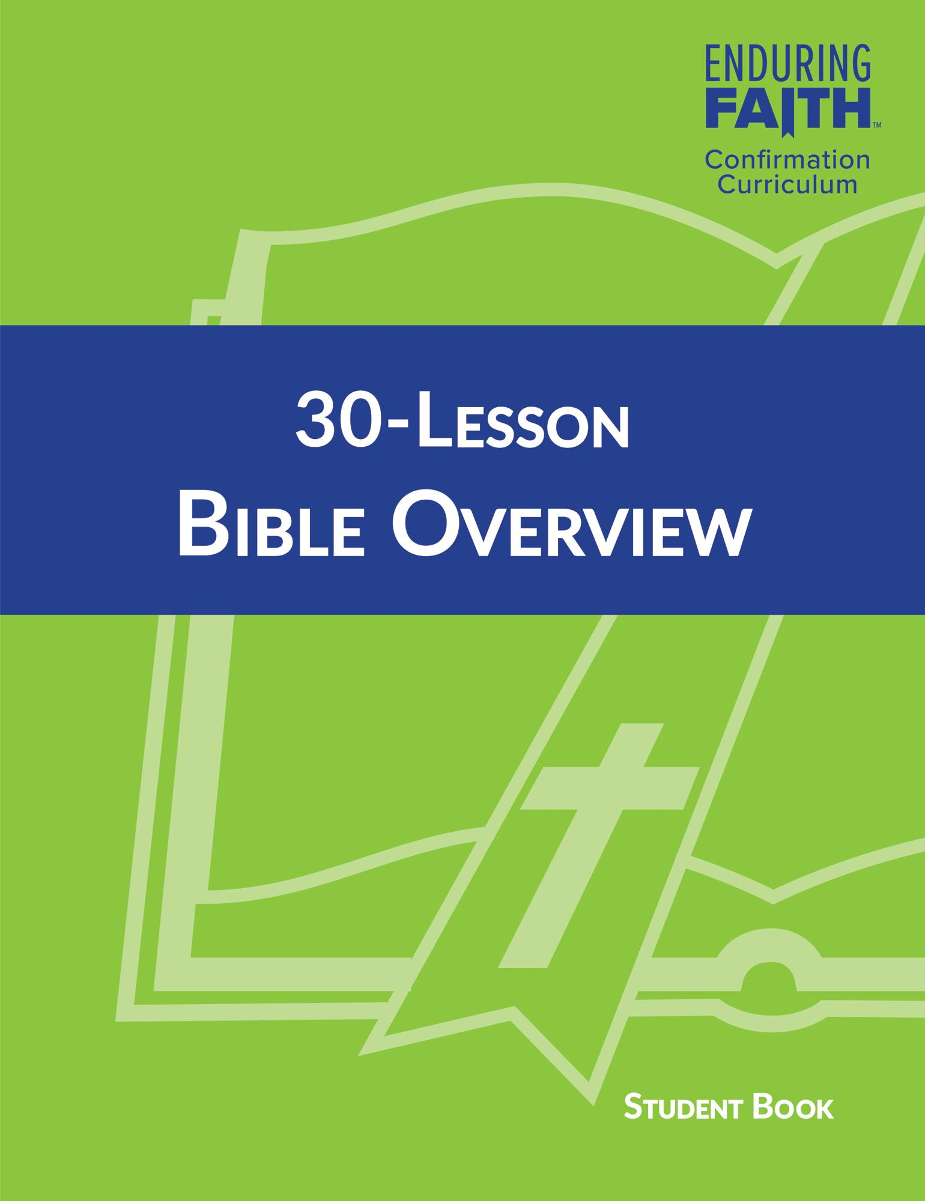
One-Year Bible Instruction

Enduring Faith 30-Lesson Bible Overview
The one year of Bible instruction is completed using the Enduring Faith 30-Lesson Bible Overview workbook from Concordia Publishing House, which is the publishing arm of the Lutheran Church—Missouri Synod. This textbook initially introduces the concept of the Bible and how to use it and then teaches the narrative of the Scriptures over the course of 30 individual lessons. Each lesson is four pages long and includes various Scripture readings and questions.

Six Unit Check-Ins
After each unit, an hour-long Unit Check-In will be offered. During this time, leaders will review key topics, answer questions, and check students' workbooks to verify that they have completed the assignments. If a student is unable to attend a check-in, they must schedule a time to review their work with the Confirmation leaders.

Twelve Memory Verses
Each unit, students will memorize two Bible verses that connect with the themes of the unit. During the Unit Check-In, students will recite the verses from memory to a Confirmation leader. Scripture memorization is an important tool for Christians to use when facing the challenges of daily life.

Year-End Faith Project
At the end of the year of Bible instruction, each student will complete a project that tells the narrative of the Scriptures. The project could take many forms, such as a timeline, a genealogy, a video, a poem, a song, a poster, or anything else creative that successfully details the overarching narrative of the Bible and how it all points to Jesus Christ.

One-Year Catechism Instruction

Confirmation Covenant
Every student and parent is asked to make a covenant with each other, with St. Stephens Lutheran Church & School, and with the Lord regarding their active participation in the Confirmation program. To this end, please pray and seek the Lord’s guidance and discernment regarding the timing and commitment of your child[ren] for confirmation.

Journal
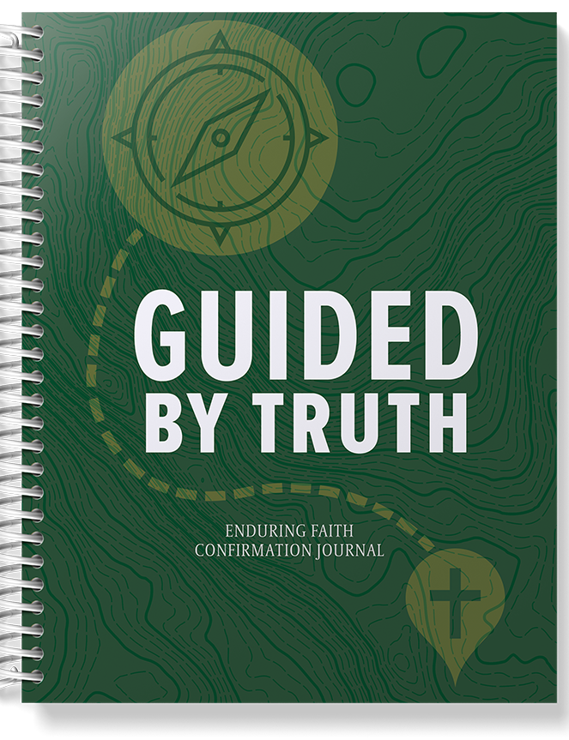
The one-year Catechism instruction will use the Guided by Truth Enduring Faith Confirmation Journal. Throughout the journal, students will review key passages from the Bible and learn the six chief parts of Luther's Small Catechism. Students must answer each question in the journal with a 2-3 sentence response. The journal will be completed at home by the student with the assistance of their parents.
The journal contains eight units, each with a varying number of sections. A schedule of approximately two sections per week will be shared. Each unit must be completed in advance of a corresponding thematic worship service and Unit Check-In. Students are allowed to miss only one thematic worship service and Unit Check-In.

Mentors and Prayer Partners
Each student will be assigned both a mentor and a prayer partner. Mentors will work with 3-4 students and go through the journal at the same time in order to answer questions. Their primary responsibility will be at Unit Check-Ins, but they must be available for questions throughout the year. Prayer partners will be assigned only one student and will promise to pray for their assigned student each day. Their primary responsibility will be at Unit Check-Ins, during which they will pray for the students in person.

Seven Check-Ins
At the end of each unit throughout the year, following the 10:30 am service, confirmation students, along with their parents, mentors, and prayer partners, will participate in a Unit Check-In. During this check-in, the mentors will spend 30 minutes debriefing with their students to ensure their understanding of the completed unit. After this, the mentor will review each student's journal to confirm they are on schedule while the prayer partners will have a brief prayer time together with the students. During the check-in, Confirmation leaders and the pastors will meet with the parents.

Sermon Notes
To demonstrate active participation and understanding of the sermon, students are required to submit a minimum of eight sermon notes per year. These notes prompt the student to explain what the sermon says about Christian identity and life. Forms can be picked up in the narthex near the sanctuary entrance, and completed forms can be turned in at the same spot.

Year-End Confirmation Verse Banner
Each student will work with the pastor(s) to choose a Bible verse to be their confirmation verse. Then, they will create a unique banner that explains the meaning of the verse and why it is important to them. The banner should correspond in some way to the confirmation verse, including displaying the book, chapter, and verse. Students should bring this banner to both the Celebration Interview and Confirmation Sunday, as it will be displayed when they read their statement of faith.

Statement of Faith
Each student will write a statement of faith that highlights "What I believe" and "How God is working in my life" to share on Confirmation Sunday. The statement should also briefly explain why the student chose their confirmation verse. Specific instructions will be provided, but each statement should be around 500 words and be ready to be shared during the Celebration Interview.

Celebration Interview
At the Celebration Interview, students will demonstrate their readiness to publicly confirm their Christian faith and showcase what they have learned. The interview will involve the students, their parents, mentor, and prayer partner, as well as their elder, pastors, and Confirmation leaders. The mentor will lead the interview and prompt the student to discuss their beliefs based on questions and themes from the eight journal units. Additionally, the student will share a draft of their statement of faith and display their confirmation banner. Students and parents will schedule a time between April and August with the Youth Director for the Celebration Interview.

Confirmation Sunday
Beginning in 2024, Confirmation Sunday will take place each year in October on Reformation Sunday. As in the past, there will be a special afternoon service in which students will publicly confirm their faith.

Schedule 2025-2026

Confirmation Informational Meeting
This meeting introduces families to the confirmation process and helps them decide when their student is ready to participate. Covenant forms and a schedule will be handed out for families to review before committing.
Bible Instruction Orientation  Sunday, August 24, 2025  Unit 1 Check-In: Bible Basics  Sunday, September 28, 2025  Unit 2 Check-In: The Beginning  Sunday, November 9, 2025  Unit 3 Check-In: The Exodus and Conquest—Sunday, December 14, 2025  Unit 4 Check-In: The Kings  Sunday, January 18, 2026  Unit 5 Check-In: The Life of Christ*  Sunday, February 22, 2026  Unit 6 Check-In: The Church  Sunday, March 22, 2026  Presentation of Faith Projects—  Sunday, May 3, 2026  *Communion Instruction with Pastor  Sunday, February 22, 2026 OR  Sunday, March 22, 2026  For Student & Parents/Guardian  Lunch Provided  Confirmation Retreat  Friday-Saturday, January 16-17, 2026 OR  Sunday-Monday, January 18-19, 2026 |  | Catechism Instruction Orientation  Sunday, August 24, 2025  Unit 1 Check-In: Faith Habits for the Journey—Sunday, September 28, 2025  Unit 2 Check-In: Commandments  Sunday, November 9, 2025  Unit 3 Check-In: The Creed  Sunday, December 14, 2025  Unit 4 Check-In: The Lord’s Prayer  Sunday, January 18, 2026  Unit 5 Check-In: Baptism*  Sunday, February 22, 2026  Unit 6 Check-In: Confession and Absolution—Sunday, March 22, 2026  Unit 7 Check-In: The Lord’s Supper  Sunday, May 3, 2026  Celebration Interviews—  Schedule a time between May - August  Confirmation – Reformation Sunday  Sunday, October 25, 2026

