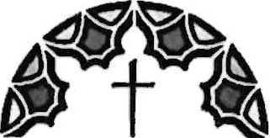
COVENANT
presbyterian church

Covenant Presbyterian Church Child Development Center Checklist
Thank you for choosing to apply at Covenant Presbyterian Church Development Center. This checklist is to help you be sure you have filled out al/ of the necessary forms for enrollment.
Covenant CDC Application
Parent Agreement Form
Emergency Care Form
____Children's Medical Form
Travel and Activity Authorization
Infant Feeding Plan (If Applicable)
Infant/ToddIer Safe Sleep Form (If Applicable)
Signed Acknowledgement of the NC Child Care Laws and Rules Brochure
Prevention of Shaken Baby and Abusive Head Trauma Form
Tobacco-Free Policy for North Carolina Child Care Centers
Covenant Presbyterian Church Photography and Publicity Policy Form
____ Documentation of Discussion of Parent Participant Plan
____ Parent Handbook

