PRAYER CONCERNS: John Chwastyk, Carol Heller, Cathy Carty, Lori Hayes, Bruce Scheyhing, Kate Kenny, Barbara Harris, Madison Luyber, Mary Raroha, Girard Kalinay, Sue Mitchell, Ruth Rosvold, Esther, Jenny Zollers, Gene Glavin, Joyce Thompson, Jeanne Hoffner’s sisters Anne Patterson and Mary Cardi, Peggy Carson, Sandy Handal, Betsy Heinz, Shirley Ridgway, all who mourn, those recovering from natural disasters, for all living amidst war and violence, those being persecuted for their faith, and for refugees who suffer worldwide.
THE ROSES ON THE ALTAR are given to the Glory of God and in celebration of the Baptisms of Lillian June Roberto and Benjamin Thomas Roberto today, daughter of Laura and Thomas Roberto.

 | ELECTRONIC GIVING OPTION – If you would like to make an electronic donation to FMC Moorestown, go to www.fmcmoorestown.com/give or scan this QR code to connect to our digital giving page. Please consider giving generously to support the ministries of FMC that impact communities locally and globally!

STAFF OF FIRST METHODIST CHURCH
Rev. Dr. Gina Hendrickson, Lead Pastor Gina@fmcmoorestown.com
Jeremiah Appleton, Program Ministries Director Jeremiah@fmcmoorestown.com
Barbara Morgan, Executive Office Administrator Devika Gill, Preschool Director
Matt Callender, Communications Director Bill Marshall, Property Coord.
Donna Banes, Co-Music Leader Sarah Owens, Nursery Coord.
Dustin Beck, Co-Music Leader & Worship Prod. Manager Antonio Silva, Sound Tech.

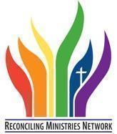
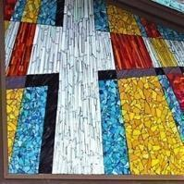
WORSHIP SCHEDULE
9:00 A.M. Contemporary Worship
11:00 A.M. Traditional Worship
Services are held in our Sanctuary and livestreamed
on Facebook and YouTube
CCLI License #782839 |Streaming License #CSPL124152 | CVLI License #504330184
  facebook.com/fmcmoorestown |   youtube.com/@fmcmoorestown446 |   instagram.com/fmc_moorestown

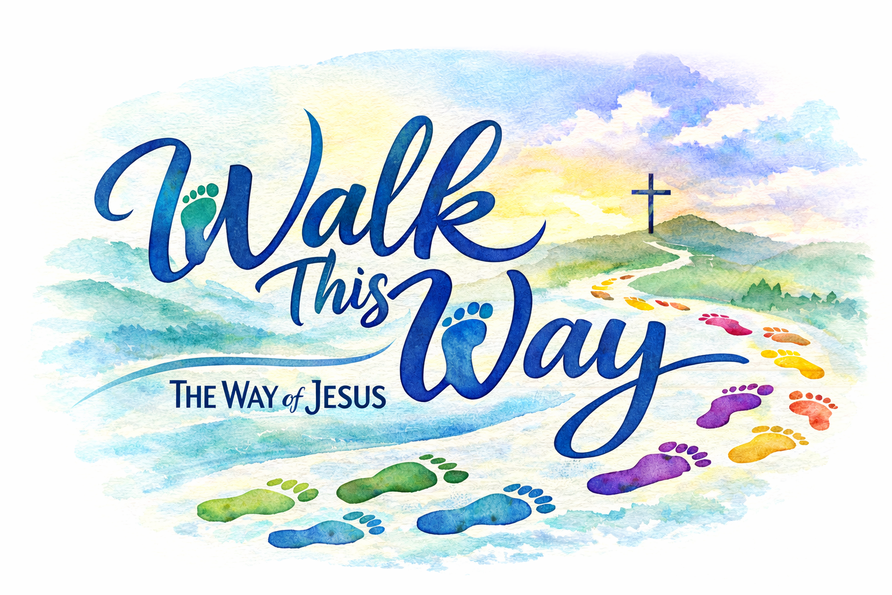
LOVE GOD ~ REACH PEOPLE ~ SERVE ALL

May 31, 2026 TRINITY SUNDAY 11:00 A.M

PRELUDE Bretheren, We have Met To Worship arr. Littleton Adult Handbell Choir

WELCOME Rev. Dr. Gina Henrickson

*HYMN #64 Holy, Holy, Holy! Lord God Almighty

*CALL TO WORSHIP Jeremiah Appleton
L: We gather in the presence of the Triune God—
Creator, Christ, and Holy Spirit.
P: One God, flowing in love, grace, and relationship.
L: The Creator formed us and calls us beloved.
P: Jesus walks beside us and shows us the way.
L: The Holy Spirit moves within us still.
P: Giving courage, connection, and new life.
L: Come, let us walk in the flow of God’s love.
ALL: Let us worship the Triune God! Amen.

OPENING PRAYER Jeremiah
Holy God, You are greater than we can fully understand, yet closer than we sometimes realize. In this time of worship, quiet our distracted minds and open our hearts to Your presence. Teach us to follow the way of Jesus with compassion and courage, and breathe Your Spirit into our lives so that we may live with hope, grace, and love. Draw us deeper into relationship with You and with one another, that our lives may reflect Your goodness that flows out into the world. In the name of the Father, Son, and Holy Spirit, we pray. Amen.

BAPTISM Pastor Gina and Jeremiah Appleton
LIllian June Roberto & Benjamin Thomas Roberto
We will sing verse 1 of Jesus Loves Me #191 UMH as a response.

PSALTER #854 Psalm 139: 1-10 (sung resp) Jeremiah

MORNING PRAYER/THE LORD’S PRAYER Jeremiah
Our Father, who art in heaven, hallowed be thy name. Thy kingdom come, thy will be done on earth as it is in heaven. Give us this day our daily bread. And forgive us our trespasses, as we forgive those who trespass against us. And lead us not into temptation, but deliver us from evil. For thine is the kingdom, and the power, and the glory, forever. Amen.

PRAYER RESPONSE # 334 Sweet, Sweet Spirit

*AFFIRMATION OF FAITH (2026 Confirmands) Rev. Dr. Gina Hendrickson
L: We believe in God, Creator of life itself, who accepted us and forgave
our sins.
P: God sent His only begotten Son to die for us so that we may have the
gift of eternal life.
L: We believe in Jesus Christ, the Holy Son, who out of love became one of us
and offered Himself in merciful sacrifice for our salvation.
P: He is with us and in us for all eternity.
L: We believe in the Holy Spirit, who has come to live within us and build
faith through us.
P: The Holy Spirit brings us together, creating unity, and moves us into
service so that others can see the light in us.
L: We believe in the prevenient grace of God, unending and ultimately
reassuring.
P: This grace was not earned but is always freely given.
L: And so we choose to believe in the Triune God.
ALL: To be a shepherd to God’s many lambs, by being a servant of God
through our time, our talents, and our treasures. Amen.

CELEBRATING OUR LIFE TOGETHER Jeremiah
We welcome all who worship with us this morning. Please fill out an attendance card as well as prayer concerns (on the back of the attendance card) at this time.

OFFERING OUR GIFTS AND TITHES Jeremiah
We ask you to prayerfully consider giving generously to support the ministries of FMC and the communities we serve for Christ. You can place your offering in the offering plate as the ushers pass it to you. Gifts can also be given online and prayers can be emailed to church@fmcmoorestown.com.

OFFERTORY It Is Well with My Soul Beck
FMC Worship Choir

*HYMN # 61 Come, Thou Almighty King

SCRIPTURES John 1:1-5; 14 & Romans 8:26 (NRSVUE) Pastor Gina

MESSAGE Walk in the Flow Pastor Gina

*HYMN #2223 They’ll Know We Are Christians by Our Love

*BENEDICTION Pastor Gina

*POSTLUDE

*THE PEOPLE STAND IN BODY OR SPIRIT

