Introduction and Review

Romans 15:14
And concerning you, my brethren, I myself also am convinced that you yourselves are full of goodness, filled with all knowledge and able also to admonish one another.

1. What do we want to accomplish?

To understand our sanctification

To learn what the Bible teaches about the issues and challenges of life.

To learn how to use the Bible to address the issues and challenges of life.

To develop confidence in accurately handling the Word of Truth

To learn how to examine yourself through the lens of Scripture.

To help Christian men and women learn how to minister the Word to other brothers and sisters in Christ in discipleship and counseling.

Develop and enhance biblical skills in addressing and solving problems biblically, as a disciple-maker, a shepherd, mentor or as a trained lay counselor.

To understand the conflict between secular counseling reasoning and a biblical worldview and how to recognize the difference and address it through a biblical lens.

2. All people in every society and culture asks these questions:

WHO are we?
WHAT HAPPENED?
Why do we do the things we do?
What MOTIVATES people?
What are the CAUSES of our psychological ills?
How do we CHANGE?
How do we HEAL?
What is the goal of change?
We propose to answer these questions from a biblical worldview!

3. Biblical Counseling Defined:

Biblical counseling is the personal discipleship ministry of God’s people to others under the oversight of God’s church, dependent upon the authority and sufficiency of God’s Word through the work of the Holy Spirit.
Biblical counseling seeks to reorient disordered desires, affections, thoughts, behaviors, and worship toward a God-designed anthropology, in an effort to restore people to a right fellowship with God and others.
This is accomplished by speaking the truth in love and applying Scripture to the need of the moment by comforting the suffering and calling sinners to repentance, thus working to make them mature as they abide in Jesus Christ.
Dale Johnson and Samuel Stephens: The Church as a Culture of Care (9)

4. Biblical Foundations in Overcoming Sin and Suffering – Romans 15:14

God’s people are called to minister to one another, to care for one another, to confront and restore one another in sin, to comfort and to build one another up in suffering.

We are called to admonish, exhort, encourage, and instruct one another.

Why would we send a brother or sister out into the world for help when God’s people are competent to help?

5. Our Sanctification: (Romans 8:28-29; Ephesians 5:1; Colossians 1:28)\

Q: What is our goal in sanctification?

Q: What is our goal in ministering to one another in sanctification?

A: To become like Christ; to imitate God; to be complete/mature in Christ.

6. Authority and sufficiency of Scripture

The Bible, consisting of the sixty-six books of the Old and New Testaments, is the inerrant and complete Word of God, the final authority in all matters of faith and practice. (2 Pet 1:19-21: 2 Tim 3:16-17; Psalm 19:7-14)

God’s Word is sufficient to meet every need of the human soul as David verifies frequently in his psalms.
Psalm 19:7-14 is the most comprehensive statement regarding the sufficiency of Scripture. It is an inspired statement about Scripture as a qualified guide for every situation. (John MacArthur)

7. Authority of Scripture
> Scripture is the Word of God and,
> God is the Ultimate Authority, so
> The words of God are authoritative.
> Conclusion: Scripture is authoritative.

8. Authority and sufficiency of Scripture
God’s Word is sufficient to meet every need of the human soul as David verifies frequently in his psalms.
Psalm 19:7-14 is the most comprehensive statement regarding the sufficiency of Scripture. It is an inspired statement about Scripture as a qualified guide for every situation.
Scripture is comprehensive, containing everything necessary for one’s spiritual life.
Scripture is surer than a human experience that one may look to in proving God’s power and presence.
Scripture contains divine principles that are the best guide for character and conduct.
Scripture is lucid rather than mystifying so that it enlightens the eyes.
Scripture is void of any flaws and therefore lasts forever.
Scripture is true regarding all things that matter, making it capable of producing comprehensive righteousness. Because it meets every need in life,
Scripture is infinitely more precious than anything this world has to offer.
(John MacArthur)

9. Four Purposes of Scripture When Counseling Others

2 Timothy 3:16-17 - 16 All Scripture is inspired by God and profitable for teaching, for reproof, for correction, for training in righteousness; 17 so that the man of God may be adequate, equipped for every good work.

Every time God’s Word is used it is profitable for:

TEACHING: The Bible teaches comprehensive truths about God, people, sin and its effects, and the hope that is found in Christ. Scripture equips people with an accurate and complete framework for rightly understanding all of human life before God. In a culture filled with competing truth claims and alternative narratives for understanding our lives, biblical counselors instruct counselees with God’s Word so that they can know and believe what is true.

REPROOF: God’s Word is useful for exposing wrongly held beliefs in one’s life. In response to the snare of wrongly-held beliefs in one’s life, biblical counselors use Scripture to help their counselees through loving and gentle rebuke, so that they might repent of believing what is false and embrace what is true about God and His gospel.

CORRECTION: As the preceding purpose relates to wrongly held beliefs in inner person, “to correct” refers to confronting and correcting sinful behavior expressed externally in one’s life.
Biblical counselors use Scripture in this way as well, not only to help rescue people from wrong belief but also to demonstrate how our actions reflect the true motivations of our hearts.

TRAINING IN RIGHTEOUSNESS: Scripture’s usefulness refers not only to growth in the knowledge of God but to the pursuit of godliness and a transformed life. God uses His Word to train us, teaching us what it is like to follow Jesus in daily life so that we will learn to observe all that He has commanded (Matt. 28:20). biblical counselors help their counselees move toward the goal of Christlikeness so that they will not only know what is true but that their lives would reflect this truth as well.

10. These four purposes of Scripture combine to produce one intended result: that the man of God may be complete, equipped for every good work” (2 Tim. 3:17

The usefulness of God’s Word is meant to produce MATURITY and GODLINESS in the lives of those we counsel, but also a growing capacity for ministry in the lives of other people.

God speaks in His Word to instruct, reprove, correct, and train so that those we counsel/disciple would bear fruit that leads to further disciple-making, for God’s glory (2 Tim. 2:2).

11. 2 Peter 1: 3-11 God’s people have everything necessary in Scripture, the indwelling Holy Spirit, and the Church to minister to us and one another in overcoming ALL forms of sin and suffering

12. Why should we minister to one another? 2 Cor 1:3-7

13. Goals of Biblical Counseling:

True biblical counseling has clearly defined and communicated goal of helping a counselee glorify God, beginning at the heart level and extending to every aspect of their life – thought, word, deed, motive.

Counselee’s problems are used to teach and train them at the heart level to think and act in a way pleasing to the Lord. Problems are viewed in light of how God is using them to sanctify us (2 Cor. 5:9, Gal. 1:10).

Solving problems are secondary to the goal of pleasing Christ in every circumstance, resulting in gained hope. Hard circumstances become opportunities rather than insurmountable problems.

This is sanctification! The process of sanctification involves the progression of putting off wrong thinking, behavior, and emotions; renewing the mind by God’s Word; and putting on biblical thinking and acting (Ephesians 4:17-32, Colossians 3).

14. Hopeful Counseling/Discipleship. Goal, method, focus, target, and tools of intensive discipleship and biblical counseling:

a. The GOAL is heart TRANSFORMATION and relational restoration (2 Cor. 5:12-21).

b. The METHOD is truth in the context of grace (John 1:14).

c. The FOCUS is mind, will, emotions, and right behavior—renewed MIND, submitted WILL, informed EMOTIONS, and godly BEHAVIOR.

d. The TARGET is beyond behavior to the desire and motivations of the inner man.

5. The TOOLS are the Word of God, Spirit of God, community of God (2 Peter 1:3).

15. Four Levels of Problems

- Perception/Perceptual Level: Where the Problem Begins
Mind-set, established attitude, values. Often a conscious choice to adopt a certain manner of thinking. Interpretation of reality. Idols of the heart.
- Preconditioning Level
Learned patterns: unconscious, absorbed patterns from various influences in our lives,
including sinful choices which have become regularized behavior.
- Performance Level: How one acts
“Doing level” Ask what, when, how and who questions to discover why this behavior is characteristic of this counselee. Performance includes a variety of behaviors such as brooding, being critical, slamming doors, overeating, lying, clamming up
- Presence/Presentation Level - Observable
What is felt: this includes what a person projects – constant frown, rigid muscle tone – and what he feels and talks about feeling. Depression, listlessness, confusion, fearfulness, relational problems, suicidal ideations, inability to control anger.

16. Biblical Counseling Goal is Heart Change (Pr. 4:23; Jer 17:9-10; Mark 7:14-23)

Heart change = Behavior change

Change of behavior without heart change is temporary and hypocritical

The Christian life is a dynamic life!

The Christian life is about change – healthy, maturing, spiritual growth to become complete in Christ – Christ-likeness (Col. 1:28)

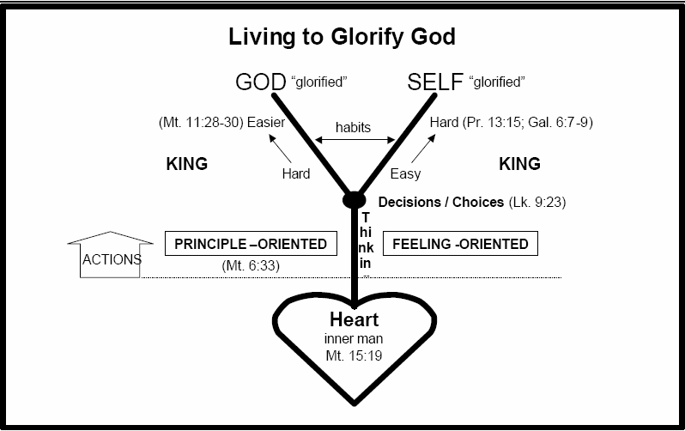

Biblical Counseling Learning Objectives

The following were covered in the Fall semester 2024. Slides, handouts and most audio/video presentations are online at https://smcc.church/biblical-counseling-training

Qualifications of a Biblical Counselor

1. Characterizes spiritual maturity as a believer (e.g., Rom. 15:14 full of goodness, etc.)
2. Strives towards godliness
3. Serves God, not man
4. Demonstrates biblical fidelity
5. Accurately handles Scripture

Passages to Consider: Romans 5:1; 14:13-14; John 14:16; 16:5-11; Galatians 3:1-3; 1 Timothy 4:6-16; Matthew 15:8

Qualifications of a Biblical Counselor
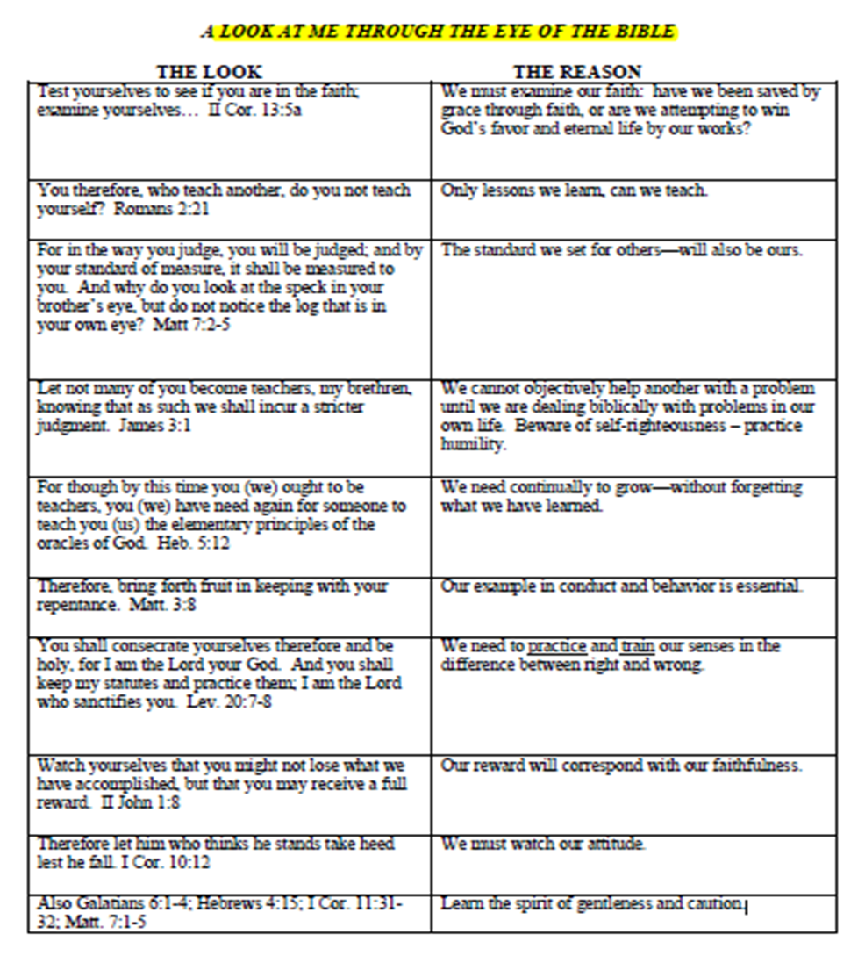

Key Elements in Biblical Counseling
Gathering Data > Information > Knowledge
Discerning Problems Biblically
Biblical terms, descriptions
Biblical prescriptions and principles
Biblical solutions
Establishing Involvement with Counselees
Giving Hope; Providing Instruction; Giving Homework / Evaluating Homework

Key Elements in Biblical Counseling
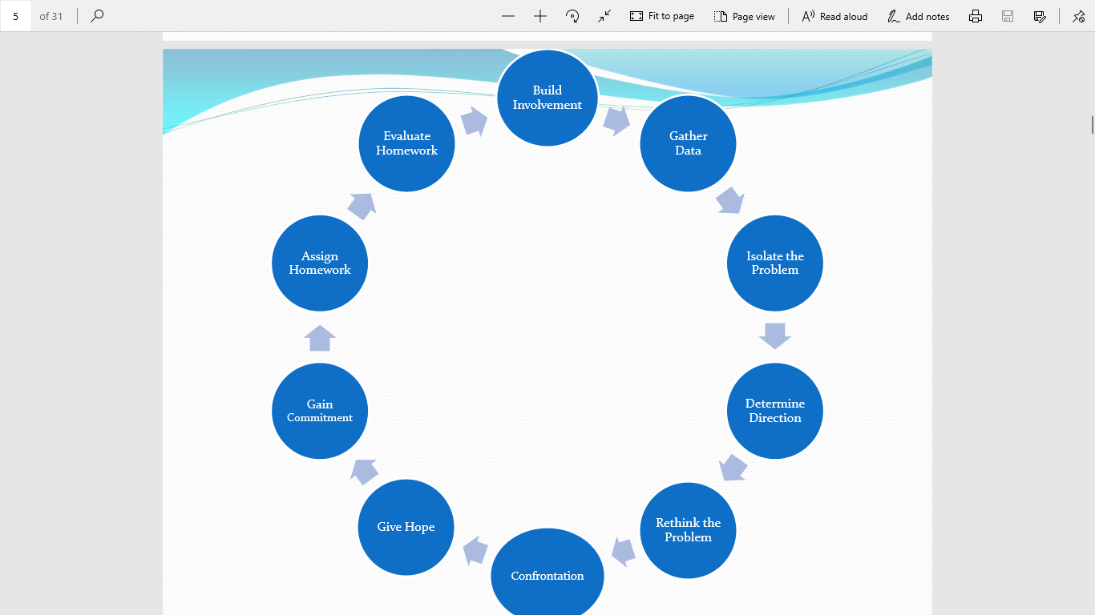

Secular and Integration Theories

1. Distinguish between secular, integration, and biblical models of counseling
2. Understanding the foundations of secular and integration models
3. Understanding the goals of secular and integration models
4. Explain difference between descriptive data and prescriptive data
5. Purposes of General Revelation and Special Revelation
6. The Nature of Truth (e.g., All truth is God’s truth?)
This is how we as counselors, disciplers, mentors, leaders, and helpers must be examining ourselves daily so that we may minister to others!

TENETS OF HUMANISTIC METHODS OF SOLVING MAN’S PROBLEMS

The Tenet | The Rationale | The Biblical Response
Man is basically good | Man’s basic problem is that he does not live up to his inner potential. He is intelligent and rationale and has within him the resources to effect his own transformation. | Romans 3:10–18, 23
Man can effect his own transformation | Man’s bad behavior for which he is not responsible, is the cause of his problems; but he can change his behavior and overcome his problems. | Jeremiah 13:23  Romans 7:18
Man is a victim | He is a victim of his conscience, the victim of other’s abuse, the victim of his environment, and/or the victim of his subconscious drives and is therefore not responsible for his actions. Therefore, he must identify those who victimize him, identify who is to blame, and must be re-socialized. | 1 Timothy 4:1–2  Romans 1:18–25
Man is an animal | Man, the superior animal must meet his needs any way he can, so long as in doing so he does not violate others. | Ezekiel 18:20–21
Man is a negotiator | The politics of happiness describes man’s negotiating problems concerning interpersonal relationships. The quality of life is enhance by the equality of balance.  But bargaining means my priority is ME; therefore, I am willing to give you some of what you want so that you will give me what I want. But negotiation from this selfish perspective is not God’s way. | James 3:14–16  Philippians 2:3–4  Isaiah 55:9

Schools of Modern Psychology and Presuppositions

School of Thought | Freud  (Freudian) | Ego  Psychology  (Freudian) | Rogers  (indirect; human potential) | Skinner  (Behaviorism) | Existentialist  (Human potential) | Third Force  (Human potential)
Man | Self-gratifying animal | Basically good | Basically good | Man is a zero | Man is absurd | Man has great potential
Problem | Inner anxiety and drives create conflict between the id and super-ego | Weak ego | Inhibition and anxiety | Environmentally programed improperly | Anxiety (angst) from dealing with own absurdity | The awareness of not reaching his potential
Responsibility | Person is responsible to live out his drives without social conflict | Same as Freud | Person is responsible for not being himself, i.e., being free | Society, not the individual | Rests with the counselee | Rests with the counselee
Guilt | Result of the super ego having had society’s values forced upon it or the conflict between the id and super ego | Same as Freud | No guilt, but rather an incorrect learned negative evaluation | No such thing | Man | Bad feelings for not having achieved potential
Treatment | Gratification of desires in society in socially acceptable ways | Strengthen ego through self-determinism;  Strong ego-guiltless and no angst | Reflection and insight | Reengineer the environment | Projecting reality (a self-fulfilled prophecy) create mood! | Change environment – learn how to reach potential
Counselor | Explores the past where frustrations occur – make advisements; help to exercise acceptance | Guide strengthening process | Mirror reflection | Environmental engineer | One who enables counselee to reestablish hope in projection. | Facilitates what is pragmatically closest to potential

Guilt and Repentance

1. Contrast true guilt (justification) from false guilt (feelings of guilt)
2. Provide instruction regarding biblical confession (see Prov 28:13; Js 5:14)
3. Repentance in relation to sanctification.
4. Show how repentance is deeply trinitarian (e.g., roles of God, Holy
Spirit, and Jesus Christ)
Passages to Consider: Proverbs 28:13; James 5:14; John 16:8; Acts 2:37; John 7:7; Galatians 6:1; Psalm 32:5; Matthew 11:28-30; 1 John 1:9; 1 Timothy 1:5; Hebrews 9:14; 13:18; 1 Peter 3:16

Forgiveness

1. Define forgiveness biblically, especially regarding its role in reconciliation
2. Outline popular views centering on forgiveness (transactional/ interpersonal vs. personal/heart transformative)
3. Describe the consequences of a spirit of unforgiveness/pride/arrogance (e.g., root of bitterness)
4. Demonstrate what behaviors, actions, and attitudes describe a peacemaker from Scripture
Passages to Consider: Neh. 9:16-17; Ps. 86:5; Rom. 5:6-8; Ps. 103; 10-12; Jer. 50:20; Rom. 5:16-21; 8:1, 33-34; 1 John 1:9; Eph. 4:32; Col. 3:13; Mark 11:25; Matt. 18; Luke 23:39-43; 1

Trials and Suffering

1. Explain the reality of trials and suffering in this world
2. Define trials and suffering biblically (as opposed to temptations, etc.)
3. Show how God redeems trials and suffering
4. Emphasize the importance of counseling with love, concern, and patience unto those who suffer
Passages to Consider: Gen.1:31; 2; 3:17-19; 6:5-6; Phil. 2:5-11; Acts 20:28; Heb.2:14; Rev. 21:1-22:5; 1 Cor. 15:54-57; 1 Sam. 12:9-12; Job 1:8; 2 Cor. 11:23-29; Acts 2:23; 4:27; Ps.66:10

Anger

1. Contrast the biblical understanding of emotion from the emotion of anger
2. Contrast righteous and unrighteous anger from Scripture by examining motives, means, and outcomes
3. Demonstrate the common manifestations of unrighteous anger
4. Point out the roots of unrighteous anger (e.g., sensuality; desires of the flesh; unforgiveness; desire for control, etc.)
Passages to Consider: Psalm 37:8; Proverbs 12:16; 14:17; 15:18; 16:32; Eccl. 4:31; James 1:19, 20; Genesis 4:5-8; Kings 5:10-14; 2 Chron. 26:16-23; Exodus 22:24; Matt. 21:12-13; Mark 3:5

Depression

1. Explain the cyclical process/downward spiral of depression (e.g., how worrisome thoughts lead to deeper despair, taking eyes of off God, etc.)
2. Define depression biblically along with its redemptive purpose
3. Demonstrate a connection between sinful depression and repentance
4. Emphasize the need for compassion during a season of grief/sorrow/depression
Passages to Consider: Ephesians 1:3-2:10; 5:18-6:9; 1 Corinthians 10:31; 2 Corinthians 5:9; Romans 8:28-29; 1 Peter 1:3, 13; Psalm 42-43; 131; 2 Peter 1:1-11

Physical Illness and Biblical Counseling

1. Biblical principles of health and illness
2. Spectrum of disease (spiritual to organic, emphasis on response)
3. Encouraging appropriate medical care
4. Biblical victory in the midst of difficult prognosis
5. Ministering to the suffering
Passages to Consider: Genesis 3:15-19; Psalm 38:3-11; 1 Corinthians 11:29-30; John 9:1-3; Philippians 1:29; James 5:11; 2 Kings 20:5; 2 Corinthians 12:7; Proverbs 17:22; Romans 12:15; 1 Corinthians 10:13; Deuteronomy 29:29; Philippians 4:8; 2 Corinthians 4:6-9

Psychotropic Drugs and Biblical Counseling

1. The need for compassion and humility
2. Medical diagnosis vs. psychiatric diagnosis (no identifiable pathology)
3. Chemical imbalance theory (definition, history, implications within current psychiatry, etc.)
4. Psychotropic drug information (e.g., mechanisms uncertain)
5. Do antidepressants work? (i.e., What do you mean by “work”)
6. Counselors and Medications
Passages to Consider: 2 Timothy 2:24; Matthew 10:16; Acts 17:11; 1 Thessalonians 5:21; Galatians 5:22-23; 2 Corinthians 1

Understanding the Heart of Addictions

When our desires conflict with what we believe, we don’t always live according to what we say we believe.
Addiction is a physical symptom of a deeper, spiritual problem of the attitudes of the heart generally called “idolatry” in the Bible. (Ezek. 14:5)
Since we live in a culture encouraging self-indulgence, it is no surprise that addictions are everywhere.
The word “addiction” characterizes a pattern of behavior rather than fully explaining its underlying causes.
“Addictions” - a cycle of binging, withdrawal, and craving, implying a lack of self-control and compulsive behavior despite negative consequences.
“Idolatry is by far the most frequently discussed problem in the Scriptures.” David Powlison, “Idols of the Heart and ‘Vanity Fair’” (JBC vol 13).
Sin is when you worship anything other than the true God.
John 8:34 -Jesus answered them, “Truly, truly, I say to you, everyone who commits sin is the slave of sin.”
*Sin is our deepest problem. If not, then the gospel of Jesus is not the most important event in human history.
When we look at it closely, drunkenness [et.al] is a lordship problem. Who is your master, God or your desires? Do you desire God above all else or do you desire something in

creation more that you desire the Creator? At root drunkards are worshiping another God – alcohol.
If your addiction is an unconquerable compulsion, then you are stuck; if your biggest problem is that you are a sinner, there is hope.

Addictions are ultimately a worship disorder

Passages to Consider: Matthew 7:24-27; Ezekiel 14:5; Romans 7:18; 1 Timothy 1:13-15; John 8:34; Proverbs 6:16-19; 23:29-35; 1 John 2:15-17;

Conclusion:

We proclaim Him, admonishing every man and teaching every man with all wisdom,
so that we may present every man complete in Christ.
Colossians 1:28
And concerning you, my brethren, I myself also am convinced that you yourselves are full of goodness, filled with all knowledge and able also to admonish one another.
Romans 15:14

Class Summary:_____________________________________________________________________________________________________________________________________________________________________________________________________________________________________________________________________________________________________________________________________________________________________________________________________________________________________________________________________________________________________________________________________________________________________________________________________________________________________________________________________________________________________________________________________________________________________________________________________________________________________________________________________________________________________________________________________________________________________________________________________________________________________________

