FBC Welcome Youth

  - Welcome to Welcome – Youth!
If you have students in 6th – 12th grade, our Youth Group invites you to come have fun and worship Jesus together! We gather Sunday Mornings for Sunday School, Sunday nights for study and fun & games (and food on occasion!) and Wednesday nights as well.
We do separate Middle School and High School sessions as well as combined activities. Our goal is to share the love of Jesus with your students, help them to realize the depth and breadth of God’s love for them, share the Gospel with them and to deepen their relationship with Jesus Christ.

Events & Schedule
Meeting Times:
Sunday School – 9:30 – 10:30 AM
Middle and High School combined; study of topics guided by students’ interests; examples include “End Times”, “Angels”, “Eternal Salvation – or Not?”, etc.
Sunday Night – 6:00 – 8:00 PM
Currently Middle and High School combined; time of games and fun with a lesson mixed in. Each Sunday slightly different:
1st Sunday – Food Night! We’ll feed them and have hanging out and fun n games. A light devotion thrown in
2nd Sunday – our ‘normal’ Sunday of a more in depth lesson the first hour followed by an activity or two and/or games
3rd Sunday – Typically an afternoon event/activity in place of Sunday night. Example – Surge Trampoline Park after AM services and a fast food meal
4th Sunday - our ‘normal’ Sunday of a more in depth lesson the first hour followed by an activity or two and/or games
5th Sunday – No Youth (even MADDAWG needs a break now and then!)
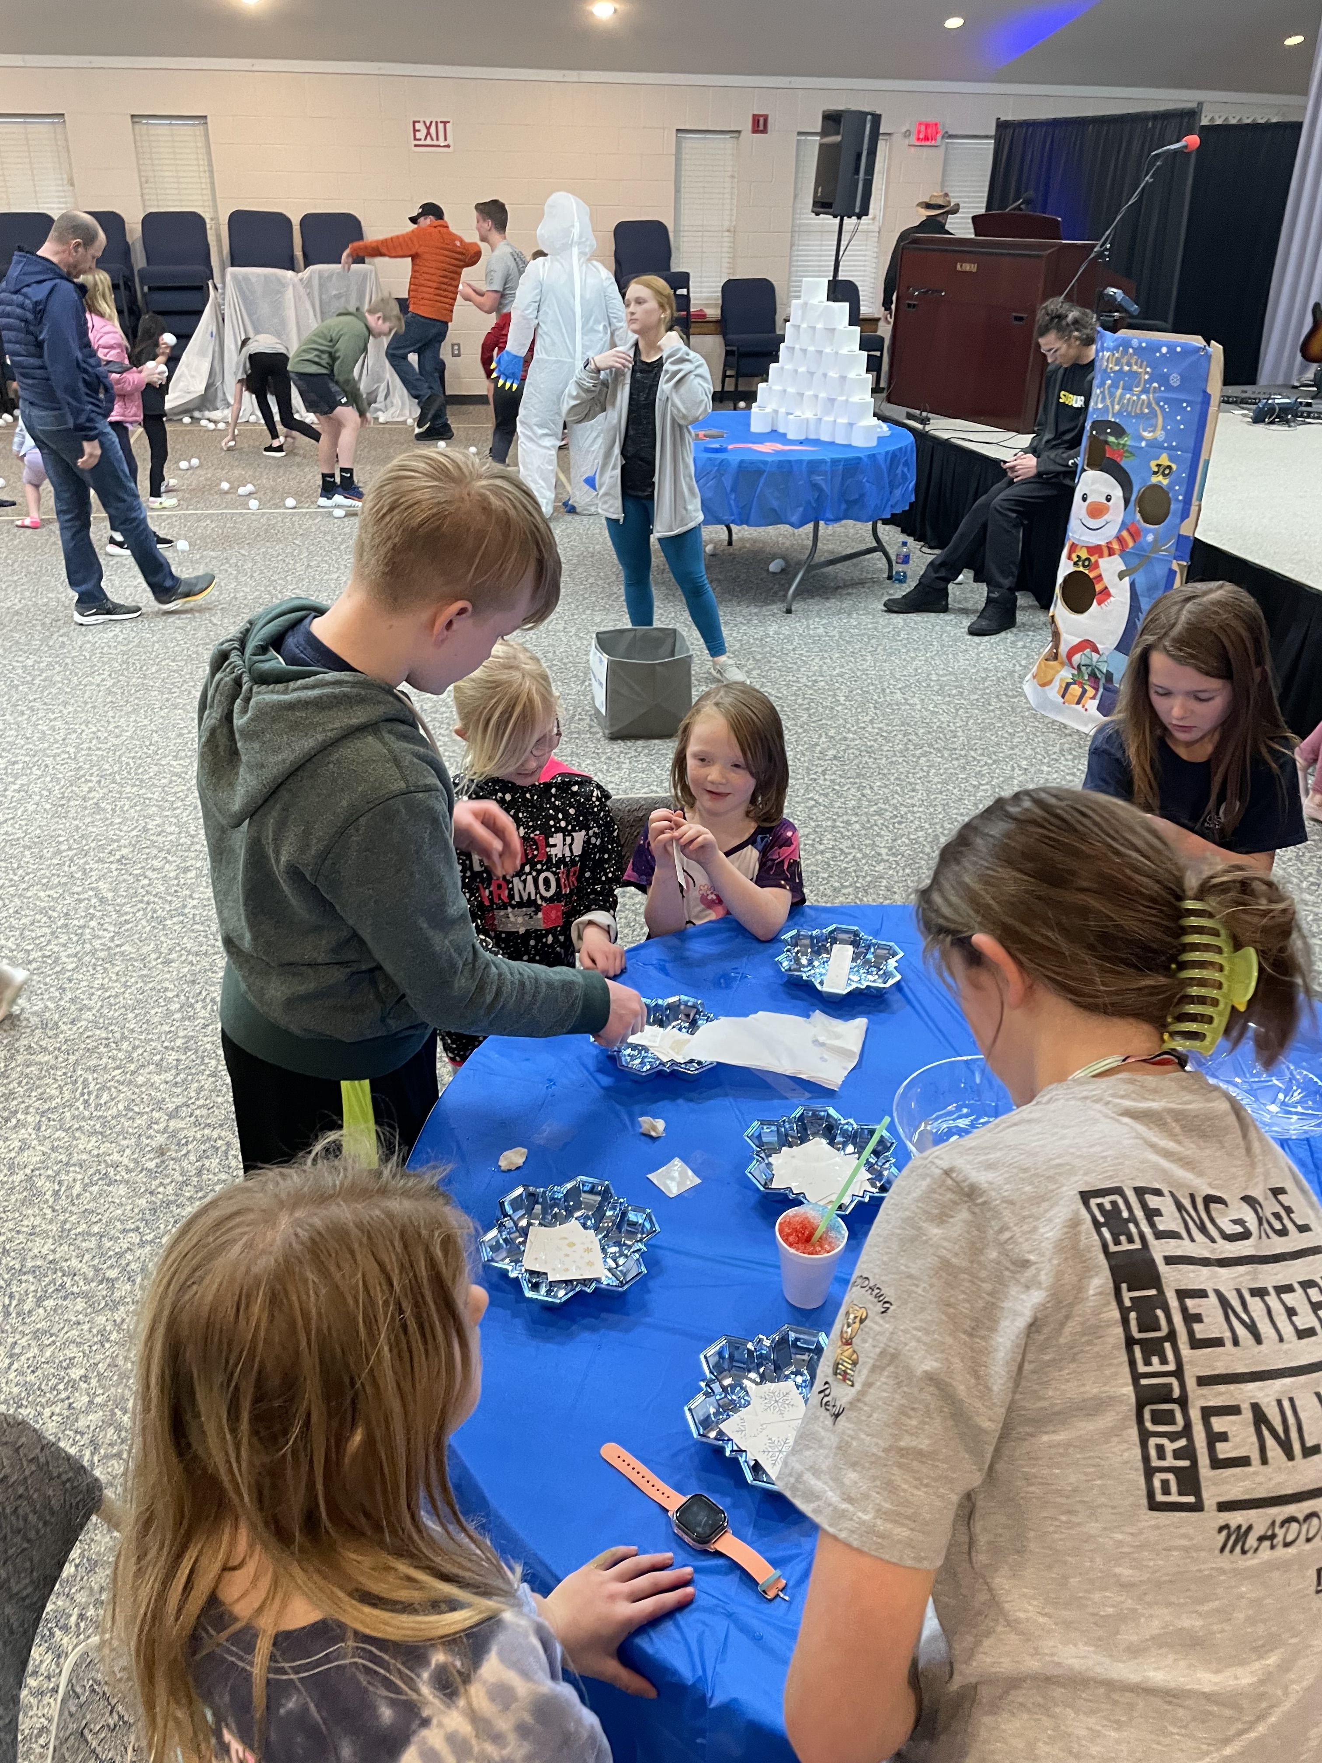
Wednesday Night – 7:00 – 8:00 PM
Initial game followed by separate Middle School and High School lesson
Events/Fun Stuff:
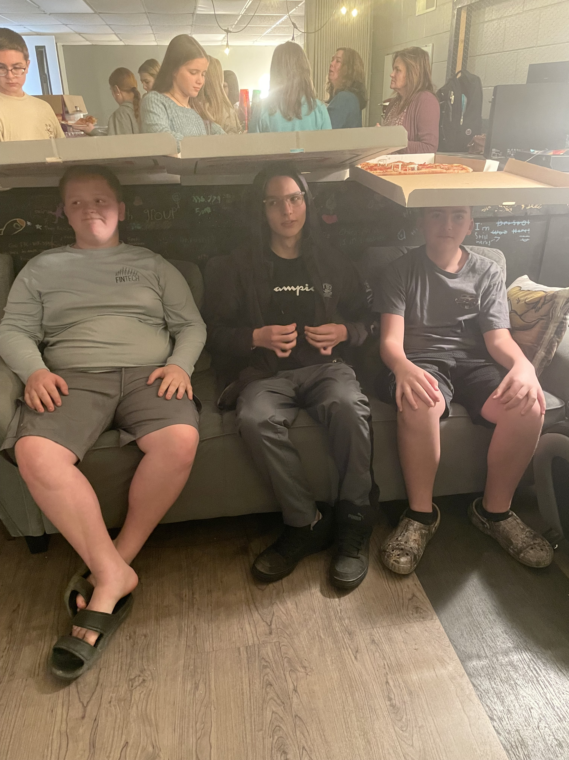
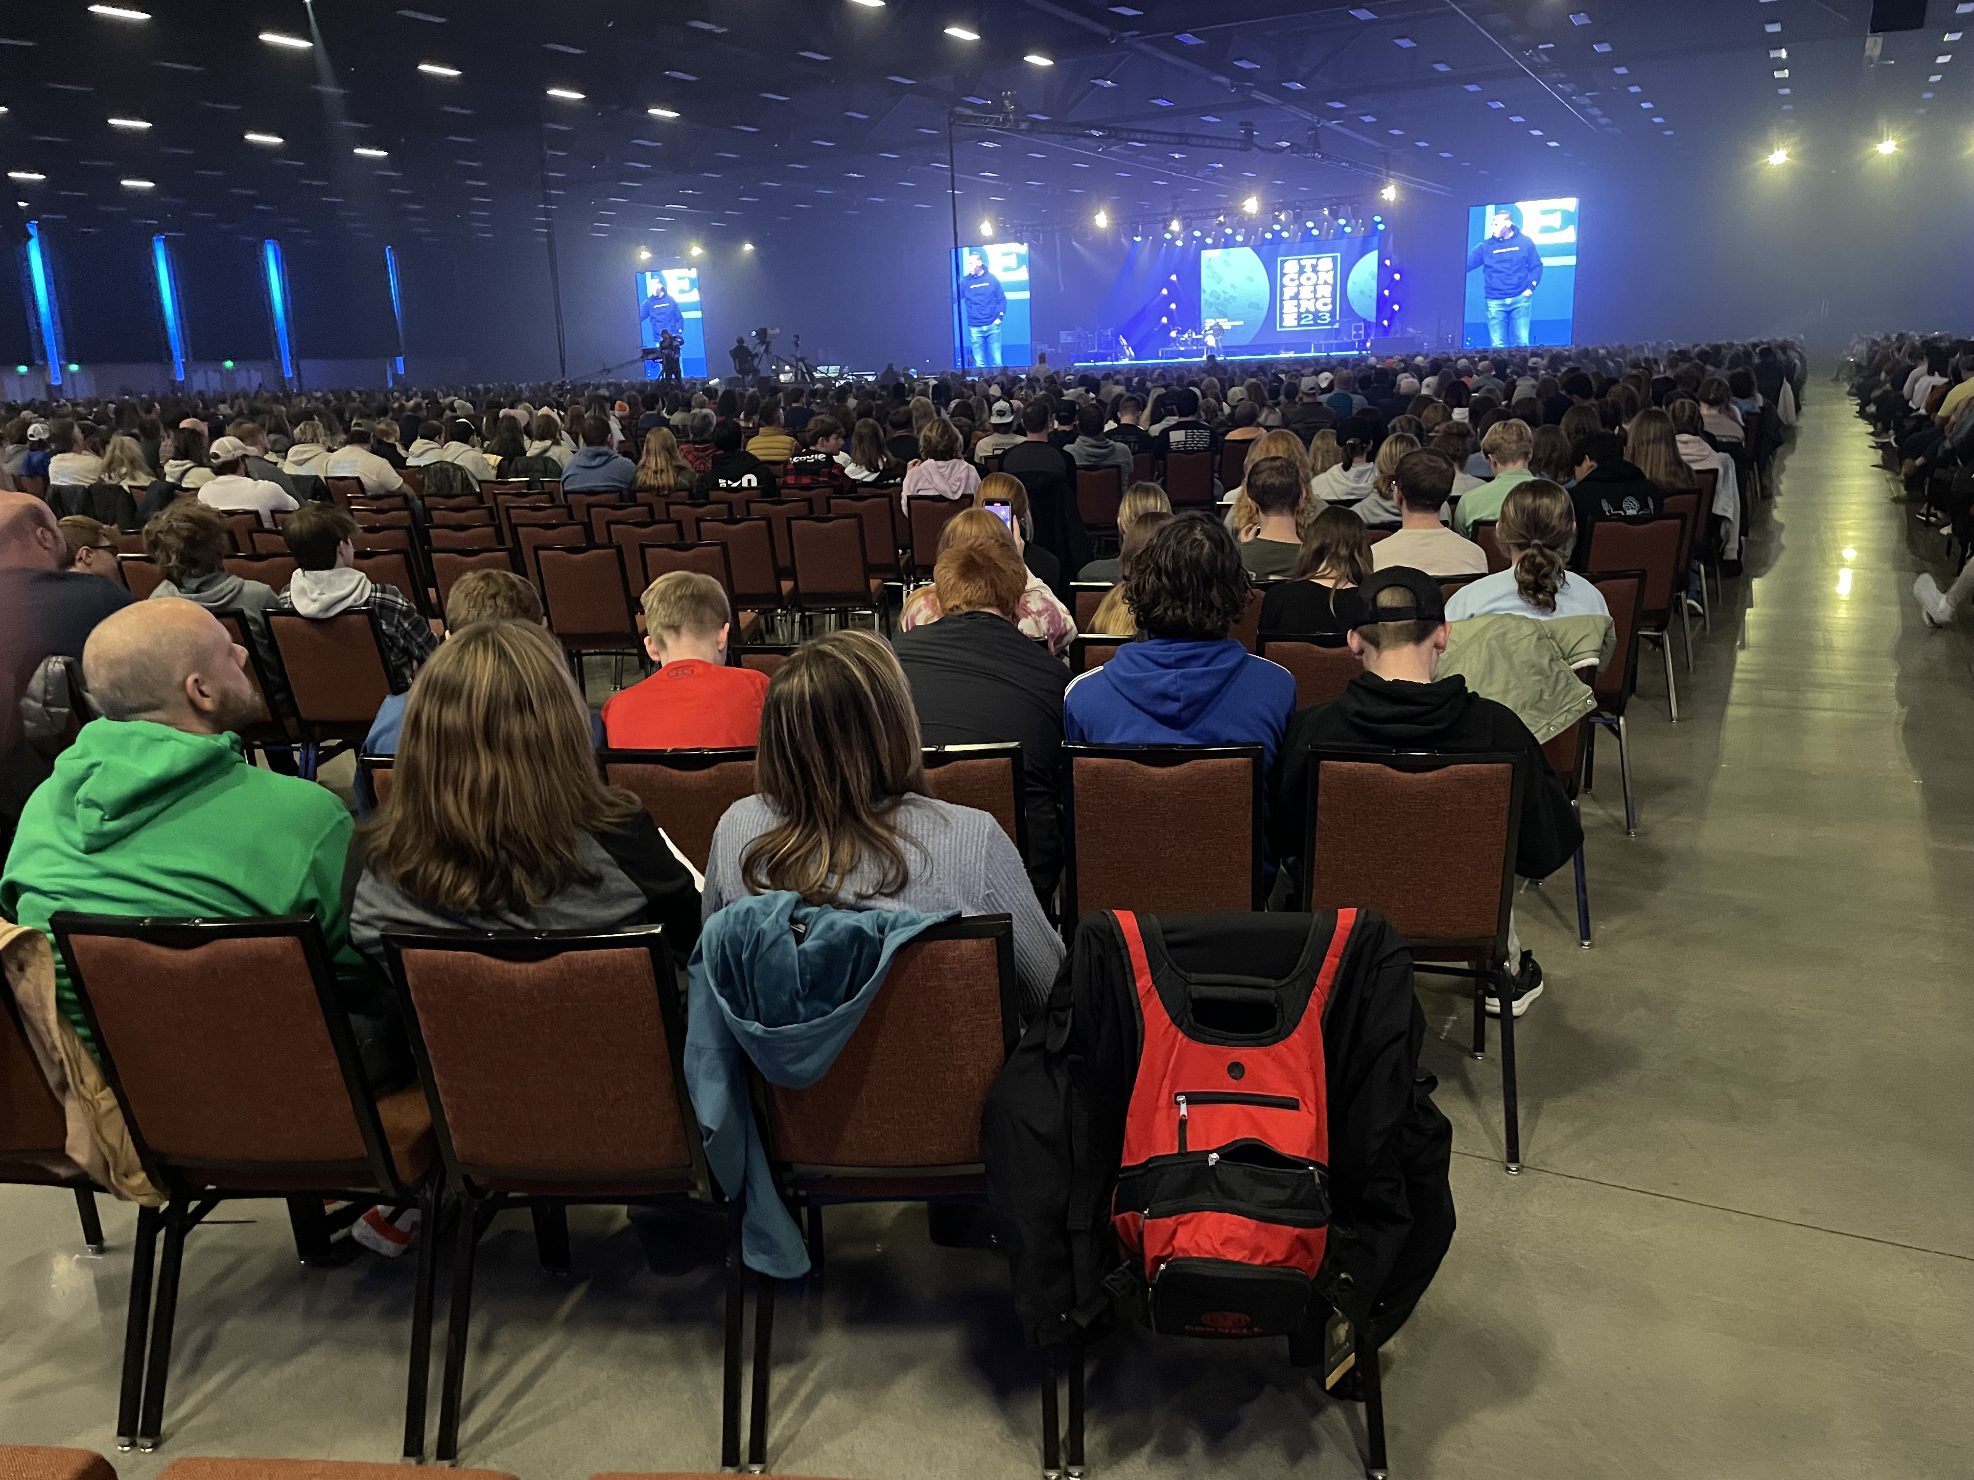
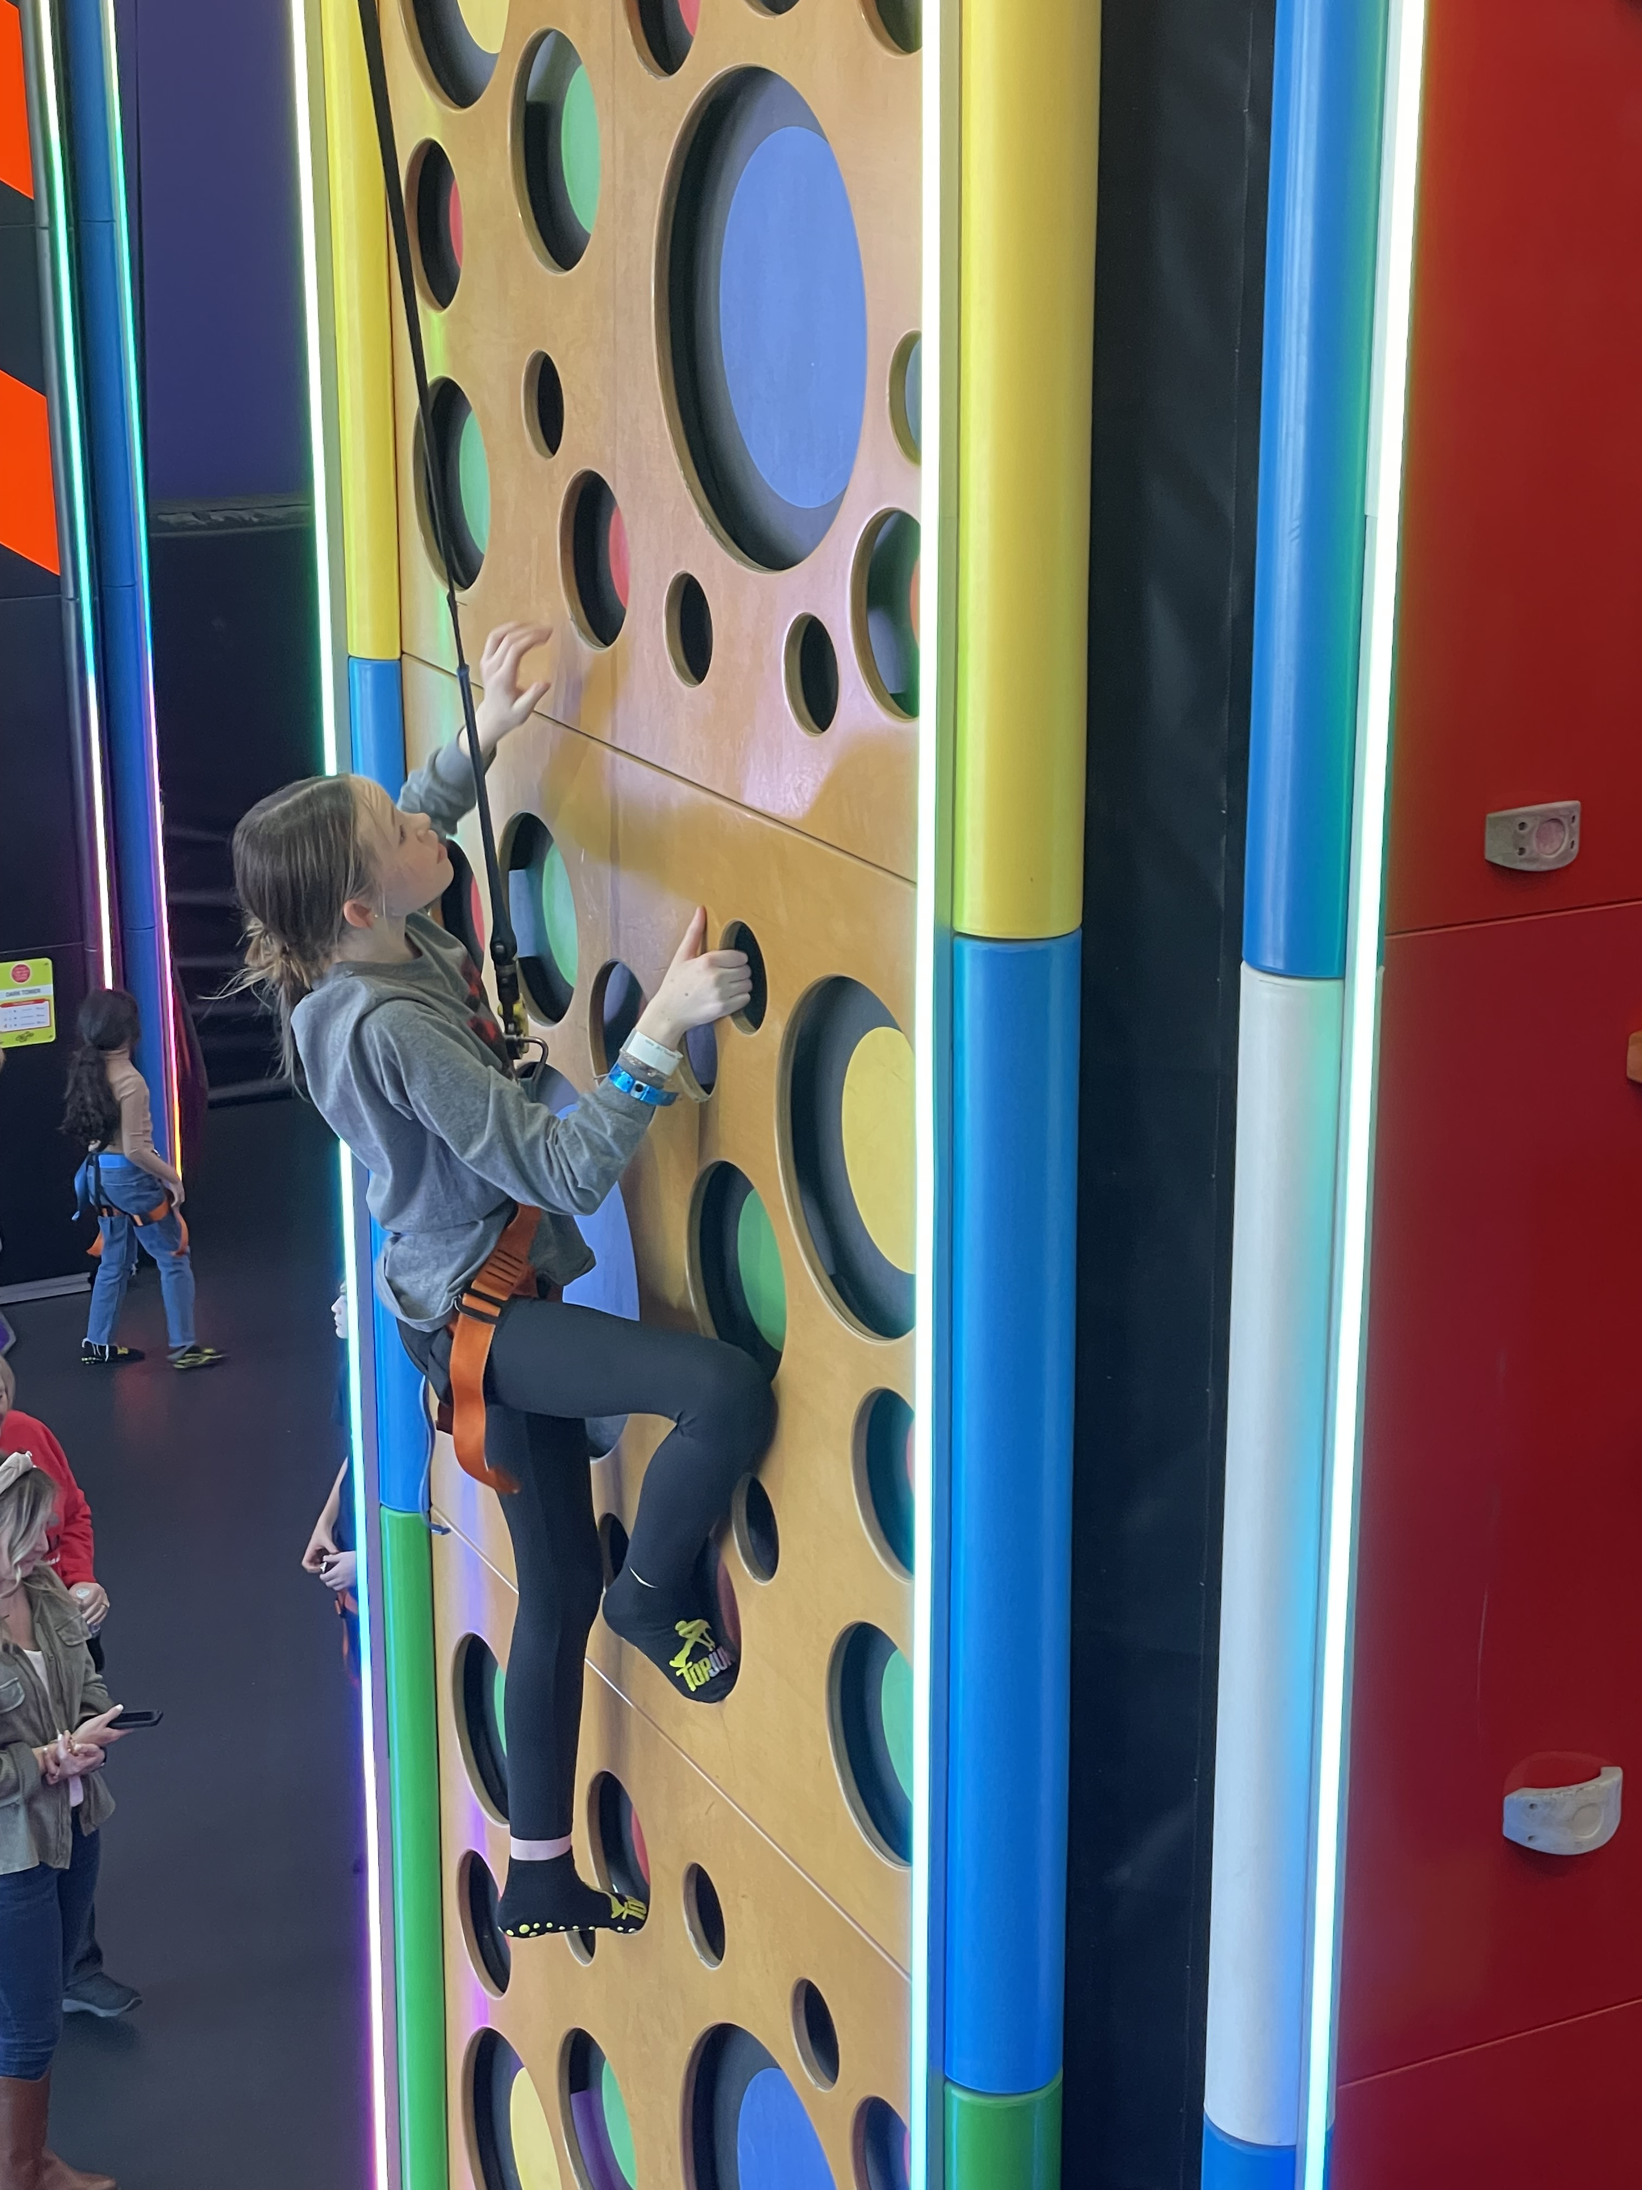
Whether it’s a trampoline and wall climbing adventure, helping out with our Children’s program, attending a conference or concert, or hanging out with pizza on your head, we are the place for you!
Contact Mike “MADDAWG” Darrow for more info –
maddawgdarrow@gmail.com 336.225.0868

