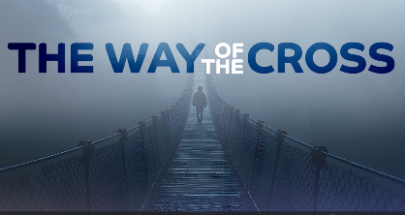
Bethany Church
1110 Echo Lane, Green Bay, WI 54304
920-494-8801

office@bethanygreenbay.org
pastor@bethanygreenbay.org

Maundy Thursday
4/2/26 6:00 pm

Prelude: - Elaine Moss, Piano

*Light of Christ Brought Into Worship

*Greeting and Call to Worship (on screen)

* Hymn: “Come, Share the Lord” Faith We Sing #2269

Prayer/The Lord’s Prayer

Message: The Way of the Cross - Pastor Robb McClintock
John 13:1-17, 34-35, Mark 8:31-38

Anthem: Face the Cross - Bethany Choir

Holy Communion
Confession and Pardon, Passing The Peace
The Great Thanksgiving (on screen)
Sharing in the Bread and Cup (song: Were You There?)

Hymn: “Lamb of God” FWS #2113

*Blessing to Go Forth

*TAKING THE LIGHT OF CHRIST INTO THE WORLD
[Please remain standing as the Light of Christ is carried out before us, leading us to follow Jesus as we love God, love others, and serve the world.]

* Postlude:
---------------------------------------------------
*Please stand as you are able
