English Language: GCSE Non-Fiction Writing Styles
Revision Booklet

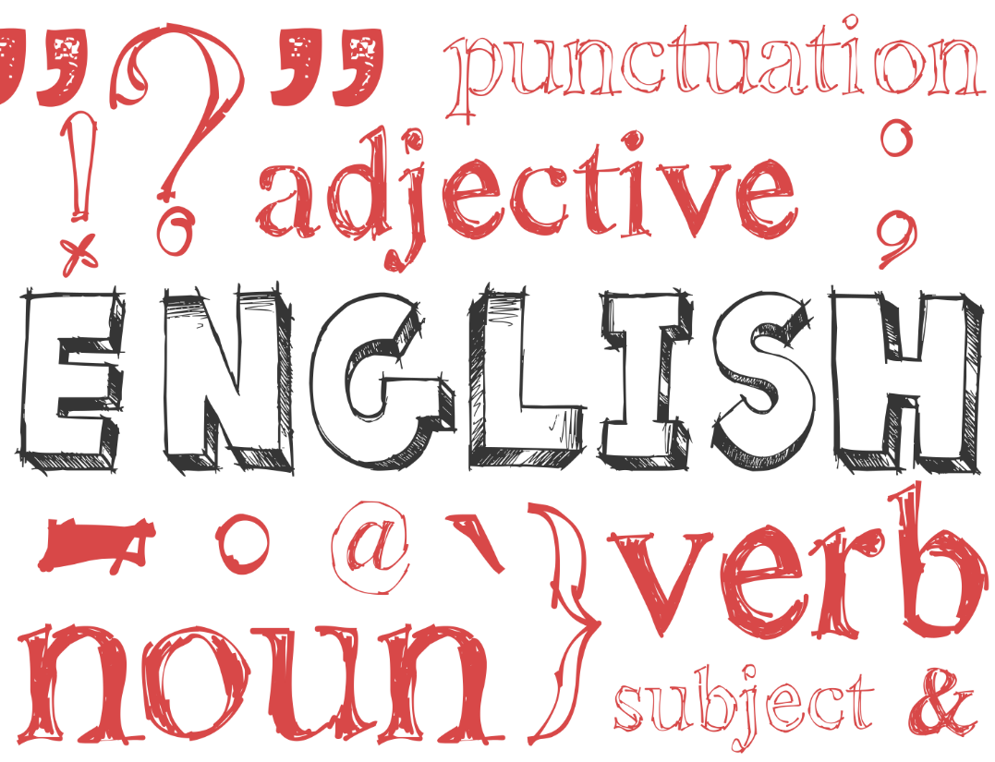

Name: ____________________________

Features of each non-fiction writing style
Writing Style | Unique Features
Formal Letter

Informal Letter

Article

Review

Speech

Report

Leaflet

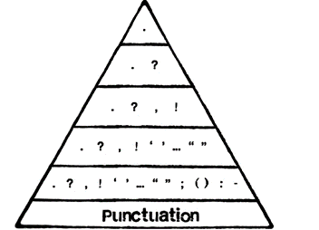
Universal Aspects
Persuasive Devices | Audience Awareness (Tone)
Layout | SPaG

TASK : Some people believe it is preferable to stay in Britain rather than travel abroad on holiday. Write a letter to a newspaper to give your opinion on this topic.
Example
44 Zoo Lane,
Hindley,
Wigan,
WN3 4HZ

26th March 2016
The Wigan Observer,
42 Tottenham Road,
Wigan,
WN3 6PS

Dear Editor,
Having recently read several articles that suggest it is unethical to travel abroad, I thought I would express an alternative point of view. I am the first person to express love for my country: England is my home and I’m proud to be English, however, I simply cannot agree with the idea that holidays abroad should be avoided.
I don’t mean to give Mother Nature a cough, but I fail to see how one tiny flight a year can compare to the hundreds of coal stations around the world that pump millions of tonnes of waste into the environment. Let me make it clear to every one of your readers: I am passionate about the natural world and I am not one of those fools who claims that global warming is a myth. I recycle. I never drop litter. I even have a solar panel on my roof at home. So, with all the effort I put into protecting our planet, do I not deserve a quality holiday every summer?
It’s not as if the sun usually visits us in England. Our version of summer is waking up to a sky that isn’t the same colour as the pavement! You can keep your wet weekends in Devon; I’ll sip cocktails on a beach in Mexico. I mean what would you prefer: a game of cards in a caravan or the crystal clear sea and softly swaying palm trees? I’m not putting down our home, but you must remember that travel allows you to experience a new culture and meet new people.
Have you ever seen the Eiffel Tower? The Pyramids? The Statue of Liberty? Every time I’ve been abroad it has broadened my horizons and I’ve been amazed at the beauty of the world. Staying at home and Googling pictures of these places just isn’t the same. My children have learnt more from seeing Mount Vesuvius than they have from building a model of a volcano in their science lesson. Also, consider what would happen to countries that rely on tourism. I dread to think of what would happen to Egypt, Turkey and many other places without the financial support of travellers.
I know there is a cost to the environment when we travel, but I choose to travel only once a year. It makes all the difference to my family; we work hard all year and it is our one treat. I do not deny the cost to the planet, but the look on my children’s faces the first time they saw Disneyland was priceless. I’ll never forget the incredible memories I have from travelling abroad and I would encourage your readers to travel (inside and outside the country) as much as possible.

Yours faithfully,

Tim Blake

TASK: You have a friend at university who is considering entering a clinical trial to earn money. Write a letter to your friend to express your opinion.
Example
17 Bold Street,
Chester,
CH4 5ER
1st March 2016
Dear Kyle,
I thought I’d write to you straight away as I saw on Facebook that you were considering getting involved in clinical trial at university to pay your rent. Now, I’m not one for dramatics, but I have to ask: have you lost your mind? No, I’m serious! I know life at uni is difficult and that money is tight, but to allow someone to pump you full of an untested drug seems beyond stupid. I know that you can be a little… shall we say ‘rash’ sometimes… so I wanted to sort this out before it goes too far.
Now I know I sound extreme, and that I’m coming on a little intense, but you’re one of my oldest mates and there is no way I can sit back and just watch you do this. Only a total moron would consider risking their health for a few quid. I know it must sound exciting, and there were a few people on Facebook who commented on your status to encourage you, but please don’t listen to them. They don’t have your best interests at heart; they see it as entertainment and a bit of laugh, but the laughter will stop quickly if something goes wrong…
You do realise what you’re getting yourself into, don’t you? These random drugs have NEVER been tested on a human being before. Ever. Only rats. Which basically makes you a human rat. Their little pet for tests. Does that sound like a good time? Most of the drugs have names that aren’t even pronounceable! Also, they make you sign a contract before you take them so that you can’t sue them when things go wrong. That fact doesn’t exactly inspire faith, does it? I can just imagine the (mad) scientist saying: “Here, sign this paper. Now bend over for this giant needle.” Not much fun…
Besides you also need to consider the side effects. Oh yes, you didn’t even think about those, did you? Not only are you choosing to take dangerous, untested drugs (that most normal people would run a mile from), but they cause side effects: which means you could end up with a hairy back, a third-eye or even a heart attack. Again, not much fun…. I bet that thousand pounds isn’t sounding like such a good deal now. Have you spoken to your parents about this? I’d hate to see your mum in a state because you decided to make some ‘easy’ money. I know life at uni is expensive, but your health is priceless. It’s just not worth the risk, mate.
If I were you, I’d look for a job. I know that doesn’t sound exciting, but it’s better than the alternative. I’d get a job in a bar or club, then someone can pay you to party! Plus you could use it as an opportunity to chat up the girls (I know what you’re like!) Seriously though, think about it hard before you decide and give me a call to talk it through.
See you soon,
James

TASK: Write an article for a teenage magazine about a person who you admire or detest.
Example
The Saviour of Pop Music
I’ve got a confession to make: I’m not a big fan of pop music. I know, it’s unusual. I’m one of the few. It’s ‘pop’ as in ‘popular’, yet I can take it or leave it. To me it’s all the same: manufactured, cheap and predictable. That’s until I heard Lily Allen. I know, not your typical candidate for world’s greatest pop star, but hear me out…
Lily burst onto the music scene in 2006, with the infectious ‘Smile’, and immediately made an impact. Like a breath of fresh air, she offered witty lyrics (full of cockney rhyming slang) and an off-beat style (trainers and dresses – bizarre, I know). She went on to sell 2.6 million copies of her debut album, ‘Alright, Still’ and won pretty much every major music award in the process. But she didn’t let that success go to her head; instead she remained the same down to earth teenager and went on to even bigger and better things with her amazing follow up, ‘It’s Not Me, It’s You’ (2009).
Impressively, Lily writes all her own music. And she can sing. A strange statement considering she’s a pop star, but consider some of the other “talent” (I’m looking at you, Katy Perry!) If you don’t believe me, visit YouTube and check out ‘Somewhere Only We Know’. The vocals are breathtaking – up there with Adele or Florence Welch! She also sings live. Always. No lip-syncing here (listen and learn Cheryl Cole!)
But what I most admire about Lily is her attitude: she’s feisty, fearless and funny. She doesn’t use her body to sell her music (unlike Miley ‘twerking’ Cyrus or Nicki ‘I’ve lost my underpants’ Minaj). In an age where most pop stars Photoshop themselves and hide behind press releases, I find it refreshing that Lily will go on national television to happily discuss her stretch marks and cellulite. She isn’t afraid to show her flaws and be honest.
Also she took five years out of the music business to have her children. Can you think of many other pop stars who would risk their fame for their family? I think that’s pretty amazing and it makes her a role model. Even after her long break, she returned with another superb album, the hilariously titled, ‘Sheezus’ (2014).
But Lily’s not perfect: she’s had many petty Twitter arguments with other celebrities and her comments in the media can sometimes be childish and attention seeking. But, if I’m honest, that just makes me like her more! Give me a flawed artist over all those other plastic divas any day. Keep it up Lily; to me you’re nothing less than the saviour of pop music.

TASK: Write a film review for a teenage magazine.
Example

Star Wars Episode Three: The Revenge of Mediocrity
So, after the disappointment of 1999’s highly anticipated prequel ‘The Phantom Menace’ and the excess of 2002’s frankly quite terrible ‘Attack of the Clones’, the question on everybody’s lips is “has George Lucas redeemed himself with Episode Three: Revenge of the Sith?”
The answer, judging by the noisy, shallow and virtually pointless mess I have just had the misfortunate of sitting through for two hours, is a resounding “no”! Part of the problem, if you have been following the whole Star Wars Saga, is that we know the outcome of the film before it even begins, therefore undercutting any potential tension from the start.
It’s all about the transformation of the clean-cut Anakin Skywalker (teen heartthrob Haydn Christenson) to the evil dark lord Darth Vader, along with some incredibly tedious stuff about the shifting of the Jedi’s political climate.
Ultimately, though, the plot takes a back seat to the action, becoming nothing more than a skeleton on which to hang endless battles in outer space and lightsabre fights on various planets. This may sound like a good thing; sometimes a brainless, action-packed rollarcoaster ride is just what we need. However, Episode Three’s action sequences do not differ that greatly to those we were treated to in Episode One and Two, and the spectacular, mind-numbing overuse of CGI means you’d probably be better off sitting at home staring at a computer screen.
As a result, Episode Three is not an engaging film. It does not make you care about any of the characters. None of the actors are remotely charismatic or even convincing. Even the usually dependable Ewan McGregor turns in an emotionless performance, while Christenson does little other than spare at the camera menacingly.
What should have been the most horrific scene, Skywalker killing a group of defenceless children (or ‘younglings’ in Star Wars speak) was made amusing simply by the poor effort put into the scene by any of the actors. Admittedly, the film is not without strengths - the attention to detail is often quite stunning, the backdrops are rich and colourful – but these are not enough to carry the film on their own.
I’m sure you could have done better, Mr Lucas.

Rating: **

TASK: A website has invited the public to produce a video chat about the standard of programmes on television. The website is offering a cash prize for the best response. Write your speech.
Example

Recently the television has been invaded by a host of ridiculous ‘talent’ shows. Having been subjected to the ‘entertainment’ of these talent shows for so long, I wish to put the world to rights: They are a travesty and poisonous to our culture! Weekly, I am forced to suffer through the agony of the X-Factor. These shows present pathetic low-lives who parade around the stage, claiming that they are “doing it for their nan”, in feeble attempts to snatch fifteen minutes of fame. The whole concept is wrong and this type of show should be banished from our screens forever.
Firstly, the audition rounds are a form of human bear-baiting! Desperate souls look for some form of acceptance from a big shot in the music business, whilst millions at home laugh and cringe at their ridiculous attempts at hitting the right notes! Last week, I had to mute the television as I could no longer stand the screeches of a 43 year old prison officer from Stoke, who took it upon himself to offer us a rendition of ‘Barbie Girl’. Who wants to hear this nonsense? The only conclusion I can draw is that his friends from the pub heard him at karaoke and dared him to inflict his ‘singing’ on the entire nation!
Furthermore, the shows are clearly fake. The X-Factor and Britain’s Got Talent are littered with deluded individuals who mindlessly moan such lines as “oh please, it’s my life” or “just one more chance”. It’s all an act. I even find myself shouting insults at the television (such as “not even a tear”) when an act breaks down crying after not getting to the next stage. I’m a teacher and if I were to take the same attitude as Simon Cowell every time my students made a mistake I’m sure there would be serious consequences. These shows do not reflect real life and send the wrong message to young people.
Finally, I find it outrageous that so many people fail to see that these shows are nothing more than money-making machines. I understand how the nation can be gripped by a favourite act or an exciting performance. However, I fail to see how the television executives can justify £2.00 per vote. Is it fair that these men make millions whilst the people who vote suffer through the recession, struggling to live? I can’t help but think of the Food Bank in my town centre and how that money could be better spent…
In fact, if I were to win the prize money, my plan is to use it to have Simon Cowell deported. I think we can all agree that would be a useful public service!

TASK: Write a report about the catering services at your school.

The Catering Services at The Yellow House School
A report to: Mr Ollier (head teacher)
Introduction
This report will address the catering services at The Yellow House School. Currently the school has a main dining hall, the unit (a ‘grab-and-go’), and several vending machines to deliver its catering services. This report will evaluate the quality/variety of food; queuing and seating; and payment system throughout the school.
The quality/variety of food
The catering services offers a good range of food: from waffles and toast at break, to a wide range of choices at lunch (including vegetarian options). The school offers several options each dinner time and this changes every day. On Fridays a fish option is available. The unit has sandwiches, pastas and pizzas available every day. When surveyed, most pupils were happy with the price and variety of food, but a significant portion (35%) claimed that the quality of food could improve. Many stated that the pasta was swamped in water and that the pizzas were greasy.
Queuing and seating
The student voice survey also revealed that many pupils think that the queues in school are extremely long and, in some cases, there is an issue with pupils pushing in the queue. This results in some pupils missing out on food, or the food being luke-warm when they fight their way through the queue and finally find a seat. Younger students sometimes find seating an issue as they are intimated by large groups of older pupils.
Payment system
The school has implemented a new payment system recently: it has moved away from paying cash at the till to a cashless system with money added online. This is popular with students; it means pupils do not have to worry about forgetting dinner money. However, the new system, as it is placed near the entrance to the dining room, has contributed to the queues at peak times.
Recommendations
Although the overall quality of food it good, the pasta and pizza need improvement. Both are produced in the unit dining room, so it may be possible to add staff, or improve facilities to increase the quality of food served there. A new seating system should be implemented so that year groups sit together; this will avoid younger pupils feeling intimidated by the older pupils. Finally, the payment system should be available before and after school so that pupils can add/check their credit outside of peak times. This would help to reduce queues at lunch time.
Report by: Joe Bloggs

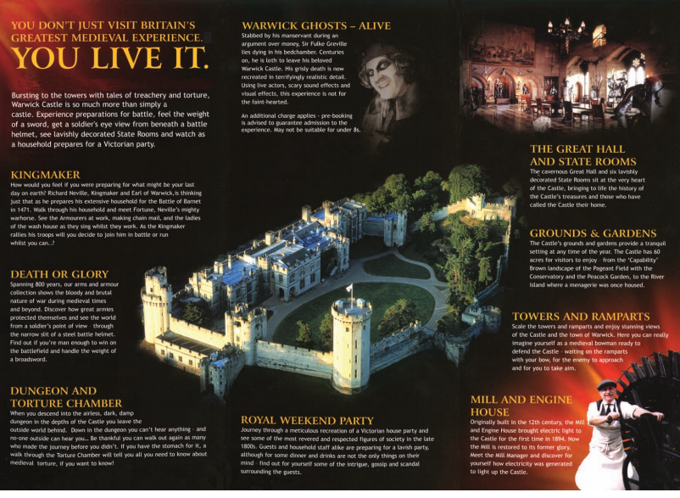
Past Writing Questions

2016
- Speech – organise a charity events in school
- Report – report on behaviour in school
2015
- Letter – Defend your school from closure
- Speech – Argue for a destination for an end of year trip

2014 1. Formal Letter – complaint about a disastrous train journey
2. Lively review – film/TV programme or a book you have read
2013 1. Formal Letter – your views on raising the legal age for driving
2. Lively article – “Keeping fit and healthy”
2012 1. Formal Letter – (to a newspaper) your views on TV talent shows
2. Leaflet – Guide to attract tourists to a city or town in your area
2011 1. Formal Letter – your views on plan to build a supermarket over land currently used by children to play sport
2. Speech – to a group of elderly people to persuade them to use the internet
2010 1. Letter to a friend – opinion about him/her taking up boxing
2. Lively article – recent trends in music/film/fashion
2009 1. Formal letter – views on motorcycle racing in local streets.
2. Article for school mag on issue of saving energy.
2008 1. Lively article – how to cope with teenagers.
2. Formal letter – views on smoking ban.
2007 1. Lively magazine article for people your age – joys of exercise.
2. Formal letter to a newspaper – views on holding music festival in your area.

2006 1. ‘Rough Guide’ review for a tourist attraction/area you know.
2. Letter to a friend – opinion about him/her running marathon.

2005 1. Formal letter to MP – views on cars and pollution.
2. Review of book/film/music CD for magazine aimed at your age group.

2004 1. Lively article on British eating habits.
2. Letter to a friend – he/she considering living abroad – give your opinions.

2003 1. Leaflet to advertise a tourist attraction.
2. Lively article – latest trends in music/film/TV/fashion.

2002 1. Speech to your class – views on how to deal with teenage crime
2. Formal letter to newspaper – views on high salaries paid to footballers/celebrities.

