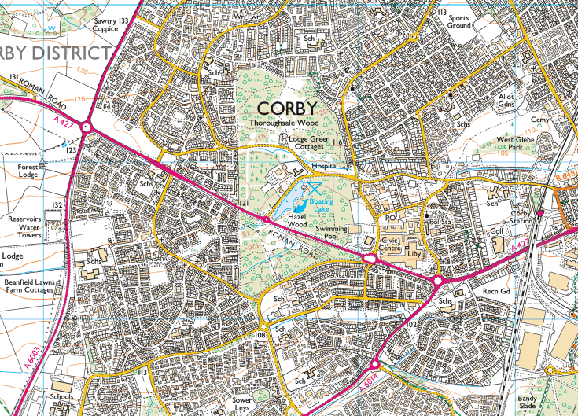
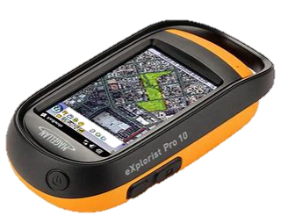
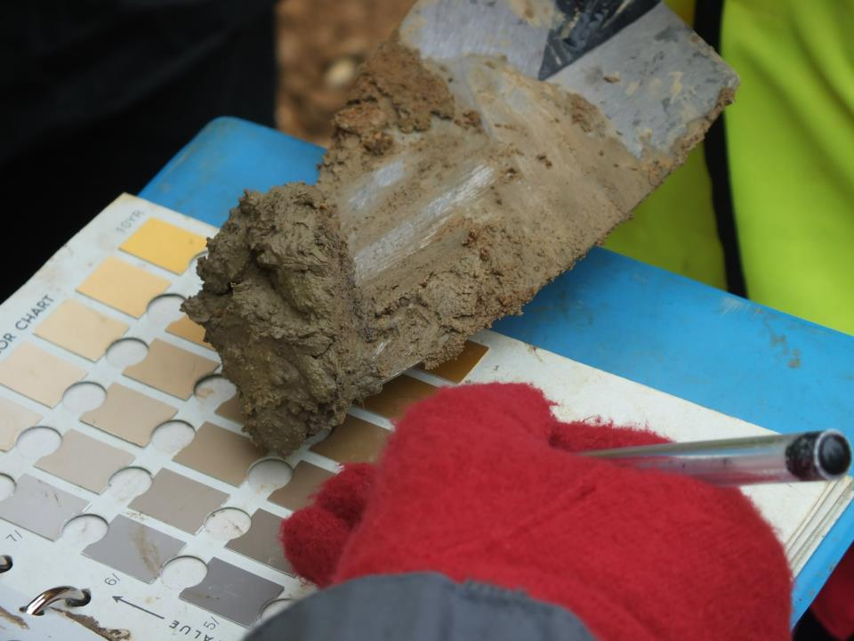
THIS BOOKLET IS YOUR OWN RESPONSIBILITY

Name: ___________________________

GEOGRAPHY SKILLS ACTIVITIES
PAGE | TOPIC | TICK WHEN COMPLETED
1 - 13 | SECTION 1 – MAP SKILLS
14 - 19 | SECTION 2 – DATA SKILLS
20 - 22 | SECTION 3 – INTERPRETING PHOTOS
23 | Notes page
Contents Page

How to use your skills booklet
Attempt EVERY question as answers will be self and peer reviewed during lessons
Coloured boxes indicate question levels. Tick the colour matching the level of question you have answered
Purple boxes indicate areas where you can “level up” your skills and explains how to do so, with practice questions

SELF/PEER ASSESSMENT
WWW | EBI (Areas I am still unsure about)
e.g. I am able to identify 4 figure references …  e.g. You are able to compare maps and identify human features | e.g. I am unsure how to complete 6 figure references  e.g. You need to review how to read population graphs
RED PEN REFLECTION
TEACHER COMMENT

Use the green self-assessment boxes to complete the in class selF assessment activities

Glossary of key words and command words
KEY WORDS
OS Map | Ordinance Survey Map
grid reference | a map reference indicating a location
Contour lines | a line on a map joining points of equal height above or below sea level (demonstrating height)
Data | Values – Typically letters or numbers
Statistical data | Information in the form of numbers, usually presented in tables
Fossil fuels | Natural fuel formed from the remains of living organisms. E.g. Oil and Gas. Fossil fuels are NON RENEWABLE.
Non renewable | Finite. It will eventually run out
Renewable | Energy sources that are replenished and do not run out, e.g. Solar Power
primary employment | Primary jobs involve getting raw materials from the natural environment e.g. Mining, farming and fishing
secondary employment | Secondary jobs involve making things (manufacturing) e.g. making cars and steel.
Tertiary employment | Tertiary jobs involve providing a service e.g. teaching and nursing.
population | all the inhabitants of a particular place.
weather | The day to day changes in atmosphere
climate | the weather conditions of an area over a long period of time
atmosphere | thin layer of gases that surrounds the Earth.

Command Word | Meaning
account for | explain (reason)
analyse | examine closely; examine in parts; show how the parts contribute to the whole
assess | decide the value of; judge; measure the importance of
compare | discuss two or more things in terms of their similarities and differences
critically evaluate | weigh arguments for and against something; assess all evidence; decide which opinions, theories, models or items are preferable.
describe | give a detailed account of the features of something without interpreting the information
discuss | present and give a judgement on the value of arguments for and against; consider all angles
evaluate | judge; criticise in terms of impact/significance, and investigate the implications
examine | make clear the details/meaning of; look in particular at reasons, causes and effects; account for; give reasons; justify
explore | describe in detail and note impact
indicate | focus on specific areas (similar to illustrate)
interpret | make clear the meaning of; consider implications
outline | describe main features; give a broad but thorough account; identify briefly the main features of
relate | show similarities and connections between two or more things
review | describe chief features and criticise generally (important parts)
SECTION 1 - Map Skills
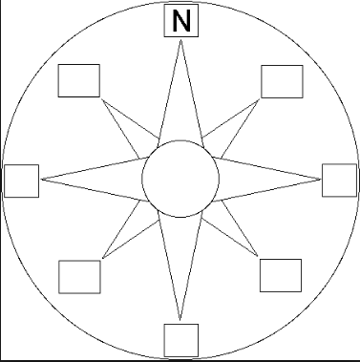
- Label the 8 points on the compass
NW

NE
SE

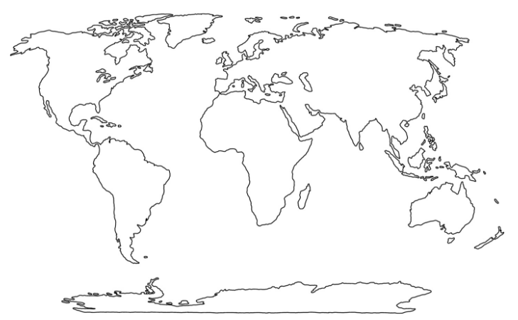
- Label the following continents and oceans
- Antarctica
- South America
- North America
- Africa
- Australasia
- Europe
- Asia
- Southern Ocean
- South Pacific
- North Pacific
- Indian Ocean
- Arctic Ocean
- North Atlantic
- South Atlantic

- Complete the grid references section of the booklet
HELPFUL HINTS:
Remember, coordinates can be separated into 4 and 6 figure references.
i.e. 54 67 OR 56 8 57 4
How to:
To find a location on the map, follow the grid along to the row your location is in. This is your “Easting”.
Then, move up the column (your “Northing”) to the box your location is in.
You can remember this as going “along the corridor and up the stairs”

Find the 4 figure grid reference for each shape
17 11
_ _ _ _
_ _ _ _
_ _ _ _

14

10
13

10
10

10
12

10
11

10
10

10
15 16 17 18 19

14

10
13  10  10  10 |  |  | 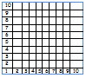
12

10
11

10
10

10
15 16 17 18 19
LEVEL IT UP:
You can make your directions clearer by using a 6 FIGURE GRID REFERENCE

To do this, split your box into 10X10

Your reference would then read; your 4 figure reference, plus the number from your 10x10 square
i.e. 18 8 13 5

14

10
13

10
10

10
12

10
11

10
10

10
15 16 17 18 19
Find the 6 figure grid reference for each shape
_ _ _ _ _ _
_ _ _ _ _ _
_ _ _ _ _ _
_ _ _ _ _ _
_ _ _ _ _ _

SELF ASSESMENT – OS MAPS AND SYMBOLS
WWW | EBI (Areas I am still unsure about)
RED PEN REFLECTION
TEACHER COMMENT
- OS Maps and symbols
What is a map scale?
The scale of a map shows how much you would have to enlarge your map to get the actual size of the piece of land you are looking at. For example, your map has a scale of 1:25 000, which means that every 1cm on the map represents 25 000 of those same units of measurement on the ground (for example, 25 000cm = 250 metres).
That might sound a bit complicated, but OS maps have been designed to make understanding scale easy. Look at the front of a 1:25 000 scale map and you will see that the scale has been also written out for you like this:
4cm to 1km
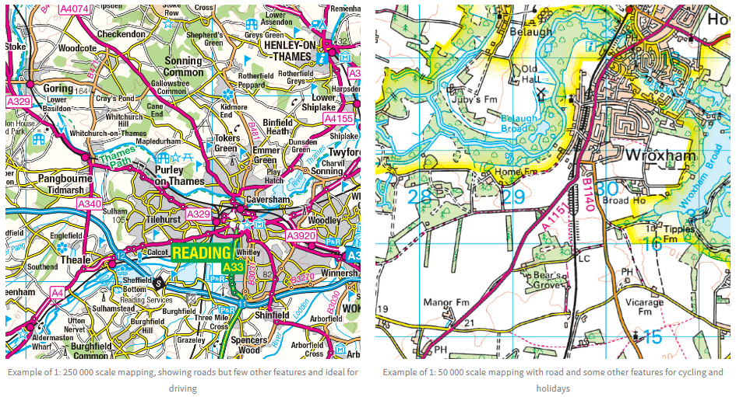
This means that every 4cm on a map = 1km in real life. To make it even easier, the grid lines are exactly 4cm apart, so every square is 1km by 1km.
Explain why it is useful to have maps in different scales
Describe the differences between the two different scales of map

OS symbols
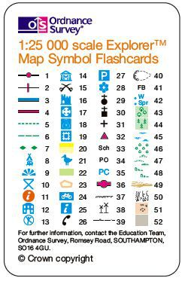
Name the OS symbols

1.
2.
3.
4.
5.
6.
7.
8.
9.
10.
11.
12.
13.
14.
15.
16. 21. 26.
17. 22. 27.
18. 23. 28.
19. 24. 29.
20. 25. 30.

31. 41. 51.
32. 42. 52.
33. 43.
34. 44.
35. 45.
36. 46.
37. 47.
38. 48.
39. 49.
40. 50.

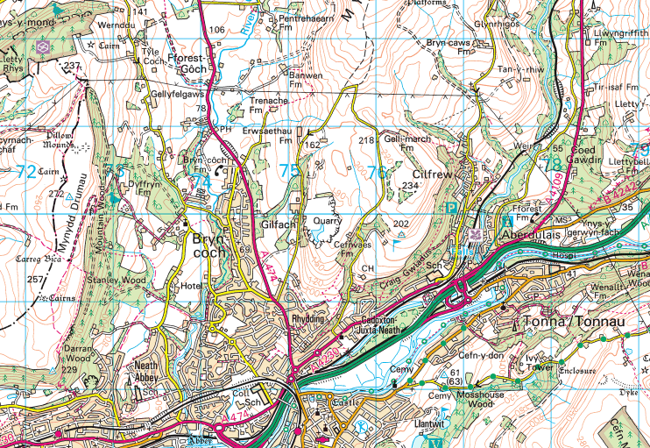
FIGURE A
State the types of tourism available in Figure A

Explain the human landscape of Figure A, in reference to tourism

Describe the human landscape of Figure A

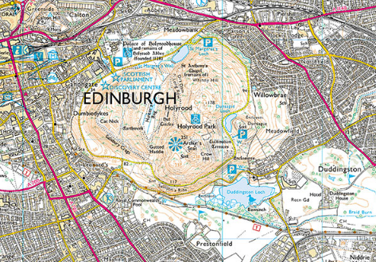
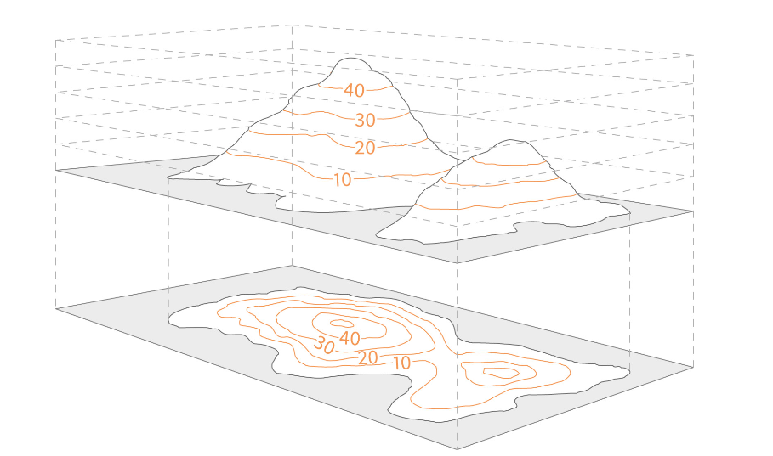
TASK:
FIGURE 1
Using the contour map and hint box above, draw a sketch map of the landscape looking West from Meadow field

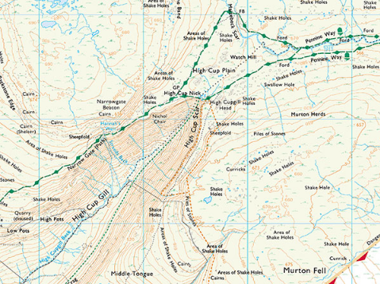
Describe the change in landscape from the top of the Pennie Way (NE) to the end of Narrow Gate (Path) (SW)

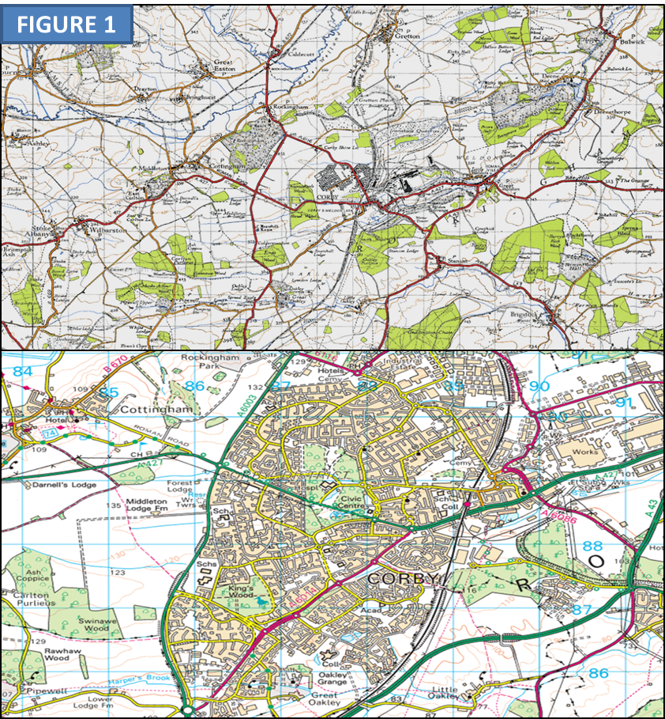
FIGURE 1

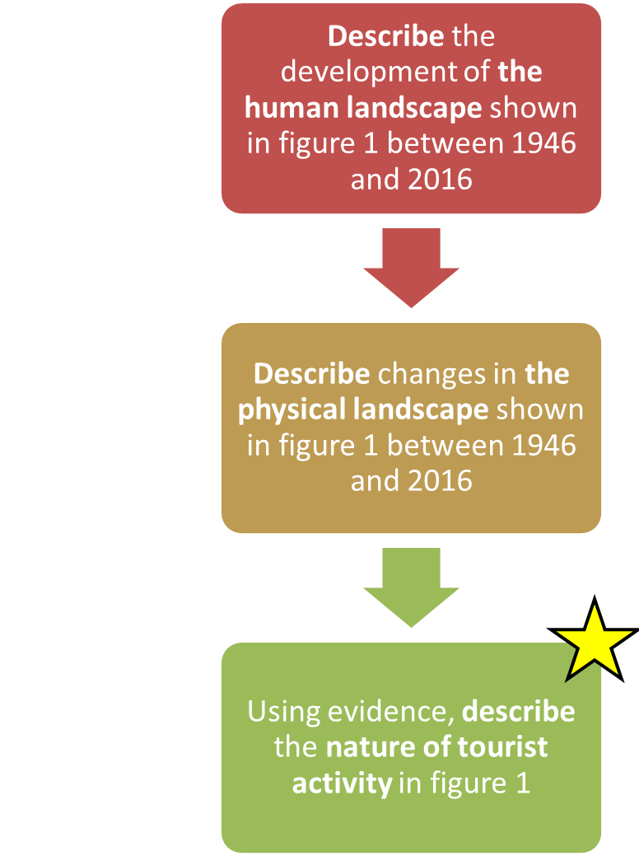


Human landscape –
Landscape designed and adapted by humans. For example roads, buildings, cultivated farmland
Physical landscape –
The natural landscape, for example woodlands, forests, rivers and hills/mountains

SELF/PEER ASSESMENT – OS MAPS AND SYMBOLS
WWW | EBI (Areas I am still unsure about)
RED PEN REFLECTION
TEACHER COMMENT
SECTION 2 – Graphs and data skills
Different types of graph are used to represent statistical data.
Most graphs have two axes: the X axis is horizontal (across the bottom) while the Y axis is vertical (up the left side). The two axes each represent a different set of data.
HELPFUL HINTS:
LINE GRAPHS
Line graphs are drawn by plotting points by their X and Y coordinates, then joining them together or drawing a line through the middle.
The line graph below shows how energy consumption is expected to rise, while the consumption of (use of) fossil fuels falls (goes down) and the demand for renewable energy increases.(goes up).

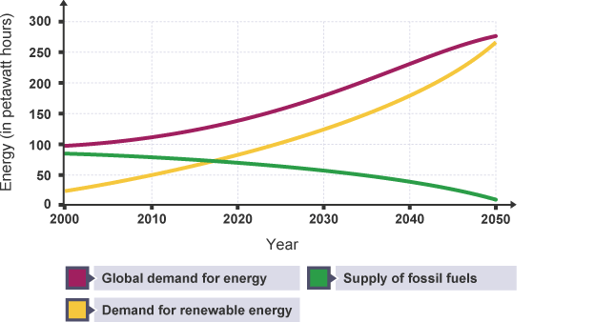
Figure 2

HELPFUL HINTS:

PIE CHARTS
Pie charts are used for showing how something breaks down into parts e.g. percentages of people.
- Pie charts are usually drawn so the biggest piece of pie comes first (starting at 12 o'clock).
- The 'others' section usually goes last (coming up to 12 o'clock).
- If each piece of pie has its percentage written in, it's easier for the reader to work out the exact proportions.

The pie charts below show differences in the split between primary, secondary and tertiary employment in USA, Brazil and Nepal.

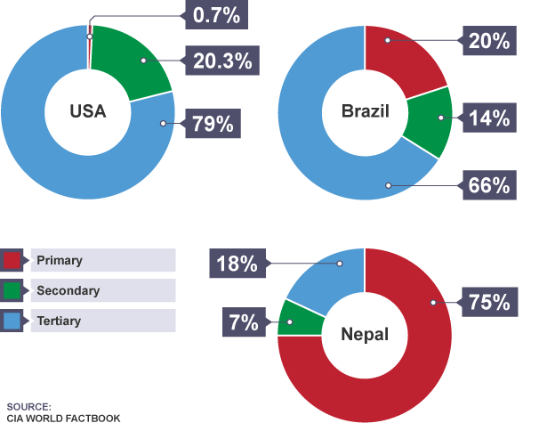
(ALL MUST COMPLETE)
Define primary, secondary and tertiary employment

Primary

Secondary

Tertiary



Which country has the highest percentage of tertiary employment?

Which country has the highest percentage of primary and secondary employment?
__________________________________
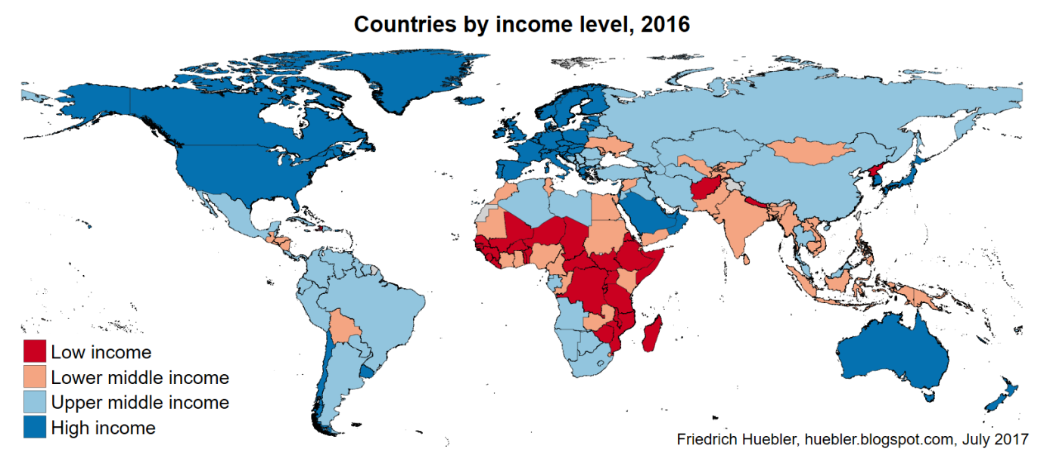
Describe and compare the employment of Nepal and Brazil

Using evidence from graph 2 and figure 3, suggest why the United States of America has a higher percentage of tertiary sector employment than Nepal

HELPFUL HINTS:
BAR CHARTS
The X axis shows what type of data each column represents, and the Y axis shows a value for that type of data. For example, in a rainfall graph, each column on the X axis represents a month of the year, with the height of each column on the Y axis showing the amount of rainfall in that month.

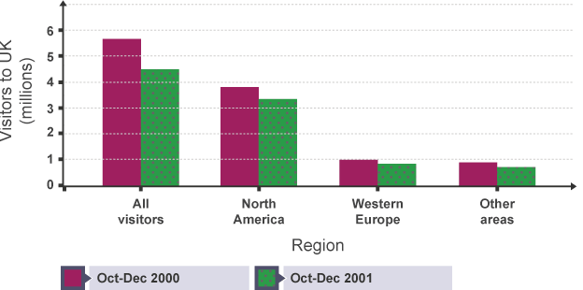
TRUE OR FALSE? (tick the appropriate box)
 | TRUE | FALSE
The number of visitors to the UK decreased between 2000 and 2001
A higher number of visitors to the UK came from North American in 2001
The total number of visitors to the UK in 2000 was over 5.5 million
There were less visitors in total from both Western Europe and other areas than from North America
There were more visitors from Western Europe in 2000 than other areas
From this graph in can be deduced that the highest number of visitors from other areas came from South America

HELPFUL HINTS:
CLIMATE GRAPHS
A combination of a bar graph and a line graph. Temperature is shown on a line graph, with the figures being shown on the right side of the graph. Rainfall is shown by a bar graph, with the figures being shown down the left side of the graph.

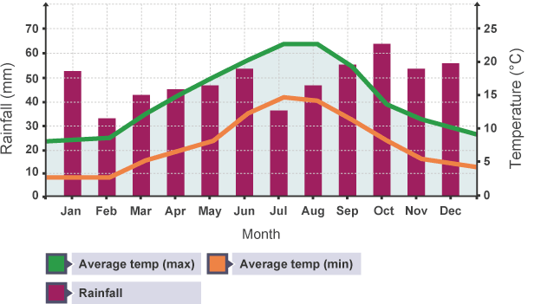

Which month has the lowest temperature?
___________
Which month has the highest rainfall?
___________
What is the difference between the maximum and minimum temperature in July?
___________
What is the range of temperature across the year? (Subtract the minimum temperature from the maximum temperature).
___________
What is the total annual rainfall? (Add each moths total rainfall together)
____________
Describe the climate of this area

____________________________________________
SELF/PEER ASSESMENT – OS MAPS AND SYMBOLS
WWW | EBI (Areas I am still unsure about)
RED PEN REFLECTION
TEACHER COMMENT

SECTION 3 - Interpreting photos
HELPFUL HINTS:
Photos may be used to illustrate almost any aspect of geography. You need to be able to identify, describe and interpret the geographical processes that can be seen in a photo. You may be asked to identify or comment on what you can see or to compare the information from a photo with that from a graph or map.

Take a look at the picture below. Annotate (label) the PHYSICAL and HUMAN features you can see

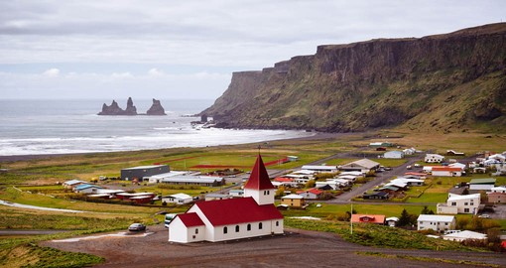

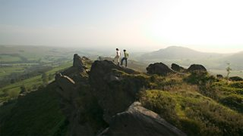
Describe the possible impacts of the activity shown
__________________________________________________________________________________________________________________________________________________________________________________________________________________________________________________________________________________________________________________________________________________________________________________________________________________________________________________________________________________________________________________________________________________________________________________________________________________________________________________________________________
Suggest ways in which these impacts can be reduced
_______________________________________________________________________________________________________________________________________________________________________________________________________________________________________________________________________________________________________________________________________________________________________________________________________________________________________________________________________________________________________________________________________________________________________________________________________________________________________________________________________________________________________________________________________________________________________________________________________________________________________________________________________________________________________________________________________________________________________________________________________________
SELF/PEER ASSESMENT – OS MAPS AND SYMBOLS
WWW | EBI (Areas I am still unsure about)
RED PEN REFLECTION
TEACHER COMMENT
NOTES PAGE

