Maths Book 1 LEARNING OBJECTIVES
Learning Outcome | Tier | R | Y | G

Topic 1: Calculations (Core)
LO1: To be able to use a method to solve multiplication problems | F | R | Y | G
LO2: To be able to use a method to solve division problems | F | R | Y | G
LO3: To be able to use BIDMAS to calculate solutions | F | R | Y | G
LO4: To be able to state a value to a required degree of accuracy | F | R | Y | G

Topic 2: Algebra (Core)
LO1: TBAT simplify like terms | F | R | Y | G
LO2: TBAT expand brackets and simplify the result | F | R | Y | G
LO3: To be able to factorise expressions | F | R | Y | G

Topic 3: Fractions (Core)
LO1: To be able to use the property of fractional equivalence | F | R | Y | G
LO2: To be able to add and subtract fractions | F | R | Y | G

Topic 4: Area and Volume (Core)
LO1: To be able to calculate area of compound shapes | F | R | Y | G
LO2: To be able to derive and use formula for area | F | R | Y | G
LO3: To be able to apply the formula for volume of a prism (excluding cylinders) | F | R | Y | G

Topic 5: Percentages (Core)
LO1: Calculate a percentage of a quantity using a calculator where appropriate | F | R | Y | G
LO2: Express a quantity as a percentage of an amount | F | R | Y | G

Topic 6: Algebra (Core)
LO1: TBAT solve simple equations with integer solutions | F | R | Y | G
LO2: TBAT recognise the difference between an equation, formula and identity | F+ | R | Y | G
LO3: TBAT rearrange and substitute into formulae | F | R | Y | G
LO4: TBAT interpret simple expressions as function machines | F | R | Y | G

Topic 7: Graphing (Core)
LO1: TBAT plot simple graphs of linear functions | F | R | Y | G
LO2: TBAT plot simple graphs of quadratic functions | F | R | Y | G

Topic 8: Probability (Core)
LO1: TBAT identify when events are mutually exclusive and know the sum of these events would be 1 | F | R | Y | G

F - Foundation
F+ - Additional foundation
H – Higher

Stage C – Topic 1 Calculations
LO1: To be able to use a method to solve multiplication problems
1 | 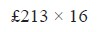
2
3 | 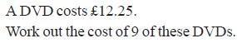
4 | 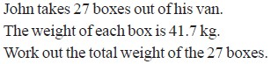
LO2: To be able to use a method to solve division problems
1
2
3 |  | 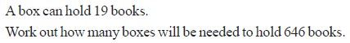
4 |  | 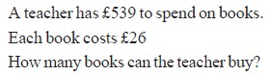
5 |  | 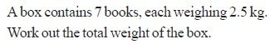
6 |  | 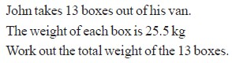
LO3: To be able to use BIDMAS to calculate solutions
1
2
3
4
5 |  | 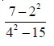
6 |  | 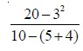
LO4: To be able to state a value to a required degree of accuracy
1
2 |  | 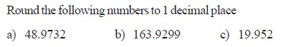
3 |  | 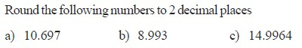
4 |  | 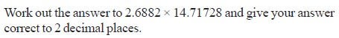
5 |  | 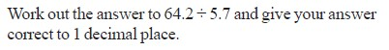
Mixed Problems
1 |  |  | David is saving for a new bike which costs £175. He has been saving £7 a week for 9 weeks. How much more does he need to save?
2 |  |  | 18 eggs are needed to make an omelette for 6 people, how many eggs are needed to make an omelette for 4 people?
3 |  |  | I bought a card costing £1.76 and a chocolate bar costing 63p. There was a 10% sale that day. How much did I spend?
4 |  |  | Carmen weighs 53kg. Her sister weighs 18kg less. She said: ‘Together, we weigh 23kg less than our Dad!’ How much does their Dad weigh?

Stage C – Topic 2 - Algebra
LO1: To be able to simplify like terms
1 | Simplify the following expressions:  a) y + y + y b) z x z x z x z x z c) a + 5a + 2a + 3a d) 4a + 9a e) 8b - 10b  f) 3f + 6g + 4f + 5g g) 5a + 2b + 6a – 2b h) 6c + 5d - 3c + 8d i) 7b + 6a - 5b + 3a  j) 3ab - 2bc + 6ab + 9bc + 5ad k) 2x² - 3x + 3x² + 6x l) 6ab + (- 6ab) – 3bc – (-4bc) m) 5h x 6h
LO2: To be able to expand brackets and simplify the result
1 | Expand:  a) 3(x4) b) 6(x2) | c) 5(x4) | d) 3(x9)
 | e) 4(2x3) f) 5(4x2) | g) (x1) | h) (4x2)
2 | Expand and Simplify:  a) 2(x1)3(x2) | b) 4(x3)2(x7)
 | c) 5(x3)2(x7) | d) 8(x10)2(x4)
3 | Expand and Simplify: (watch out for the negative signs)  a) 4(x4)3(x2) b) 5(x2)2(x1)  c) 7(x3)4(x2) d) 2(5x10)2(3x1)
4 | 5. Expand and Simplify: (as tricky as they get)  a) 4(x5)2(x3) b) 4(x2)6(x4)

 | c) 4(2x4)5(2x1) d) 6(3x2)4(5x9)
5 | A rectangle measures (x3) m by 5m. Write an expression for the:  a) area of the rectangle b) perimeter of the rectangle
6 | Write an expression for the perimeter and the area of the rectangle below.  3x + 5  7x - 3
LO3: To be able to factorise expressions
1 | Factorise the following:  a) 4t + 20 b) 8u – 40 c) 12v – 30 d) 24 + 8w e) 6d – 3
2 | Factorise the following:  a) a) w² + 8w b) a + 2a² c) 2a² - 3a d) 6d² – 3d e ) 4p² - 2p
3 | Factorise the following:  a) a) 4b+10ab b) 2cd-5c c) ab + bc - bd d) 6ab² + 15a²b
4 | Factorise the following fully:  a) abc - 2bc b) 4b + 8b² c) 12m - 18m² d) 8k² + 12k³
5 | Factorise the following fully:  a) 4c²d³ - 10cd² b) 2ab + 3a²b + 4a²b²
6 | Factorise the following fully:  6𝑎 𝑏 − 8𝑎 𝑏 + 12𝑎 𝑏
Extension
Work out what each of the bricks at the bottom simplify to, then add the 2 bricks next to each other to give the brick above them.
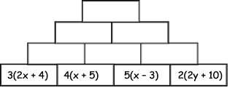

Stage C – Topic 3 - Fractions
LO1: To be able to use the property of fractional equivalence
1 | 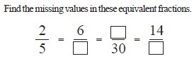
2 | 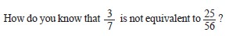
3 | 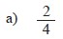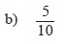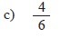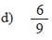
4 | 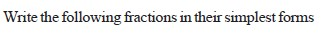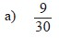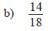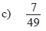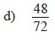
LO2: To be able to add and subtract fractions
1 | 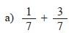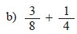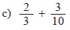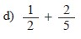
2 | 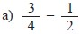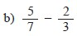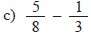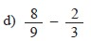
3 | 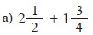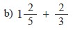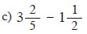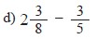
4 | 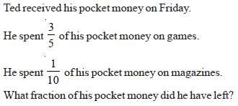
5 | 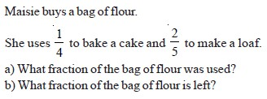
Mixed Problems
1 | Andy and Bob have a pizza each. After they have eaten some of their pizzas, Andy has of his pizza left and Bob has of his left. What fraction of pizza do they have left in total?
2 | Charlene has a bag of sweets. She gives to her friend and eats . What fraction of the bag of sweets does Charlene have left?
3 | Dave and Ed are putting together bags of marbles to sell for charity. Dave has of a bag left over and Ed has of a bag left. Can they combine what they each have left to make another bag? (You must show your workings)
4 | Freya wants to make two cakes. She has of a bag of flour. The first cake requires of a bag of flour and the second cake needs of a bag of flour. Does Freya have enough flour to make both cakes?  (You must show your workings)
5 | George’s van can carry a maximum of 5 tonnes. George needs to deliver two loads weighing 3 tonnes and 1 tonnes. Can George take both loads at once? (You must show your workings)
6 | Harriet is sowing grass seed in her garden. She has 1 bags of grass seed. Her front garden needs of a bag and the back garden needs of a bag. Does Harriet have enough grass seed? (You must show your workings)

Stage C – Topic 4 - Area and Volume
LO1: To be able to calculate area of compound shapes
1 | 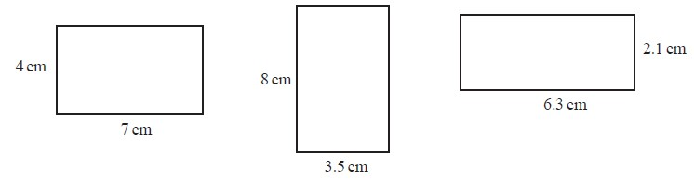
2 | 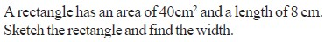
3 | 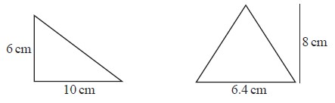
4 | 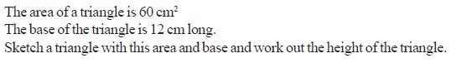

5 | 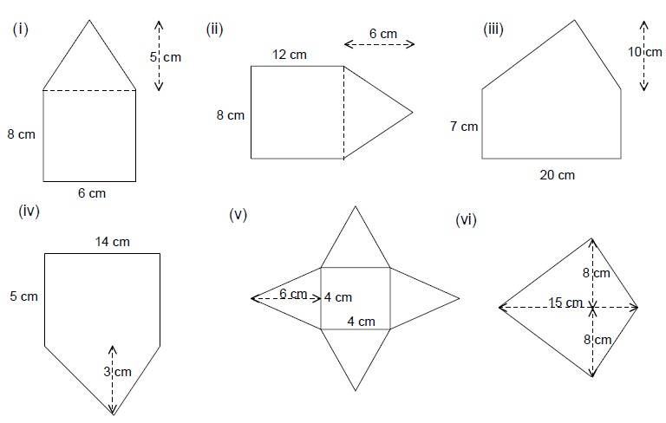
6 | 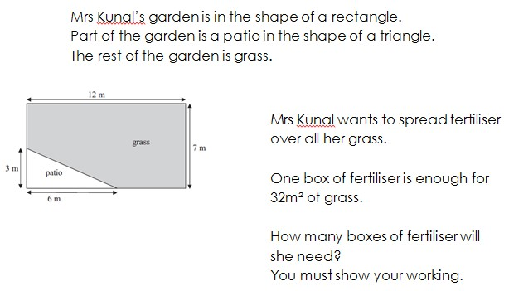
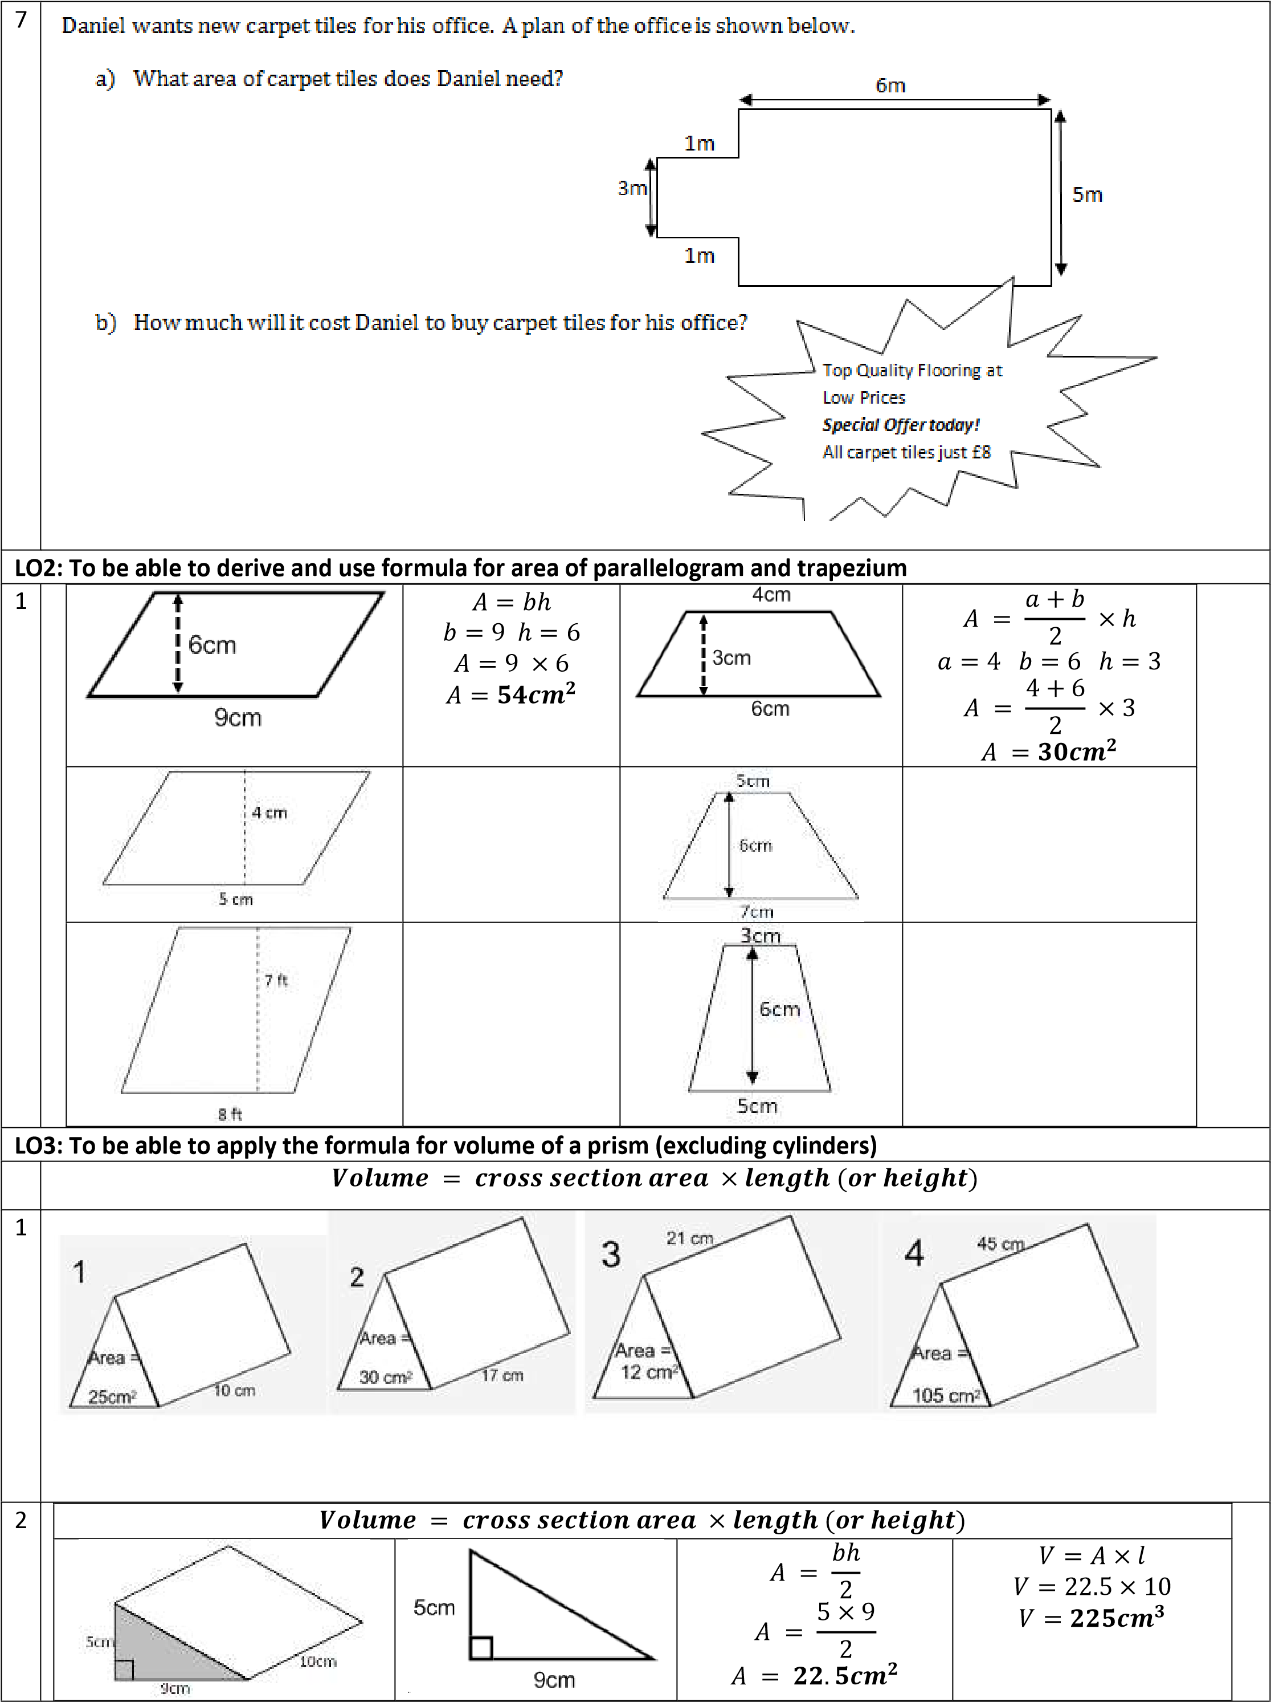
 |  | 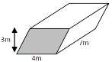
 |  | 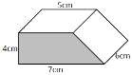
 |  | 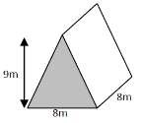
 |  | 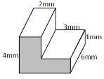
3 | 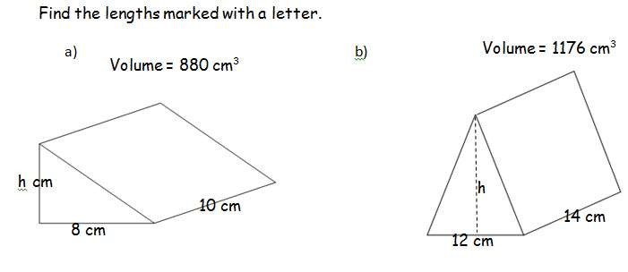

Stage C – Topic 5 Percentages
LO1: To be able to calculate a percentage of a quantity using a calculator where appropriate
1 | Without using a calculator, work out the following:  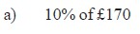
2 | 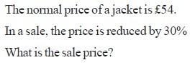
3 | 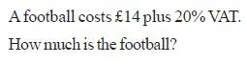

4 | Using a calculator, work out the following:  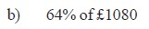
5 | 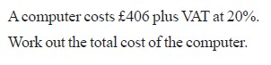
6 | 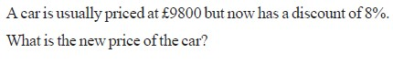
7 | 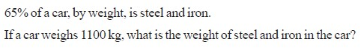
8 | 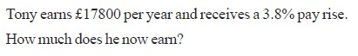
LO2: To be able to express a quantity as a percentage of an amount
1 | Without using a calculator, write the following as percentages:
2 | 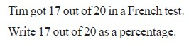
3 | 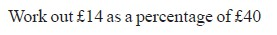
4
5 | Using a calculator, write the following as percentages:  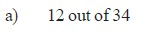
6 | 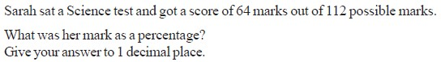
7 | 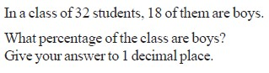
8 | 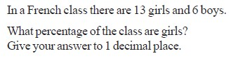

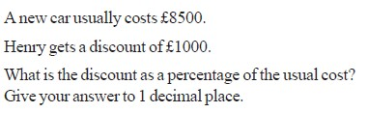
9

Mixed Problems

1

The captain of a football team scored 17 out of the 85 goals they scored that season. What
percentage of the goals di
d he score?

2

Alex has 3 dolls, 12 teddy bears and 5 soft rabbits. What percentage of her toys are

a) teddy bears

b) dolls

c) cuddly toys?

3

Joe buys a new laptop in a sale. He gets a discount of 20%. The laptop originally cost £350
what price did J
oe pay?

4

Income tax is 20%. What is the net income of someone who earns £800 per month?

5

The population of grey seals in Scotland is under threat. It has declined by 30% in the last
decade. In 2000 there were 1500 grey seals, how many are there today?

Stage C – Topic 6 Algebra
LO1: To be able to solve simple equations with integer solutions
1 |  | 𝑥 − 5 = 18  +𝟓 + 𝟓  𝒙 = 𝟐𝟑 | 4𝑥 = 32  ÷ 𝟒 ÷ 𝟒  𝒙 = 𝟖 | 𝑥  = 5  7  × 𝟕 × 𝟕  𝒙 = 𝟑𝟓 | 4𝑥 − 5 = 15  +𝟓 + 𝟓  𝟒𝒙 = 𝟐𝟎  ÷ 𝟒 ÷ 𝟒  𝒙 = 𝟓
1 |  | 2𝑥 = 12 | 7 = 𝑥 − 3 | 𝑑  = 7 4 | 3𝑘 + 8 = 20
1 |  | 3𝑚 − 7 = 20 | 𝑎  + 7 = 13  4 | 6𝑛 − 4 = 32 | 5𝑐 + 9 = 39
1 |  | 7𝑟 − 10 = 25 | 2𝑎  − 7 = 13  4 | 5𝑥 + 7 = 57 | 9𝑚 + 5 = 3𝑚 + 23

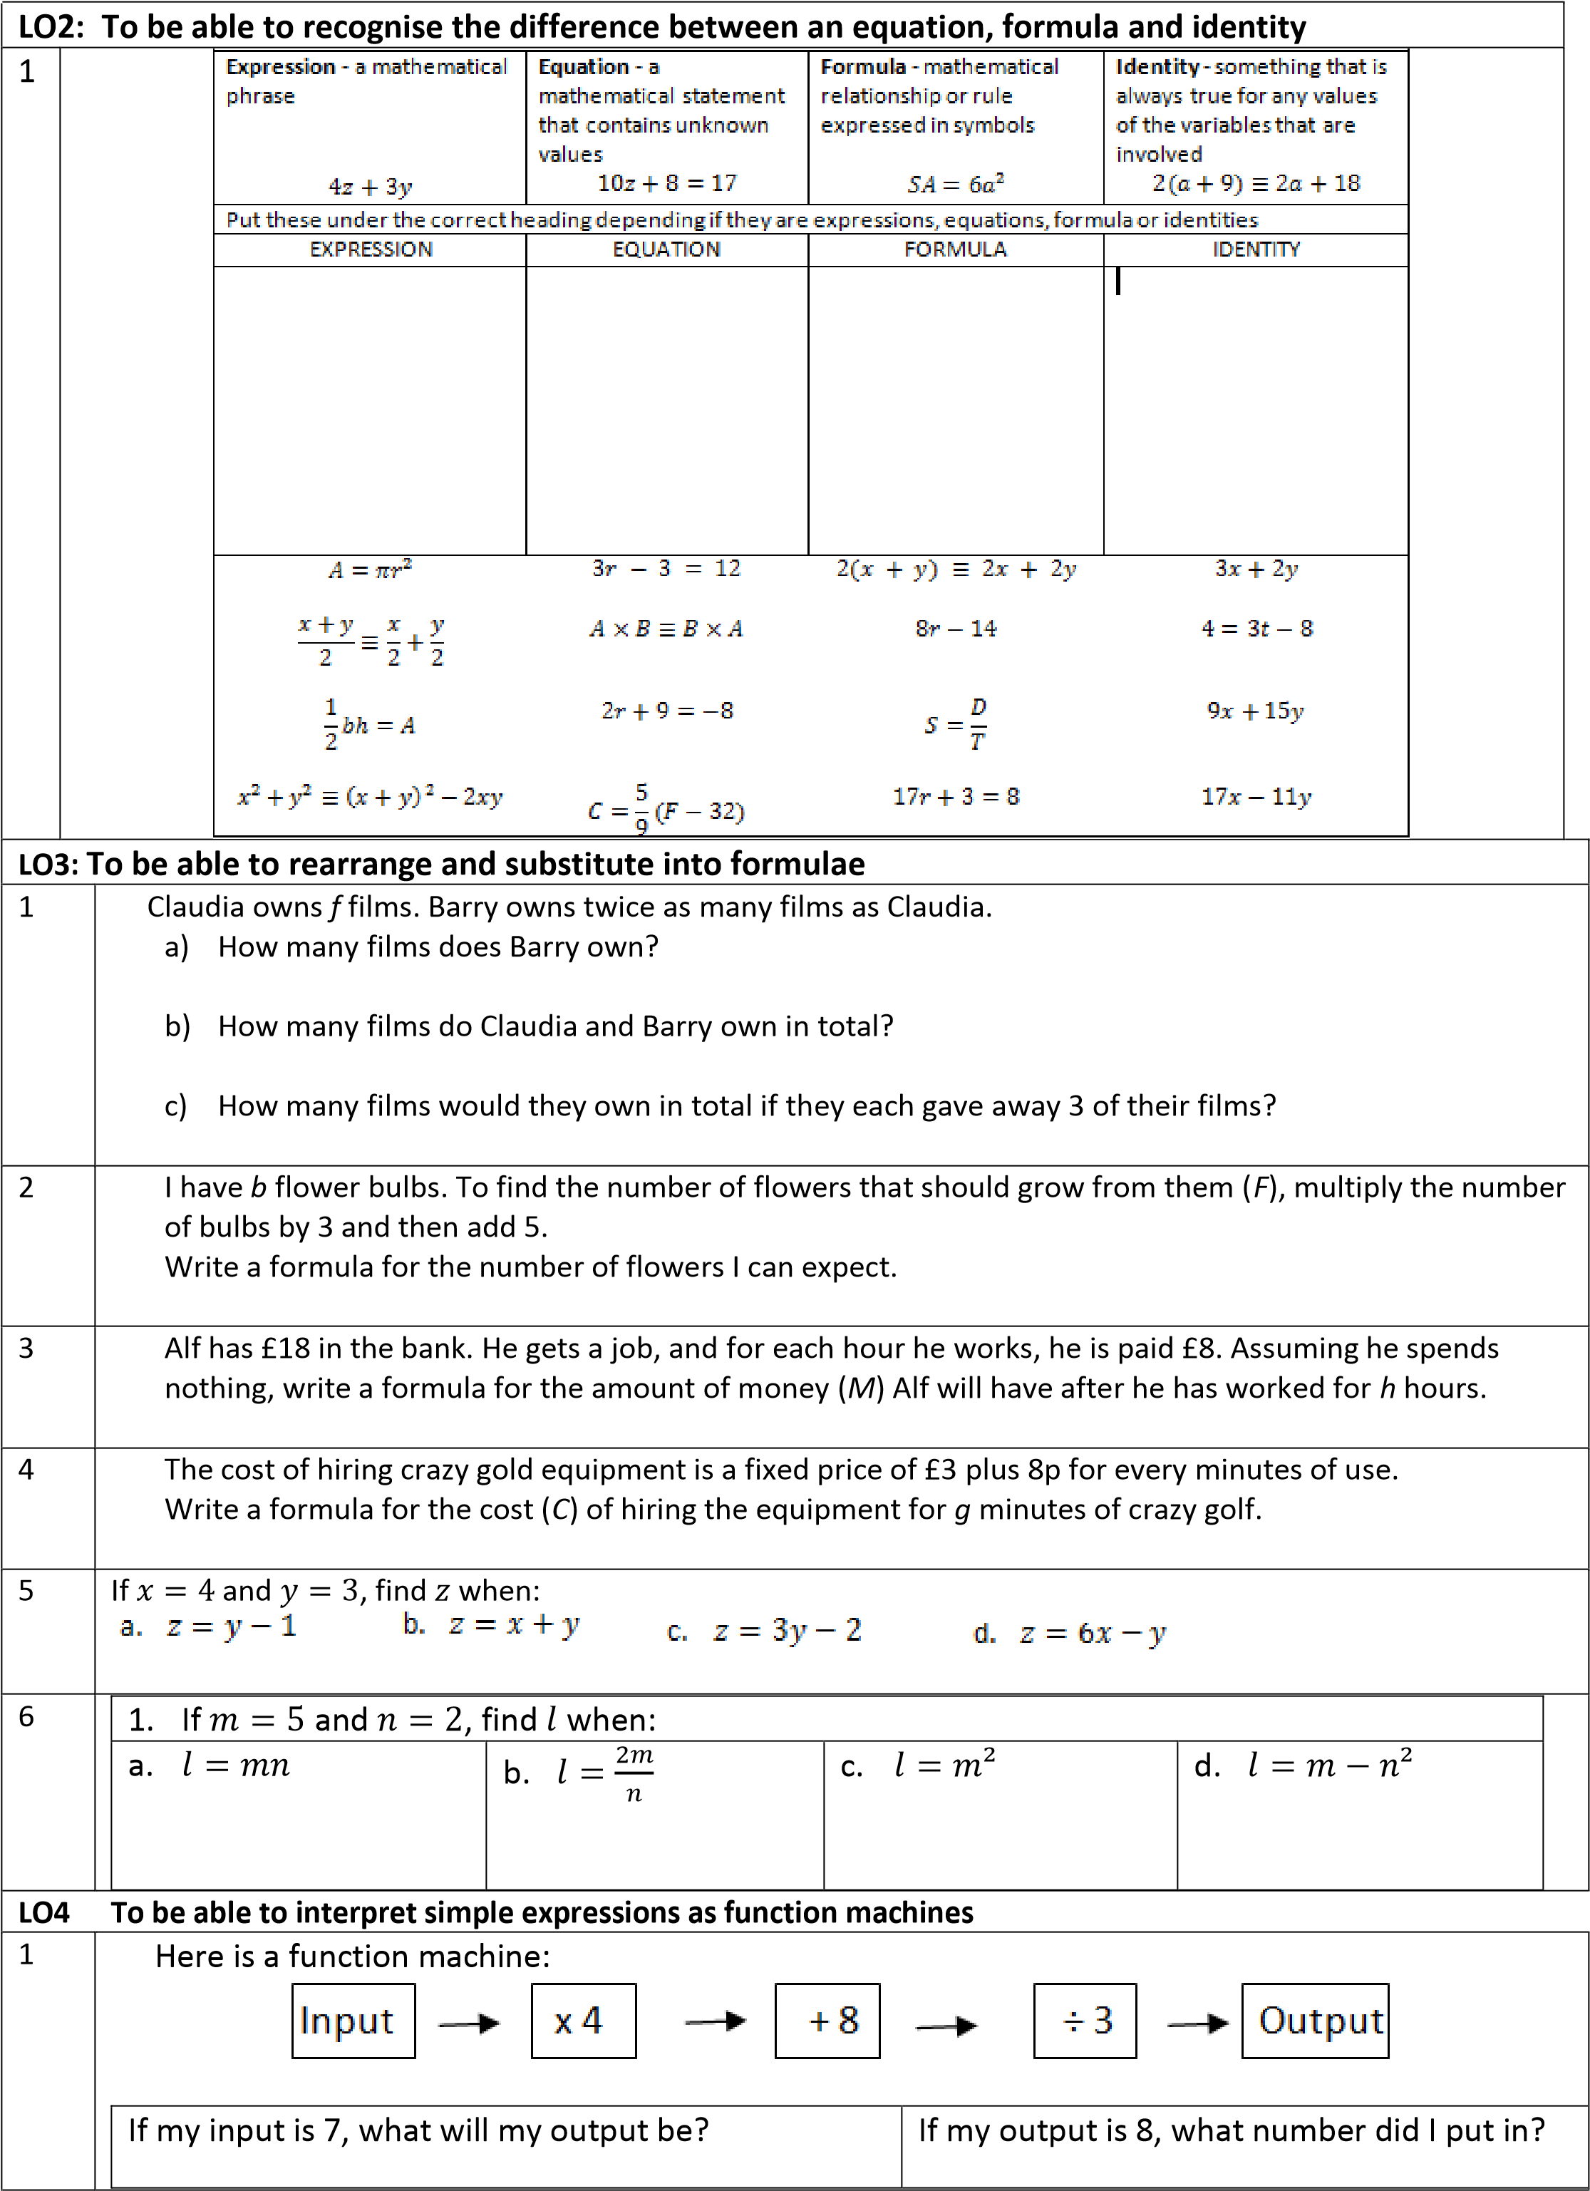
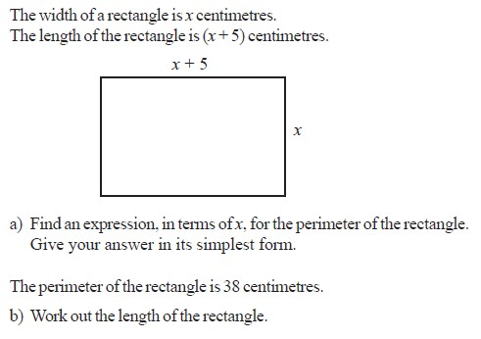

2

Here is a function machine:

If my input is 6, what will my output be?

If my output is 20, what number did I put in?

Here is a function machine:

If my
input is 14, what will my output be?

If my output is 108, what number did I put in?

Mixed
Problems

1

2 | 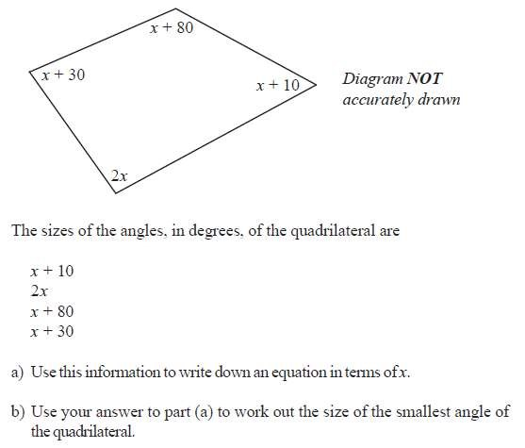

Stage C – Topic 7 - Graphing
LO1: To be able to plot simple graphs of linear functions
1 | 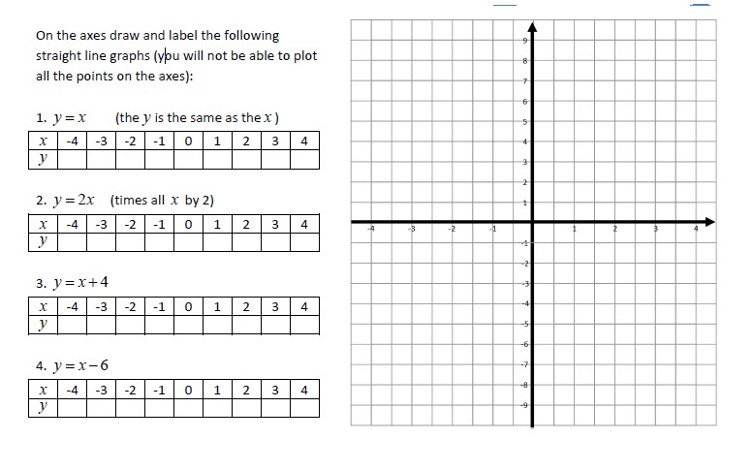
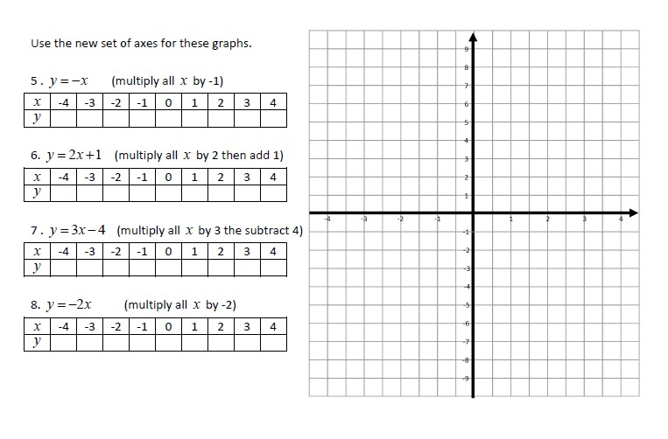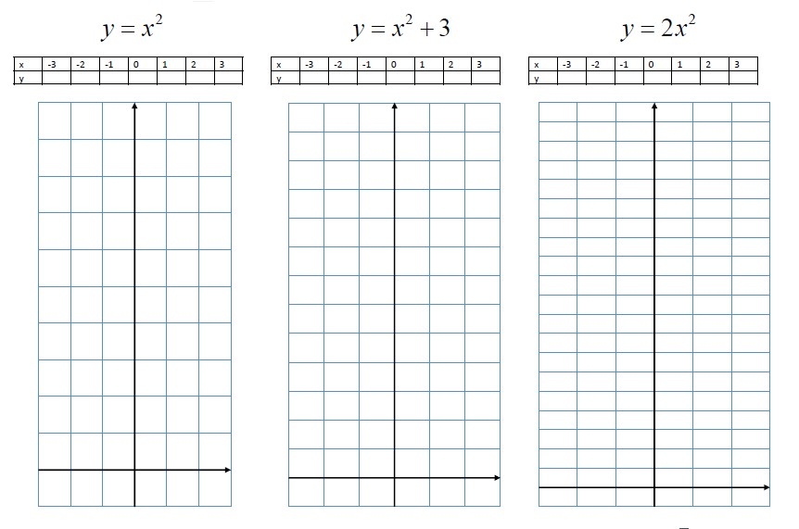
2

O2:
L
To be able to

plot simple

graphs of quadratic functions

1

2 | 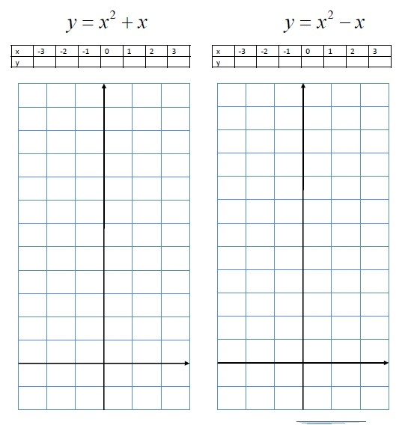

3 | 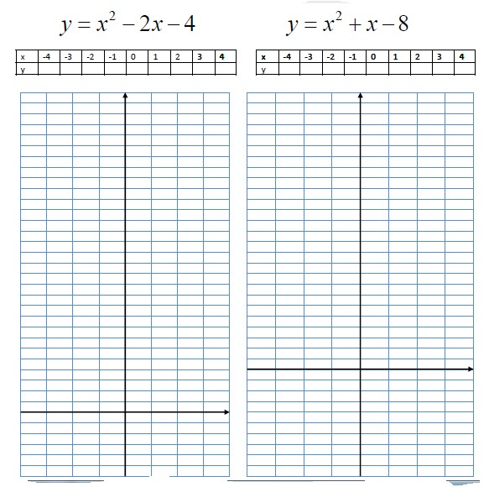
Mixed Problems

1 | 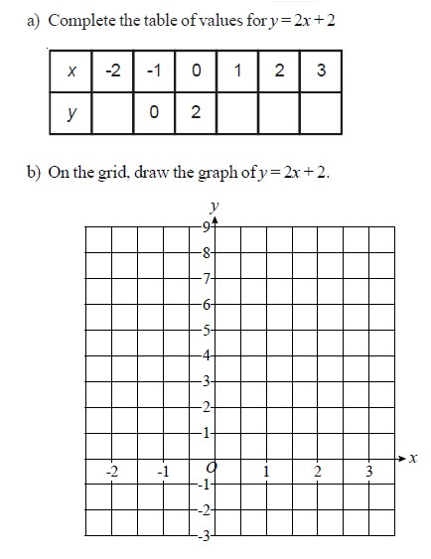
2 | 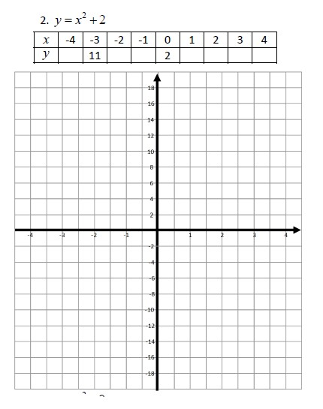

3 | 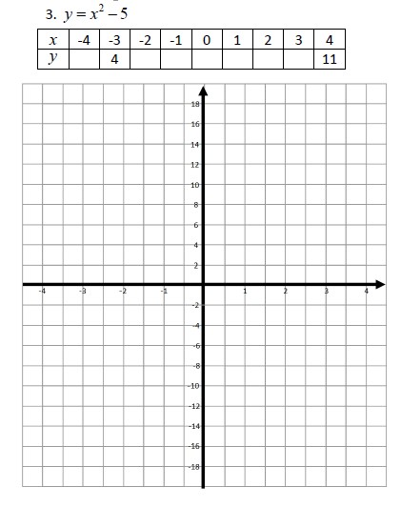
4 | 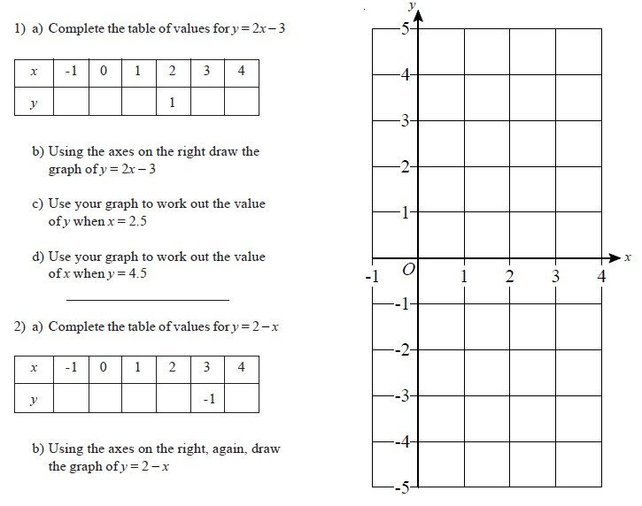

5 | 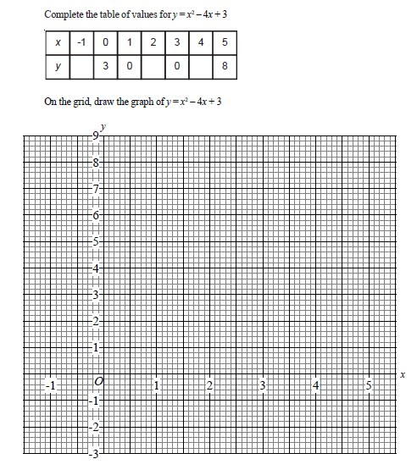
6 | 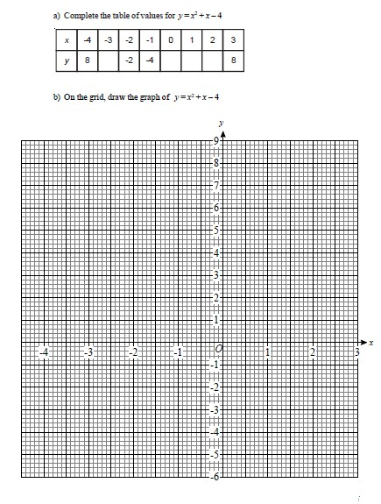

Stage C – Topic 8 - Probability
LO1: To be able to identify when events are mutually exclusive and know the sum of these events would be 1
1 | These events are called mutually exclusive because they can’t happen at the same time.  A six sided dice is rolled. Which of these pairs of outcomes are mutually exclusive?  - The number is even and a multiple of 3  - The number is odd and a multiple of 2  - The number is odd and square
2 | Which of these pairs of events are mutually exclusive?  - Winning a football match and drawing the same match  - Wearing one red sock and one blue sock  - Eating toast for breakfast and Chips for dinner  - Being on time and being late for a day at school

3 | The probability that it will rain tomorrow is . What is the probability that it won’t rain?
4 | 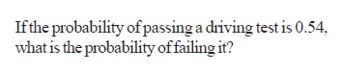
5 | 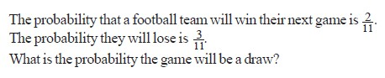
6 | 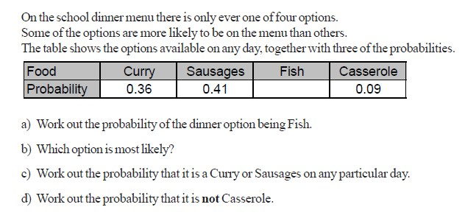
7 | 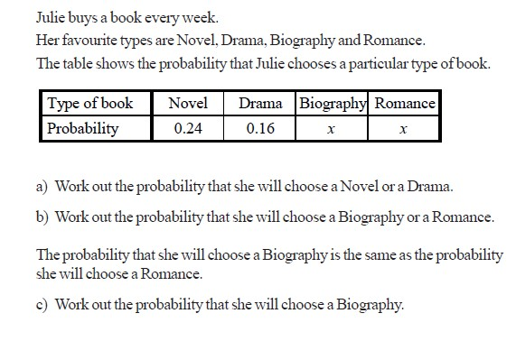

Mixed Problems
1 | There are some blue, red, green and purple balls in a bag, find the probability of a purple ball being pulled out if these are the probabilities of the other colours:  a.  b.  c.  Complete the table.
  Blue | Red | Green | Purple
  0.1 | 0.3 | 0.3
  Blue | Red | Green | Purple
  0.15 | 0.42 | 0.23
  Blue | Red | Green | Purple
  0.4 | 0.35 | 0.02
2 | A dice is rolled.  - List the six mutually exclusive outcomes and their probabilities.  - What is the probability of a 6?  - What is the probability of not getting a 6?
3 | Jean is going on an activities holiday. Each activity lasts a whole day. She can only do one activity a day. The probability that she will go pony-trekking on any one day is 0.6  - Work out the probability that Jean will not go pony-trekking on the first day.  - The probability that Jean will go windsurfing on any one day is 0.25  Work out the probability that Jean will go windsurfing or pony-trekking on the first day.
4 | 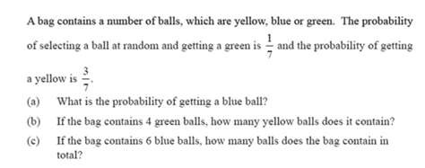
5 | 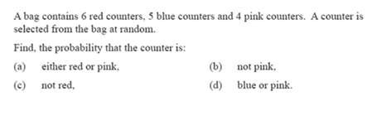
6 | 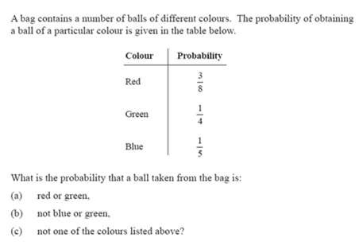

STAGE C ANSWERS
 | Stage C : Topic 1 - Answers
LO1 | To be able to use a method to solve multiplication problems
1 | £3408
2 | 745.2
3 | £110.25
4 | 1125.9kg
LO2 | To be able to use a method to solve division problems
1 | a) 65 b) 56 c) 17 d) 13
2 | a) 30 b) 60 c) 30 d) 7
3 | 34
4 | 21
5 | 17.5kg
6 | 331.5kg
LO3 | To be able to use BIDMAS to calculate solutions
1 | 32
2 | 27
3 | 14
4 | 9
5 | 3
6 | 11
LO4 | To be able to state a value to a required degree of accuracy
1
2 | 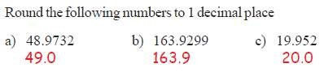
3 | 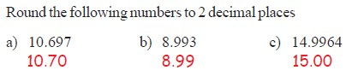
4 | 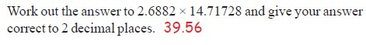
5 | 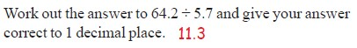
 | Mixed Problems
1 | 175 – (7 x 9) = £112

2 |  | 18 ÷ 6 = 3 x 4 = 12 eggs or 4 ÷ 6 x 18 = 12 eggs
3 |  | (1.76 + 0.63) x (100% - 10%) = £2.15
4 |  | 53 + (53-18) = 88 + 23 = 111kg
Stage C – Topic 2 - Algebra Answers
LO1: To be able to simplify like terms
1 | Simplify the following expressions:  a) y + y + y = 3y b) z x z x z x z x z = 5z c) a + 5a + 2a + 3a = 11a d) 4a + 9a = 13a  e) 8b - 10b = -2b f) 3f + 6g + 4f + 5g = 7f + 11g g) 5a + 2b + 6a – 2b = 11a  h) 6c + 5d - 3c + 8d = 3c + 13d i) 7b + 6a - 5b + 3a = 9a + 2b j) 3ab - 2bc + 6ab + 9bc + 5ad = 9ab + 7bc + 5ad k) 2x² - 3x + 3x² + 6x = 5x² + 3x l) 6ab + (- 6ab) – 3bc – (-4bc) = bc m) 5h x 6h = 30h²
LO2: To be able to expand brackets and simplify the result
1
Ans | Expand:  a) 3(x4) b) 6(x2) c) 5(x4) d) 3(x9)  = 3x + 12 = 6x - 12 = 5x + 20 = 3x + 27  e) 4(2x3) f) 5(4x2) g) (x1) h) (4x2)  = 8x + 12 = 20x - 10 = -x - 1 = -4x + 4
2
Ans | Expand and Simplify:  a) 2(x1)3(x2) = 5x + 8 b) 4(x3)2(x7) = 6x + 26  c) 5(x3)2(x7) = 7x + 29 d) 8(x10)2(x4) = 10x + 88
3
Ans | Expand and Simplify: (watch out for the negative signs)  a) 4(x4)3(x2) = x + 10 b) 5(x2)2(x1) = 3x + 8  c) 7(x3)4(x2) = 3x + 13 d) 2(5x10)2(3x1) = 4x + 18
4
Ans | Expand and Simplify: (as tricky as they get)  a) 4(x5)2(x3) = 2x - 14 b) 4(x2)6(x4) = -2x + 16  c) 4(2x4)5(2x1) = -2x - 11 d) 6(3x2)4(5x9) = -2x + 24
5
Ans | A rectangle measures (x3) m by 5m. Write an expression for the:  a) area of the rectangle = 5x + 15 b) perimeter of the rectangle = 2x + 16

6 | Write an expression for the perimeter and the area of the rectangle below.  3  x +  5  7x - 3
Ans | Perimeter = 2(7x – 3) + 2(3x + 5) = 20x + 4  Area = (3x + 5) (7x – 3) = 21x² + 26x - 15
LO3: To be able to factorise expressions

1
Ans | Factorise the following:  a) 4t + 20 b) 8u – 40 c) 12v – 30 d) 24 + 8w e) 6d – 3  = 4(t + 5) = 8(u – 5) = 6(2v – 5) = 8(3 + w) = 3(2d – 1)
2
Ans | Factorise the following:  b) a) w² + 8w b) a + 2a² c) 2a² - 3a d) 6d² – 3d e ) 4p² - 2p  = w(w + 8) = a(1 + 2a) = a(2a – 3) = 3d(2d – 1) = 2p(2p – 1)
3
Ans | Factorise the following:  c) a) 4b + 10ab b) 2cd - 5c c) ab + bc - bd d) 6ab² + 15a²b  = 2b(2 + 5a) = c(2d – 5) = b(a + c – d) = 3ab(2b + 5a)
4
Ans | Factorise the following fully:  a) abc - 2bc b) 4b + 8b² c) 12m - 18m² d) 8k² + 12k³  = bc(a – 2) = 4b(1 + 2b) = 6m(2 – 3m) = 4k²(2 + 3k)
5
Ans | Factorise the following fully:  a) 4c²d³ - 10cd² b) 2ab + 3a²b + 4a²b² = 2cd²(2cd – 5) = ab(2 + 3a + 4ab)
6
Ans | Factorise the following fully:  6𝑎 𝑏 − 8𝑎 𝑏 + 12𝑎 𝑏  = 2a²b³(3a²b³ - 4ab² + 6)
Extension
 | Work out what each of the bricks at the bottom simplify to, then add the 2 bricks next to each other to give the brick above them.

Stage C – Topic 3 - Fractions Answers
LO1: To be able to use the property of fractional equivalence
1 | 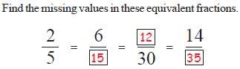
2 | 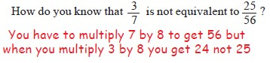
3 | 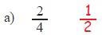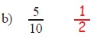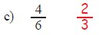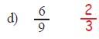
4 | 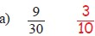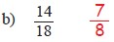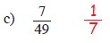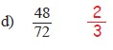
LO2: To be able to add and subtract fractions
1 | 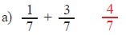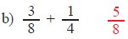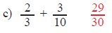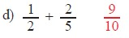
2 | 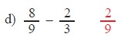  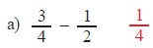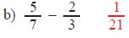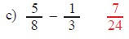
3 | 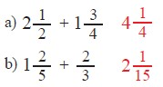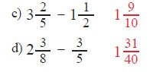
4 | 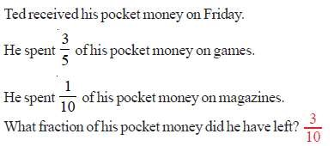
5 | 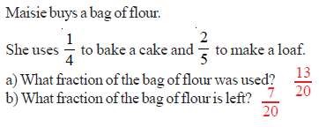
Mixed Problems
1
Ans | Andy and Bob have a pizza each. After they have eaten some of their pizzas, Andy has of his pizza left and Bob has of his left. What fraction of pizza do they have left in total?
2
Ans | Charlene has a bag of sweets. She gives to her friend and eats . What fraction of the bag of sweets does Charlene have left?
3
Ans | Dave and Ed are putting together bags of marbles to sell for charity. Dave has of a bag left over and Ed has of a bag left. Can they combine what they each have left to make another bag? (You must show your workings) = 1 , Yes
4
Ans | Freya wants to make two cakes. She has of a bag of flour. The first cake requires of a bag of flour and the second cake needs of a bag of flour. Does Freya have enough flour to make both cakes?  𝟑 𝟐 𝟕 𝟕 _{𝟑}  (You must show your workings) - = ; is greater than _{𝟏𝟎} , so Yes  𝟒 𝟓 𝟐𝟎 𝟐𝟎
5 | George’s van can carry a maximum of 5 tonnes. George needs to deliver two loads weighing 3 tonnes and  1 tonnes. Can George take both loads at once? (You must show your workings)  + = = = 5 , Yes
6 | Harriet is sowing grass seed in her garden. She has 1 bags of grass seed. Her front garden needs of a bag and the back garden needs of a bag. Does Harriet have enough grass seed? (You must show your workings)  - = = - = = − , So No

Stage C – Topic 4 – Area and Volume Answers
LO1: To be able to calculate area of compound shapes
1 |  | 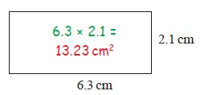  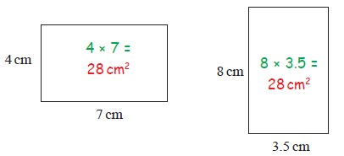
2 |  | 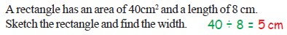
3 |  | 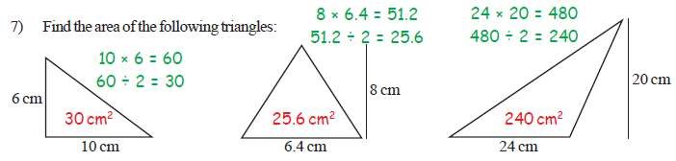
4 |  | 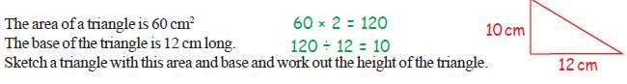
5 |  | i) 48 + 15 = 63cm² ii) 96 + 24 = 120cm² iii) 140 + 100 = 240cm² iv) 70 + 21 =  91cm²  v) 16 + 48 = 64cm² v) 120cm²
6 |  | (12 x 7) – (6 x 3 ÷ 2) = 75 ÷ 32 = 2.34375, hence 3 boxes
7 |  | - (6 x 5) + (1 x 3) = 33cm²  - 33 x 8 = £264
LO2: To be able to derive and use formula for area of parallelogram and trapezium
1
Ans |  | a) 5 x 4 = 20cm² b) 7 x 8 = 56ft c) {(5 + 7) ÷ 2} x 6 = 36cm² d) {(3 + 5) ÷ 2} x 6 = 24cm²
LO3: To be able to apply the formula for volume of a prism (excluding cylinders)
1
Ans | a) 25 x 10 = 250cm³ b) 30 x 17 = 510cm³ c) 12 x 21 = 252cm³ d) 105 x 45 = 4725cm³
2
Ans | a) 3 x 4 x 7 = 84cm³ b {(5 + 7) ÷ 2} x 4 x 6 = 144cm³ c) (8 x 9 ÷ 2) x 8 = 288cm³ d) (2 x 4 x 6) + (3 x 1 x 6) = 66cm³
3
Ans | - 880 ÷ 10 x 2 ÷ 8 = 22cm  - 1176 ÷ 14 x 2 ÷ 12 = 14

 | Stage C : Topic 5 Percentages - Answers
LO1 | To be able to calculate a percentage of a quantity using a calculator where appropriate
1 | 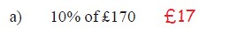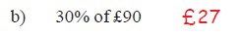  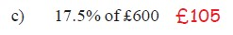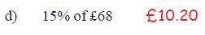
2 | 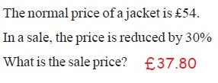
3 | 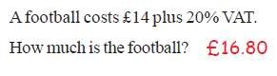
4 | 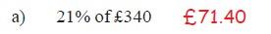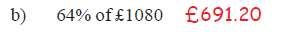  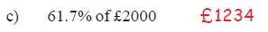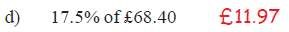
5 | 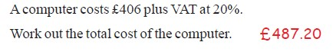
6 | 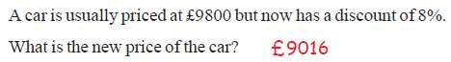
7 | 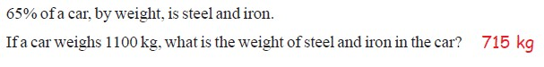
8 | 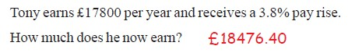
LO2 | To be able to express a quantity as a percentage of an amount

1 | 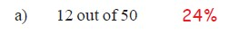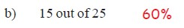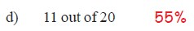
2 | 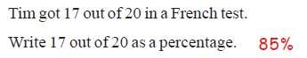
3 | 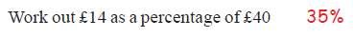
4
5 | 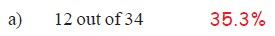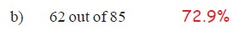
6 | 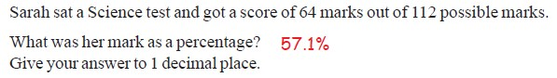
7 | 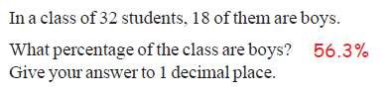
8 | 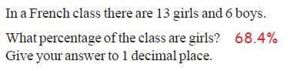
9 | 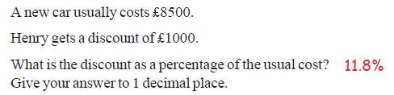
 | Mixed Problems
1 | The captain of a football team scored 17 out of the 85 goals they scored that season. What percentage of the goals did he score? 20%
2 | Alex has 3 dolls, 12 teddy bears and 5 soft rabbits. What percentage of her toys are  a) teddy bears ? 60% b) dolls ? 15% c) cuddly toys? 25%
3 | Joe buys a new laptop in a sale. He gets a discount of 20%. The laptop originally cost £350 what price did Joe pay? £280
4 | Income tax is 20%. What is the net income of someone who earns £800 per month? £160
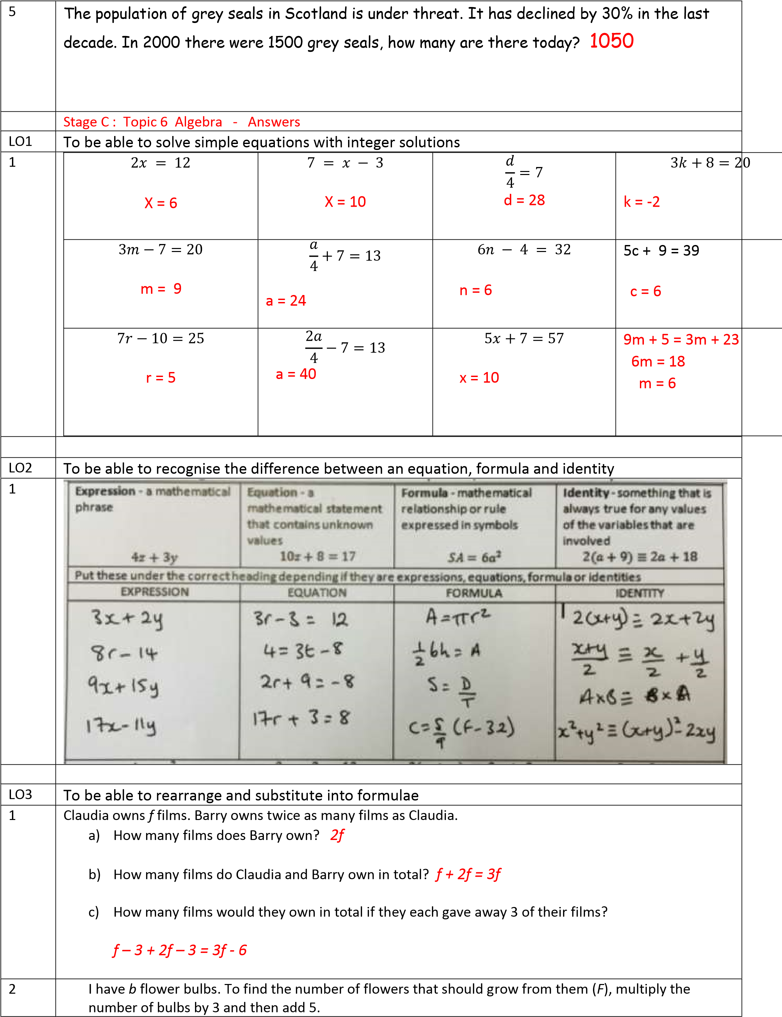
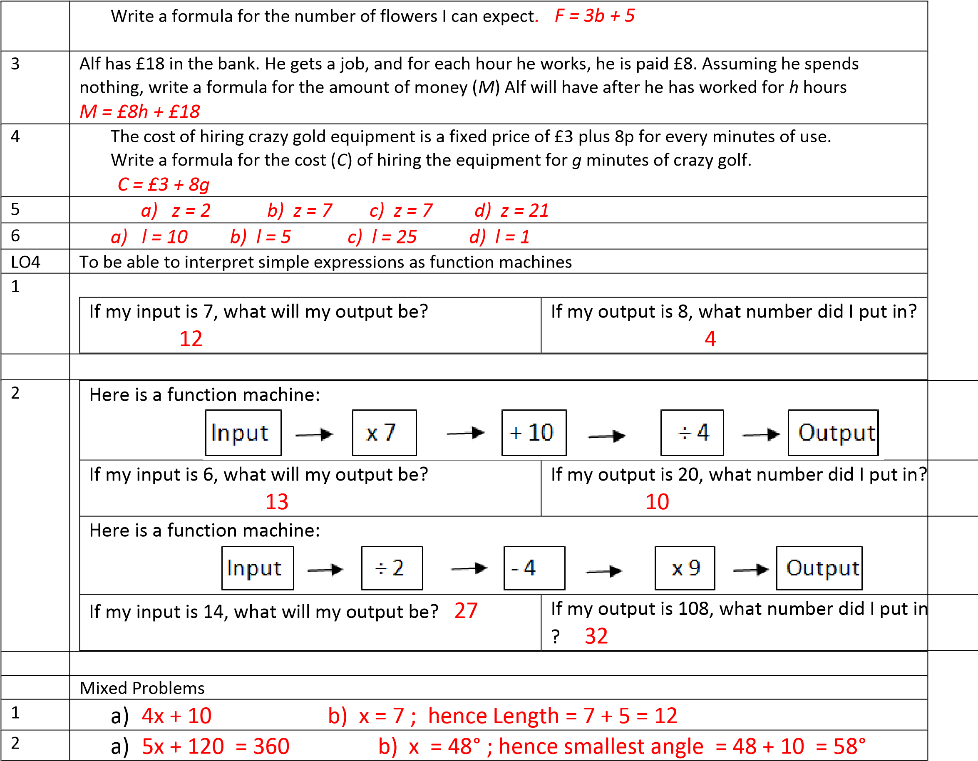
Stage C – Topic 7 – Graphing Answers
LO1: To be able to plot simple graphs of linear functions

1 | 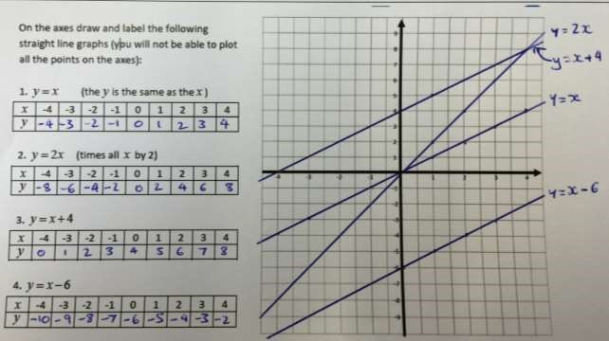
2 | 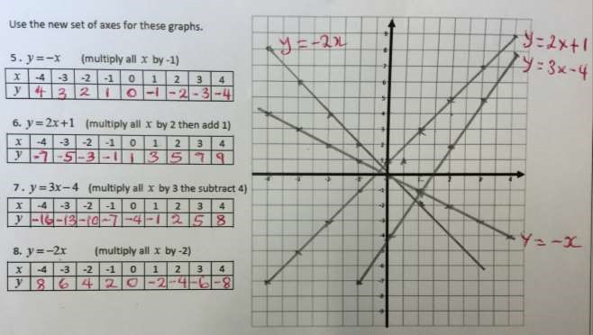
LO2: To be able to plot simple graphs of quadratic functions

1 | 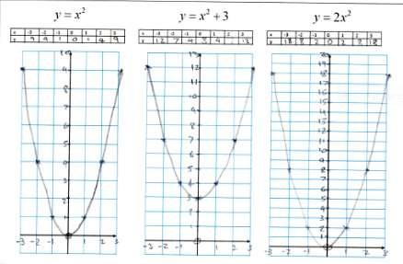
2 | 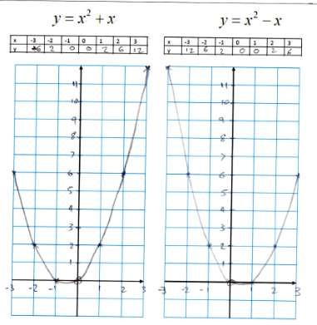

3 | 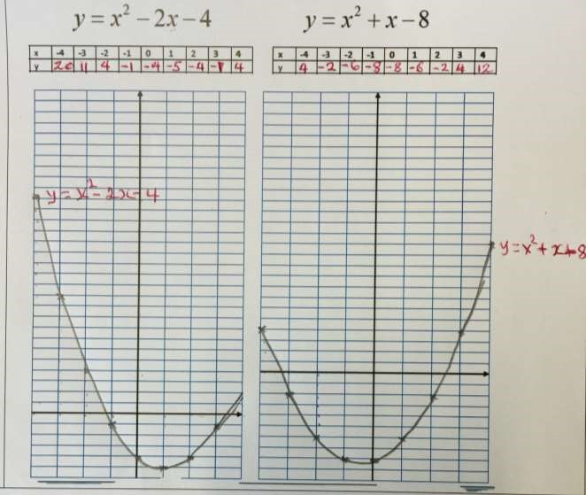
Mixed Problems

1 | 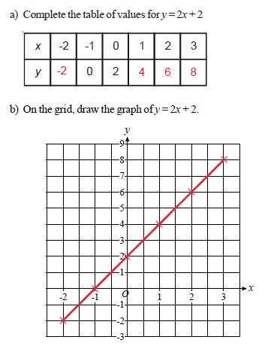
2 | 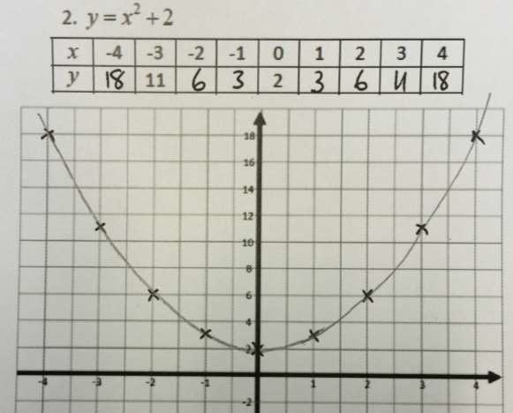

3 | 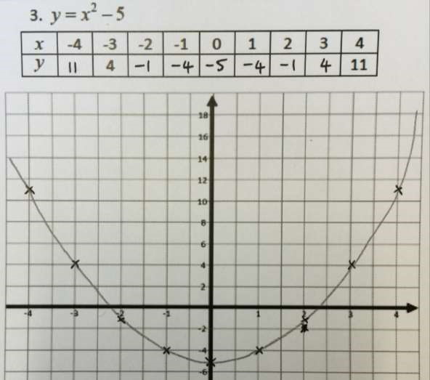

4 | 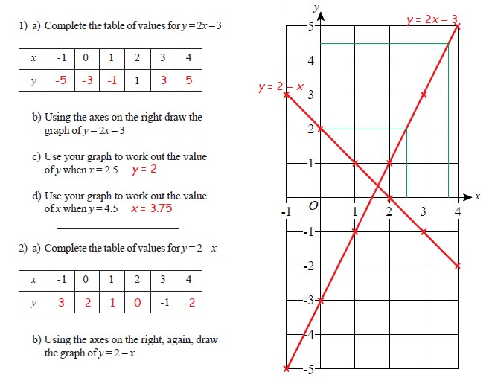
5 | 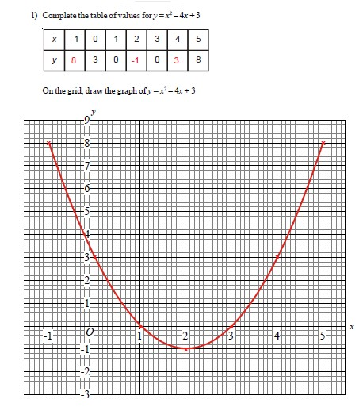
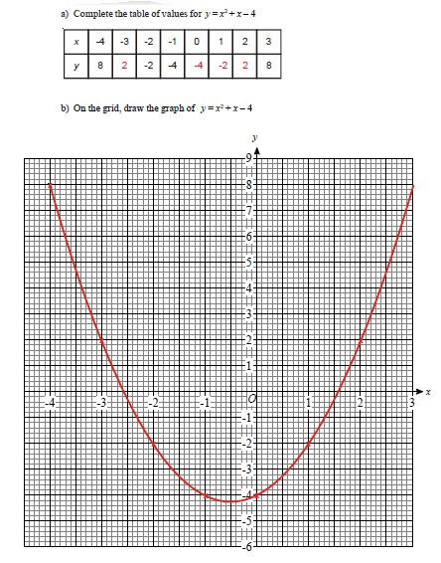
6

Stage
–

Topic 8
–

Probability

Answers

LO1:
To be able to

identify when events are mutually exclusive and know the sum of these events wou
ld be 1

1

Ans

A six sided dice is rolled. Which of these
pairs of outcomes

are mutually exclusive?

A
The number is even and a multiple of 3

Not mutually exclusive

c.

The number is odd and a multiple of 2
mutually exclusive

d.

The number is odd and
square
Not mutually exclusive

2

- Winning a football match and drawing the same match mutually exclusive
Ans

Which of these pairs of events are mutually exclusive?

- Wearing one red sock and one blue sock Not mutually exclusive

- Eating toast for breakfast and Chips for dinner Not mutually exclusive

- Being on time and being late for a day at school mutually exclusive
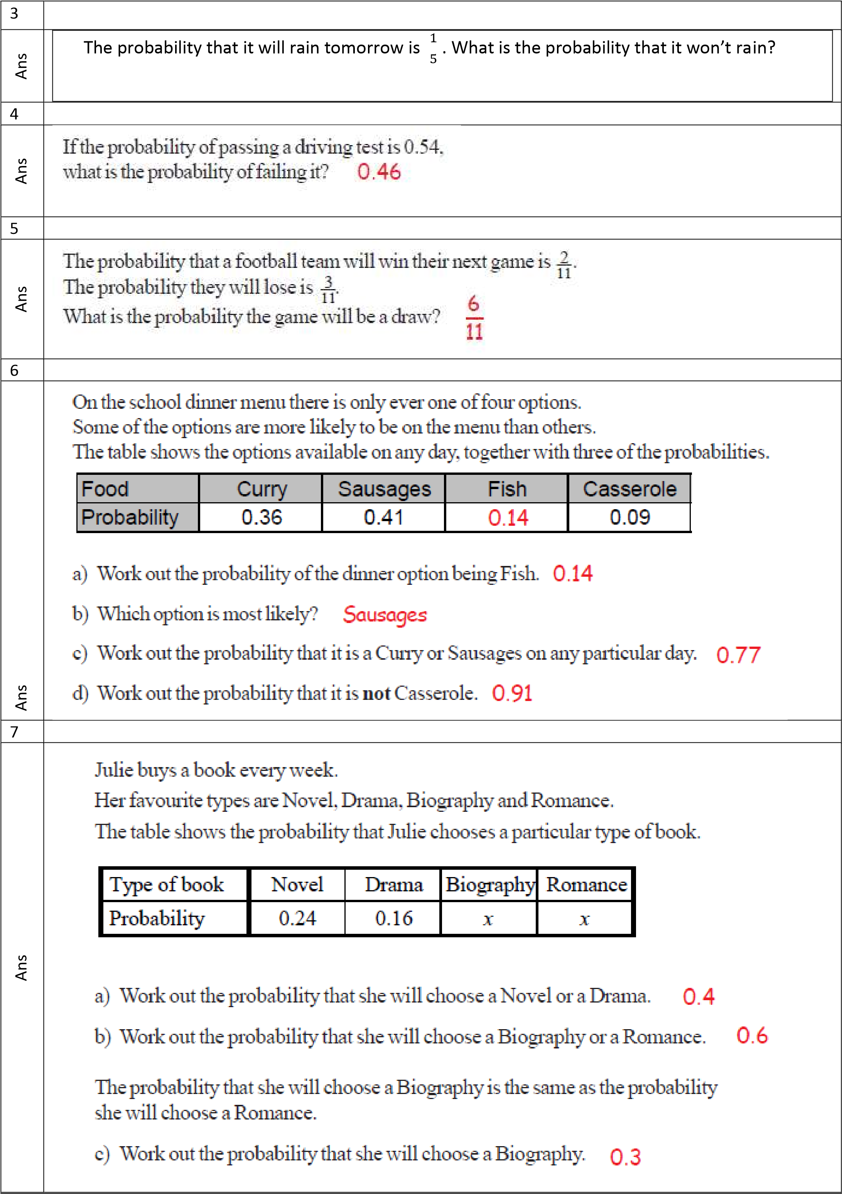

Mixed Problems
1
Ans | There are some blue, red, green and purple balls in a bag, find the probability of a purple ball being pulled out if these are the probabilities of the other colours:  a.  b.  c.
  Blue | Red | Green | Purple
  0.1 | 0.3 | 0.3 | 0.3
  Blue | Red | Green | Purple
  0.15 | 0.42 | 0.23 | 0.2
  Blue | Red | Green | Purple
  0.4 | 0.35 | 0.02 | 0.23
2
Ans | A dice is rolled.  a. List the six mutually exclusive outcomes and their probabilities. 1, 2, 3, 4, 5, 6 b. What is the probability of a 6?  c. What is the probability of not getting a 6?
3
Ans | Jean is going on an activities holiday. Each activity lasts a whole day. She can only do one activity a day. The probability that she will go pony-trekking on any one day is 0.6  - Work out the probability that Jean will not go pony-trekking on the first day. 0.4  - The probability that Jean will go windsurfing on any one day is 0.25  Work out the probability that Jean will go windsurfing or pony-trekking on the first day. 0.6 + 0.25 = 0.85
4
Ans | a) | b) 3 x 4 = 12 balls c) 2 + 6 + 6 = 14 balls
5
Ans | a)  b) | P(red or pink) = =  P(not pink) =
 | c) | P(not red) = =
 | d) | P(blue or pink) = =
6
Ans | a)  b) | P(red or green) = + =  P(not blue or green) = 1 – ( + ) =
 | c) | P(not red, green or blue) = 1 – ( + + ) =

