Maths Book 3 LEARNING OBJECTIVES
Learning Outcome | Tier | R | Y | G

Topic 1: Fractions (Core)
LO1: To be able to multiply fractions | F | R | Y | G
LO2: To be able to divide fractions | F | R | Y | G

Topic 2: Percentages (Core)
LO1: To be able to calculate proportional change | F | R | Y | G
LO2: To be able to calculate repeated proportional change | F+ | R | Y | G

Topic 3: Bearings
LO1: To be able to calculate, measure and use bearings to describe direction | F | R | Y | G

Topic 4: Probability (Core)
LO1: To be able to calculate the probability of successive independent events | F+ | R | Y | G
LO2: To be able to use and apply an understanding of experimental probability | F/F+ | R | Y | G

Topic 5: Averages and spread
LO1: To be able to interpret the averages and spread of data sets | F | R | Y | G
LO2: To be able to calculate averages from frequency tables | F | R | Y | G

Topic 6: Pie charts
LO1: To be able to construct and interpret pie charts | F | R | Y | G

Topic 7: Area and volume (Core)
LO1: To be able to calculate lengths and areas of parts of circles | F | R | Y | G
LO2: To be able to calculate the volume of a cylinder | F | R | Y | G
LO3: To be able to calculate the surface area of a cuboid | F | R | Y | G

Topic 8: Fractions (Core)
LO1: To be able to use BIDMAS to calculate solutions | F | R | Y | G
LO2: To be able to order and compare fractions, decimals and percentages | F | R | Y | G

Topic 9: Ratio and proportion (Core)
LO1: To be able to use knowledge of ratio and proportion to solve problems in context. | F | R | Y | G
LO2: To be able to divide a quantity into two or more parts and solve problems involving ratio | F | R | Y | G

Topic 10: Properties of numbers (Core)
LO1: To be able to find the HCF and LCM of two numbers | F | R | Y | G
LO2: To be able to use prime factors | F | R | Y | G
LO3: To be able to round to the appropriate number of significant figures | F | R | Y | G

F - Foundation
F+ - Additional foundation
H - Higher

Stage E – Topic 1 - Fractions
LO1: To be able to multiply fractions
Work out the following
1 | 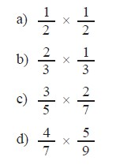
2
3 | 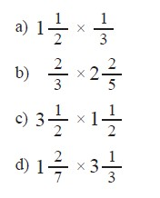
LO2: To be able to divide fractions
1 | 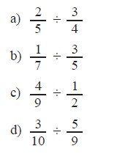

2 | 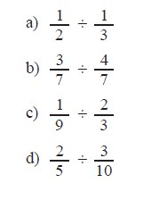
3 | 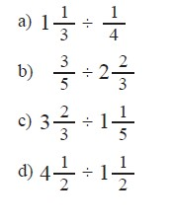
4
5 | 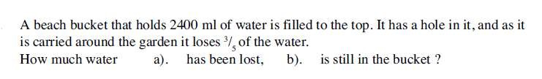
6 | 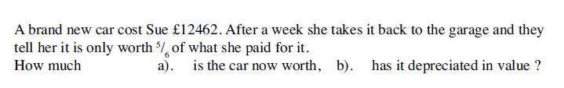
7 | 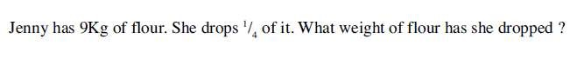
8 | 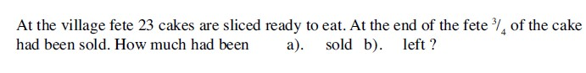
9 | 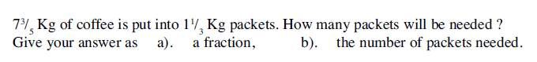
10
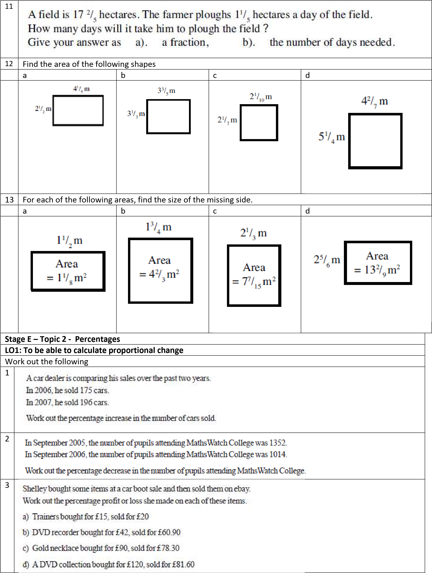

4 | 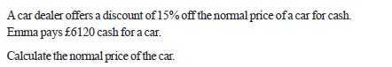
5 | 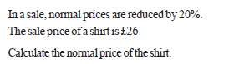
6 | 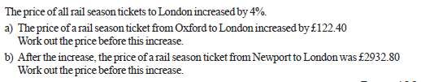
LO2: To be able to calculate repeated proportional change
1 | 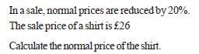
2 | 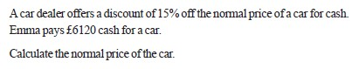
3 | 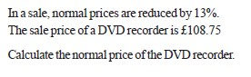
4
a
b

Stage E – Topic 3 - Bearings
LO1: To be able to calculate, measure and use bearings to describe direction
1 | 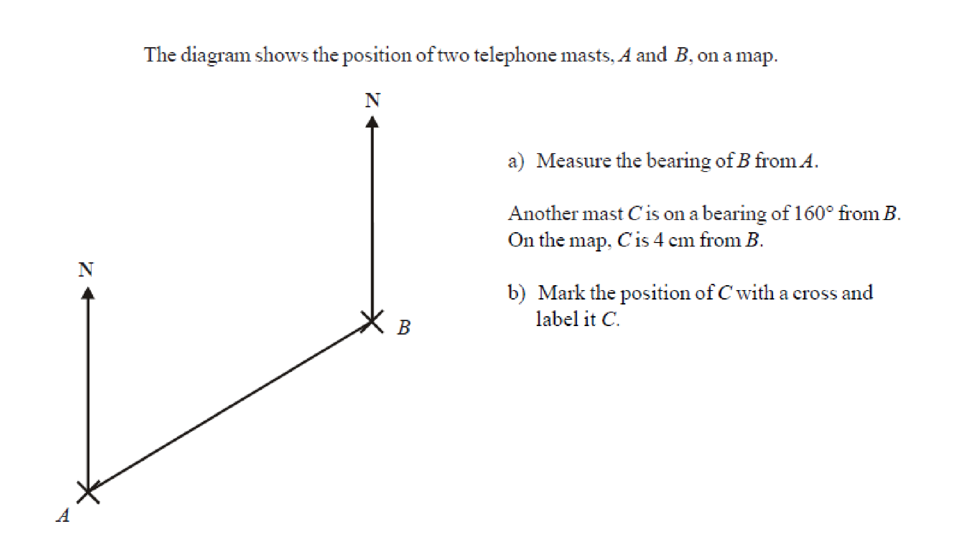
2 | 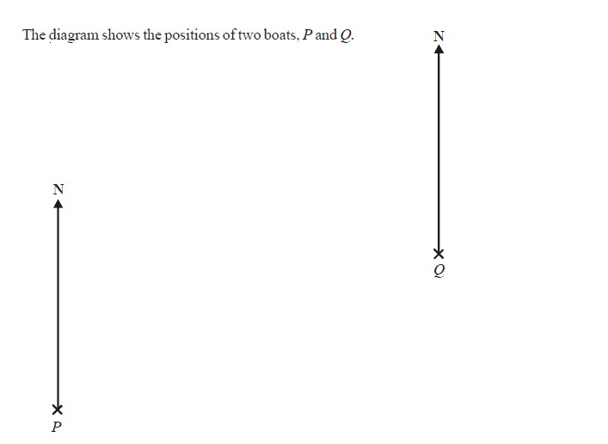

 | 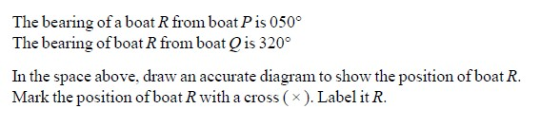
3 | 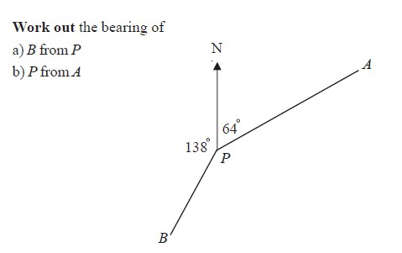
4 | 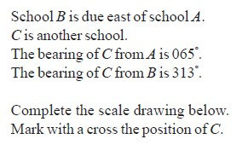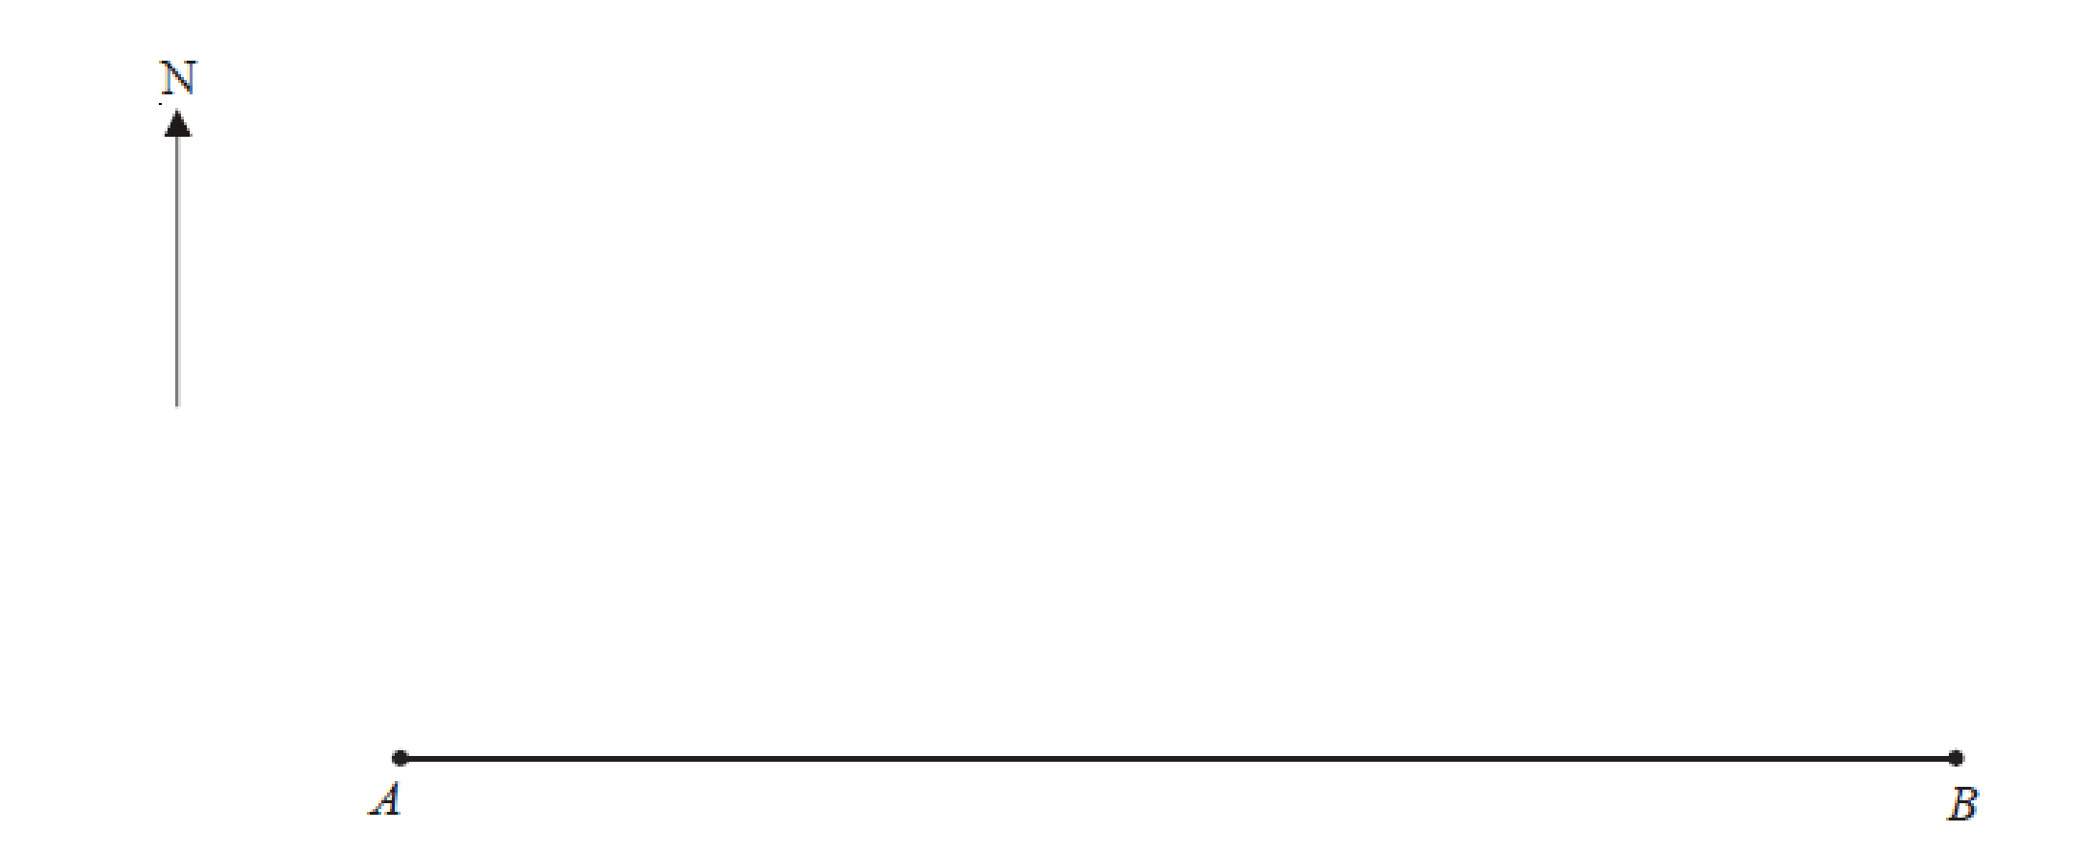

5 | 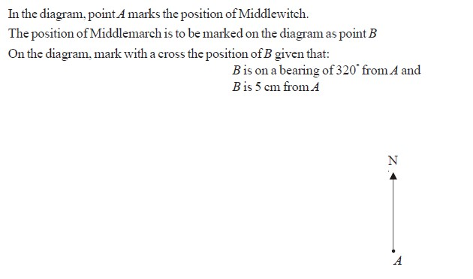

Stage E – Topic 4 - Probability
LO1: To be able to calculate the probability of successive independent events
1 | 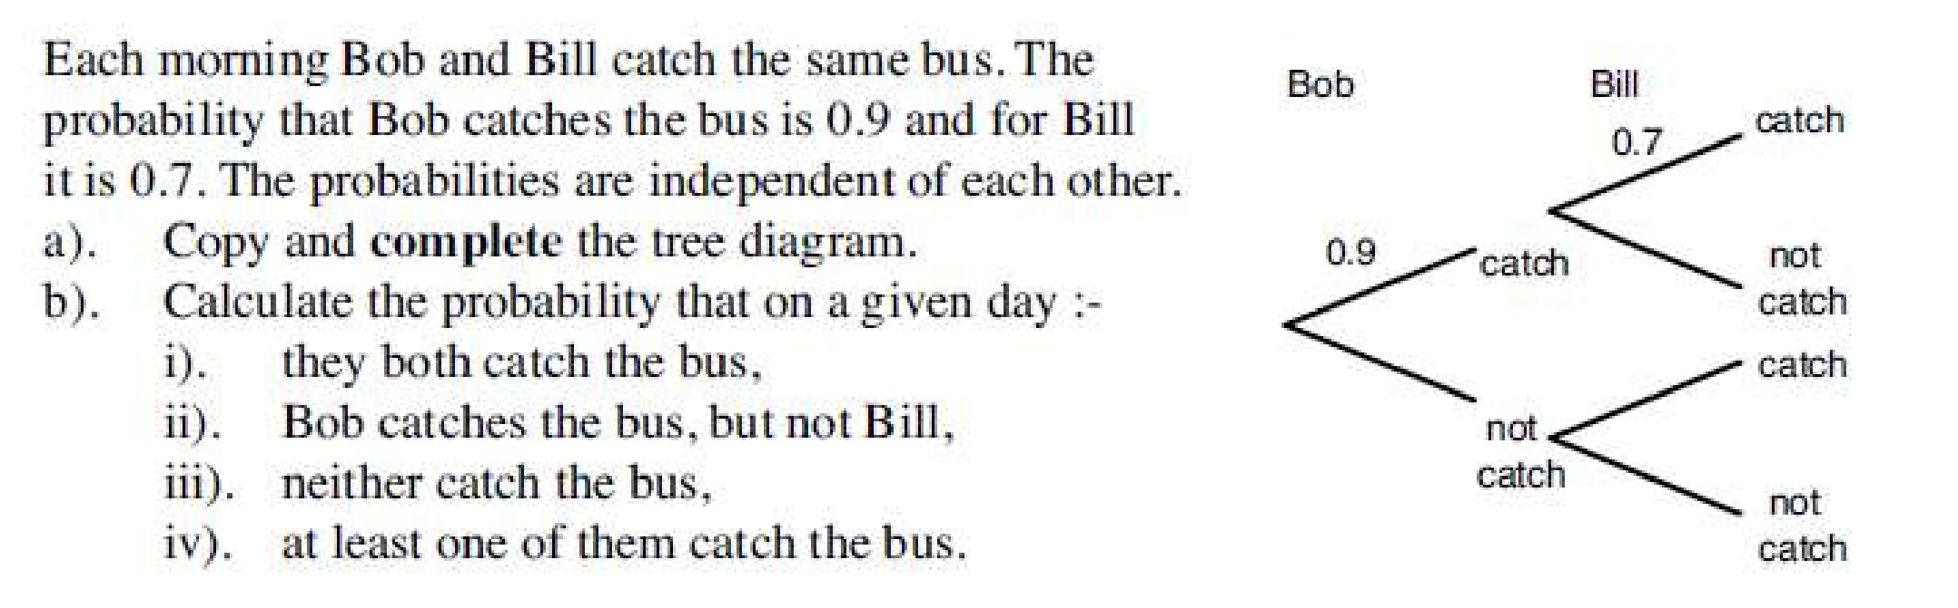
2 | 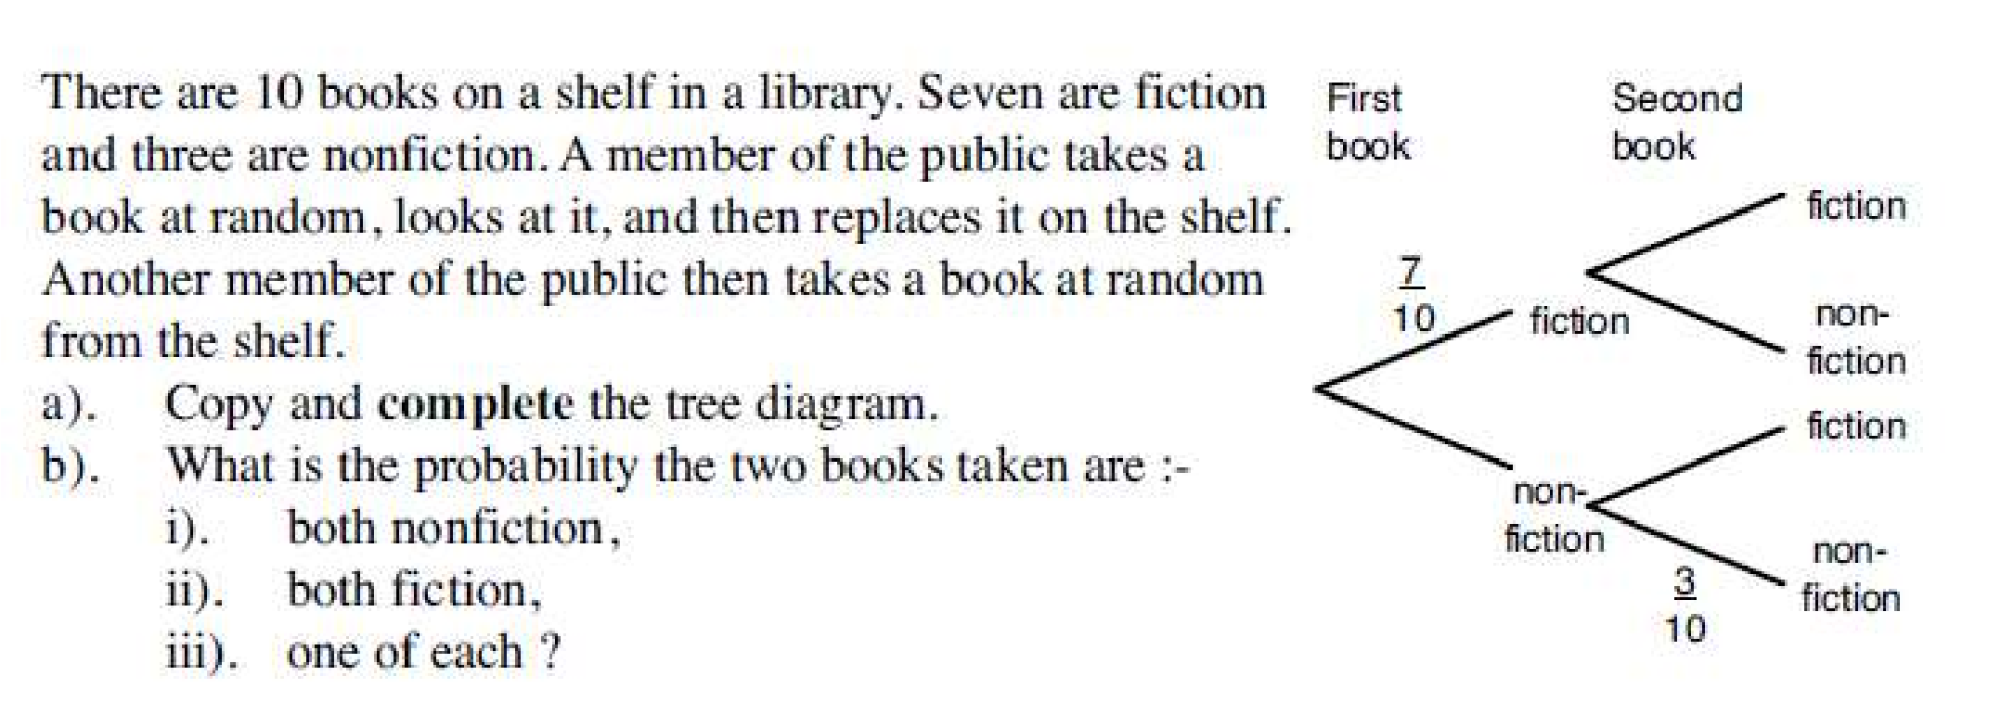
3 | 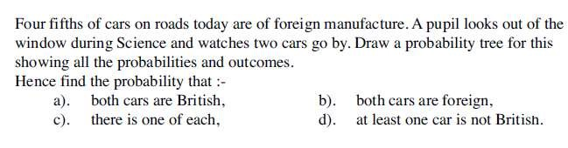
4 | 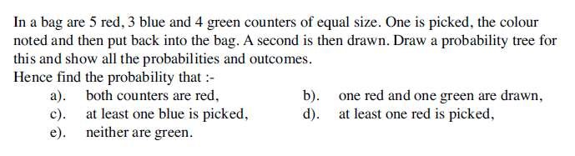
LO2: To be able to use and apply an understanding of experimental probability

1 | 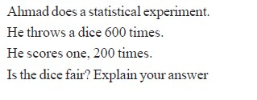
2 | 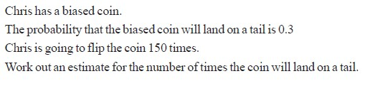
3 | 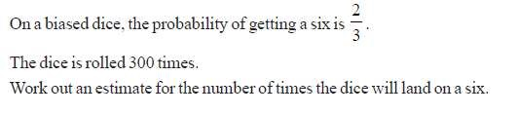
4 | 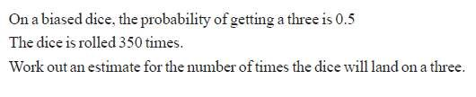
5 | 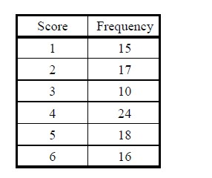  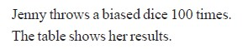
a | 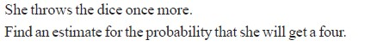
b

Stage E – Topic 5 - Averages and spreads
LO1: To be able to interpret the averages and spread of data sets
1 | 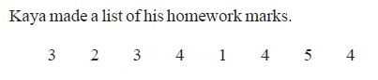
a | 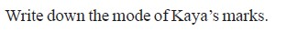
b | 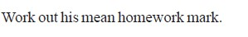
2 | 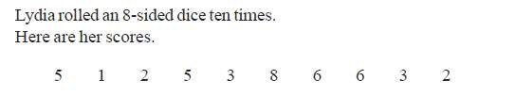
a | 
b | 
3 | 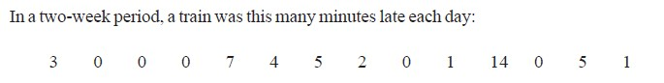
a
b
4 | 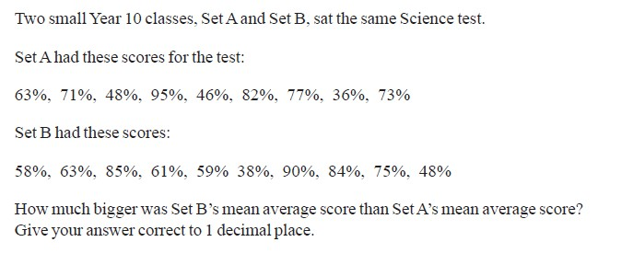
5 | 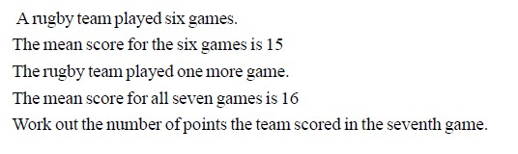
LO2: To be able to calculate averages from frequency tables

1 | 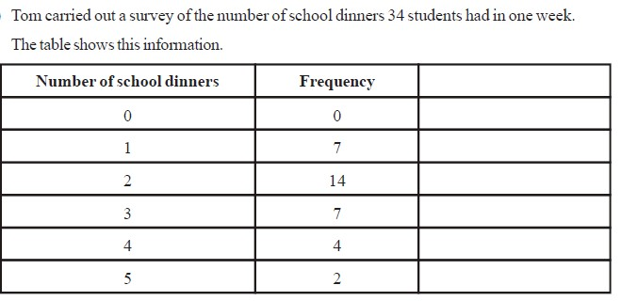
a | 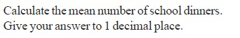
2 | 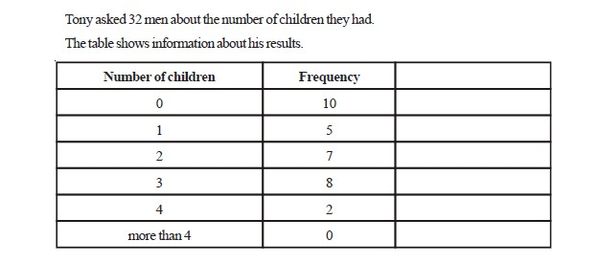
a
b | 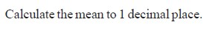
3 | 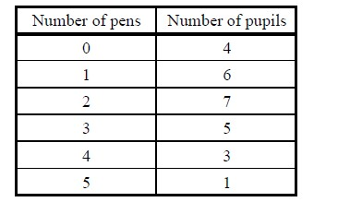
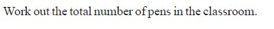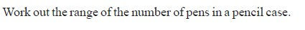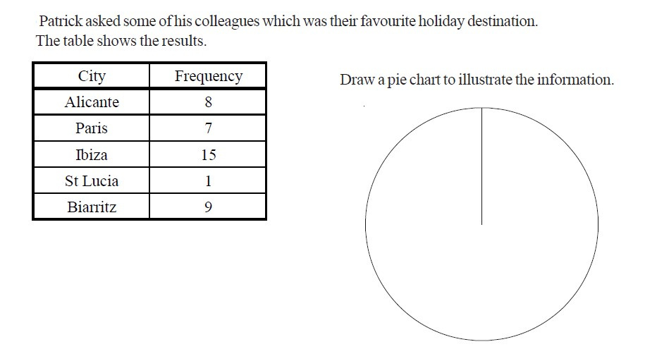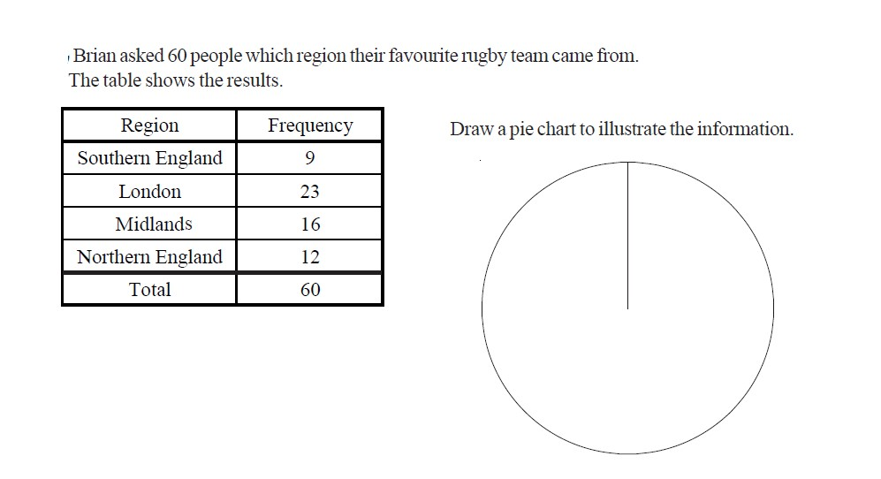
a

b

c

d

Stage E
–

Topic 6
-

Pie charts

LO1: To be able to construct and interpret pie charts

1

2

3 | 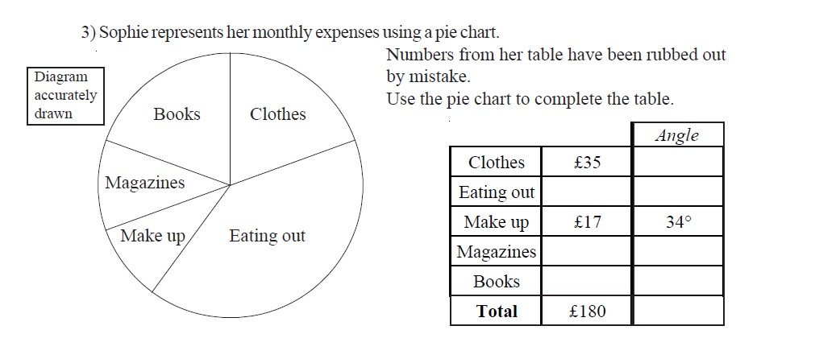
4 | 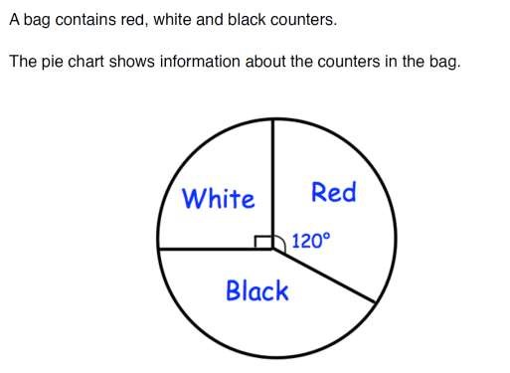
a | What fraction of the counters are white? Give your answer in its simplest form
b | What fraction of the counters are red? Give your answer in its simplest form
c | There are 24 counters in the bag Work out how many are black?
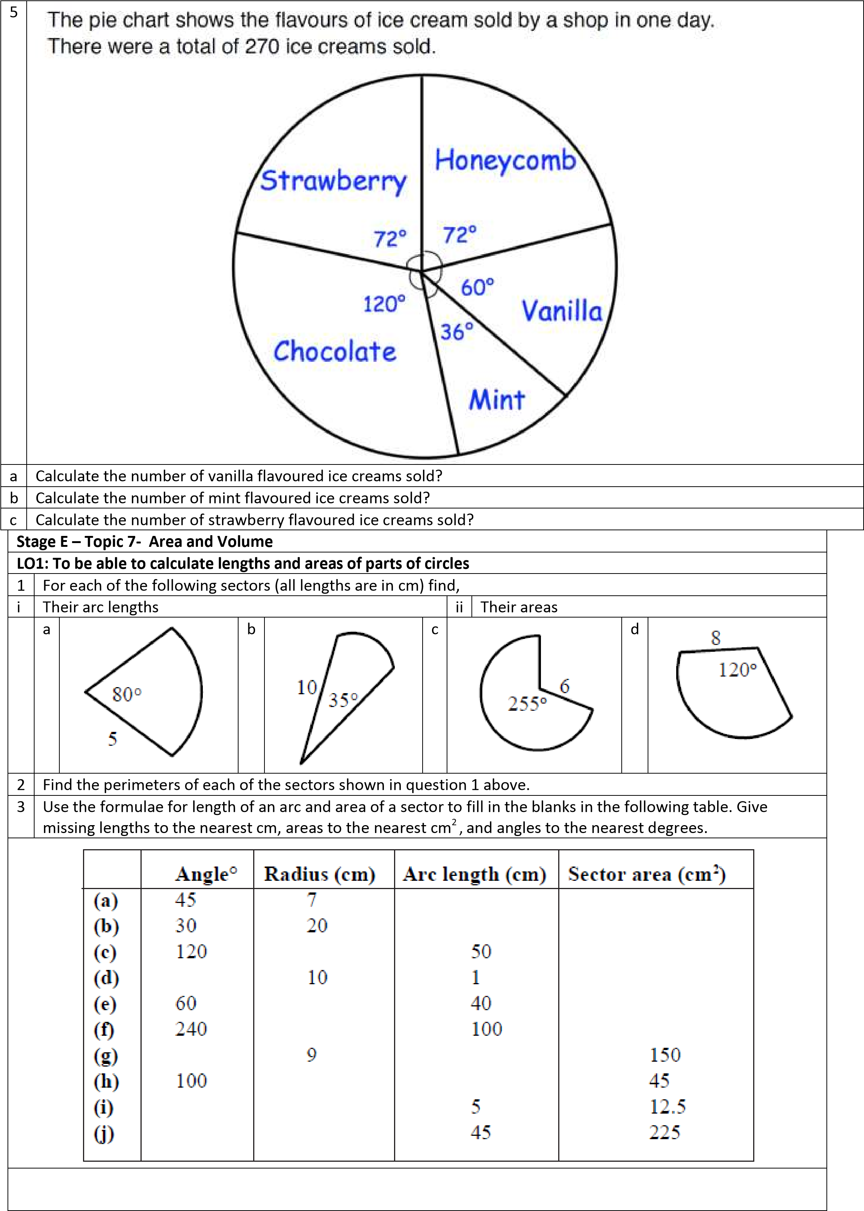

LO2: To be able to calculate the volume of a cylinder
1 | Find the volume of each of these cylinders  a)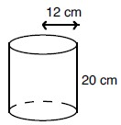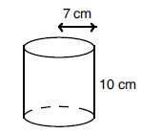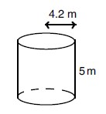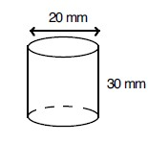  b)  c)  d)
2 | a)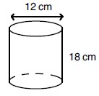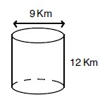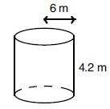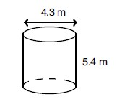  b)  c)  d)
LO3: To be able to calculate the surface area of a cuboid
1
 | 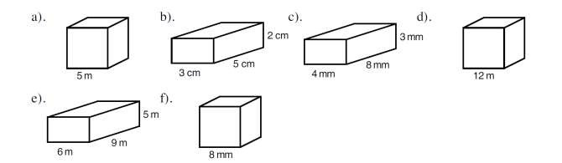
Mixed Problems
1 | 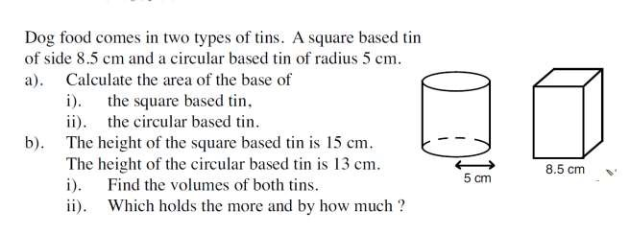
 | 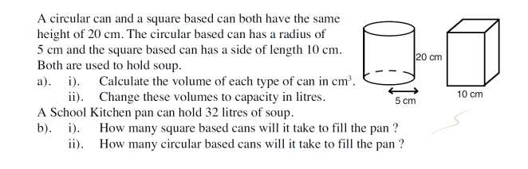

Stage E – Topic 9 - Ratio and Proportion
LO1: To be able to use knowledge of ratio and proportion to solve problems in context.
1 | Simplify the following ratios
 | 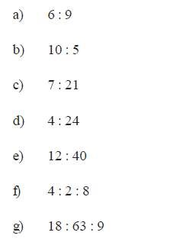
2 | Write in the missing values for the following ratios
 | 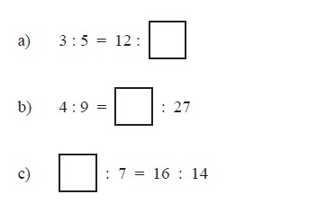
3 | 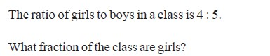
4

a | 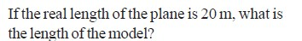
b | 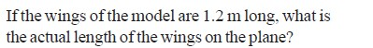
5 | 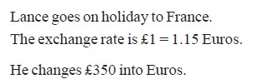
a
b
6 | 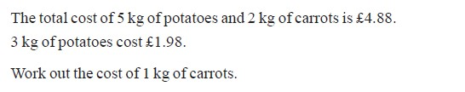
7 | 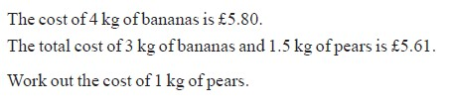
8
9
10
11
LO2: To be able to divide a quantity into two or more parts and solve problems involving ratio
1 | 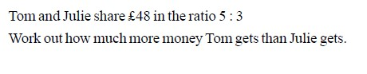
2 | 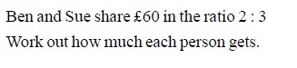

3 |  | 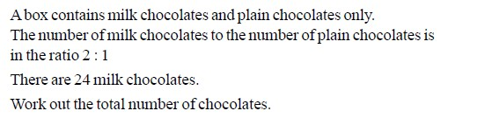
4 |  | 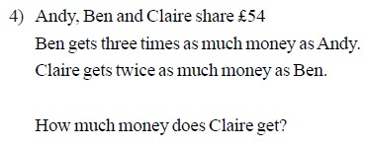
5 |  | 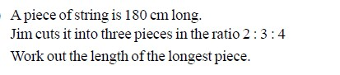
6 |  | 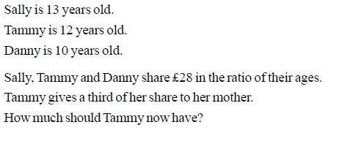
Stage E – Topic 10 - Properties of Numbers
LO1: To be able to find the HCF and LCM of two numbers
1 | 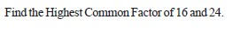
2
3 | 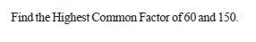
4 | 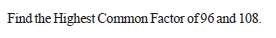
5 | 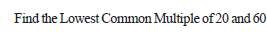
6 | 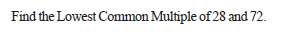
7 | 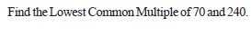
8 | 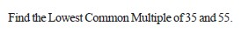
LO2: To be able to use prime factors
1 | 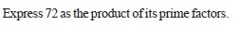
2 | 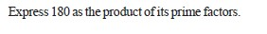
3 | 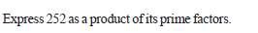
4 | 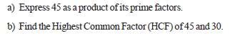
5 | 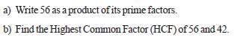
6 | 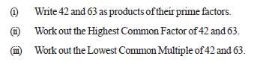
LO3: To be able to round to the appropriate number of significant figures
1 | Round the following to 1 significant figure
 | a |  | 428 | b | 783 |  |  | c | 5608 |  | d | 3521
2 | Round the following to 2 significant figures
 | a |  | 846 | b | 2647 |  |  | c | 3552 |  | d | 46817
3 | Round the following to 3 significant figures
 | a |  | 91249 | b | 64182 |  |  | c | 223058 |  | d | 389512
4 | Round the following to 1 significant figure
 | a |  | 0.00618 | b | 0.00482 |  |  | c | 0.00006492 |  | d | 0.004981
5 | Round the following to 2 significant figures
 | a |  | 0.035812 | b | 0.00082477 |  |  | c | 0.0038611 |  | d | 0.000037211
6 | Round the following to 3 significant figures
 | a |  | 0.00143229 | b | 0.000721981 |  |  | c | 0.0000044251 |  | d | 0.000668821
Mixed Problems
1 | Work an estimate for the following calculations
1 | a |  | 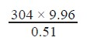 |  |  | b | 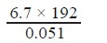 |  |  | c | 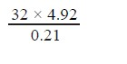
 | d |  | 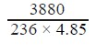 |  |  | e | 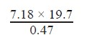 |  |  | f | 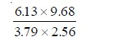

STAGE E ANSWERS
Stage E – Topic 1 – Fractions Answers
LO1: To be able to multiply fractions
1 | 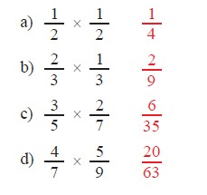
2 | 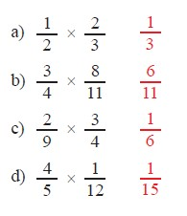
3 | 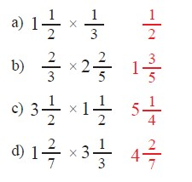
LO2: To be able to divide fractions
1 | 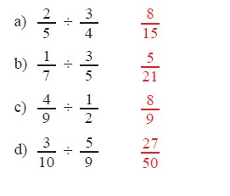

2 | 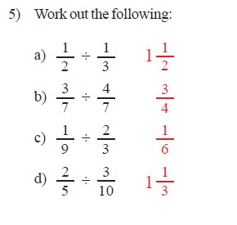
3 | 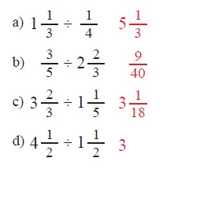
4
Ans | £64.18
5 | 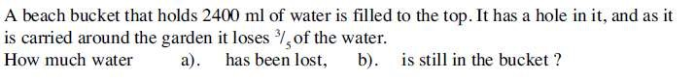
Ans | a) 1440 𝑚𝑙 b) 960 𝑚𝑙
6 | 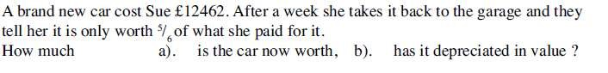
Ans | a) £10385 b) £2077
7 | 2
8 | a) 17 b) 5
9 | 5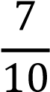
10 | 3
11 |  | a) 14 | b) 15
12 | a | 10 | b | 12 | c | 4 | d | 22
13 | a | 3 | b | 2 | c | 3 | d | 4
4

Stage E – Topic 2 – Percentages Answers
LO1: To be able to calculate proportional change
1 | 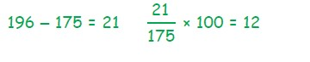
2 | 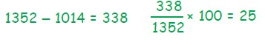
3a | 
3b | 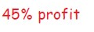
3c | 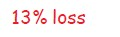
3d | 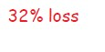
4
5
6 | 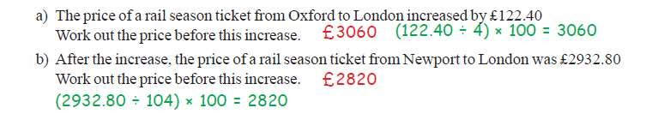
LO2: To be able to calculate repeated proportional change
1 | 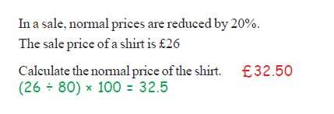
2 | 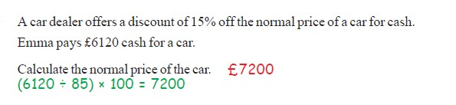
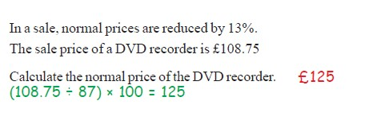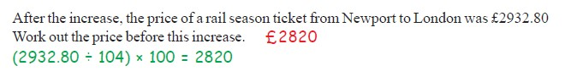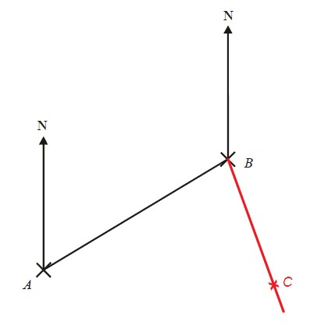
3

4
a

b
4

Stage E

–

Topi
c 3
–

Bearings

Answers

LO1:
To be able to calculate proportional change

1

2 | 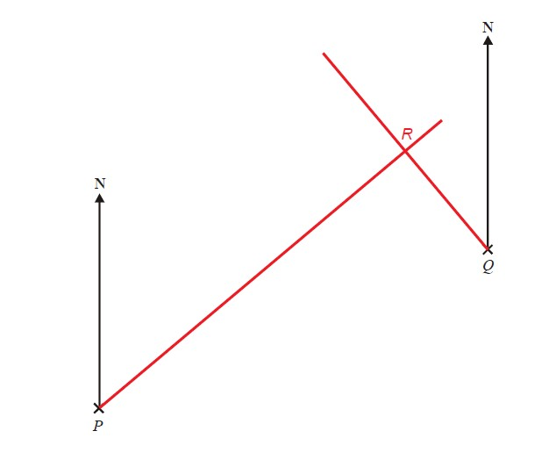
3 | 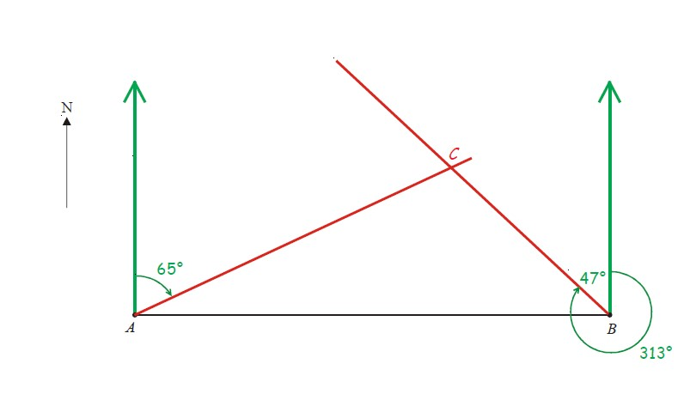
4 | 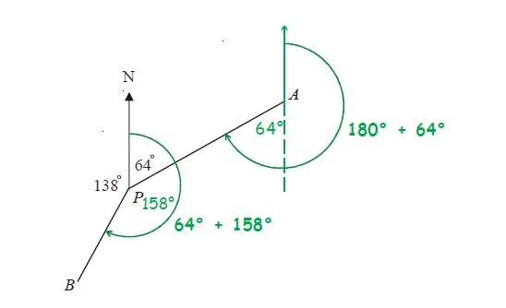
5 | 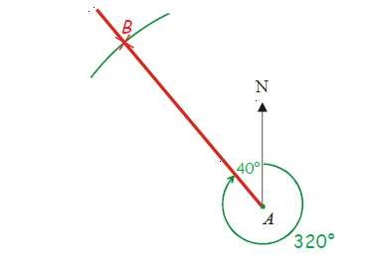

Stage E – Topic 4 - Probability Answers
LO1: To be able to calculate the probability of successive independent events
1a | Correct diagram
1b
i | 0.63
ii | 0.27
iii | 0.03
iv | 0.97
2 | Correct diagram
2b
i | 0.09
ii | 0.49
iii | 0.42
3
a | 0.04
b | 0.64
c | 0.32
d | 0.96
4
a | 25144
b | 5  18
c | 63  144
d | 4  9
LO2: To be able to use and apply an understanding of experimental probability
1
2
3 | 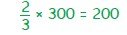
4
5
a | 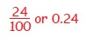
b | 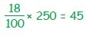

Stage E – Topic 5 – Averages and spread Answers
LO1: To be able to interpret the averages and spread of data sets
1 | 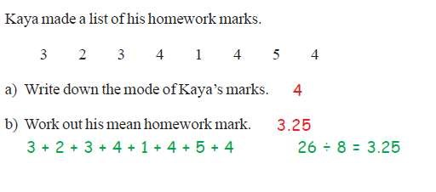
2 | 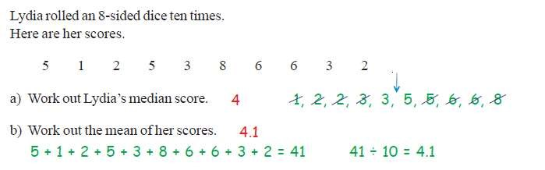
3 | 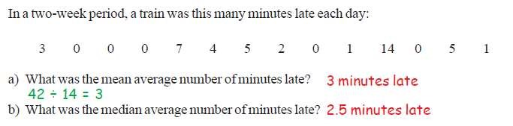
4 | 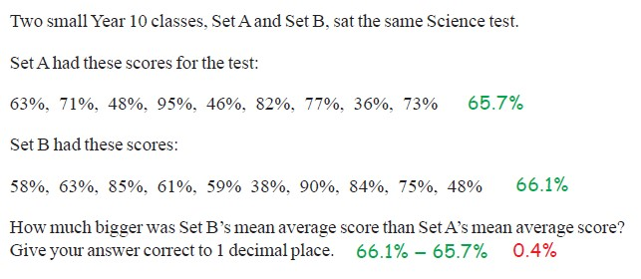
5 | 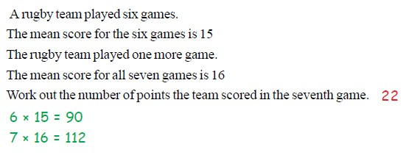

Answers
LO2: To be able to calculate averages from frequency tables
1
2
a
b
3 | 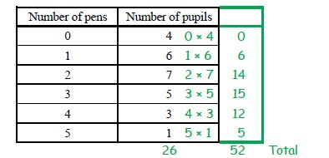
3a
3b
3c
3d | 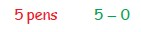

Stage E – Topic 6 – Piecharts Answers
LO1: To be able to construct and interpret pie charts
1 | 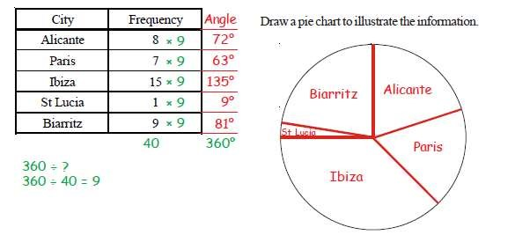
2 | 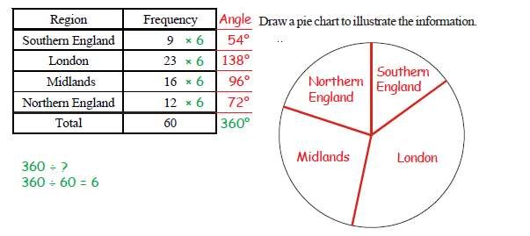
3 | 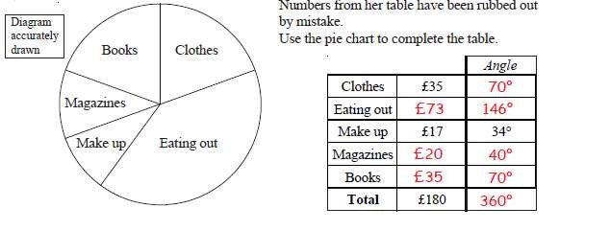
4
a | 1  4
b
c | Angle for black counters =  360⁰ – (120⁰ + 90⁰)  360⁰ – 210⁰  = 150⁰  360⁰ = 24 counters  30⁰ = 8 counters  150⁰ = 40 counters  Answer 40 counters
5
a | 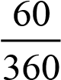u270 45
b | 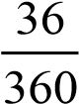u270 27
c | 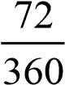u270 54

Stage E – Topic 7 – Area and Volume Answers
LO1: To be able to calculate lengths and areas of parts of circles
1i | - 6.98  - 6.11  - 26.7  - 16.8
1ii | - 17.5  - 30.5  - 80.1  - 67.0
2 | - 17.0  - 26.1  - 37.3  - 32.8
3 | 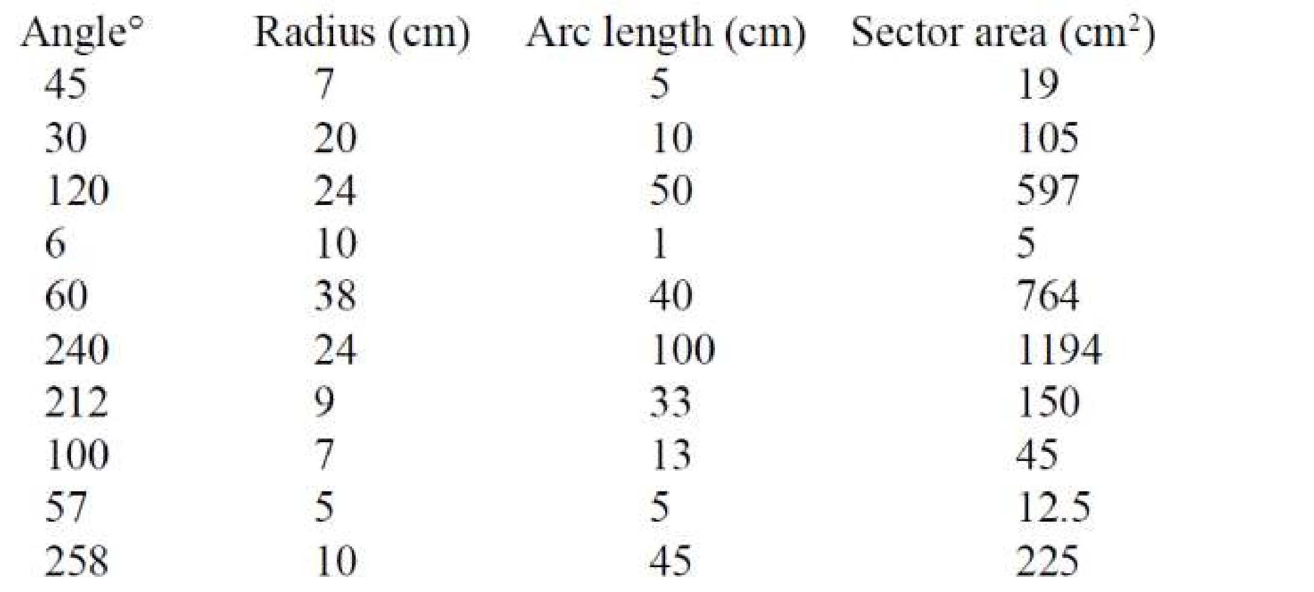
LO2: To be able to calculate the volume of a cylinder
1 | a) | 9043.2
 | b) | 1538.6
 | c) | 276.9
 | d) | 9420
2 | a) | 2034.7
 | b) | 763.0
 | c) | 474.8
 | d) | 78.4
LO3: To be able to calculate the surface area of a cuboid
1 | - 125m²  - 62 cm²  - 136cm²  - 864 cm²  - 258 cm²  - 128 m²
Mixed Problems
1a
i | 72.25
ii | 78.5
1
b
i | 108.75, 1020.5
ii | Cuboid 63.25
2a
i | Cylinder 1570, cuboid 2000
ii | 1.57 , 2
2
b
i | 16 tins
ii | 20.38 21 tins

Stage E – Topic 9 – Percentages Answers
LO1: To be able to calculate proportional change
1 | 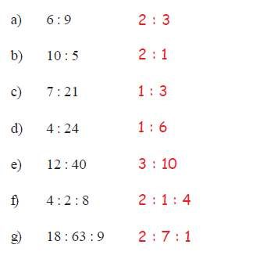

2 | 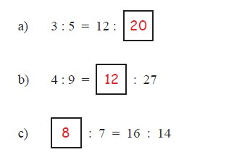
3 | 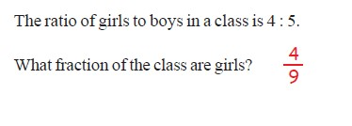
4 | 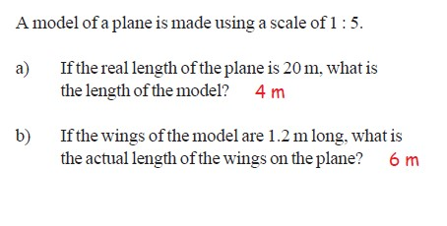
5 | 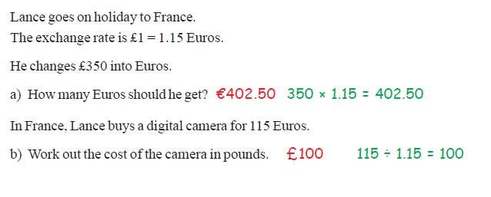
6 | 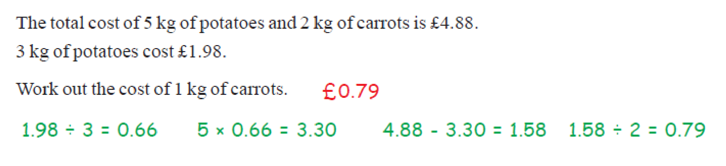

7 | 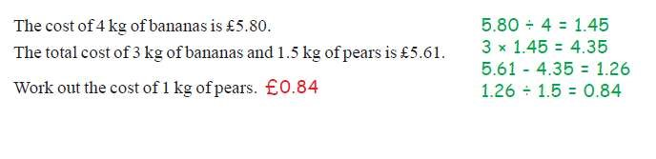
8 | 1 hour 12 mins
9 | 1 hour 40 mins
1  0 | 16 mins
1  1 | 1 hour 30 mins
LO2: To be able to XXX
1 | 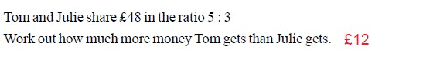
2 | 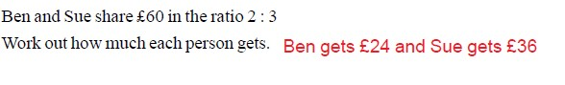
3 | 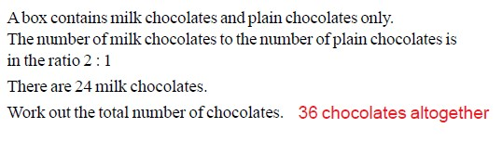
4 | 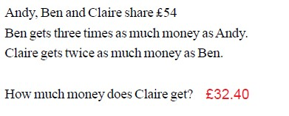
5 | 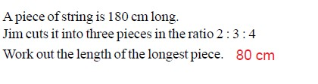

6 | 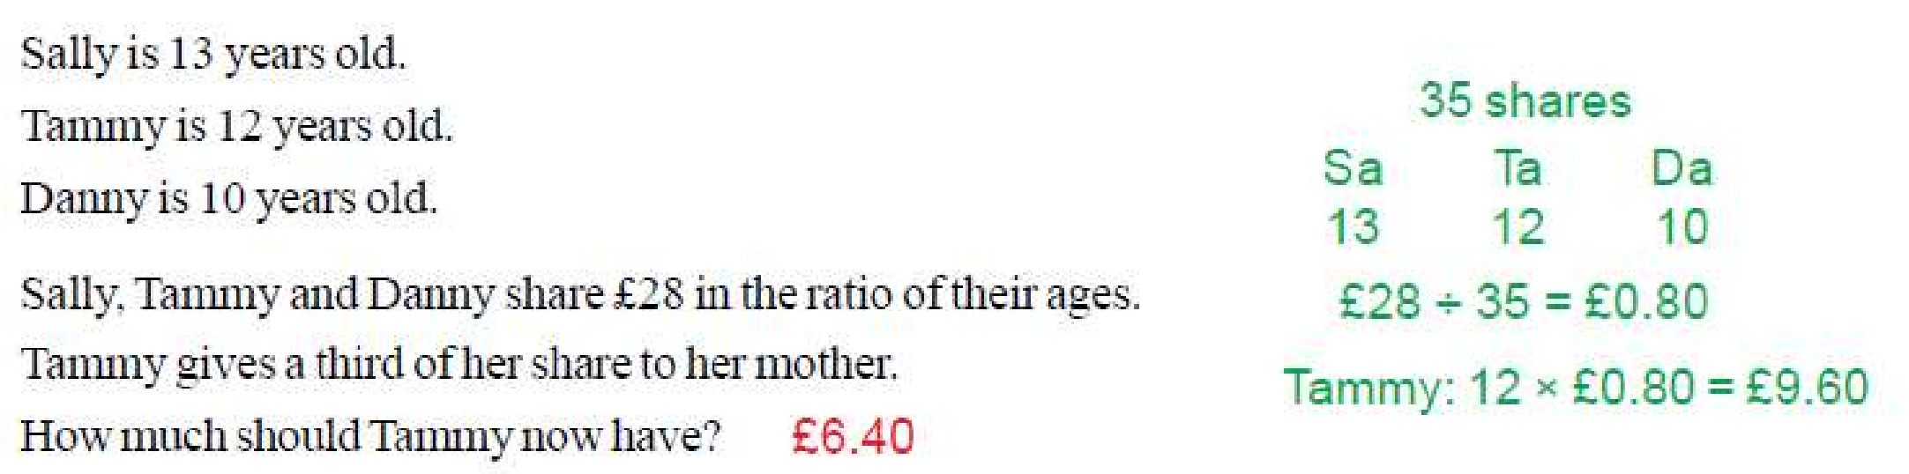
Stage E – Topic 10 – Properties of Numbers Answers
LO1: To be able to find the HCF and LCM of two numbers
1 | 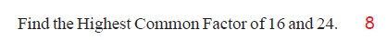
2 | 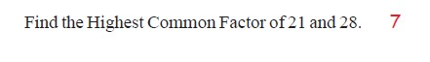
3 | 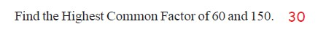
4 | 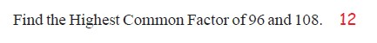
5 | 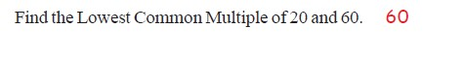
6 | 
7 | 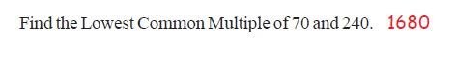
8 | 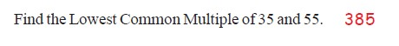
LO2: To be able to use prime factors
1 | 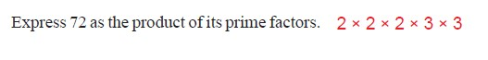
2
3 | 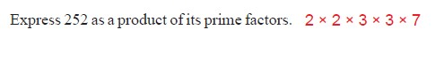
4a
4b
5a
5b |  | 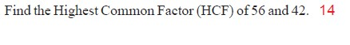
6i
6ii
6ii
i

Answers
LO3: To be able to round to the appropriate number of significant figures
1 | 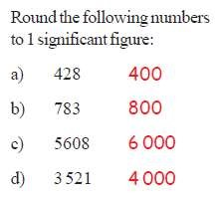
2 | 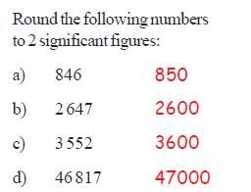
3 | 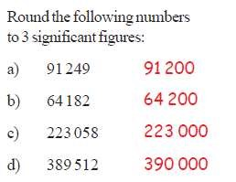

4 | 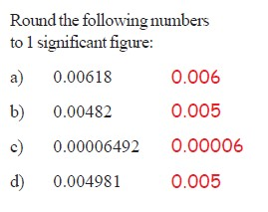
5 | 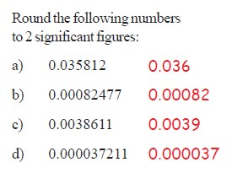
6 | 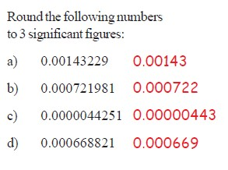
Mixed Problems
1a | 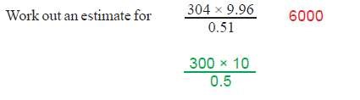
1b | 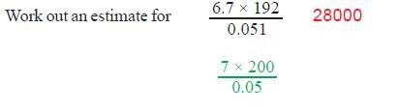
1c | 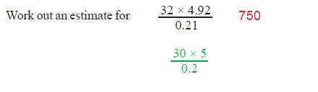
1d | 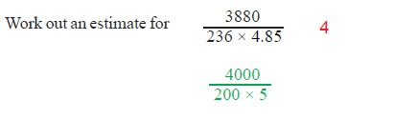
1e | 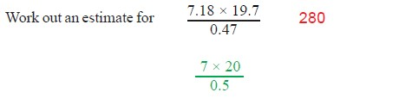
1f | 