Elements of Design
- Line
The first and most basic element of design is that of the line. Lines are useful for dividing space and drawing the eye to a specific location. For example, think about how a magazine uses lines to separate content, headlines and side panels.
Here are a few examples of what we traditionally think of when we think of lines:
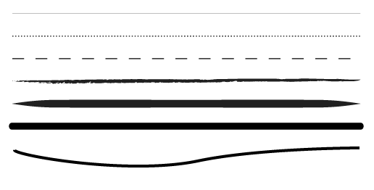
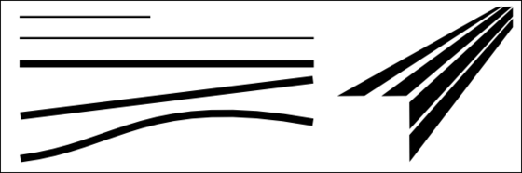
Guidelines For Using Lines
1. Think about what kind of line you will use. Thick, thin, wavy, dotted, dashed, hand-drawn. Each type of line can convey a different feeling.
2. What’s the purpose of the line? Is it to join related content or to separate unrelated content? Is it to add a border around an image?
3. If you’re using a grid, are your lines helping to reinforce the grid, or are they breaking out of the grid? Either can be good, as long as you know what the lines are supposed to be doing and you’re making a conscious decision about it.
4. Think about multiple lines to create texture. A repeating thin hairline can be used as a background texture, as can an elaborate hand-drawn pattern of lines.
5. Don’t just put lines in for the sake of it. As with any design element, if you don’t need it take it away.
- Color
Color is one of the most obvious elements of design, for both the user and the designer. It can stand alone, as a background, or be applied to other elements, like lines, shapes, textures or typography. Color creates a mood within the piece and tells a story about the brand. Every color says something different, and combinations can alter that impression further.

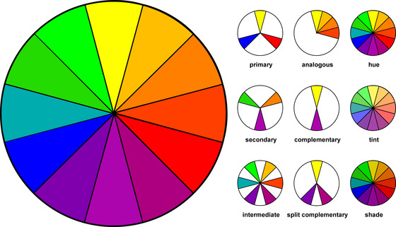
- Shape
Shapes, geometric or organic, add interest. Shapes are defined by boundaries, such as a lines or color, and they are often used to emphasize a portion of the page. Everything is ultimately a shape, so you must always think in terms of how the various elements of your design are creating shapes, and how those shapes are interacting.
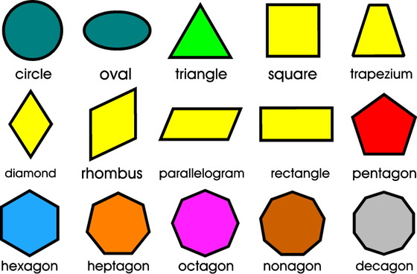

- Typography
Perhaps the single most important part of graphic and web design is typography. Like color, texture, and shapes, the fonts you use tell readers you’re a serious online news magazine, a playful food blog or a vintage tea tins shop. Words are important, but the style of the words is equally essential.
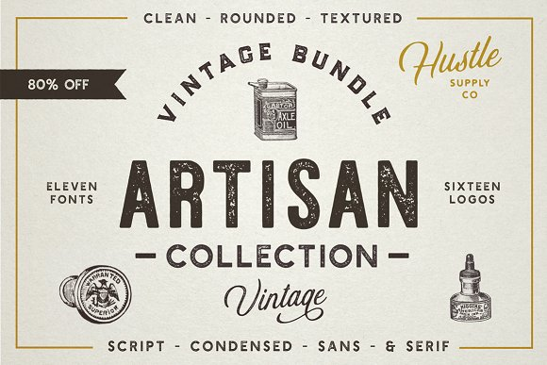
- Texture
It’s counter-intuitive to think about texture when the piece isn’t ever going to be touched. Websites and graphic design do rely on the look and impression of texture on the screen, however. Textures can create a more three-dimensional appearance on this two-dimensional surface. It also helps build an immersive world.
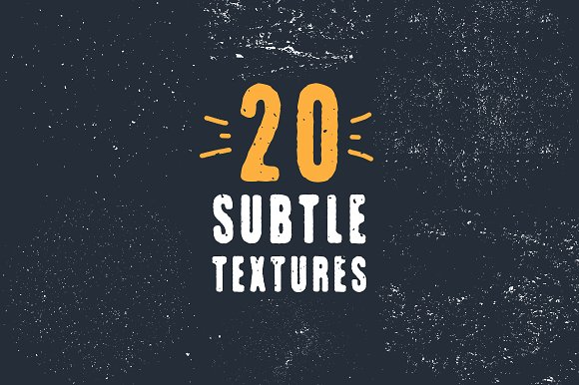
- Space

Negative space is one of the most commonly underutilized and misunderstood aspects of designing for the page. The parts of the site that are left blank, whether that’s white or some other color, help to create an overall image. Use negative space to create shapes as you would any other element. Check out this article if you're interested in learning more about frequently used design terms like negative space.
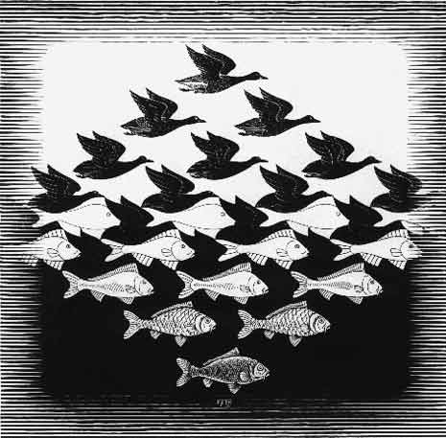
- Scale
Playing with the scale and size of your objects, shapes, type and other elements add interest and emphasis. How boring would a symmetrical website with all similarly sized ingredients be? Very. But the amount of variation will depend heavily on the content within. Subtle differences suit professional content, while bold ones prefer creative enterprises.
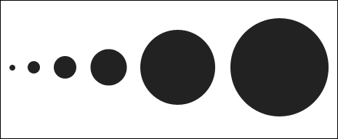

- Dominance and Emphasis
While you can talk about emphasizing one thing or another, the element of emphasis has more to do with an object, color or style dominating another for a heightened sense of contrast. Contrast is intriguing, and it creates a focal point.

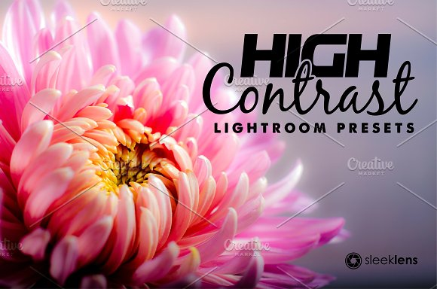
- Balance
There are two schools of balance: symmetry and asymmetry. While most designers, artists, and creative folks much prefer asymmetry for its eye-catching nature, symmetry does have its place. Sometimes.
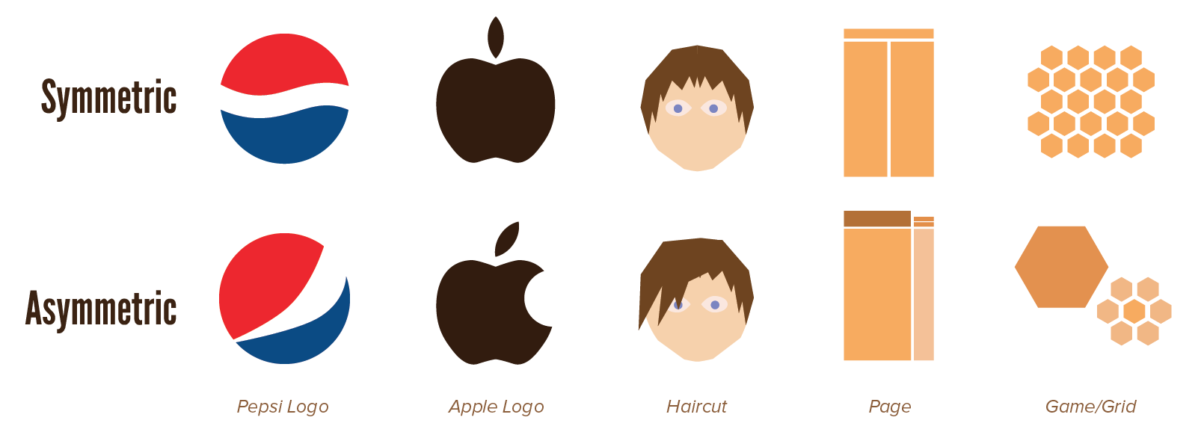

- Harmony
Harmony is “The main goal of graphic design,” according to Alex White, author of “The Elements of Graphic Design.” So, you know it must be important. Harmony is what you get when all the pieces work together. Nothing should be superfluous. Great design is just enough and never too much. Make sure all the details accord with one another before you consider the project complete.
