Movie & Food or Drink Label
Expectation
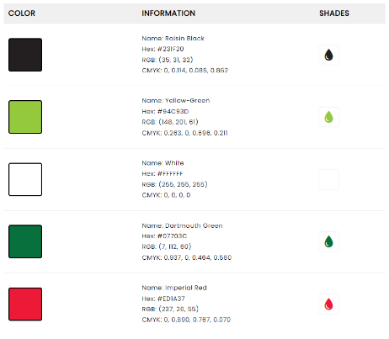
To recreate a label for your favorite food or drink combined with your favorite movie. All items must be vector images, colors must match the EXACT color of the manufacturer. The label must look as if it was created by the original manufacturer.
Criteria
- All items must be vector images.
- Must research to find the exact colors.
- Make sure it is the exact size of your item.
- Must have the ingredients list.
- Must have nutritional information.
- Must have bar code.



