Personal Monograms (For an Individual Person)
A personal monogram can consist of one, two, or three initials. The initials you choose along with color combinations and other features can all come together to create an item that is yours
and yours alone.
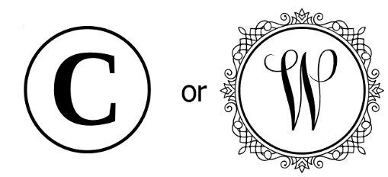
A. One Initial. There are no formal rules for a single-letter monogram. Either the initial of the first or last name can be used. This rule applies to men, women, unmarried women and even children.
First name: Charles
Middle name: Lee
Last name: Williams


B. Two Initials. If using two initials, an individual monogram traditionally consists of first name and last name (surname) initials. Both initials should be same size. This format is also used for someone who does not have a middle name.
First name: Emily
Middle name: Marie
Last name: Brown

C. Three Initials. If using three initials, the monogram traditionally uses all three names (i.e., first, middle and last names).

- If all the letters in the monogram are the same height, then the ordering is first name initial, middle name initial, last name initial.

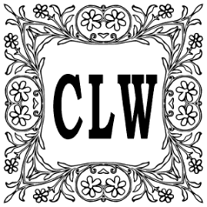
First name: Charles
Middle name: Lee
Last name: Williams

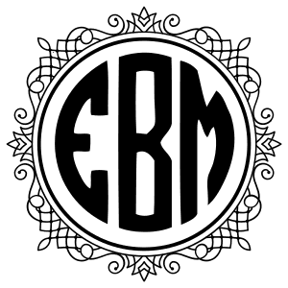
- If the monogram features an initial which is larger than the other two, then the larger initial is used for the last name. In this case, the correct ordering is first name initial (top or leftmost), last name initial, then middle name initial.
First name: Emily
Middle name: Marie
Last name: Brown

Couple Monograms (Joint Monogram)
A joint monogram can be a lovely way to customize your wedding, as well as your home after your big day. You might want to incorporate your joint monogram on stationary, engrave your monogram on crystal, or embroider your monogram onto linens. A monogram for a couple can consist of one, two, or three initials. Use the rules and examples below to help guide you in creating a perfect monogram.

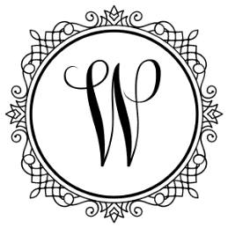
A. One Initial. If using only one initial, traditionally couples use only the initial of their common
last name as shown below.

First name (spouse 1): Emily
First name (spouse 2): Charles
Common last name: Williams

B. Two Initials. If the bride (or partner) decides to keep her given or maiden name, then the monogram for the couple would be the two last name initials separated by typically a diamond (dots and other design elements can also be used.) Both initials should be same size.

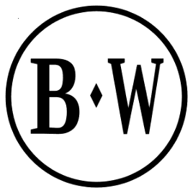
Spouse 1:
First Name: Emily
Last Name: Brown
Spouse 2:
First Name: Charles
Last Name: Williams


C. Three Initials. If the bride (or partner) takes the groom’s last name, then the ordering goes wife’s first name initial, shared common last name initial, husband’s first name initial. The size of the initial for the common last name is slightly larger than the other two initials.

First name (spouse 1): Emily
First name (spouse 2): Charles
Last name: Williams

Expectation:
- Create two monograms, chose two of the three styles
  - Three letter monogram.
  - Two letter monogram.
  - One letter monogram.
- Boarders
  - At least one monogram must have a boarder.
  - No monogram can have the same boarder.
- Letters to use?
  - Your initials
  - Family initials
  - Kimberly’s initials (last resort)
- Artboards
  - Design it on a 6 by 6 art board.
  - Have two art boards in one file.


