Screen Printing Safety Notes

General Safety

- Safety is always the number one priority in any activity.
- Your most important safety device is your BRAIN.
  - THINK BEFORE you DO
- COMMON SENSE is incredibly UNCOMMON.
- Safety rules (laws) are developed by the Department of Commerce.
  - Department of Commerce is a federal government organization which develops safety laws used in schools.
- The appropriate safety glasses approved by OSHA have Z87 written on the frame.
- General safety concerns can be broken into general categories, ACCIDENTS, and HAZARDS.
  - An accident is an occurrence that results in damage to equipment, materials, or in an injury to an individual.
    - Virtually all accidents are preventable in some way.
  - A hazard is an unsafe condition.
    - An accident waiting to happen
- In order to prevent accidents and hazards, you need to follow some basic safety rules:
  - Always learn how to do before you do it
    - If you don’t know how to do or use something, ASK YOUR INSTRUCTOR.
  - Always wear your Personal Protective Equipment (PPE):
    - Safety glasses
    - Face shield (when appropriate)
    - Rubber gloves
    - Apron
    - Appropriate clothing:
      - No open-toed shoes, sandals, or slippers
      - Loose clothing
      - Hair tied up
- Safety Data Sheets (SDS)
  - Since you will work with various chemicals, it is important for you to know where to access information about their composition in the event of an accident.
  - By law, ALL chemicals used in the lab (including cleaning chemicals) are required to have an SDS.
  - It’s important for you to know where the SDS binder is located.
    - The SDS binder is located in the printing lab next to the phone in the south west corner of the room.
  - SDS are used to:
    - Identify the chemical compositions of chemicals used.
    - Identify the chemicals reactivity (acidic, basic, caustic, corrosive, etc.)
    - Identify basic precautions needed when using the chemicals.
    - Identify emergency protocols for what do if you come in contact with or ingest chemicals.
- Volatile organic compounds. VOCs are toxic substances that pass into the air in the pressroom, the workers’ lungs, and the air outside.
  - Inks, blanket wash, fountain solution, and plate cleaners are example of organic solvents.
- All chemical bottles used in the lab must be returned to the flammable cabinet when cleaning up.
- Ink and solvent soaked rags must be disposed in a red oily waste can.
Hazards

- Because hazards can often lead to accidents, hazard ABATEMENT is an important activity. Hazard abatement can be as complex as developing a safety program, or as simple as good housekeeping.
- Here are some simple HAZARD ABATEMENT rules:
  - If you spill something, CLEAN IT UP!
    - Tell your instructor.
    - Spills are one of the biggest causes of accidents in the workplace.
  - Always clean up after yourselves.
    - When the instructor asks you to clean up before the end of class, STOP WHAT YOU ARE DOING AND CLEAN UP.
    - ALWAYS LEAVE IT CLEANER THAN YOU FOUND IT.
  - If you see a hazardous situation that you feel is beyond your responsibility, tell the instructor.
    - This includes behavior.
  - Absolutely no horseplay
  - Never assume that the person you are working with or around knows what they are doing.
  - If you don’t know how to do something ASK THE INSTRUCTOR.
Accidents

- In the event of an accident you are required to inform the instructor about what happened, NO MATTER HOW MINOR.
- If you injure yourself, you must tell the instructor IMMEDIATELY.
- If you spill chemicals on yourself, you need to flush the area with running water.
  - Tell instructor.
  - ALWAYS WASH YOUR HANDS AFTER WORKING IN THE LAB.
- If chemicals are splashed in your eyes, you must FLUSH YOUR EYES CONTINUOUSLY FOR 15 MINUTES WITH RUNNING WATER.
  - Then seek medical attention.
- If you are burned, run cold water over the burn for 5-15 minutes to reduce swelling and pain.
  - Then seek medical attention.
- If you cut yourself, use a clean gauze pad or paper towel to apply direct pressure to the wound.
  - Seek immediate medical attention.
  - NEVER WIPE UP THE BLOOD OF A CLASSMATE.
    - ALWAYS tell the instructor.
    - Blood borne pathogens include things like HIV, and Hepatitis.
- If you come in contact with spilled blood, immediately clean with soap and water and tell the instructor.

Equipment Safety
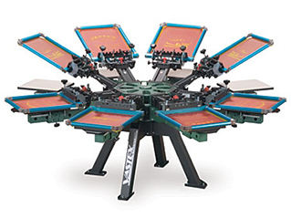
- Screen Printing Press
  - Watch for spinning screens.
  - Watch for spinning pallets.
  - Watch out for pinch points.
    - Where two parts of the machine come together,
      - 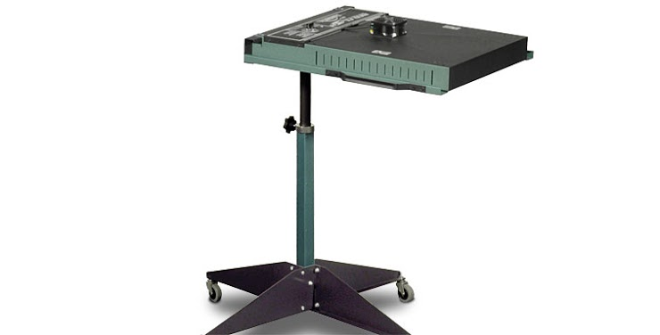It’s where you could get a finger or some part of your body caught in between the parts of the machine.
- Flash Cure
  - Never touch the top.
  - Don’t set anything on the top.
  - Only move it by holding the upright support or the side rails.
  - Always assume it’s on and hot.
- Conveyer Dryer
  - Never touch the top.
  - Don’t set anything on the top.
  - 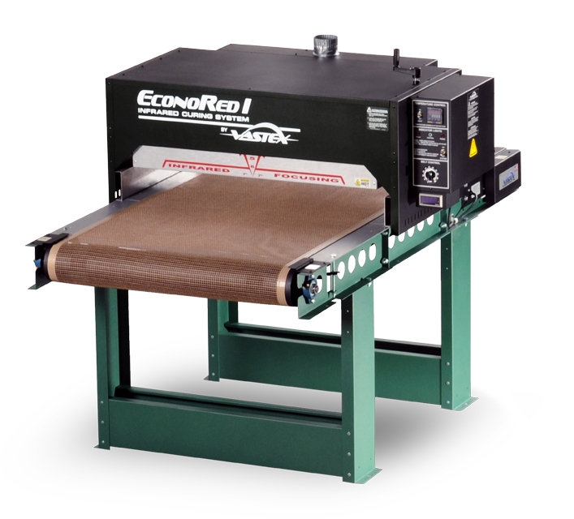Take care in handling the shirts at the end they are very hot.
  - Always assume it’s on and hot.
  - Watch out for the zipper, it’s hot.

