
Board Report
Analysis of Variance 2023
Papakaio School

The BOT set two key achievement goals towards improving overall student achievement for the 2023 year. This is an analysis of the outcomes against these goals.

I would like to acknowledge the hard work of our staff in addressing the learning needs of our target groups and for their work around helping all our children to achieve in an extremely disrupted year.

Goal 1:
Reading:

Reading was seen as a target area for us last year and we set ourselves the goal of:
Annual Goal 1: To accelerate the learning of all students achieving below their curriculum expectations in Reading. Acceleration is defined by progressing by at least 2 sub levels over the year according to Asttle Reading assessment.

Analysis

The following recommendations were made as actions that we could take. In red are the responses that we have made to these recommendations to this point in the year:

- Double down on our Structured Literacy Approach to further support our students to improve in both reading and writing. More PLD and staff training has been funded and one staff meeting a term is dedicated solely to the implementation and review of our Structured Literacy program.
- Put budget money into purchasing resources.- A number of resources have been purchased along with funding for PLD
- Ensure that we have a TA in every classroom to support the classroom delivery for our targeted learners- Due to budget constraints this was not possible for this year, however we do have TAs positioned in the classrooms of the most need.
- Continue with the Booster Buddies programs to target our “lower” readers, especially boys- This is continuing but needs to be reviewed to ensure we are getting maximum impact from the strategy
- Further refine our “assessment for learning” strategies to specifically target areas of improvement for our boys. This is an area that still needs to be addressed, nothing of value has come up in my investigations
- Continue with a “Structured Literacy Approach” school wide from day 1, Week 1 in 2022
- Continue to use a “Visible Learning Curriculum” to allow all students to clearly analyse their strengths and areas for development in the area of Literacy. This is up and running and is supporting student agency as evidenced by our Student led conferences.
- Continue to source and purchase resources to engage boys in reading at all levels of the school. Purchase of a number of decodable resources for boys
- Further research areas of PLD for improving boys literacy. This was addressed through the implementation of the IMSLE training program for staff
- Continue to celebrate the successes of all our students in the area of Literacy and promote reading across the school. This is an area that has not adequately been addressed to this point.
- Continue to dedicate time in staff meetings to professional discussions around our struggling learners in Literacy, particularly boys, and the actions that we are taking to address these issues. This is a part of every staff meeting and regular discussions take place

In order to further improve the results we doubled down with those students that were classed as “at risk” and “working towards. These students were all placed either on Individual Plans (IEPs) or put into Target Groups. Both of which required specific, targeted interventions for those students. The actions that have been taken to this point have been detailed in the supplied document entitled “Target Data Report”

Below is a comparison graph of where we stand as a school at the end of the year compared to the data at the same point in 2022 and 2021:
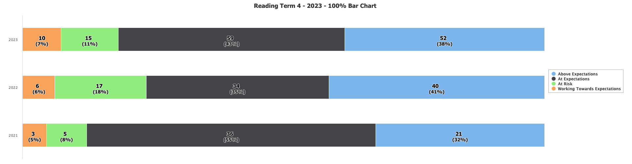

This graph throws up the following points:

- We have 81% of our students across the school who are achieving at or beyond the expectations for their current age and stage. This is a 5% improvement schoolwide on the data result from mid year (not shown) and 5% up on the data from the end of last year.
- At this point of last year we had 76% of students achieving at or beyond expectations. The gains are significant as 2022 end of year data represented 97 students. This year we are reporting on 136 students. A large proportion of these students arrived in the middle of the school year. In June we had 17 students (23%) of our students achieving below or well below. This number has been reduced to 15 or (18%) despite a number of new enrollments in the senior classes since mid year who came in below curriculum expectations. This suggests that we have made solid progress in reading achievement this year
- The percentage of students working beyond has reduced slightly from 41% in 2022 to 38% in 2023, however 38% of students operating above expectations is an excellent statistic.
- The percentage of students working within has increased significantly with a positive shift from 35% in 2022 up to 43% in 2023.
- This appears to be due to another very pleasing shift in the percentage of students who are at risk or just below- from 18% down to 11%.
- When we identify names with these numbers, 8 of the 25 of the students in achieving below/well below arrived after mid year. Of those students 4 have English as a second language.

Split across genders we can see the following: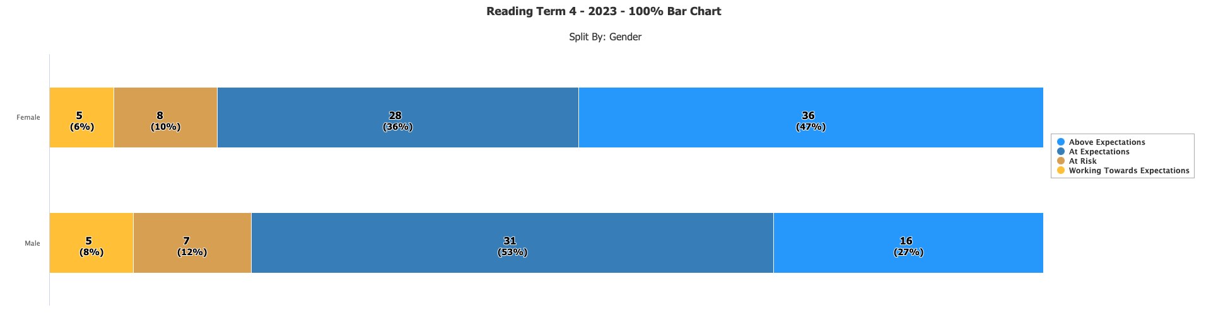

- This data shows that in reading our girls still outperform boys in reading with 83% of female students achieving at or above.
- However our boys have made remarkable progress in the second half of the year. At mid year ⅓ of our boys were struggling in reading. This has been reduced to 20% and is in line with expected results nationwide. To have that much of a positive shift in 6 months is extremely encouraging. Especially as it aligns with the MSLE training that staff have undertaken since the middle of the year.

When split by ethnicity the data looks as follows:
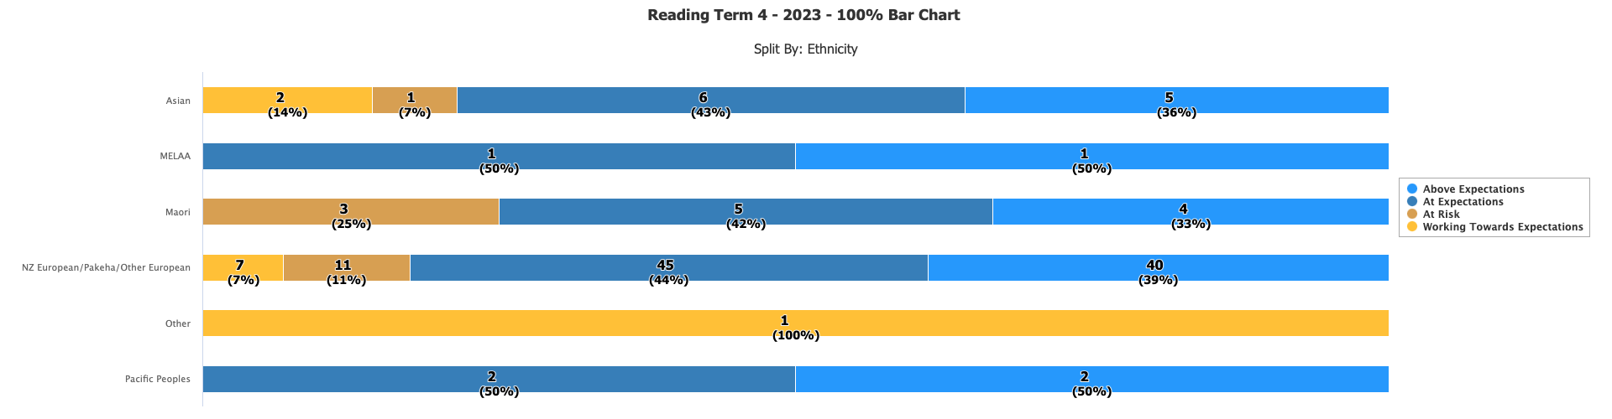
- This data shows that our Māori students are achieving in comparable percentages to other ethnicities, as are our Filipino students, (shown here as “Asian”) which is encouraging.
- For the first time we have usable data for Pacific peoples. This represents 4 students.

When split across year levels we can see a clearer picture of where the real progress has taken place and where the needs are:

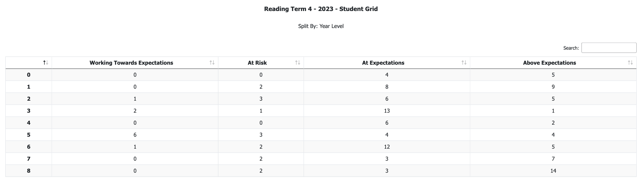

We can see here that the Year 5 cohort has made significant positive shifts. This is extremely pleasing, and again appears to align with the timing of the training that the Year 5 teacher undertook in the mid year break and the implementation of this new learning within the classroom. To see this shift in 6 months is extremely encouraging, and justification for placing that rest of the teaching staff on the same training to ensure a continuation of the methodology and pedagogy that has seen success with a cohort of students that have historically struggled in reading. In the mid year report I made the following comment:

“However we can not escape the fact that we also have 5 students who have been at Papakaio for all (if not a significant period) of their education who were sitting in the “working towards” category in June last year and are still there today. The majority of these students made accelerated progress in the second half of last year and by December 2022 we had only 2 students “working towards”. Both of these students were on IEPs. It is not unreasonable then to expect that with a concerted effort these students can move up the levels and make progress, but it remains a concern that these students tend to yo-yo between the levels each year. This is an issue that we really need to address moving forward.”

The data would suggest that our intervention is working, which as I have stated is very pleasing.

A look at the whole school in comparison to the same time last year looks as follows:

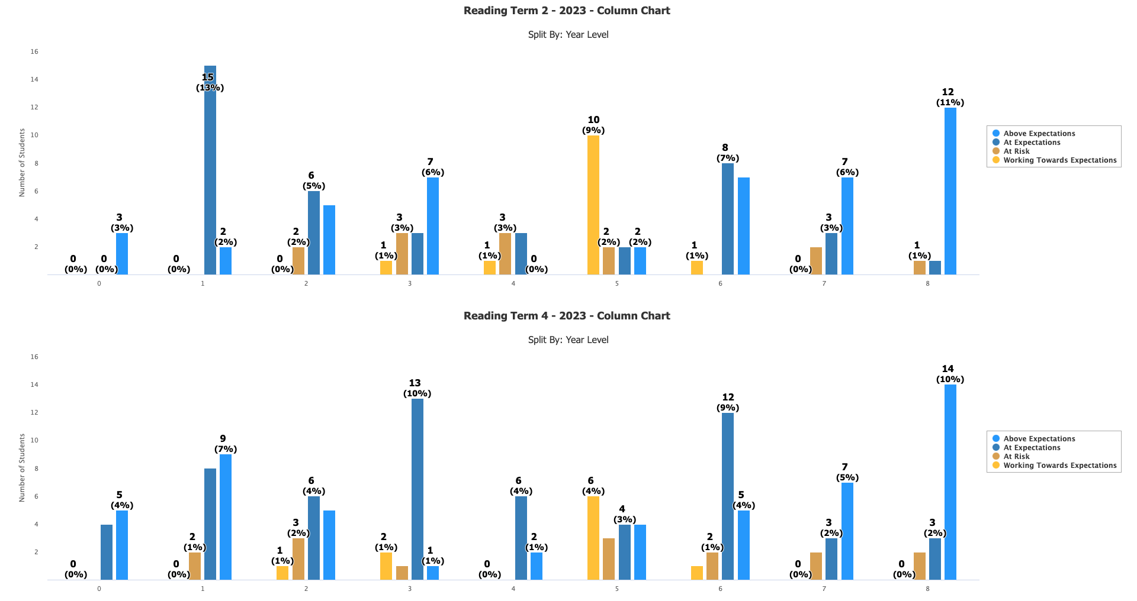

- This comparison shows that we have maintained progress or made positive shifts in every year level.

Evaluation:
Although this goal was not 100% achieved

Summary

Although this goal was not achieved, as a school we can be very proud of the progress that we have made in reading this year, particularly in the last 2 terms.
We have shown overall improvement and positive progress in student achievement, with 81% of students performing at or beyond expectations, representing a 5% improvement compared to mid-year data and the previous year, despite continued roll growth.
The data shows a reduction in the number of students achieving below or well below expectations, from 23% to 18%. There has also been a positive shift in the percentage of students working within expectations, from 35% to 43%.
Although girls still outperform boys in reading (83% vs. 80%), there has been remarkable progress among boys, reducing the percentage struggling from 33% to 20%. This positive shift aligns with the MSLE training undertaken by staff.
Māori and Filipino students are achieving comparable percentages to other ethnicities. The school has usable data for Pacific peoples for the first time, representing 4 students.
The Year 5 cohort has historically shown issues, particularly with students well below expectations. However, significant positive shifts have occurred, and can be directly linked to training undertaken by the Year 5 teacher. This success vindicates the decision to extend the training to the entire teaching staff.
However we do still have some persistent challenges. Some students, despite interventions, continue to remain in the "working towards" category each year. Although this group has reduced in size this year. This is a concern that needs to be addressed, and there is a need for a concerted effort to ensure consistent progress for these students.
Comparison across all year levels indicates that the school has maintained progress or made positive shifts in every year level, showcasing overall improvement.
Although those learners that were below or well below made progress, in some cases that progress was not accelerated to the place where we wanted it to be (2 sub levels). We also had a significant roll growth in 2023, of which a number of students came in with reading skills that were below expectations (including a proportion of ESoL students from overseas). Our mid year data was disappointing and the research and resulting PLD that has gone in to the staff since mid year is starting to pay dividends and these gains will be more evident in 2024 and beyond once these practices are embedded for staff and students alike.

Next steps:

The following actions should be considered for action for next year from the management team and the teaching staff-

- Complete the whole staff training in the MSLE approach.
- Continue to track and monitor the progress of targeted learners, particularly those in the Year 4 and Year 6 cohorts for 2024.
- Strategic placement and training of Learning Assistants to support teachers with students in cohorts that have historically and consistently struggled in reading.
- Show closer links to the reading and writing curriculum to ensure the progress in both areas.
- Continue to dedicate time in staff meetings to professional discussions around our struggling learners in Literacy, particularly boys, and the actions that we are taking to address these issues.

Goal 2:
Annual Goal 2: To provide an expression of a localised curriculum at Papakaio School that is meaningful, sustainable, integrated and relevant to the needs of our students.

Analysis

The actions toward achieving this goal were laid down as follows in the annual plan. Added to these are the indicators of success and the actual actions.

- Blue text represents Term 1 actions
- Pink text represents Term 2 actions
- Black text represents Term 3 actions
- Green text represents Term 4 actions

Intended outcomes | Actions required | Indicators of success | Review
2.1. Provide teachers with up to date, quality PLD opportunities focussing on Curriculum development  (NELP 1,2,3,4,5,6,7) | -Principal to investigate possible PLD  opportunities and foci for 2022.  - TODs planned and structured to provide  support in targeted areas to strengthen  teaching and learning programs.  - PLD Application for February round  -Engage with PLD provider in Curriculum Delivery | - Staff requesting and undertaking relevant, quality PLD  - PLD is relevant to the goals set out in the strategic plan for 2023  - Teachers can articulate how the PLD is supporting their teaching programs  - PLD hours are approved  - PLD provider is engaged with  - Staff meetings are planned and happening | - Lots of PLD in T1 including kotuitui, Numicon, PACT, curriculum refresh, te reo Māori and structured literacy. This has happened through in school PLD and exterior providers.  Term 2 staff meetings involve Principal led PLD in the effectiveness of concept based curriculum. First session was held at the end of term 1 and follow up session is on the 10th May  MSL training for 2 staff in Term 2 holidays completed  Pact Training through the CoL(all staff)  NZC Refresh training for( all staff)  LA training in Term 3 (all LA staff)  NZC refresh training in Term 4 on TOD  MSL training for Teachers in R6 and R7
2.2 Meaningful connections with local resources to encourage students to engage with learning in local contexts.  (Nelp 5,7) | - Canvass local professionals and businesses  - Investigate local issues that we can relate to the teaching and learning program | - Community engagement is evident within the learning programs at he school  - Learning programs are utilising local contexts in which to frame their learning experiences.  - Work experience days organised for Term 3. | -Visit from Nola Tipa (Moeraki) to support implementation of the “Hapori” unit. To talk about Māori communities in the past and today.  - Luzette engaged as a local artist to consult with staff students and community over the new mural  Mural is underway, Luzette has sketched the outlines and the students are now engaged in the process of painting  Engaged with Sport Waitaki for the PAL program  WRSN Leadership camp  Young leaders day in Dunedin was attended by Year 8 students  Mural work started up again in Term 3. Luzette working with student to complete  Mural was completed in early Term 4  Principal to attend hui at Moeraki on 6th December intended to strengthen link with local Runaka- sadly meeting was cancelled by the Runaka
2.3 Principal to engage with local PLD provider around Localised Curriculum engagement  (NELP 7) | - Investigate effective PLD providers  - Contact and book PLD for principal  - Build on principal PLD with whole staff  PLD in the second half of the year. | - Research completed into local providers  - Preferred provider contacted  - Provider engaged  - Principal to complete PLD in Ters 1 and 2  - Staff PLD initiated in Terms 3 and 4 | - PLD process has begun, Principal is in the process of completing the application  PLD application is now complete and submitted (Term 2 week 3)  PLD Application denied. Training to begin with management in September(dates confirmed)  Second application completed in Week 9 of term 3.  2 staff meeting were planned and implemented in Term 4 with PLD provider  Graduate Profile created with PLD provider and SLT..
2.4. Specialist Year 7/8 program in place engaging the local community.  (NELP 1,2,7) | - Sailing, mountain biking and STEM  - Digital Learning Curriculum implemented in the senior room  - Leadership program introduced  - Inspiring futures program | - Leadership program is in place (badges awarded at assembly)  House leaders running lunchtime clubs, events and assemblies.  Year 7/8 attend the inspiring futures program | -Leadership program is running in R6 we have PAL, House leaders, Buddy system, Playground monitors, fundraising opportunities and lunchtime clubs that have been taken up so far.  Year 8 students attended WRSN leadership conference at Camp Iona in week 2 of Term 2  PAL Training  Young Leaders Day attended by Yr 8 students  Year 8 camp to Wellington  Sailing and Biking in Term 4  NoSLaM VR day in Term 4 for senior class

Reflection:

The data and judgements in this area were not as quantifiable as with goal 1, due to the fact that the results were evidence in the gaining of experiences for both staff (the PLD) and students (the execution of the PLD).

The first half of the year was spent very much “in the sandbox”. Trialling different methods of delivery before we embarked upon the training in the second half of the year. In Terms 2 and 3 we engaged with Megan Gallagher for first management days and then whole staff development.

As a group we found this challenging but also informative and ultimately transformational for pedagogy from where we were at the start of the year.
As a result I believe that we can say we are well on the way to providing a meaningful, sustainable, integrated and relevant localised curriculum to support our students' learning.

The data that we can use to make this statement is anecdotal and can be found in the efficacy and confidence of our teachers to plan and implement this form of inquiry learning, and will be proven over the next 12-24 months when we are able to deliver the concepts based learning program to the students in a way that is meaningful and rich in valuable learning that can be transferred across the curriculum.

Added to this we were able to engage with the local community to provide opportunities for students at all levels of the school. From visits to Willow Park to create art and writing around autumn leaves and again for daffodils in spring. We also engaged in a number of local EOTC opportunities for the students through mountain biking, sailing and kayaking, as well as farm visits and trips to the local Library, Art gallery and Museum to support learning in Terms 1 and 4. NOSLaM also connected with us as a host school for 2 “VR Days” to explore local waterways through virtual reality headsets. On these days we hosted a number of other local schools to use the equipment.

In Term 1 we were visited by Nola Tipa from our marae at Moeraki. She went through classrooms and shared pūrakau and tāonga from our local rōhe. We also linked with local farmers and finished the term with a visit from BX Foods- a local Beef and Lamb supplier for a community barbecue.

In Term 2 we linked with the local community through the lens of Matariki culminating in a shared breakfast with the community.

In Term 4 we linked with the local community through the museum, library and art gallery, as well as camps at Iona and mountain biking and sailing using local services and trips to the pool as part of the Alps to Ocean bike day with Yr 3 students.

With all this it is fair to say that linking with local services and experts was a real focus this year and greatly enriched the learning in a local context.

Another excellent example of engaging learning within a local context was through the linking with creatives in schools and the planning and creation of the new Papakaio School “Our Place” mural (below) which represents our local community and environment and was created in consultation with family and whānau and local iwi of the rōpu to create a meaningful and long lasting representation of our community that will be around for many many years.

This was a focus for a large part of the year across Terms 1,2 and 4. We had a break in Term 3 due to unfavourable weather conditions. Every student at the school was involved in some way in the painting and many were involved continuously over a number of months. This was the most important facet of the project; our ākonga designed and created it and were involved in every step of the process– from start to finish.

