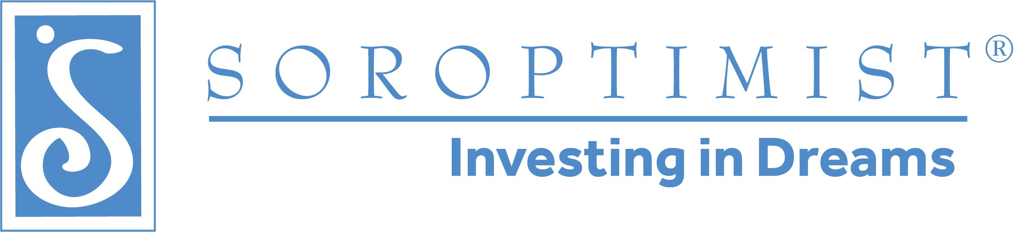


Founder Region Amended 2025 Calendar
Soroptimist International of the Americas Elise Balgley, Governor

August 1-3, 2025 | Region Board Meeting *
August 8-10, 2025 | Fellowship Board Meeting **
August 11- 24, 2025 | Presidents’ Roundtables Times and locations to be set by District Directors
October 3, 2025 | Districts I and II Meet and Greet with SIA ED/CEO Michelle Burnett
October 4, 2025 | Districts I and II District Meeting-Concord Host Clubs: SI/24-680 (Walnut Creek) and SI/American Canyon 2018
October 10, 2025 | Districts III & IV Meet & Greet-Redwood Valley
October 11, 2025 | District III and IV District Meeting-Redwood Valley Host Clubs: SI/Novato & SI/Arcata

October 18, 2025 | District V Meeting: Maui  Host Clubs: SI/Maui
October 18, 2025 | District V Meet & Greet-Maui
October 19, 2025 | District V Leadership Training -Maui
November 7-9, 2025 | Region Board Meeting *  VIA ZOOM
November 15, 2025 | Fellowship Board Meeting Via Zoom
November 17-23, 2025 | Presidents’ Roundtables [Times and locations to set by District Directors]
December 1, 2025 | Nominations due for 2026-2028 Region and Fellowship Boards
2026
January 31-February 2, 2026 | Founder Region Board Meeting *
February 6-8, 2026 | Fellowship Board Meeting **
February 16-28, 2026 | Presidents’ Roundtables [Times and locations to be determined by District Directors]
February 20-21, 2026 | Fellowship Interviews [Hawaii]
March 6, 7, and 8, 2026 | Fellowship Interviews [California]
March 24, 2026 | Caucus [To be confirmed]
April 30, 2026 | Region and Fellowship Conference Board Meetings-San Ramon Marriott
May 1-3, 2026 | Founder Region Conference-San Ramon Marriott  Host Clubs: SI/The Redwoods, SI/Eel River Valley, SI/Noyo Sunrise
June 6, 2026 | Leadership Training-Concord
June 11-12, 2026 | New Board Training-Eureka
June 12, 2026 | Leadership Training-Eureka
June 14, 2026 | Memorial Grove
June 26, 2026 | Leadership Training via Zoom

*Region Board meetings are planned to be held in Hopland, CA
**Fellowship Board meetings are also planned for Hopland, CA other than the November meetings

Please Note:

Region Board members are expected to attend the following:
- Board training-June 7, 2024 in Eureka
- As many leadership training meetings as possible
- Memorial Grove
- All Region Board meetings
- All District meetings in their Districts (District Directors) and all District meetings (Officers)

