Revised 2024



Conference
Manual


Founder
Region

Table of Contents
Conference Coordinator 2
Club Conference Coordinator 4
Host Club Duties 5
Club Responsibilities 6
Participant gifts 6
VIP Gift Baskets – donated by host clubs 6
Registration 7
Credentials 8
Opportunity Drawing Tickets 8
Friday Banquet (Fellowship Awards) 9
Saturday Business Meeting(s) 10
Saturday Banquet – Host Club 10
Sunday Awards Brunch 10
What the Region Provides the Host Clubs 10
What the Club Does Not Do 11
Floor Chair 11
Pages 12
Friday Morning Session 12
Friday Lunch 12
Friday Dinner 13
Saturday Business Meeting(s) 13
Saturday Lunch 14
Saturday Banquet 15
Sunday Award Lunch 15
Registration Chair 16
Prior to Conference 16
During Conference 17
Attendance Report Template 17
Credentials Chair 18
Prior to Conference 18
During Conference 19
Trade Fair Chair 20
Memorial Celebration of Service 21
Delegate Credentials 24
Founder Region Ballot Template 25
Founder Region Fellowship Ballot Template 26

Conference Coordinator

- Get a copy of the Hotel Contract and the Conference Budget from the Governor.

- You and the Governor will meet with the Hotel – find out who you will be talking to and what do they need to get started. If possible confirm the meeting rooms you will be using.

- After the November Board Meeting, or when the Governor has all the details on Conference, you will have a meeting with the Host Club(s); prepare an agenda.
  - It is recommended to introduce yourself to the Host club(s) in the Fall to begin to open the lines of communication and encourage participation. You will not have the details but the club(s) may have questions regarding their responsibilities.
  - This early structural meeting for the host club(s) is critical to their ability to identify and assign duties amongst their groups.

- Communicate all logistic requirements to the hotel banquet manager for the event orders. The event orders accuracy will ensure a smooth running conference. Invoice accuracy is also predicated on advance logistic details being agreed and approved by you. See sample conference logistics spreadsheet on separate file.

- Prepare the evaluation survey questions to be reviewed and approved by the Governor. After approval, create the survey through Survey Monkey. The link to the survey will be posted on the region website, Facebook page and emailed to club members.

- When you arrive at the hotel (Wednesday) check in with the Hotel staff and let them know you are there. Help the Region Board check in. If possible have the hotel coordinator with you to assist.

- When the Governor gives you the list of the people that are being comped for meals (i.e. winners, guests, chairs, etc.), give that information to the registration chair.

- You will give the master room listing to the hotel. This list is composed of everyone that will be on the master billing (region board, official guests, fellowship board) Ask for everyone to be on the same floor (the one that has the concierge service, if applicable). If there are incidentals on the master billing, the Governor will decide if she wants to bill anyone or not. (On Fellowship, there are usually charges the conference treasurer will pay and then bill Fellowship for their charges. Fellowship will pay for their own rooms, as well as the Fellow Reception. If possible, arrange to have a separate billing for the Fellowship expenses.

- The Governor will give you copies of the seating charts – You keep a copy and give a copy to the Floor Chair so table tents can be placed on the dais when there is a change in the head table seating.

- Table Tents – make or have made the table tents. Give the table tents to the Floor Chair with printouts of the head table seating charts.

- You are responsible for getting a Floral Arrangement which goes in front of the podium. It needs to be an arrangement that will last the entire weekend. (This is at the Governor’s request and budget).

- Safety Deposit Box – make sure 2 (two) of them are available – locate the region treasurer & the fellowship treasurer – escort them to the front desk so they can fill out the information card and pick up the key(s).

- Thursday Board Meeting – verify which room the meeting will take place in, make sure there is water on the table, and make sure you have lunch menus available and a list so they can choose their lunch. The board, and official visitor are all invited to lunch. NO ORDERING OF ANYTHING DURING THE BOARD MEETING.

- Reserve tables in the back of the room for the entire duration of the conference, they are for you and the host club(s).

- Friday of Conference – if necessary reserve tables for lunch for legislative advocacy committee and their guests if they are not all able to be accommodated on the dais.

- Make sure water & glasses are on the dais at all times.

- Saturday of conference – Reserve a section for delegates – and if business is not completed, after lunch you will need to have reserved seating for delegates again.

- Saturday – reserved seating for Past Governors.

- Saturday dinner – reserve tables for the Governor’s & Governor–elect’s families for installation.

- Reserved seating areas – per Governor.
- Sunday of conference – reserved tables for winners and their guests. If you see tables are not filling up, then remove reserved signs from some of them.

- Table Opportunity Drawing Monies – make sure pages pick up table drawing envelopes and give to conference treasurer– two members will count and give the money & total amount raised to the conference treasurer.

- The Floor Chair is responsible for putting together the Table drawing Tickets/items (unless otherwise directed from the Governor) – prior to each meal for placement on the tables.

- One week prior to conference – call in the final meal count – at that point let the registration chair and conference treasurer know, and from that moment on, there will be no refunds on meals.

- At the end of conference you will meet with the Hotel – review the bill – then you will receive the master billing – if everything is correct – forward to the conference treasurer for payment.

- The conference treasurer keeps a list of all overpayments; clubs need to provide a written request for any and all refunds (these come to you) you will keep a copy. All refunds must be approved by the Governor – once approved, give to the conference treasurer so checks can be written.

- No refunds are given until after conference is over. Once all other bills are paid, the refund list is given to the conference treasurer with the Governor’s approval.

- The welcome gift item (donated by the host club(s)) are given to the Region Board (11 – 4-Officers, 5-Directors, Parliamentarian, & You), Fellowship Board (7 – President, Treasurer & 5- Directors), Official Visitor (1 or 2), etc... These are delivered to the rooms by the Hotel on Thursday – Or you can deliver them to the suite, or maybe give them to the boards at the board meetings on Thursday if they are ready.

- The most important thing to remember is that your committee members (host club(s)) are comfortable in their job duties.

Note: Advanced Instructions
The Nominating Committee needs instructions and guidelines on how to run and set up the voting room for voting. (This comes from the parliamentarian). If a member of the nominating committee is running for office they need to remove themselves from this committee as they cannot be in or be a part of the voting process.
- How is the room set up
- What do they do when a re-vote occurs
- How is it presented to the Governor

Club Conference Coordinator

The club conference coordinator is the direct liaison between the conference coordinator and the host club(s). She will work closely with the conference coordinator to ensure a successful conference.

The club coordinator will work with the other chairs to ensure that all the members needed are available. In the event the club(s) needs help from volunteers (friends and neighbors) she will be the one to contact the other clubs for help.

The club coordinator will be the one the conference coordinator contacts to “fill in the blanks” on questions regarding the host club(s).

The club coordinator will need to provide the following information to the conference coordinator by the February Board Meeting.

- Names of the personal stewards for the Governor, Governor-elect and Official Visitor.

- Names of the individuals who will give the host club welcome and inspiration on Friday lunch or Saturday night – (this is determined by the Governor which night). FRF directors provide both at the Friday dinner and FR directors provide both at the Saturday lunch.

- Names of the pages who will be microphone attendees on Saturday during the business meetings.

- Names of the pages who will be the time-keepers on Saturday during the business meeting.

- The names of the group of individuals who will act as the color guard on Friday evening.

- The name of the dignitary who will give the “official welcome” Friday night.

- All other duties assigned by the conference coordinator as needed.

Host Club Duties
The host club(s) works with the conference coordinator to make the conference logistics come together.

The conference coordinator is in charge of the conference in conjunction with the Governor. The Governor does the planning; the conference coordinator and host club take care of operations.

Host Club Members Provide:

- The host club(s) will provide chairs to work with the conference coordinator for the following:

- Club Conference Coordinator – liaison between the club and conference coordinator. NOTE: usually the club president when there is only one host club. May not be necessary when multiple clubs are hosting conference.
- Registration Chair
- Credentials Chair
- Floor Chair
- Trade Fair Chair
- Stewards for the Governor, Governor-elect, Official Visitor (note: it is important that the stewards are seated in direct eye contact with the officers during all meetings, and have their cell phones available for calls or texts from the officers at all times.

- All club members should plan to attend and work the conference in some capacity.

- Select some item for your members to wear so they can be easily identified. Examples of items used in the past: hats, blouses, mouse ears, corsages, necklaces, bright badges, and blinky-light pins.

- Wear comfortable shoes, especially the floor committee and pages, you will be on your feet a lot and you will feel better in shoes that fit well.

- SMILE, be helpful and friendly; the host club is part of the team to make the conference run smoothly.
- Be FLEXIBLE and go with the flow.

- HAVE FUN. If the coordinating team has a good time, the attendees will too!

Club Responsibilities

Participant gifts
- A keepsake item or welcome bag is determined by the Governor and may be included in the conference budget.
  - Keepsake item – notebook, folder, binder personalized with Soroptimist logo
  - Welcome Bag – may be donated or personalized with Soroptimist logo
- Items can include pens, pad of paper, promotional items donated by your club and/or community business, bottle water.

- Bags (or manila envelope if giving something else) will include: the conference programs, and other items to be distributed to the conference attendees.

- You will need somewhere to store all these items prior to conference (someone’s garage, place of business, etc.).

- Stuffing these bags/envelopes can be a fun event for your members. If it can be done prior to going to conference or may be conveniently done on Thursday, depending on the logistics of transporting the items.

VIP Gift Baskets – donated by host clubs

- One for each of the following people

- Region Board (10 including the parliamentarian)
- Fellowship board members (7)
- The SIA official visitor (1)
- Other guest(s) as designated by the Governor

- The baskets/bags can contain light snacks (water, wine, crackers, and fruit) and other items you would like to include. Get the items donated from businesses in your community as the region does not reimburse the club for the gift baskets.

- Include a card from the host clubs welcoming them to conference.

Registration

- The conference treasurer will receive and record the money and registration forms (usually begins in March after the Call to Conference has been sent out). The conference treasurer will scan and send via email the registration & credential forms to the registration chair and conference coordinator. The conference chair will then record on the official conference spread sheet in the region Google Drive. Full editing rights should be given to the Governor, conference coordinator and conference treasurer, but only viewing rights to the registration, credential, and FRF President. They can then download the document and gather/sort the data they need.

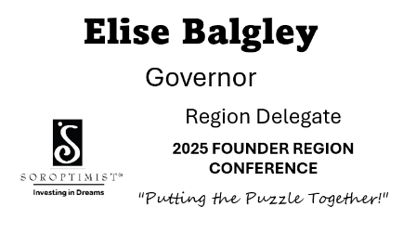
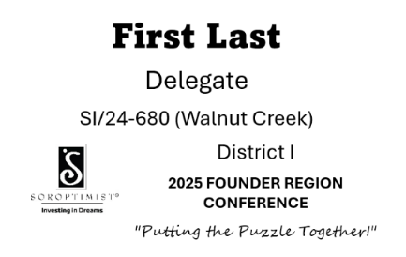
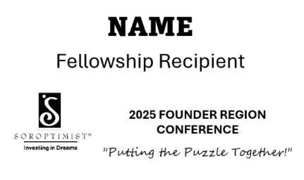
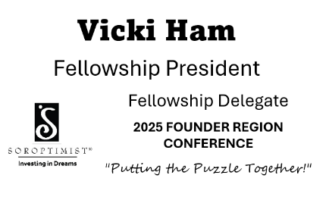
- Print the name tags and meal tickets for each attendee and guest (paper is provided by the region - Avery 74459 (badge and sheet) and Avery 5392 (extra sheets)). Make sure the column names on your spreadsheet match the field names you want to show on the name badges.
Name Badges
  - First and last name – Amasis MT Pro Black 26 font
  - Designation – Aptos 20 font
    - board member office, past governor,
pillar chair
First Last
    - Award Recipient, Fellowship Recipient,
    - Speaker
- Club Delegate, Fellowship Delegate or Region Delegate
  - Club – Aptos 16 font (check spellings & formats)
    - Fellowship & Region – no club or district listed
  - District – Aptos 9 font (roman numerals)
First Last
  - 2026 Founder Region Conference – Bold Aptos 12 font
  - “Putting the Puzzle Together” – Segoe Script 11 font
  - Soroptimist Logo – left side

Meal tickets
  - MEAL – Aptos 28 bold capitalized
  - Add “VEGAN” or “VEGETARIAN” if applicable
First Last
  - Add “GLUTEN FREE” if applicable
  - Add “NO Meals” if applicable

Mail Merge Instructions:
  - The Excel spreadsheet to be used in the mail merge is stored on your local computer
  - On the Mailings tab in Word, choose the ‘Start Mail Merge’ button, a list of different types of documents will drop down, choose Avery 74459.
  - Choose the ‘Select Recipients’ button and choose ‘Use an Existing List’ – find your excel file
  - Inserting the merge fields: On the Mailings tab, choose the ‘Insert Merge Field’ button, a list of the column headers on your saved excel document will drop down (i.e. Name, Club etc.). Choose the appropriate field you want to merge and choose Insert. Repeat step for each of the fields you want to merge and choose Close when done & click ‘Save’.
  - Edit the design: Edit the font, size, and insert logo to your preference.
  - Previewing the mail merge: On the Mailings tab, choose ‘Preview Results’. The merge fields will be populated with the data on the first row of your excel document.
  - Merging and saving your mail merge: On the Mailings tab, choose the ‘Finish & Merge’ button, a list of different types of merges will drop down, choose ‘Edit Individual Documents’. A ‘Merge to New Document’ pop-up box will appear, choose ‘OK’ (access “Help” feature in Word for further instructions)
  - Note: mark “print each row on new page” so there is one sheet per attendee.

- Early registration may begin Thursday evening if all is ready. General attendee registration begins on Friday morning. It would be helpful for you to have 10-12 members to help in shifts. The biggest rush will be on Friday afternoon and Saturday morning.

- The Region and Fellowship board member will register on Thursday. Deliver to their respective board meeting room locations with their conference bags/keepsake gift or let them know when early registration will begin so they can register themselves.

Credentials

- The conference treasurer will email the credentials spreadsheet to the credentials chair.
- Keep a record of the delegates from each club.
- Verify delegates eligibility (member and club must be in good standing).
- Distribute delegate cards to the delegates on Friday and Saturday. Will require two people during rush time on Friday.
- Credentials Cards – regular colored paper (50 each color) suggested colors below.
District 1 – green
District 2 – yellow
District 3 – purple
District 4 – turquoise
District 5 – pink

Opportunity Drawing Tickets

- The region board will determine where the proceeds from each meal opportunity drawing (except Friday night) will be donated. A $50 bill will be provided to the winner of the drawing by the Region Treasurer or the FRF Treasurer (Friday night only). (Typically: Friday lunch is donated to Legislative Advocacy issue; Friday evening is donated to Fellowship; Saturday and Sunday proceeds are donated to the Dream Programs through SIA.)

- Envelopes and tickets will be placed on every table (including the head tables).

- You will need envelopes with tickets (10- 12) per table. (2016 included 36 tickets per envelope ~ selling 1 ticket for $3, 2 tickets for $5, and 5 tickets for $10).

- Opportunity Drawing Tickets: Put enough double side tickets (keep one/deposit one) in envelopes. There are normally 10 people at a table. Have a basket available to deposit the tickets for the Governor to draw the winner.

- Number of envelopes for each meal will be determined by the registration chair.

- Follow instructions from conference treasurer for collection of tickets and money.

Friday Banquet (Fellowship Awards)

- Have a dignitary from your community (if possible) provide the “official” welcome to the conference: Suggestions: the mayor, city council, chamber president or board member.
- If the dignitary can stay for dinner the meal is complimentary; if the person can only be there to give the welcome that is okay.
- The complimentary meal must be approved by the Governor and a registration form must be mailed to the conference treasurer.
- Provide a color guard to present the flags and lead the Pledge of Allegiance to the Flag of the United States of America.
- The color guard carries the flags of the states (and territories) within the region, the United States flag, and the flag of the SIA official visitor (if the visitor is from another country) it may be as many as six flags. (Currently: USA, California, Hawaii, Guam, and Northern Mariana Islands).
- The region will provide all the flags, poles and stands.
- Please try to find a Girl Scout troop, S-Club, or other “women or girls” group to be the color guard.
- The name of the group and the names of the individuals in the group must be given to the conference coordinator by the February Board Meeting or no later than March 1st to be included in the conference program.
- FRF Directors will provide the welcome and inspiration.

Saturday Business Meeting(s)

- Floor chair and pages to be microphone attendees and timers, instructions will be given by the region parliamentarian.
- FR Directors will provide the welcome and inspiration for Saturday lunch.

Saturday Banquet – Host Club

- One person to welcome attendees on behalf of the club (usually the club president).

- One person to give the inspiration. Be sure it is an inspiration, not an invocation – DO NOT say a prayer or other religious themed statement.

Sunday Awards Brunch

- You may be asked to assist with the fundraising “basket” drawing that is conducted by the region fundraising committee.

What the Region Provides the Host Clubs

- A total of two rooms to be split amongst host clubs at the hotel for three nights (Thursday, Friday & Saturday); you decide the utilization of the room (usually the Registration, Credentials, Floor and Trade Fair Chairs share the two rooms). These rooms will be paid directly by the chairs and submit for reimbursement on a region expense voucher (1/2 room for each of the 4 chairpersons– in case they share with others).
- The meal package and registration fee are provided for the registration chair, credentials chair, floor chair and trade fair chair. All other club members will be responsible for registration, meals and hotel rooms.
- Reserved tables near the rear of the ballroom so your host club members can come and go easily.
- Reserved seating at the front of the ballroom for the pages.
- Binder and other items for the registration and credential chairs as needed.
- Flags, poles, and stands for the color guard are in the Region storage unit.
- Reimbursement for copies and postage relative to registration and other conference requirements – prior approval required for any expenditures – contact the conference coordinator, receipts must be attached to the region voucher.

What the Club Does Not Do

- You are not responsible for anything the hotel does or anything an attendee asks for. The hotel is instructed that the only people who can make changes or request anything are the conference coordinator and/or the Governor.

- Please refer all questions, problems (not directly related to host club tasks) to the conference coordinator.

- The club may be responsible for printing name tags and meal tickets. Paper will be provided by the region or the club will be reimbursed for the expense of purchasing and printing. Meal Tickets must include the date and the meal. (Example: Sunday Brunch, May 3) White Avery card sheets are used for the name tags and meal tickets, this has made it easier for the registration process. Different colors for each district will be used for the credential cards. The Conference Coordinator will make the decision.

- The host clubs are not responsible for the memorial service on Sunday. However, you should assign 2 club members to assist line up of those club member’s representing their deceased member. Or, other duties as assigned by the Governor.

- Table decorations: those are provided by the hotel. Check with Governor if other minor items are to be added to the tables.

Floor Chair
Floor chair is the coordinator for everything that happens on the floor of the ballroom, including signage, opening of doors, distribution of paperwork, collecting tickets, basket placement on Sunday morning, and all other duties as assigned.
It is highly recommended to have a meeting the weekend prior to conference to review duties and assignments with all pages and stewards. This will prepare them for a better understanding of what will transpire and the expectations for their assignments. This meeting is in addition to, and not in place of, the meeting with the Parliamentarian which will occur at Conference.
Floor chair will receive a spreadsheet and seating charts for table tents for stage and floor.
DAY | EVENT | # TABLES | RESERVED TABLES
Friday Lunch | Legislative Advocacy | 1 | Legislative Advocacy Speakers
 |  | 1 | Founder Region Board
 |  | 1 | Fellowship Board
 |  | 4 | Host Clubs
 |  | 1 | No Meal Service
 |  | 1 | Trade Fair Vendors
Friday Dinner | Fellowship Gala | 1 | Founder Region Board
 |  | 1 | Fellowship Guests
 |  | 4 | Host Clubs
 |  | 1 | No Meal Service
Saturday Morning | FR & FRF Business Meetings | 15 | Delegates
 |  | 1 | Fellowship Board
 |  | 4 | Host Clubs
 |  | 1 | No Meal Service
Saturday Lunch | Director's Lunch | 5 | Club Presidents
 |  | 1 | Fellowship Board
 |  | 4 | Host Clubs
 |  | 1 | Trade Fair Vendors
Saturday Dinner | Installation/Dance Party | 1 | Past Governor/Founder Region Board
 |  | 1 | Past Governor /Fellowship
 |  | 1 | Incoming Governor Table
 |  | 4 | Host Clubs
 |  | 1 | No Meal Service
Sunday Brunch | Memorial/Awards Program | 2 | LYD & VRA Awardees
 |  | 4 | Host Clubs
 |  | 1 | No Meal Service
All Sessions | 2 spaces reserved | AV | AV Chair and Assistant

Pages
- You will need 9 – 10 pages for the entire weekend.

- Three Stewards will be assigned to the Governor, Governor-elect and Official Visitor. Be sure these are not new members; we want them to feel comfortable working with the leadership.

- Stewards should check with their assigned person every morning to see if they need help getting items downstairs, copies, errands, messages, etc...
- Stewards should be given a key to the hotel room of their dignitary.
- Check with them at the end of each meeting.
- Be within “eye shot” of your assignment during the meetings; you will have reserved seating close to the head table.

Friday Morning Session

- Meet inside the ballroom 30 minutes before the meeting to receive instructions from Legislative Advocacy Committee on what help they need during the session (usually taking care of the microphone, distributing papers, etc.).

- Conference coordinator will have instructions for pages at the afternoon session (this depends on what the Governor has planned).

Friday Lunch

- Meet inside the ballroom immediately following the morning session and no later than 15 minute before the doors open for lunch. NOTE: if sales tables are located inside the ballroom, the doors will remain open.
- Keep doors closed until instructed to open them.
- Place signs on the head tables, according to the seating charts.
- Place signs on tables as instructed if reserved seating.
- Place the envelopes for the table drawing on each table and envelopes on the head tables on either side of the lectern.
- Pages will collect the meal ticket envelopes from each table, including the head tables, count them, and give all the tickets and count to the conference coordinator.
- Pages will collect the envelopes with the opportunity drawing money off the tables after lunch and give to the envelopes to the conference treasurer to count with 2 members, and she will in turn give the total amount raised and money to the region treasurer.
- The Governor will draw the winning number.
- All pages must attend the Delegates Briefing & Teller/Pages instructions presentation conducted by the Parliamentarian. (3:15-3:45 PM). This is especially important for pages who will be working the Saturday Business Meeting Sessions.

Friday Dinner

- Meet inside the ballroom one hour and no less than 30 minutes before the start.
- Keep doors closed until instructed to open them.
- Place signs on the head tables, according to the seating charts.
- Place signs on tables as instructed if reserved seating.
- Place the envelopes for the table drawing on each table and envelopes on the head tables on either side of the lectern.
- Pages will collect the meal ticket envelopes from each table or at the door, including the head tables, count them, and give all the tickets and count to the conference coordinator.
- Pages will collect the envelopes with the opportunity drawing money off the tables after dinner and give to the envelopes to the conference treasurer to count with 2 members, and she will in turn give the total amount raised and money to the Fellowship Treasurer, (who will provide the $50 bill for the winner).
- The FRF President will draw the winning number.

Saturday Business Meeting(s)

- Meet inside the ballroom 30 minutes before the meeting to receive instruction from the parliamentarian.
- Keep doors closed until instructed to open them. NOTE: if sales tables are located inside the ballroom, the doors will remain open.

- Microphone – 1 page at each to advise the wait what each member will speak about (question, for, against, etc.).
- Timekeepers – 2 pages will be timekeeper during both business sessions.
- Make sure the delegates are seated in the area reserved for them and all non-delegates are seated outside the delegate area.
- Make sure that anyone leaving does so quietly and returns the same way.
- Make sure there is no distracting noise from the lobby.
- Make sure the doors do not make a lot of noise.
- Pages will be responsible for taking any information to the chair – No member should be allowed to approach the chair.

Saturday Lunch

- Be inside the ballroom at least 15 minutes before the start.
- Keep doors closed until instructed to open them. NOTE: if sales tables are located inside the ballroom, the doors will remain open.
- Place the signs on the head table, according to the seating charts.
- Place signs on tables as instructed if reserved seating.
- Place the envelopes for the table drawing on each table and an envelope on the head table on either side of the lectern.
- Pages will collect the meal ticket envelopes from each table or at the door, including the head tables, count them, and give all the tickets and count to the conference coordinator.
- Pages will collect the envelopes with the opportunity drawing money off the tables after lunch and give to the envelopes to the conference treasurer to count with 2 members, and she will in turn give the total amount raised and money to the region treasurer.
- The Governor will draw the winning number.

Saturday Banquet

- Meet inside the ballroom one hour before the start.
- Keep doors closed until instructed to open them.
- Place the signs on the head table, according to the seating charts.
- Place signs on tables as instructed if reserved seating.
- Place the envelopes for the table drawing on each table and an envelope on the head table on either side of the lectern.
- Pages will collect the meal ticket envelopes from each table or at the door, including the head tables, count them, and give all the tickets and count to the conference coordinator.
- Pages will collect the envelopes with the opportunity drawing money off the tables after dinner and give to the envelopes to the conference treasurer to count with 2 members, and she will in turn give the total amount raised and money to the region treasurer.
- The Governor will draw the winning number.

Sunday Award Lunch

- Meet inside the room 30 minutes before the start.
- Keep doors closed until instructed to open them.
- Place the signs on the head table, according to the seating charts.
- Place signs on tables as instructed if reserved seating.
- Place the envelopes for the table drawing on each table and an envelope on the head table on either side of the lectern.
- Pages will collect the meal ticket envelopes from each table or at the door, including the head tables, count them, and give all the tickets and count to the conference coordinator.
- Pages will collect the envelopes with the opportunity drawing money off the tables after dinner and give to the envelopes to the conference treasurer to count with 2 members, and she will in turn give the total amount raised and money to the region treasurer.
- The Governor will draw the winning number.
- Please remain in the room after the brunch to assist the conference coordinator and the region board in assembling all items including equipment, paperwork, flags, etc. from the ballroom and conference office.

Registration Chair

Prior to Conference
- Receives registration forms for all members attending the conference from the Conference Treasurer. Registrations should come from the club, not from individuals; however, there are occasions when an individual, especially a past Governor or other region Governors will register separately.

- A list of complimentary meals including guests, region board and fellowship board will be provided by the conference coordinator.

- Use the Excel (preferred) spreadsheet provided to keep track of the registrations so that information can be sorted in a variety of ways, based on the data needed (a USB prepared by the previous registration chair is to be included in the items provided to the conference coordinator. Likewise, it is to be passed on successively.)
- You will be asked to provide the following information to the conference coordinator:
- Number registered for each meal
- Total number registered
- Names of clubs registered
- Names of registrants

- Coordinate with the Credential Chair for the delegate count.

- There will undoubtedly be changes during the week prior to conference – so be prepared to make adjustments to documents as needed.

- Requests for refunds are at the discretion of the Governor and all refunds are done after conference – all requests for refunds should be directed to the conference coordinator.

During Conference
- Work with club member (registration committee) Friday through Sunday to register attendees.
- Registration times: Thursday 3:00pm-5:00pm (Early Registration); Friday 8:00am-6:00pm; Saturday 7:30am–12:00pm: Sunday 7:00am – 9:00am.
NOTE: Registration desk is closed during business sessions.
- Heaviest traffic will be Friday and Saturday mornings, Friday late afternoon.
- It will be helpful to have a laptop and printer available for last minute changes.
- Region and Fellowship board members will need their registration packets on Thursday (at or before early registration).
- You will give an attendance report on Sunday during the brunch, usually after all the awards have been presented (Attendance Form attached).

Attendance Report Template

International Officers ______________

Federation Officers ______________

Region Officers ______________

District Directors ______________

Fellowship President ______________

Fellowship Directors ______________

Club Delegates ______________

Other Soroptimists ______________

Guest’s _______________

TOTAL IN ATTENDANCE _______________

Credentials Chair

Prior to Conference
- Conference Treasurer will provide copies of the registration forms completed by each club. The completed forms will list the name of the president and two delegates designated by each club and must be signed by the club president or club secretary so you have verification that the delegates represent the club.

- Verify that each president and delegate is in good standing (this information is given by the region treasurer or the Governor may ask for a list of members in good standing from SIA).

- Once the delegates are verified complete a Credentials Card for each president and delegate (in the color paper for the district to which the club belongs). You should have forms of credential cards from other years to follow. The vertical text on the side of the Credentials form (sample attached) should be circled on the district number for Region and Fellowship for all club delegates. The Region Board members should only be circled on their respective district number on the Region side of the form and the Fellowship Board members should only be circled on the respective district number on the Fellowship side of the form
  - Note: The region officers and directors all vote as region board members, not as club delegates. But the bylaws give them voting rights, so they are delegates, and, as such, vote for their own district director as well as region officers. Region Officers will be issued credentials cards on the color associated with their respective club’s district. The credential card should indicate their board position and their district, but not their club.
  - Founder Region Fellowship Board members are only delegates for the Fellowship Business Meeting and should be credentialed for the Fellowship business only. They are not delegates for the Founder Region Business Meeting.
  - A Fellowship board member MAY choose to be their club delegate, instead of a FRF delegate. In this case, they will be able to vote on Region and FRF business. They must notify the credentials chair of this change prior to conference.
  - The Parliamentarian is not a board member. As a parliamentarian, she does not vote, and to maintain her position of neutrality, she cannot vote on anything that is by voice vote. However, as a club delegate (if so designated), she can vote for everything that is by secret ballot. Therefore, the Parliamentarian credential card identifies her by club if she is designated as a club delegate.

- Create a roster spread sheet by District that lists every delegate; list the names of region officers whose membership is within that district at the top of the list, then organize the clubs alphabetically by District and then list the delegate by club, (region secretary has all credential supplies including binders).

During Conference
- As delegates register, check for their name on the master registration list, have them sign your sheet, and give them the ½ of the card that has the numbers along the edge (for multi votes). The other ½ is kept in your file.

- Each club may be represented by 3 delegates pursuant to SIA Bylaws. After completing registration, any alternate selected by the club board of directors to fill a vacancy in the club’s representation shall present a statement, signed by the club president or secretary, showing that she/he was duly approved giving the date of such approval and certifying that she/he is a regular member. If the president or secretary are not present at conference, any board member may sign the statement. You will then issue a credential card for the alternate delegate as usual.

- You will give Credential report during the Founder Region Fellowship and the Founder Region Business meetings.

- The 1st credentials report is given during the Founder Region Fellowship business meeting. Work with the Registration Chair to confirm that as the delegates register, they also pick up their delegate cards.
- When the Founder Region Business meeting begins, you will give a credential report at the beginning of that meeting.
- Additional credential reports will be given as required.
- The Credentials Report forms are in the conference program (Fellowship Report is slightly different).
  - You will provide:

- Credentials Report No. ______ Date ____________

- The number of clubs in Founder Region __47____

- Clubs Eligible to Vote __47__

- Clubs Not in Good Standing __­0­__

- Clubs Registered __45__

- Total Voting Clubs __45__

- Delegates Registered

- Region Officers __4___

- District Directors __5___

- Club Delegates _125__

- Total Delegates _135__

- Quorum for opening Session __68*__

  - *Quorum is determined by dividing the total number of Delegates in half (135 ÷ 2 = 67.50 in which case you will round up to the next number (68). If the number is even 134 ÷ 2 =67 you will add one for a total of 68.

  - The chairperson concludes the report by stating: "On behalf of the committee, I move the roll of delegates hereby submitted be the official roll of the voting members of the conference." She then hands her report to the Governor who calls for a vote on the credentials report.
  - Supplementary reports are presented at the beginning of each business session and as requested by the Governor. These reports shall reflect changes caused by additional registrations or by departure of delegates.
  - Upon presentation of the report, the chairperson concludes by stating: "On behalf of the committee, I move the revised roll of delegates hereby submitted be the official roll of the voting members of the conference."
  - The Credentials Committee shall send the validated roster of delegates registered to the Election Committee. This list will need to be updated as changes in delegate registration occur.

- At the close of the region business meeting, your job is done.

Trade Fair Chair
- Clubs and non-Soroptimists are invited to participate in selling items at conference this year. Remember that all items, especially items that use Soroptimists registered trademarks, are to be pre-approved by the Governor.
- Clubs selling items with the Soroptimist registered trademarks selling must observe the licensing rules/fees due to SIA
- Clubs must have a raffle permit if you are conducting a raffle.
- Allow time for items to be approved for sale and to plan for space effectively.
- Clubs must complete the “Trade Fair” form in the Call to Conference and return to the Conference Treasurer by the deadline date listed. She will then send you these forms.
- Everyone must be registered for the Conference including those members working the sales table.
- When there are space limitations, sales tables will be allocated on a first come first serve basis and preference should always be given to club sale fundraisers over outside vendors.
- Make a map of the layout of the room so you can assign tables to spread out similar merchandise. Number the tables and send an email reminder to clubs one week before with assigned table number. This makes for an easy set up.
- Clubs must supply their own extension cords and power strips. Be sure to place clubs who need access to electricity near outlets. Tape down all cords in walkways for safety.
- Cost for six-foot table space is $50.00 for members. (Two clubs may share a table)
- Cost for six-foot table space is $100.00 for non-members.
- Trade Fair Hours
  - Friday - set-up 6:30 a.m.
  - Friday - 8:00 a.m. – 5:00 p.m.
  - Saturday - 7:30 a.m. – 4:00 p.m.
  - Sales Tables are to be cleared before the Saturday Banquet.
- The host club will need to work the following stations while the trade fair is open:
  - One person to monitor the room
  - One person to work the region sales table
  - Two persons to work the purse party (if applicable)
- When conference is in Hawaii, the raffles must be called “Opportunity Drawings”.

Founder Region (Purse Party) Sales Logistics – (Optional)
- There is no way to anticipate how many purses we’ll receive, so we need to be prepared to assume a large number (two table minimum).
- Host clubs will need to provide members to accept purses and write receipts, and to collect payment.
- Instructions: When a member donates a purse or purses, a voucher/coupon is given for $10 off purchase of one purse (a $5 voucher is given for a wallet). Only one voucher is issued regardless of the number of purses/wallets donated. A receipt for charitable donation purposes is available upon request. Members may purchase any donated purse for $20.00 or wallet for $10.00. Region treasurer will provide the receipt books, square readers, a cashbox and change. We will accept cash, check, PayPal, and credit card payment.

Other Region Sales
- The Region may have other items to sell at conference. The region treasurer will complete a trade fair registration form if applicable. There is no charge to the region for their sales tables. You will need to find host club members to work this table when the sales room is open. These table are usually located inside the ballroom.
- Fellowship will need several tables for information and sales (2-3). Check with the FRF President for exact number. There is no charge for their sales tables. These table are usually located inside the ballroom.
- Region treasurer will provide the receipt books, square readers, a cashbox and change. We will accept cash, check, PayPal, and credit card payment.

Memorial Celebration of Service
The Governor will invite a non-host club in the vicinity of the conference venue to coordinate the logistical arrangements for the Memorial Celebration of Service.
The responsibilities of the Coordinating Club will be:
- Arranging for the flowers that will be needed. (Yellow roses would be ideal but may be unavailable or overly expensive, so please check with your florist and confirm with the Governor what type of flower will be ordered and the cost.)
- Region Secretary will print and bring Memorial name tags with the deceased member name and club name that will need to be attached to each flower with a ribbon. (Coordinating club should bring ribbon and scissors.)
- Someone from the club should provide a vase that can be used at the front of the ballroom to collect the flowers as the members bring them forward. (A personal vase can be used and retrieved rather than purchasing one if possible.) It should be at least 5” wide at the opening and 8-10” tall and filled with greens. It may include a bow of blue and yellow ribbon.
- Coordinating the line up outside the ballroom of the members who will carry the flowers. The lineup will be alphabetical by club name.
- Coordinating club team should be ready to go with the flowers and the above details 1 hour prior to the start of the Memorial and be prepared to answer questions from the club representatives who will carry the flowers.
- Members will be invited to retrieve their member's flower after the close of the conference.
- Collect the vase and any flowers not picked up after the close of the conference.

Conference Comps
CONFERENCE VIP'S | MEALS (registration waived) |  |  |  | HOTEL | NOTES
Federation OV | Fri lunch, Fri dinner, Sat lunch, Sat dinner, Sun brunch |  |  |  | 4 nights | Wed dinner, Thu lunch comped by the Region.
Conference Coordinator | Fri lunch, Fri dinner, Sat lunch, Sat dinner, Sun brunch |  |  |  | 4 nights | Wed dinner, Thu lunch comped by the Region.
Conf Treasurer | Fri lunch, Fri dinner, Sat lunch, Sat dinner, Sun brunch |  |  |  | 3 nights | Thu lunch comped by the Region.
Audio Visual Tech | Fri lunch, Fri dinner, Sat lunch, Sat dinner, Sun brunch |  |  |  | 3 nights
Conference Incentive Winner | Free Registration & Meal package |  |  |  | NA
HOST CLUBS
Credentials Chair | Fri lunch, Fri dinner, Sat lunch, Sat dinner, Sun brunch & 3 nights hotel
Registration Chair | Fri lunch, Fri dinner, Sat lunch, Sat dinner, Sun brunch & 3 nights hotel
Trade Fair Chair | Fri lunch, Fri dinner, Sat lunch, Sat dinner, Sun brunch & 3 nights hotel
Floor Chair | Fri lunch, Fri dinner, Sat lunch, Sat dinner, Sun brunch & 3 nights hotel
OTHER REGION DIGNATARIES – (Meals Only)
Friday lunch | Leg. Adv. Committee
Friday lunch | Friday Speakers
Friday dinner | Government Dignitary
Friday dinner | Past Fellowship Presidents |  |  | Paid by Fellowship
SATURDAY
Saturday lunch | Public Awareness Chair
Saturday lunch | Membership Chair
Saturday lunch | L&R Chair
Saturday lunch | Elections Chair
Saturday dinner | Past Governors
SUNDAY
Sunday brunch | LYD Chair
Sunday brunch | DI, BI Chair ?
Sunday brunch | S-Club chair
Sunday brunch | S-Club winner
Sunday brunch | Fundraising Chair
Sunday brunch | LYD Winners
Sunday brunch | VRA Winner

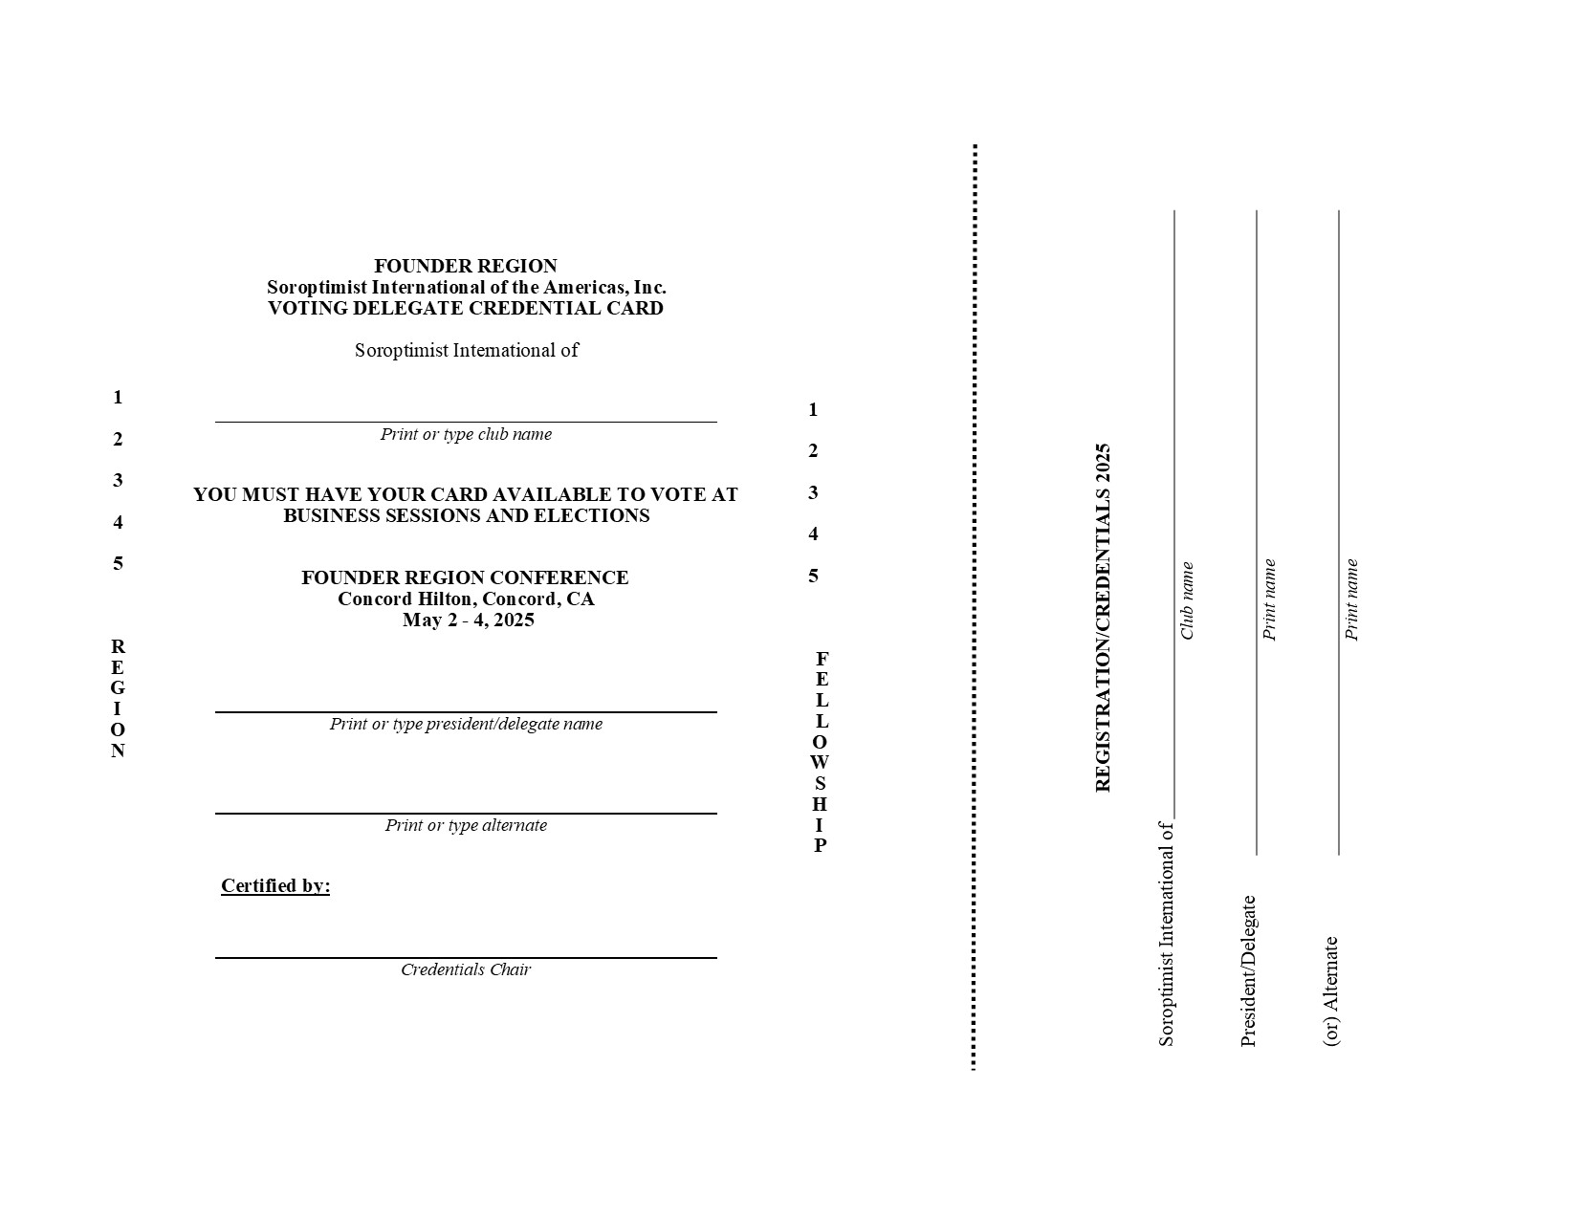
Delegate Credentials

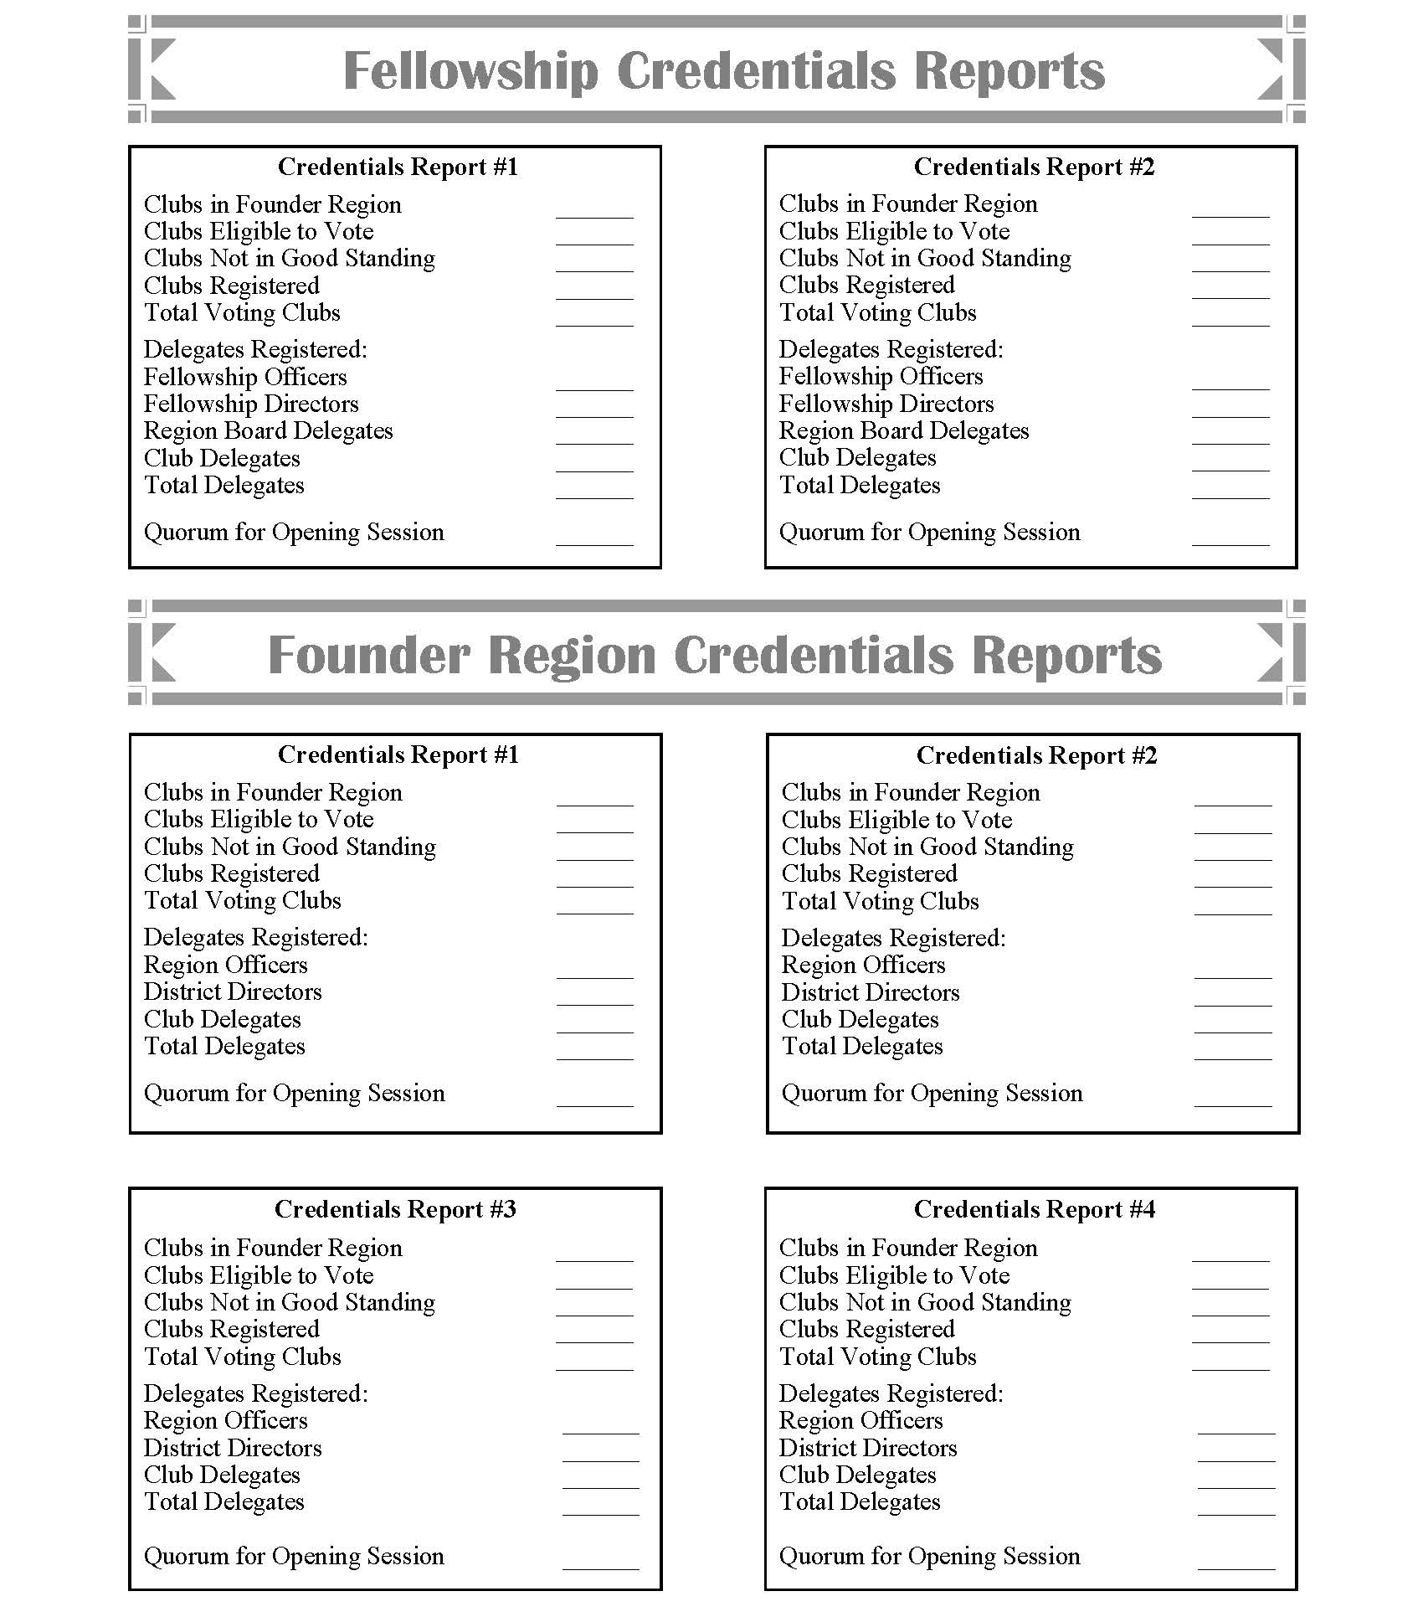
Credential Report page from conference program.

Founder Region Ballot Template
Copy & paste into new document to edit. Put two ballots on a horizontal page

FOUNDER REGION
DATE, 2025 ELECTION BALLOT
District #
Vote for one candidate per position

20XX -20XX Region Board POSITION
- NAME, SI/CLUB NAME
- NAME, SI/CLUB NAME

20XX -20XX Region Board POSITION
- NAME, SI/CLUB NAME
- NAME, SI/CLUB NAME

20XX -20XX Region Board District # Director
- NAME, SI/CLUB NAME
- NAME, SI/CLUB NAME

Founder Region Fellowship Ballot Template

FOUNDER REGION FELLOWSHIP
DATE, 2025 ELECTION BALLOT
District #
Vote for one candidate per position

20XX -20XX Fellowship Board POSITION
- NAME, SI/CLUB NAME
- NAME, SI/CLUB NAME

20XX -20XX Fellowship Board POSITION
- NAME, SI/CLUB NAME
- NAME, SI/CLUB NAME

20XX -20XX Fellowship Board District # Director
- NAME, SI/CLUB NAME
- NAME, SI/CLUB NAME
Copy & paste into new document to edit. Put two ballots on a horizontal page

